## **QUESTION 1**

1.Write a program to print the numbers from 1 to 50 using a for loop.

### **Code Solution**

for i in range(1, 51):  
 print(i)

### **FINAL Output**

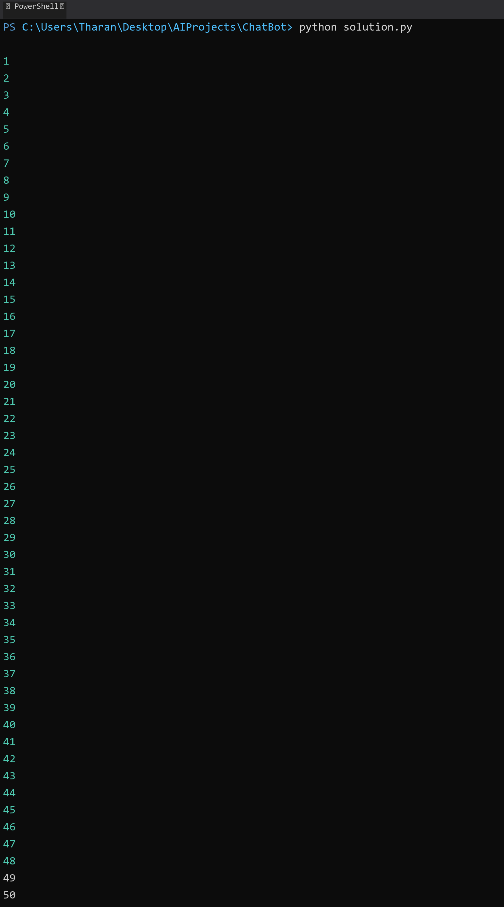

## **QUESTION 2**

2.Write a program that takes an integer as input and checks if it is even or odd.

### **Code Solution**

number = 6  
if number % 2 == 0:  
 print(f"{number} is even")  
else:  
 print(f"{number} is odd")

### **FINAL Output**

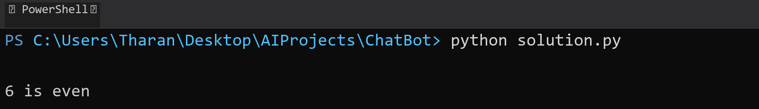

## **QUESTION 3**

3.Create a program that prints a right -angled triangle pattern of * with a height of 5.

### **Code Solution**

height = 5  
for i in range(1, height + 1):  
 for j in range(i):  
 print("*", end="")  
 print()

### **FINAL Output**

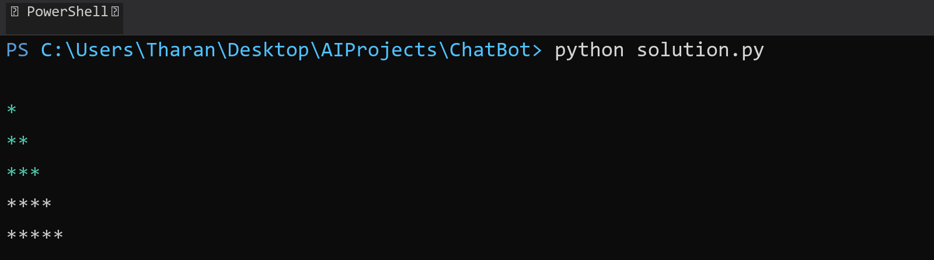

## **QUESTION 4**

4.Write a program that takes a number (1 -7) as input and prints the corresponding day of the week using a switch statement.

### **Code Solution**

number = 4  
  
def get_day(n):  
 days = {  
 1: "Monday",  
 2: "Tuesday",  
 3: "Wednesday",  
 4: "Thursday",  
 5: "Friday",  
 6: "Saturday",  
 7: "Sunday"  
 }  
 return days.get(n, "Invalid day number")  
  
print(get_day(number))

### **FINAL Output**

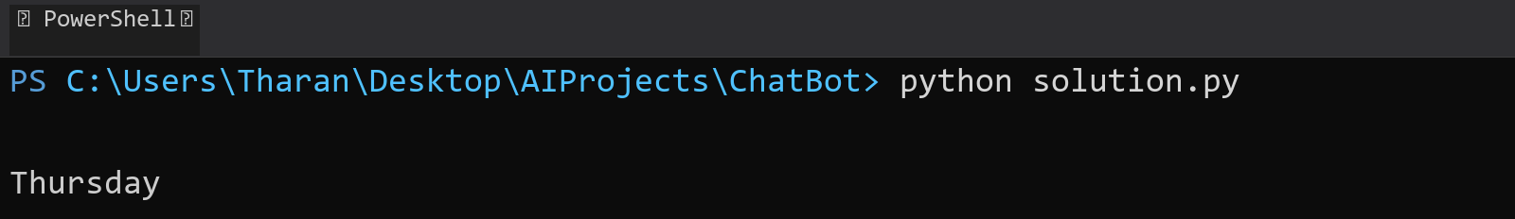

## **QUESTION 5**

5.Write a program to calculate the sum of all numbers from 1 to n using a while loop.

### **Code Solution**

n = 10  
sum = 0  
i = 1  
while i <= n:  
 sum += i  
 i += 1  
print(sum)

### **FINAL Output**

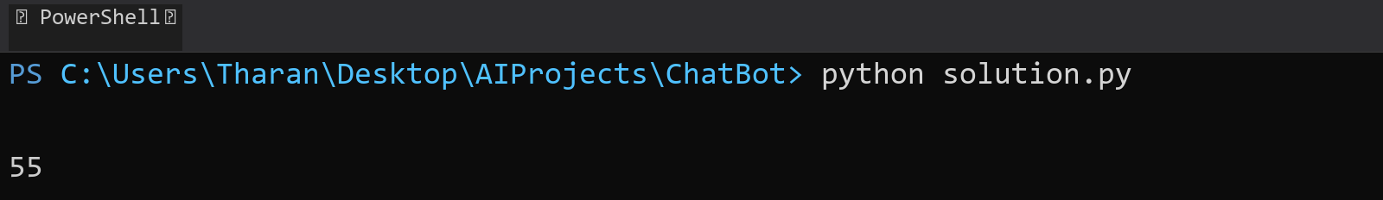

## **QUESTION 6**

6.Write a program to check if a given number is prime or not using a for loop and if conditions.

### **Code Solution**

number = 17  
is_prime = True  
  
if number <= 1:  
 is_prime = False  
else:  
 for i in range(2, int(number ** 0.5) + 1):  
 if number % i == 0:  
 is_prime = False  
 break  
  
if is_prime:  
 print(f"{number} is a prime number")  
else:  
 print(f"{number} is not a prime number")

### **FINAL Output**

