**SOFTWARE ENGENEERING**

**5 BCA B**

**Practical - 4**

***BY***

**geetha (23215134)**

**SUBMITTED TO**

**prateek singh**



**SCHOOL OF SCIENCES**

**2025-2026**

## **QUESTION 1**

1.Write a program to print the numbers from 1 to 50 using a for loop.

### **Code Solution**

for i in range(1, 51):  
 print(i)

### **FINAL Output**

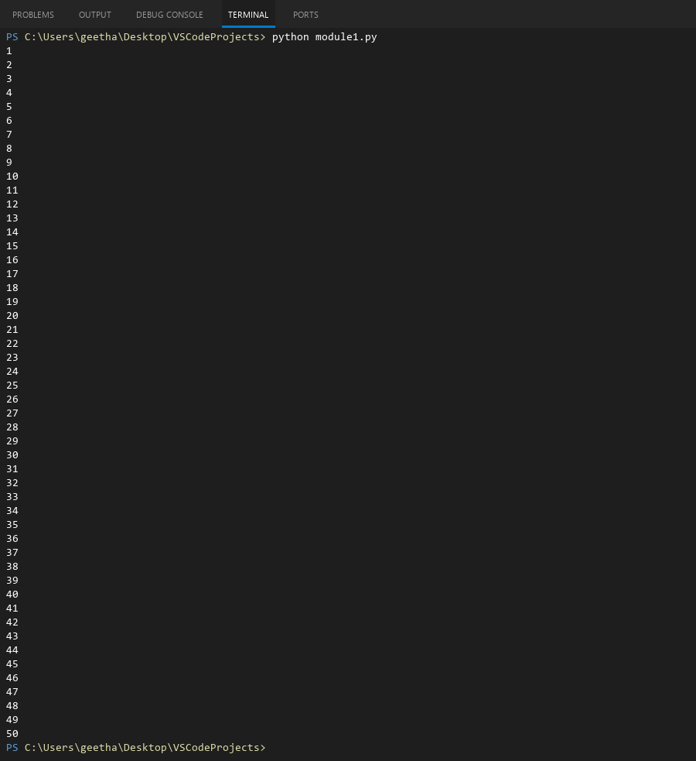

## **QUESTION 2**

2.Write a program that takes an integer as input and checks if it is even or odd.

### **Code Solution**

number = 5  
if number % 2 == 0:  
 print(f"{number} is even")  
else:  
 print(f"{number} is odd")

### **FINAL Output**

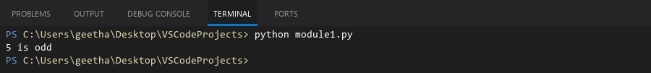

## **QUESTION 3**

3.Create a program that prints a right -angled triangle pattern of * with a height of 5.

### **Code Solution**

for i in range(1, 6):  
 for j in range(i):  
 print("*", end="")  
 print()

### **FINAL Output**

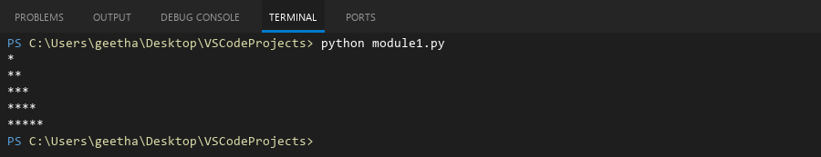

## **QUESTION 4**

4.Write a program that takes a number (1 -7) as input and prints the corresponding day of the week using a switch statement.

### **Code Solution**

def get_day(day_num):  
 match day_num:  
 case 1:  
 return "Monday"  
 case 2:  
 return "Tuesday"  
 case 3:  
 return "Wednesday"  
 case 4:  
 return "Thursday"  
 case 5:  
 return "Friday"  
 case 6:  
 return "Saturday"  
 case 7:  
 return "Sunday"  
 case _:  
 return "Invalid day number"  
  
day_number = 1  
result = get_day(day_number)  
print(result)

### **FINAL Output**

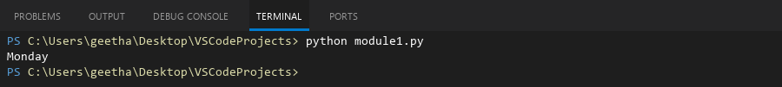

## **QUESTION 5**

5.Write a program to calculate the sum of all numbers from 1 to n using a while loop.

### **Code Solution**

n = 10  
total = 0  
count = 1  
while count <= n:  
 total += count  
 count += 1  
print(f"Sum of numbers from 1 to {n} is: {total}")

### **FINAL Output**

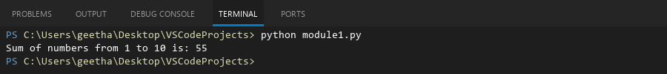

## **QUESTION 6**

6.Write a program to check if a given number is prime or not using a for loop and if conditions.

### **Code Solution**

number = 17  
is_prime = True  
  
if number > 1:  
 for i in range(2, number):  
 if number % i == 0:  
 is_prime = False  
 break  
 if is_prime:  
 print(f"{number} is a prime number")  
 else:  
 print(f"{number} is not a prime number")  
else:  
 print(f"{number} is not a prime number")

### **FINAL Output**

