*Assignment*

***Name: Tharan  
Register Number: 23215134***

***________________________________________***

## *QUESTION 1*

***1.Write a program to print the numbers from 1 to 50 using a for loop.***

### *Code Solution*

number = 9  
if number % 2 == 0:  
 print("Even")  
else:  
 print("Odd")

### *FINAL Output*

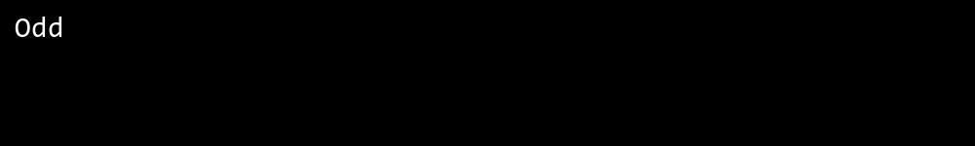

## *QUESTION 2*

***2.Write a program that takes an integer as input and checks if it is even or odd.***

### *Code Solution*

for i in range(1, 51):  
 print(i)

### *FINAL Output*

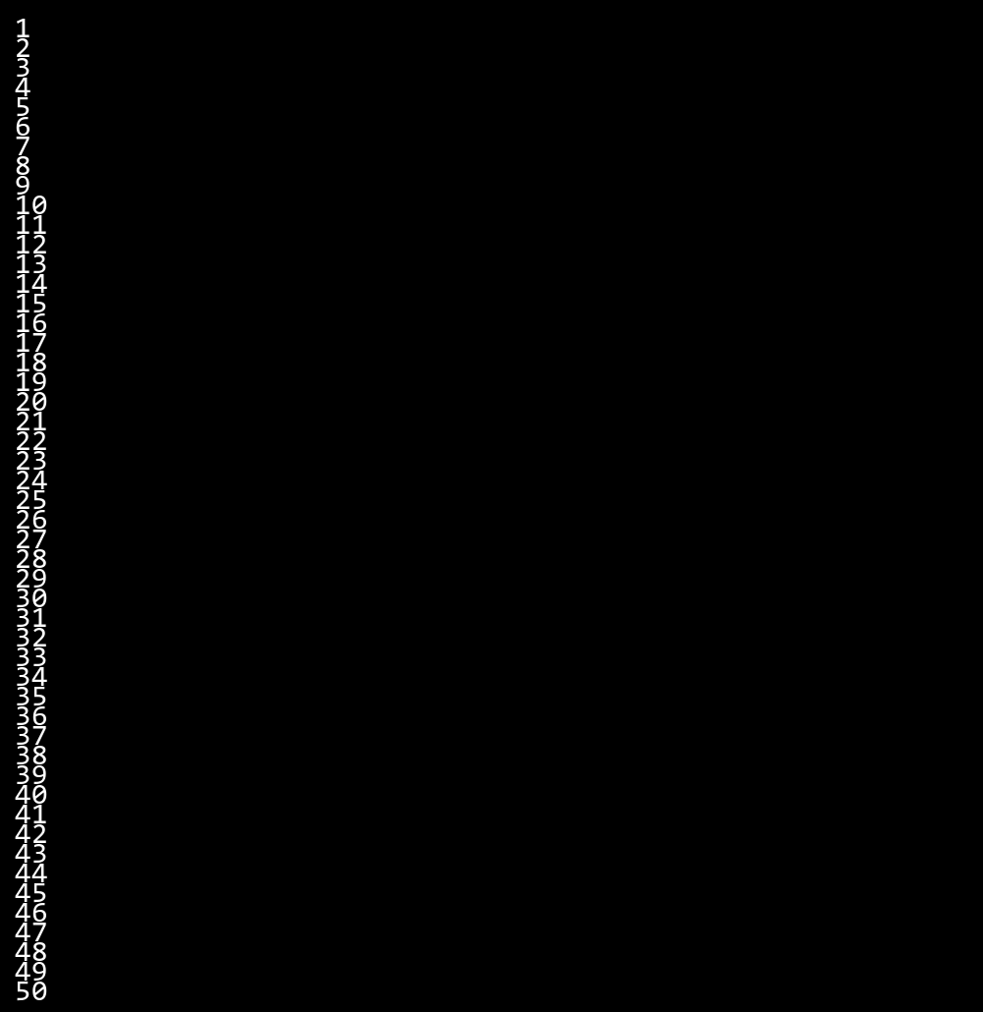

## *QUESTION 3*

***3.Create a program that prints a right -angled triangle pattern of * with a height of 5.***

### *Code Solution*

n = 5  
sum = 0  
i = 1  
while i <= n:  
 sum = sum + i  
 i = i + 1  
print(sum)

### *FINAL Output*

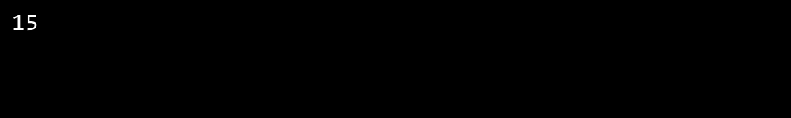

## *QUESTION 4*

***4.Write a program that takes a number (1 -7) as input and prints the corresponding day of the week using a switch statement.***

### *Code Solution*

n = 3  
  
def get_day(num):  
 switch = {  
 1: "Monday",  
 2: "Tuesday",  
 3: "Wednesday",  
 4: "Thursday",  
 5: "Friday",  
 6: "Saturday",  
 7: "Sunday"  
 }  
 return switch.get(num, "Invalid day number")  
  
print(get_day(n))

### *FINAL Output*

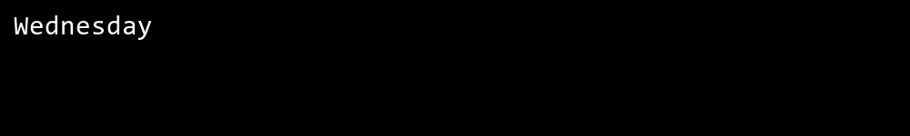

## *QUESTION 5*

***5.Write a program to calculate the sum of all numbers from 1 to n using a while loop.***

### *Code Solution*

def is_prime(num):  
 if num < 2:  
 return False  
 for i in range(2, int(num ** 0.5) + 1):  
 if num % i == 0:  
 return False  
 return True  
  
number = 17  
result = is_prime(number)  
print(result)

### *FINAL Output*

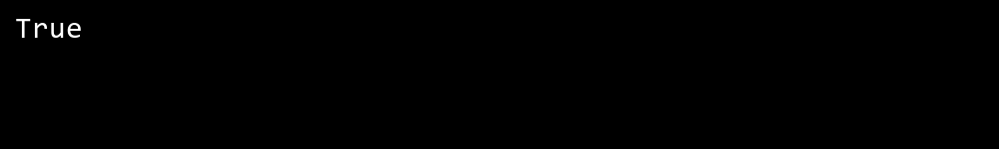

## *QUESTION 6*

***6.Write a program to check if a given number is prime or not using a for loop and if conditions.***

### *Code Solution*

for i in range(1, 6):  
 print('*' * i)

### *FINAL Output*

