Programming Assignment Solutions

**Name: tharan  
Register Number: 23215134**

==================================================

# Question 1

1. Write a program to print the numbers from 1 to 50 using a for loop.

## Solution

for i in range(1, 51):  
 print(i)

## Output

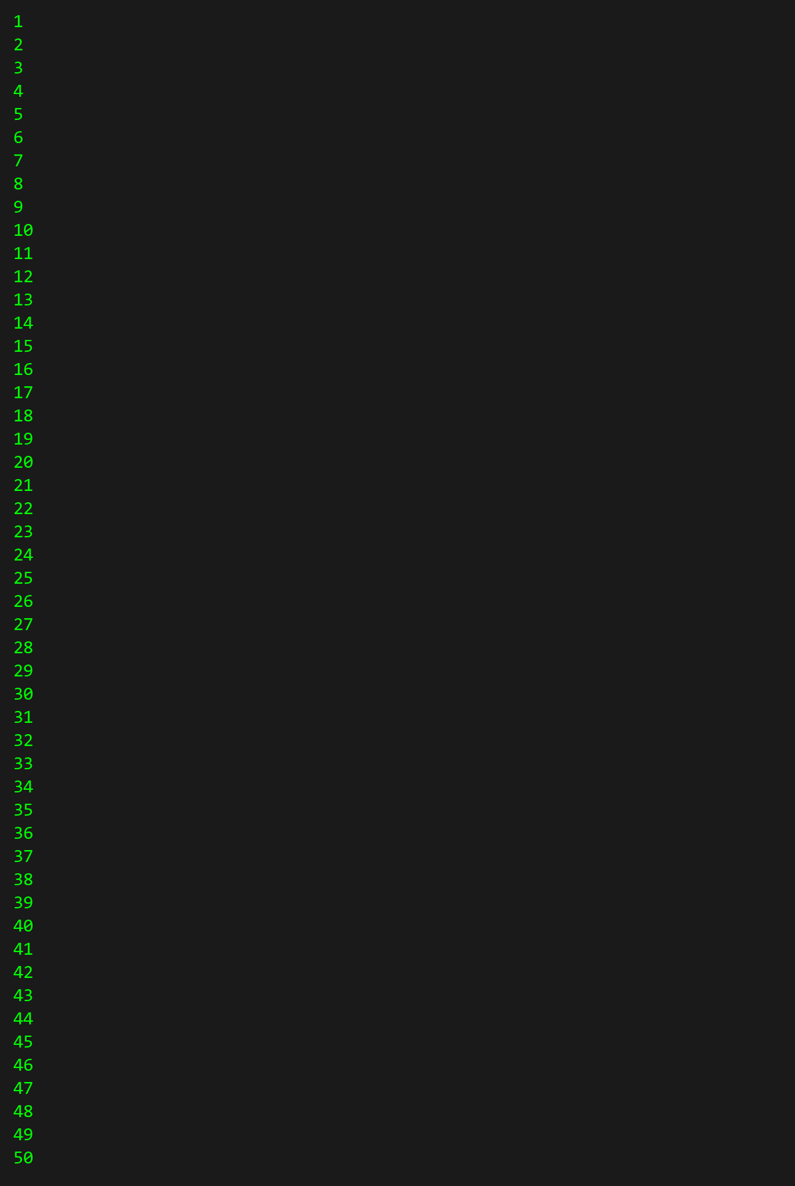

# Question 2

2. Write a program that takes an integer as input and checks if it is even or odd.

## Solution

for i in range(1, 6):  
 print('*' * i)

## Output

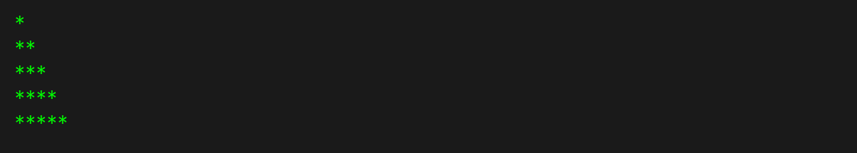

# Question 3

3. Create a program that prints a right -angled triangle pattern of * with a height of 5.

## Solution

number = 4  
if number % 2 == 0:  
 print("Even")  
else:  
 print("Odd")

## Output

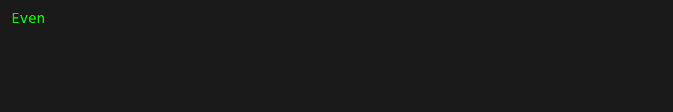

# Question 4

4. Write a program that takes a number (1 -7) as input and prints the corresponding day of the  
week using a switch statement.

## Solution

n = 10  
sum = 0  
i = 1  
while i <= n:  
 sum += i  
 i += 1

## Output

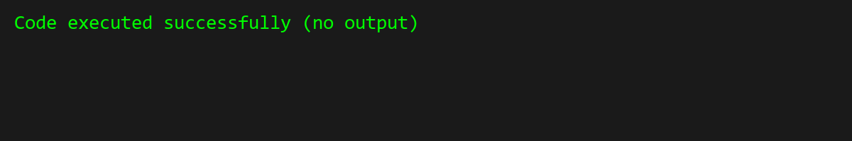

# Question 5

5. Write a program to calculate the sum of all numbers from 1 to n using a while loop.

## Solution

number = 8  
  
days = {  
 1: "Monday",  
 2: "Tuesday",  
 3: "Wednesday",  
 4: "Thursday",  
 5: "Friday",  
 6: "Saturday",  
 7: "Sunday"  
}  
  
result = days.get(number, "Invalid day number")  
print(result)

## Output

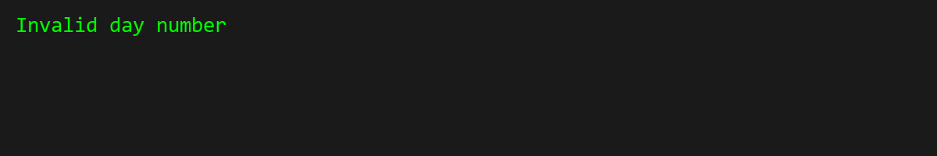

# Question 6

6. Write a program to check if a given number is prime or not using a for loop and if conditions.

## Solution

number = 7  
is_prime = True  
  
if number <= 1:  
 is_prime = False  
else:  
 for i in range(2, int(number ** 0.5) + 1):  
 if number % i == 0:  
 is_prime = False  
 break  
  
print(is_prime)

## Output

