Assignment

**Name: mathiyarasu  
Register Number: 23215134**

________________________________________

## QUESTION 1

1.Write a program to print the numbers from 1 to 50 using a for loop.

### Code Solution

n = 2  
if n % 2 == 0:  
 print("Even")  
else:  
 print("Odd")

### FINAL Output

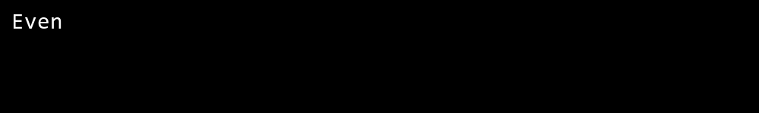

## QUESTION 2

2.Write a program that takes an integer as input and checks if it is even or odd.

### Code Solution

for i in range(1, 6):  
 for j in range(i):  
 print("*", end="")  
 print()

### FINAL Output

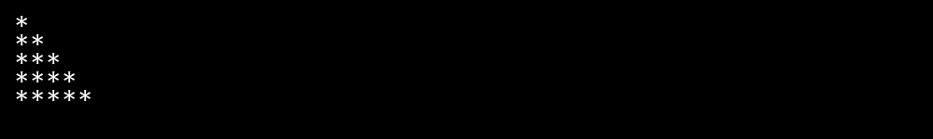

## QUESTION 3

3.Create a program that prints a right -angled triangle pattern of * with a height of 5.

### Code Solution

for i in range(1, 51):  
 print(i)

### FINAL Output

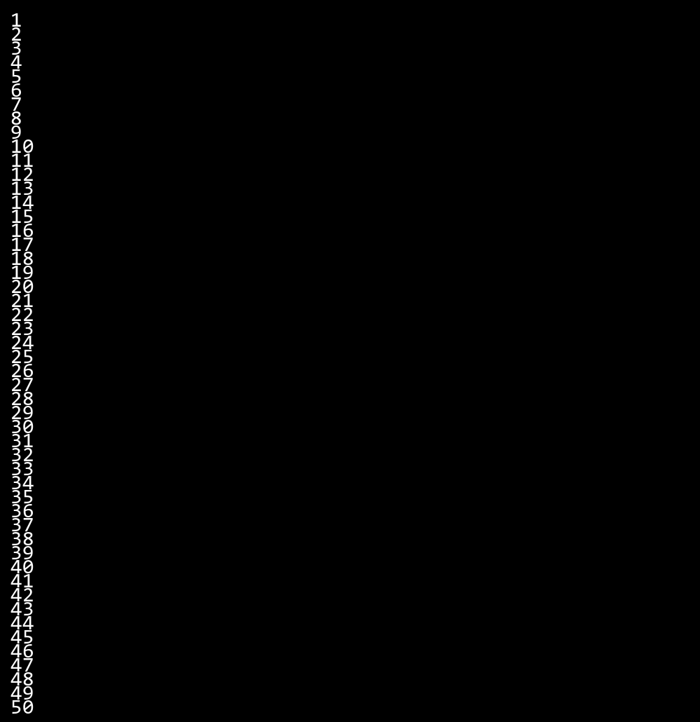

## QUESTION 4

4.Write a program that takes a number (1 -7) as input and prints the corresponding day of the week using a switch statement.

### Code Solution

n = 10  
sum = 0  
i = 1  
while i <= n:  
 sum += i  
 i += 1  
print(sum)

### FINAL Output

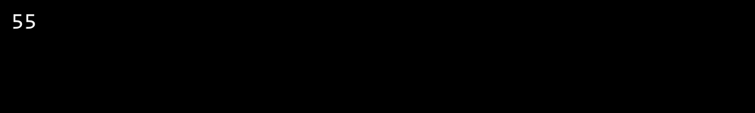

## QUESTION 5

5.Write a program to calculate the sum of all numbers from 1 to n using a while loop.

### Code Solution

def get_day(day):  
 match day:  
 case 1:  
 return "Monday"  
 case 2:  
 return "Tuesday"  
 case 3:  
 return "Wednesday"  
 case 4:  
 return "Thursday"  
 case 5:  
 return "Friday"  
 case 6:  
 return "Saturday"  
 case 7:  
 return "Sunday"  
 case _:  
 return "Invalid day"  
  
day_number = 5  
result = get_day(day_number)  
print(result)

### FINAL Output

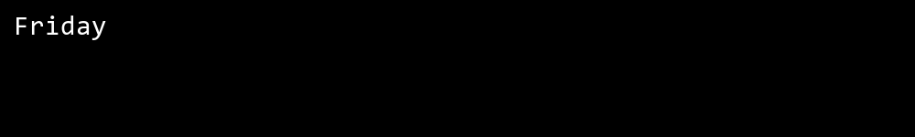

## QUESTION 6

6.Write a program to check if a given number is prime or not using a for loop and if conditions.

### Code Solution

number = 17  
is_prime = True  
  
if number < 2:  
 is_prime = False  
else:  
 for i in range(2, int(number ** 0.5) + 1):  
 if number % i == 0:  
 is_prime = False  
 break  
  
print(is_prime)

### FINAL Output

