## **QUESTION 1**

1.Write a program to print the numbers from 1 to 50 using a for loop.

### **Code Solution**

#include <iostream>  
using namespace std;  
int main() {  
 for (int i = 1; i <= 50; i++) {  
 cout << i << " ";  
 }  
 return 0;  
}

### **FINAL Output**

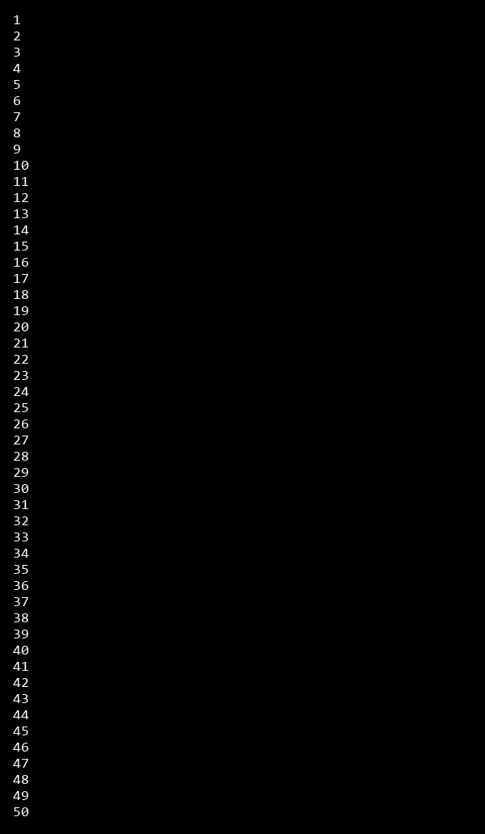

## **QUESTION 2**

2.Write a program that takes an integer as input and checks if it is even or odd.

### **Code Solution**

#include<iostream>  
int main(){  
int num=7;  
if(num%2==0){  
std::cout<<"Even";  
}else{  
std::cout<<"Odd";  
}  
return 0;  
}

### **FINAL Output**



## **QUESTION 3**

3.Create a program that prints a right -angled triangle pattern of * with a height of 5.

### **Code Solution**

#include <iostream>  
using namespace std;  
  
int main() {  
 int height = 5;  
 for (int i = 1; i <= height; i++) {  
 for (int j = 1; j <= i; j++) {  
 cout << "*";  
 }  
 cout << endl;  
 }  
 return 0;  
}

### **FINAL Output**

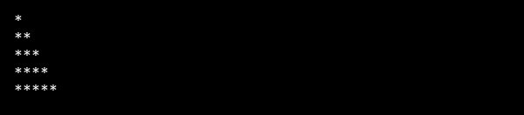

## **QUESTION 4**

4.Write a program that takes a number (1 -7) as input and prints the corresponding day of the week using a switch statement.

### **Code Solution**

#include<iostream>  
using namespace std;  
int main(){  
 int dayNumber=2;  
 switch(dayNumber){  
 case 1:  
 cout<<"Monday";  
 break;  
 case 2:  
 cout<<"Tuesday";  
 break;  
 case 3:  
 cout<<"Wednesday";  
 break;  
 case 4:  
 cout<<"Thursday";  
 break;  
 case 5:  
 cout<<"Friday";  
 break;  
 case 6:  
 cout<<"Saturday";  
 break;  
 case 7:  
 cout<<"Sunday";  
 break;  
 default:  
 cout<<"Invalid day number";  
 }  
 return 0;  
}

### **FINAL Output**



## **QUESTION 5**

5.Write a program to calculate the sum of all numbers from 1 to n using a while loop.

### **Code Solution**

#include<iostream>  
using namespace std;  
int main() {  
 int n = 10;  
 int sum = 0;  
 int i = 1;  
 while(i <= n) {  
 sum += i;  
 i++;  
 }  
 cout << sum;  
 return 0;  
}

### **FINAL Output**



## **QUESTION 6**

6.Write a program to check if a given number is prime or not using a for loop and if conditions.

### **Code Solution**

#include<iostream>  
using namespace std;  
int main() {  
 int num = 17;  
 bool isPrime = true;  
 if (num <= 1) {  
 isPrime = false;  
 } else {  
 for (int i = 2; i <= num / 2; i++) {  
 if (num % i == 0) {  
 isPrime = false;  
 break;  
 }  
 }  
 }  
 if (isPrime) {  
 cout << num << " is a prime number." << endl;  
 } else {  
 cout << num << " is not a prime number." << endl;  
 }  
 return 0;  
}

### **FINAL Output**

