**SOFTWARE ENGENEERING**

**3 bca b**

**“#practicle number”**

***BY***

**<#Student Name> (#Registration Number)**

**SUBMITTED TO**

**#teacher name**



**SCHOOL OF SCIENCES**

**2025-2026**

## **QUESTION 1**

**1.Write a program to print the numbers from 1 to 50 using a for loop.**

### **Code Solution**

n = 10  
total_sum = 0  
i = 1  
while i <= n:  
 total_sum = total_sum + i  
 i = i + 1  
print(total_sum)

### **FINAL Output**

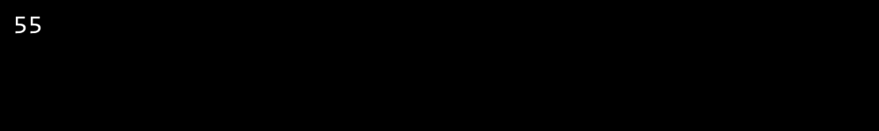

## **QUESTION 2**

**2.Write a program that takes an integer as input and checks if it is even or odd.**

### **Code Solution**

height = 5  
for i in range(1, height + 1):  
 print('*' * i)

### **FINAL Output**

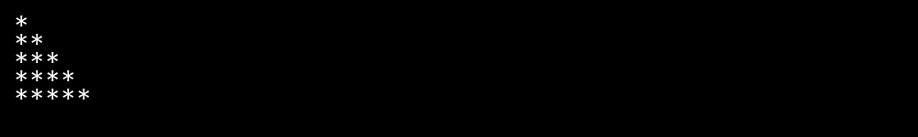

## **QUESTION 3**

**3.Create a program that prints a right -angled triangle pattern of * with a height of 5.**

### **Code Solution**

number = 4  
if number % 2 == 0:  
 print("Even")  
else:  
 print("Odd")

### **FINAL Output**

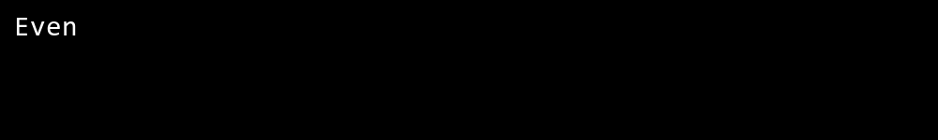

## **QUESTION 4**

**4.Write a program that takes a number (1 -7) as input and prints the corresponding day of the week using a switch statement.**

### **Code Solution**

for i in range(1, 51):  
 print(i)

### **FINAL Output**

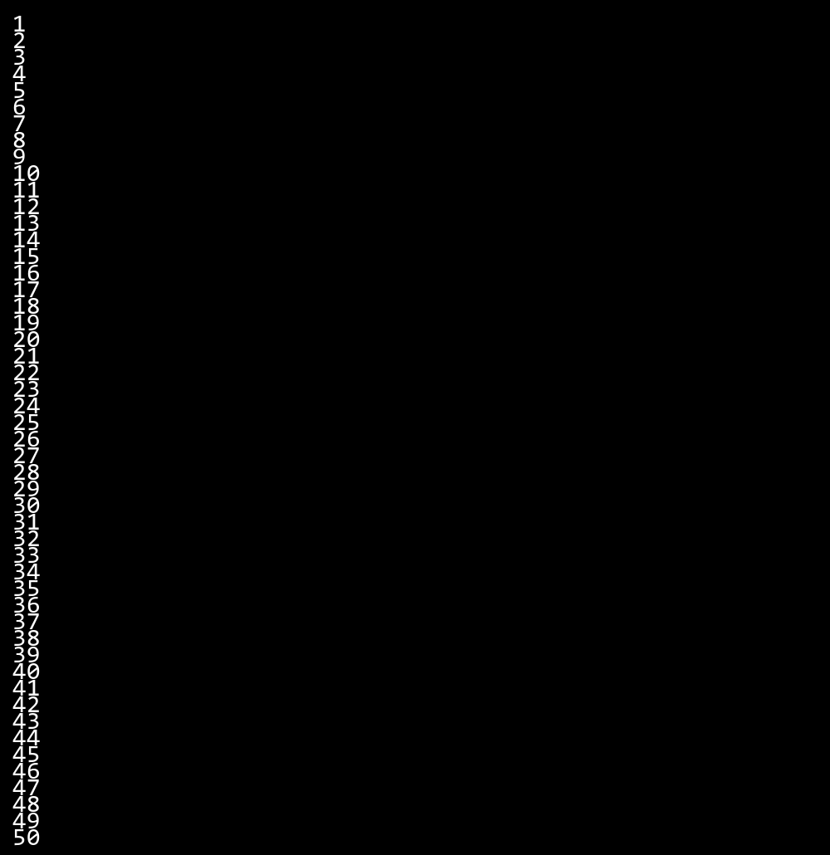

## **QUESTION 5**

**5.Write a program to calculate the sum of all numbers from 1 to n using a while loop.**

### **Code Solution**

def get_day(number):  
 switch = {  
 1: 'Monday',  
 2: 'Tuesday',  
 3: 'Wednesday',  
 4: 'Thursday',  
 5: 'Friday',  
 6: 'Saturday',  
 7: 'Sunday'  
 }  
 return switch.get(number, 'Invalid day number')  
  
number = 4  
result = get_day(number)  
print(result)

### **FINAL Output**

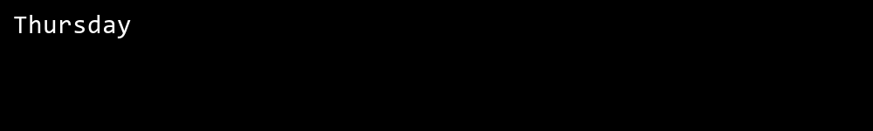

## **QUESTION 6**

**6.Write a program to check if a given number is prime or not using a for loop and if conditions.**

### **Code Solution**

def is_prime(n):  
 if n < 2:  
 return False  
 for i in range(2, int(n ** 0.5) + 1):  
 if n % i == 0:  
 return False  
 return True  
  
number = 17  
result = is_prime(number)  
print(result)

### **FINAL Output**

