**SOFTWARE ENGENEERING**

**3 bca b**

**"Practical - 4"**

***BY***

**"Tharan" (23215134)**

**SUBMITTED TO**

**prateek singh**



**SCHOOL OF SCIENCES**

**2025-2026**

## *QUESTION 1*

**1.Write a program to print the numbers from 1 to 50 using a for loop.**

### *Code Solution*

num = 8  
if num % 2 == 0:  
 print("Even")  
else:  
 print("Odd")

### *FINAL Output*

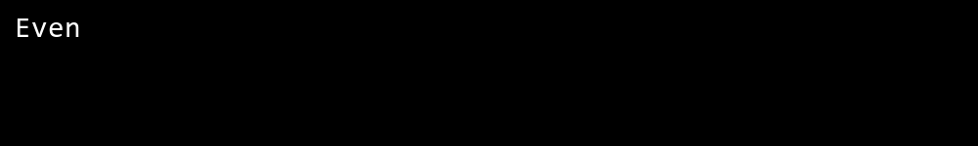

## *QUESTION 2*

**2.Write a program that takes an integer as input and checks if it is even or odd.**

### *Code Solution*

def is_prime(n):  
 if n < 2:  
 return False  
 for i in range(2, int(n ** 0.5) + 1):  
 if n % i == 0:  
 return False  
 return True  
  
number = 17  
result = is_prime(number)  
print(result)

### *FINAL Output*

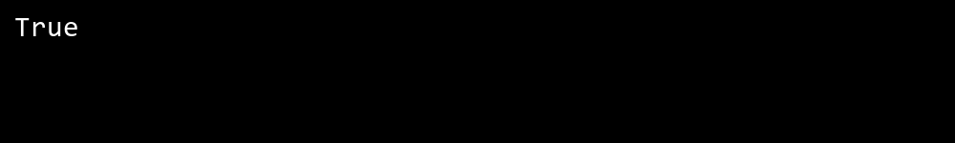

## *QUESTION 3*

**3.Create a program that prints a right -angled triangle pattern of * with a height of 5.**

### *Code Solution*

for i in range(1, 51):  
 print(i)

### *FINAL Output*

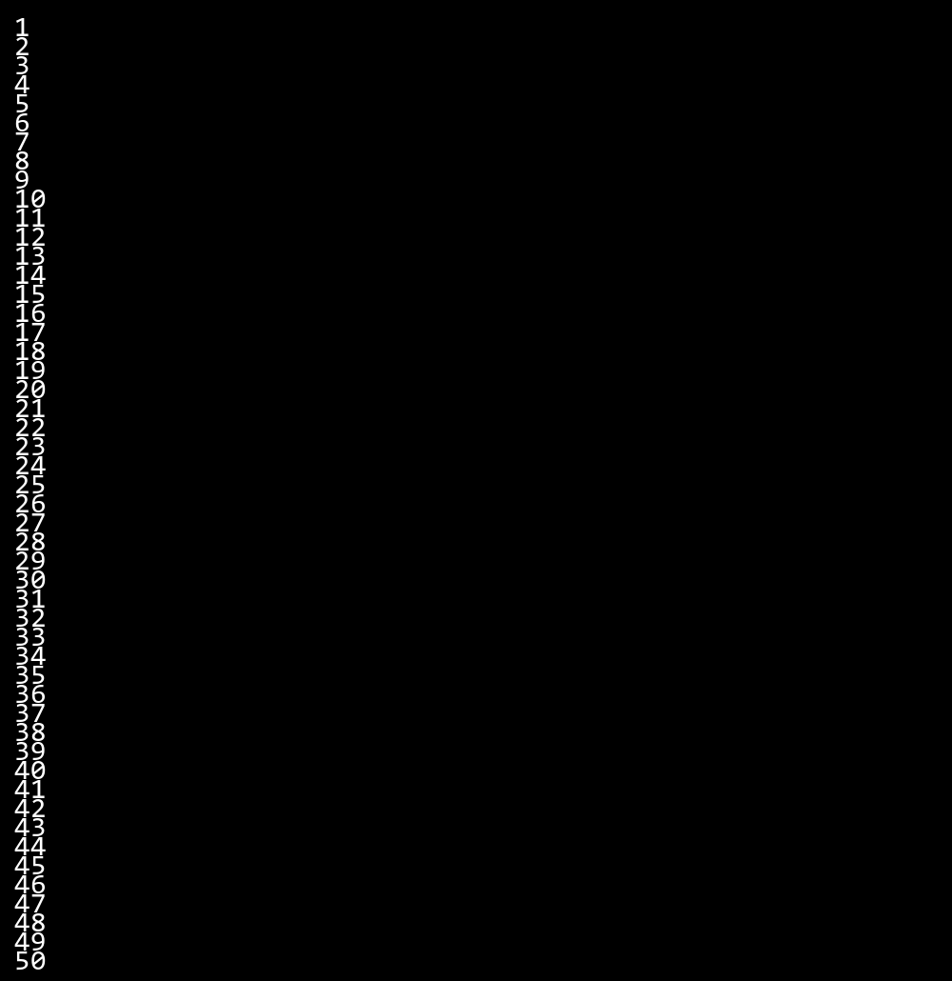

## *QUESTION 4*

**4.Write a program that takes a number (1 -7) as input and prints the corresponding day of the week using a switch statement.**

### *Code Solution*

n = 10  
sum = 0  
i = 1  
while i <= n:  
 sum = sum + i  
 i = i + 1  
print(sum)

### *FINAL Output*

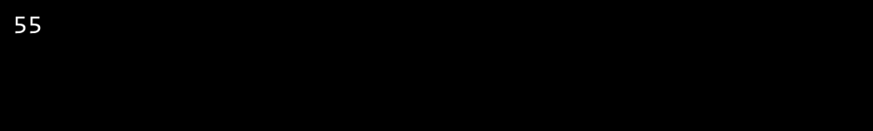

## *QUESTION 5*

**5.Write a program to calculate the sum of all numbers from 1 to n using a while loop.**

### *Code Solution*

for i in range(1, 6):  
 for j in range(i):  
 print("*", end="")  
 print()

### *FINAL Output*

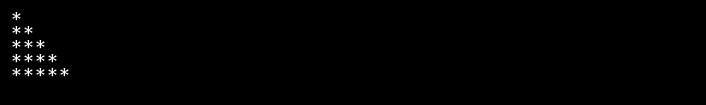

## *QUESTION 6*

**6.Write a program to check if a given number is prime or not using a for loop and if conditions.**

### *Code Solution*

n = 2  
  
def get_day(day):  
 if day == 1:  
 return "Monday"  
 elif day == 2:  
 return "Tuesday"  
 elif day == 3:  
 return "Wednesday"  
 elif day == 4:  
 return "Thursday"  
 elif day == 5:  
 return "Friday"  
 elif day == 6:  
 return "Saturday"  
 elif day == 7:  
 return "Sunday"  
 else:  
 return "Invalid day number"  
  
print(get_day(n))

### *FINAL Output*

