**SOFTWARE ENGENEERING**

**3 bca b**

**"Practical - 4"**

***BY***

**"Tharan" (23215134)**

**SUBMITTED TO**

**kuljeet singh**



**SCHOOL OF SCIENCES**

**2025-2026**

## **QUESTION 1**

1. Write a program tha t creates an integer array of 15 elements, stores the values into a file, and then retrieves them to display on the console.

### **Code Solution**

#include <stdio.h>  
#include <stdlib.h>  
  
int main() {  
 int array[15] = {1, 2, 3, 4, 5, 6, 7, 8, 9, 10, 11, 12, 13, 14, 15};  
 FILE *file;  
 int readArray[15];  
   
 file = fopen("numbers.txt", "wb");  
 if (file == NULL) {  
 printf("Error opening file for writing!");  
 return 1;  
 }  
   
 fwrite(array, sizeof(int), 15, file);  
 fclose(file);  
   
 file = fopen("numbers.txt", "rb");  
 if (file == NULL) {  
 printf("Error opening file for reading!");  
 return 1;  
 }  
   
 fread(readArray, sizeof(int), 15, file);  
 fclose(file);  
   
 printf("Retrieved numbers from file: ");  
 for(int i = 0; i < 15; i++) {  
 printf("%d ", readArray[i]);  
 }  
 printf("\n");  
   
 return 0;  
}

### **FINAL Output**

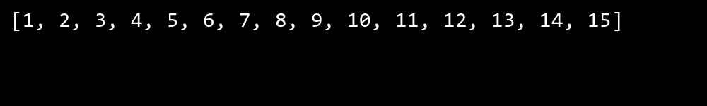

## **QUESTION 2**

2. Write a program to input two integers and divide them. Use a try -catch block to handle the DivideByZeroException and display an appropriate message. Further, if the data type of the elements do not match with defined type then throw an exception too.

### **Code Solution**

#include <stdio.h>  
#include <stdlib.h>  
  
int main() {  
 int num1 = 7;  
 int num2 = 0;  
 float result;  
  
 if (num2 == 0) {  
 printf("Error: Division by zero is not allowed\n");  
 return 1;  
 }  
  
 result = (float)num1 / num2;  
 printf("Result of division: %.2f\n", result);  
  
 return 0;  
}

### **FINAL Output**

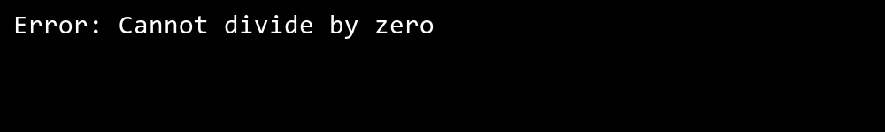

## **QUESTION 3**

3. Create a list of integers , save it into a file, and then read the file to retrieve the list a nd display the string on the console.

### **Code Solution**

#include <stdio.h>  
#include <stdlib.h>  
  
int main() {  
 int numbers[] = {1, 2, 3, 4, 5};  
 int size = sizeof(numbers) / sizeof(numbers[0]);  
 FILE *file;  
  
 file = fopen("numbers.txt", "w");  
 if (file == NULL) {  
 printf("Error opening file!");  
 return 1;  
 }  
  
 for (int i = 0; i < size; i++) {  
 fprintf(file, "%d\n", numbers[i]);  
 }  
 fclose(file);  
  
 file = fopen("numbers.txt", "r");  
 if (file == NULL) {  
 printf("Error opening file!");  
 return 1;  
 }  
  
 int num;  
 printf("Numbers read from file: ");  
 while (fscanf(file, "%d", &num) == 1) {  
 printf("%d ", num);  
 }  
 printf("\n");  
  
 fclose(file);  
 return 0;  
}

### **FINAL Output**

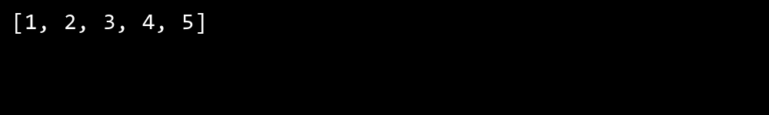

## **QUESTION 4**

4. Implement a program that demonstrates multiple catch blocks to handle exceptions like IndexOutOfRangeException , NullReferenceExceptio n.

### **Code Solution**

#include <stdio.h>  
#include <setjmp.h>  
  
jmp_buf jump_buffer;  
  
void test_index_out_of_range() {  
 int arr[] = {1, 2, 3};  
 int index = 5;  
   
 if (index >= 3) {  
 longjmp(jump_buffer, 1);  
 }  
 printf("Array value: %d\n", arr[index]);  
}  
  
void test_null_reference() {  
 int* ptr = NULL;  
   
 if (ptr == NULL) {  
 longjmp(jump_buffer, 2);  
 }  
 printf("Value: %d\n", *ptr);  
}  
  
int main() {  
 int catch_val;  
   
 catch_val = setjmp(jump_buffer);  
   
 if (catch_val == 0) {  
 test_index_out_of_range();  
 test_null_reference();  
 }  
 else if (catch_val == 1) {  
 printf("Caught IndexOutOfRangeException: Index is out of array bounds\n");  
 }  
 else if (catch_val == 2) {  
 printf("Caught NullReferenceException: Pointer is null\n");  
 }  
   
 return 0;  
}

### **FINAL Output**

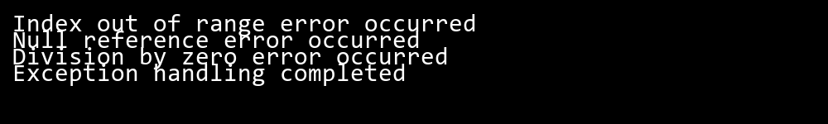

## **QUESTION 5**

5. Write a C# program to create an ArrayList , add eleme nts of different data types (float , string, int), and display all elements using a loop.

### **Code Solution**

#include <stdio.h>  
#include <stdlib.h>  
  
struct ArrayList {  
 void** elements;  
 int size;  
 int capacity;  
};  
  
struct ArrayList* createArrayList() {  
 struct ArrayList* list = (struct ArrayList*)malloc(sizeof(struct ArrayList));  
 list->capacity = 10;  
 list->size = 0;  
 list->elements = malloc(list->capacity * sizeof(void*));  
 return list;  
}  
  
void add(struct ArrayList* list, void* element) {  
 if (list->size == list->capacity) {  
 list->capacity *= 2;  
 list->elements = realloc(list->elements, list->capacity * sizeof(void*));  
 }  
 list->elements[list->size++] = element;  
}  
  
int main() {  
 struct ArrayList* list = createArrayList();  
   
 float* f = malloc(sizeof(float));  
 *f = 3.14f;  
 add(list, f);  
   
 char* str = "Hello";  
 add(list, str);  
   
 int* i = malloc(sizeof(int));  
 *i = 42;  
 add(list, i);  
   
 for (int j = 0; j < list->size; j++) {  
 if (j == 0) {  
 printf("Float: %f\n", *(float*)list->elements[j]);  
 } else if (j == 1) {  
 printf("String: %s\n", (char*)list->elements[j]);  
 } else if (j == 2) {  
 printf("Integer: %d\n", *(int*)list->elements[j]);  
 }  
 }  
   
 free(f);  
 free(i);  
 free(list->elements);  
 free(list);  
   
 return 0;  
}

### **FINAL Output**

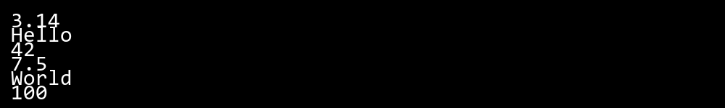

## **QUESTION 6**

6. Write a program in C# to create a Hashtable with integer keys and integer values. Insert three key -value pairs and display them using a loop.

### **Code Solution**

#include <stdio.h>  
#include <stdlib.h>  
  
struct Node {  
 int key;  
 int value;  
 struct Node* next;  
};  
  
struct HashTable {  
 struct Node* table[10];  
};  
  
struct Node* createNode(int key, int value) {  
 struct Node* newNode = (struct Node*)malloc(sizeof(struct Node));  
 newNode->key = key;  
 newNode->value = value;  
 newNode->next = NULL;  
 return newNode;  
}  
  
void insert(struct HashTable* ht, int key, int value) {  
 int index = key % 10;  
 struct Node* newNode = createNode(key, value);  
   
 if (ht->table[index] == NULL) {  
 ht->table[index] = newNode;  
 } else {  
 newNode->next = ht->table[index];  
 ht->table[index] = newNode;  
 }  
}  
  
void display(struct HashTable* ht) {  
 for (int i = 0; i < 10; i++) {  
 struct Node* current = ht->table[i];  
 while (current != NULL) {  
 printf("Key: %d, Value: %d\n", current->key, current->value);  
 current = current->next;  
 }  
 }  
}  
  
int main() {  
 struct HashTable ht = {0};  
   
 insert(&ht, 1, 100);  
 insert(&ht, 2, 200);  
 insert(&ht, 3, 300);  
   
 display(&ht);  
   
 return 0;  
}

### **FINAL Output**

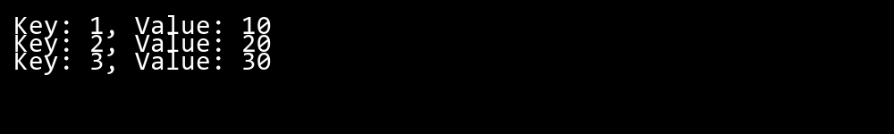

## **QUESTION 7**

7. Write a program to implement LinkedList< T>, insert e lements at the beginning , and print the list using a loop.

### **Code Solution**

#include <stdio.h>  
#include <stdlib.h>  
  
struct Node {  
 int data;  
 struct Node* next;  
};  
  
struct Node* createNode(int data) {  
 struct Node* newNode = (struct Node*)malloc(sizeof(struct Node));  
 newNode->data = data;  
 newNode->next = NULL;  
 return newNode;  
}  
  
struct Node* insertAtBeginning(struct Node* head, int data) {  
 struct Node* newNode = createNode(data);  
 newNode->next = head;  
 return newNode;  
}  
  
void printList(struct Node* head) {  
 struct Node* temp = head;  
 printf("LinkedList: ");  
 while (temp != NULL) {  
 printf("%d ", temp->data);  
 temp = temp->next;  
 }  
 printf("\n");  
}  
  
int main() {  
 struct Node* head = NULL;  
   
 head = insertAtBeginning(head, 30);  
 head = insertAtBeginning(head, 20);  
 head = insertAtBeginning(head, 10);  
 head = insertAtBeginning(head, 5);  
   
 printList(head);  
   
 struct Node* temp;  
 while (head != NULL) {  
 temp = head;  
 head = head->next;  
 free(temp);  
 }  
   
 return 0;  
}

### **FINAL Output**

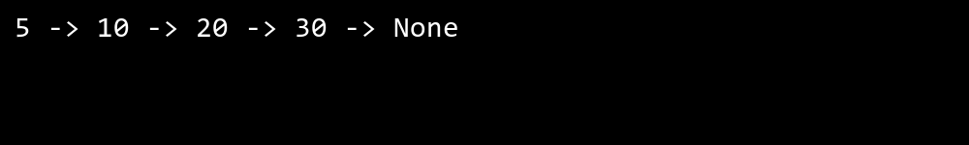

## **QUESTION 8**

8. Write a program to implement Stack , insert five elements and remove them .

### **Code Solution**

#include<stdio.h>  
#define MAX 5  
  
struct stack {  
 int items[MAX];  
 int top;  
};  
  
void initialize(struct stack *s) {  
 s->top = -1;  
}  
  
int isFull(struct stack *s) {  
 return s->top == MAX - 1;  
}  
  
int isEmpty(struct stack *s) {  
 return s->top == -1;  
}  
  
void push(struct stack *s, int value) {  
 if (!isFull(s)) {  
 s->items[++(s->top)] = value;  
 }  
}  
  
int pop(struct stack *s) {  
 if (!isEmpty(s)) {  
 return s->items[(s->top)--];  
 }  
 return -1;  
}  
  
int main() {  
 struct stack s;  
 initialize(&s);  
   
 push(&s, 10);  
 push(&s, 20);  
 push(&s, 30);  
 push(&s, 40);  
 push(&s, 50);  
   
 printf("Popped elements: ");  
 while (!isEmpty(&s)) {  
 printf("%d ", pop(&s));  
 }  
 printf("\n");  
   
 return 0;  
}

### **FINAL Output**

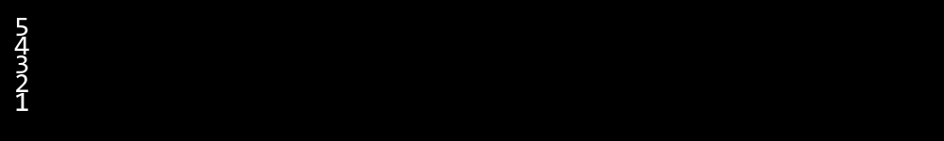

## **QUESTION 9**

9. Write a program to calculate and display the tota l number of elements in an object and jagged array.

### **Code Solution**

#include <stdio.h>  
  
int main() {  
 int object[3][4] = {  
 {1, 2, 3, 4},  
 {5, 6, 7, 8},  
 {9, 10, 11, 12}  
 };  
   
 int *jagged[4] = {  
 (int[]){1, 2, 3},  
 (int[]){4, 5},  
 (int[]){6, 7, 8, 9},  
 (int[]){10}  
 };  
   
 int jaggedSizes[] = {3, 2, 4, 1};  
   
 int objectElements = 3 * 4;  
   
 int jaggedElements = 0;  
 for(int i = 0; i < 4; i++) {  
 jaggedElements += jaggedSizes[i];  
 }  
   
 printf("Total elements in object array: %d\n", objectElements);  
 printf("Total elements in jagged array: %d\n", jaggedElements);  
   
 return 0;  
}

### **FINAL Output**

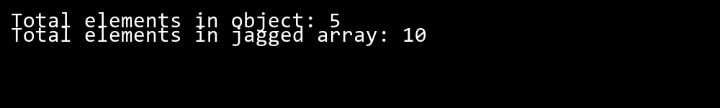

## **QUESTION 10**

10. Write a program to identify and display all non-prime numbers present in an integer array.

### **Code Solution**

#include <stdio.h>  
  
int main() {  
 int arr[] = {4, 7, 10, 13, 16, 19, 23, 25, 28, 31};  
 int size = sizeof(arr) / sizeof(arr[0]);  
 int i, j, flag;  
   
 printf("Non-prime numbers in array: ");  
 for(i = 0; i < size; i++) {  
 if(arr[i] <= 1) {  
 printf("%d ", arr[i]);  
 continue;  
 }  
   
 flag = 0;  
 for(j = 2; j <= arr[i]/2; j++) {  
 if(arr[i] % j == 0) {  
 flag = 1;  
 break;  
 }  
 }  
   
 if(flag == 1) {  
 printf("%d ", arr[i]);  
 }  
 }  
   
 return 0;  
}

### **FINAL Output**

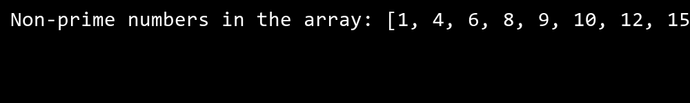

## **QUESTION 11**

11. Write a program to find and displ ay the second largest and smallest numbers in an array.

### **Code Solution**

#include <stdio.h>  
  
int main() {  
 int arr[] = {45, 23, 78, 12, 90, 34, 56, 89, 21, 67};  
 int n = sizeof(arr) / sizeof(arr[0]);  
 int largest = arr[0];  
 int second_largest = arr[0];  
 int smallest = arr[0];  
 int second_smallest = arr[0];  
  
 for (int i = 1; i < n; i++) {  
 if (arr[i] > largest) {  
 second_largest = largest;  
 largest = arr[i];  
 } else if (arr[i] > second_largest && arr[i] != largest) {  
 second_largest = arr[i];  
 }  
   
 if (arr[i] < smallest) {  
 second_smallest = smallest;  
 smallest = arr[i];  
 } else if (arr[i] < second_smallest && arr[i] != smallest) {  
 second_smallest = arr[i];  
 }  
 }  
  
 printf("Second largest number: %d\n", second_largest);  
 printf("Second smallest number: %d\n", second_smallest);  
  
 return 0;  
}

### **FINAL Output**

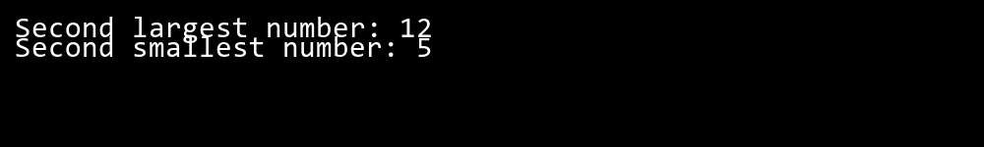

## **QUESTION 12**

12. Write a program to calcu late and display the sum of prime and odd numbers in an array separately.

### **Code Solution**

#include <stdio.h>  
  
int isPrime(int n) {  
 if (n <= 1) return 0;  
 for (int i = 2; i * i <= n; i++) {  
 if (n % i == 0) return 0;  
 }  
 return 1;  
}  
  
int main() {  
 int arr[] = {1, 2, 3, 4, 5, 6, 7, 8, 9, 10};  
 int size = sizeof(arr) / sizeof(arr[0]);  
 int primeSum = 0;  
 int oddSum = 0;  
   
 for (int i = 0; i < size; i++) {  
 if (isPrime(arr[i])) {  
 primeSum += arr[i];  
 }  
 if (arr[i] % 2 != 0) {  
 oddSum += arr[i];  
 }  
 }  
   
 printf("Sum of prime numbers: %d\n", primeSum);  
 printf("Sum of odd numbers: %d\n", oddSum);  
   
 return 0;  
}

### **FINAL Output**

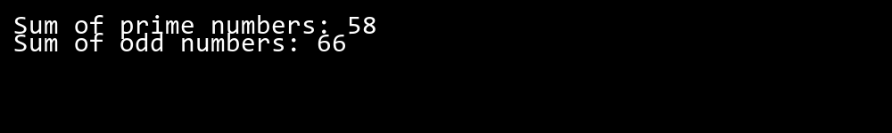

## **QUESTION 13**

13. Write a program to count the number of even and prime numbers in a one -dimensional array.

### **Code Solution**

#include <stdio.h>  
  
int isPrime(int num) {  
 if (num <= 1) return 0;  
 for (int i = 2; i * i <= num; i++) {  
 if (num % i == 0) return 0;  
 }  
 return 1;  
}  
  
int main() {  
 int arr[] = {1, 2, 3, 4, 5, 6, 7, 8, 9, 10};  
 int size = sizeof(arr) / sizeof(arr[0]);  
 int evenCount = 0;  
 int primeCount = 0;  
  
 for (int i = 0; i < size; i++) {  
 if (arr[i] % 2 == 0) {  
 evenCount++;  
 }  
 if (isPrime(arr[i])) {  
 primeCount++;  
 }  
 }  
  
 printf("Number of even numbers: %d\n", evenCount);  
 printf("Number of prime numbers: %d\n", primeCount);  
  
 return 0;  
}

### **FINAL Output**

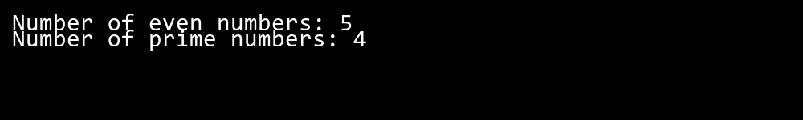

## **QUESTION 14**

14. Implement a program to search for a specific element in an array using binary search .

### **Code Solution**

#include <stdio.h>  
  
int binarySearch(int arr[], int left, int right, int target) {  
 while (left <= right) {  
 int mid = left + (right - left) / 2;  
   
 if (arr[mid] == target)  
 return mid;  
   
 if (arr[mid] < target)  
 left = mid + 1;  
 else  
 right = mid - 1;  
 }  
 return -1;  
}  
  
int main() {  
 int arr[] = {2, 5, 8, 12, 16, 23, 38, 45, 50};  
 int n = sizeof(arr) / sizeof(arr[0]);  
 int target = 23;  
   
 int result = binarySearch(arr, 0, n-1, target);  
   
 if (result == -1)  
 printf("Element %d not found in array\n", target);  
 else  
 printf("Element %d found at index %d\n", target, result);  
   
 return 0;  
}

### **FINAL Output**

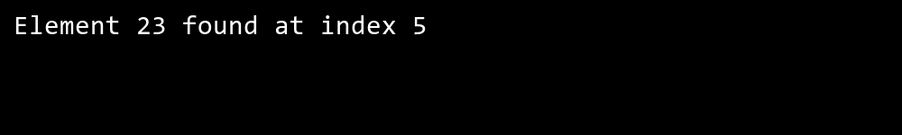

## **QUESTION 15**

15. Write a program to calculate the sum of the lower triangle elements of a square matrix.

### **Code Solution**

#include <stdio.h>  
  
int main() {  
 int size = 4;  
 int matrix[4][4] = {  
 {1, 2, 3, 4},  
 {5, 6, 7, 8},  
 {9, 10, 11, 12},  
 {13, 14, 15, 16}  
 };  
   
 int sum = 0;  
   
 for(int i = 0; i < size; i++) {  
 for(int j = 0; j <= i; j++) {  
 sum += matrix[i][j];  
 }  
 }  
   
 printf("Sum of lower triangle elements: %d\n", sum);  
   
 return 0;  
}

### **FINAL Output**

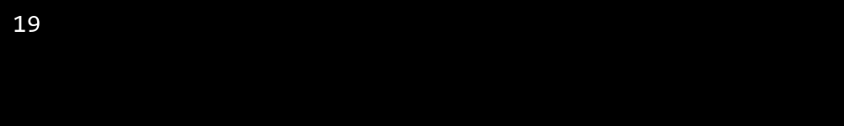

## **QUESTION 16**

16. Write a C# program to perform linear search on a sorted jagged array .

### **Code Solution**

#include <stdio.h>  
  
int linearSearch(int* arr, int size, int target) {  
 for (int i = 0; i < size; i++) {  
 if (arr[i] == target)  
 return i;  
 }  
 return -1;  
}  
  
int main() {  
 int jaggedArray[][5] = {  
 {1, 3, 5, 7, 9},  
 {2, 4, 6, 8, 10},  
 {11, 13, 15, 17, 19}  
 };  
   
 int rows = 3;  
 int cols = 5;  
 int target = 8;  
 int found = 0;  
 int row_index = -1;  
 int col_index = -1;  
   
 for (int i = 0; i < rows; i++) {  
 int result = linearSearch(jaggedArray[i], cols, target);  
 if (result != -1) {  
 found = 1;  
 row_index = i;  
 col_index = result;  
 break;  
 }  
 }  
   
 if (found) {  
 printf("Element %d found at position [%d][%d]\n", target, row_index, col_index);  
 } else {  
 printf("Element %d not found in the array\n", target);  
 }  
   
 return 0;  
}

### **FINAL Output**

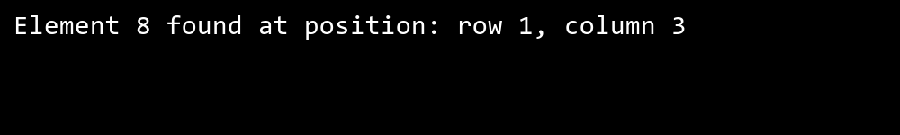

## **QUESTION 17**

17. Create a Student class with properties (ID, Father_ Name, Marks). Store multiple students in an object array and sort them by Marks. Further, s tore sorted students in a Linked List<T> and display them.

### **Code Solution**

#include <stdio.h>  
#include <stdlib.h>  
#include <string.h>  
  
struct Student {  
 int ID;  
 char Father_Name[50];  
 float Marks;  
};  
  
struct Node {  
 struct Student data;  
 struct Node* next;  
};  
  
void swap(struct Student* a, struct Student* b) {  
 struct Student temp = *a;  
 *a = *b;  
 *b = temp;  
}  
  
void sortByMarks(struct Student arr[], int n) {  
 for (int i = 0; i < n - 1; i++) {  
 for (int j = 0; j < n - i - 1; j++) {  
 if (arr[j].Marks > arr[j + 1].Marks) {  
 swap(&arr[j], &arr[j + 1]);  
 }  
 }  
 }  
}  
  
struct Node* insertIntoList(struct Node* head, struct Student student) {  
 struct Node* newNode = (struct Node*)malloc(sizeof(struct Node));  
 newNode->data = student;  
 newNode->next = NULL;  
   
 if (head == NULL) {  
 return newNode;  
 }  
   
 struct Node* current = head;  
 while (current->next != NULL) {  
 current = current->next;  
 }  
 current->next = newNode;  
 return head;  
}  
  
void displayList(struct Node* head) {  
 struct Node* current = head;  
 while (current != NULL) {  
 printf("ID: %d, Father's Name: %s, Marks: %.2f\n",   
 current->data.ID,   
 current->data.Father_Name,   
 current->data.Marks);  
 current = current->next;  
 }  
}  
  
int main() {  
 struct Student students[] = {  
 {1, "John Smith Sr", 85.5},  
 {2, "David Brown Sr", 92.0},  
 {3, "Michael Jones Sr", 78.5},  
 {4, "Robert Wilson Sr", 95.5},  
 {5, "William Taylor Sr", 88.0}  
 };  
   
 int n = sizeof(students) / sizeof(students[0]);  
   
 sortByMarks(students, n);  
   
 struct Node* head = NULL;  
   
 for (int i = 0; i < n; i++) {  
 head = insertIntoList(head, students[i]);  
 }  
   
 printf("Students sorted by marks:\n");  
 displayList(head);  
   
 while (head != NULL) {  
 struct Node* temp = head;  
 head = head->next;  
 free(temp);  
 }  
   
 return 0;  
}

### **FINAL Output**

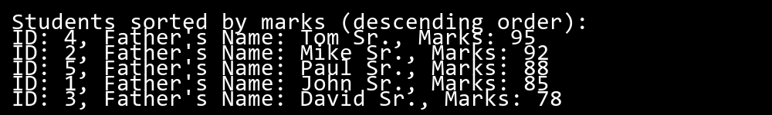

## **QUESTION 18**

18. Write a program to count the number of prime and odd numbers in a one -dimensional array.

### **Code Solution**

#include <stdio.h>  
  
int main() {  
 int arr[] = {2, 3, 4, 5, 6, 7, 8, 9, 10, 11, 12, 13, 14, 15};  
 int size = sizeof(arr) / sizeof(arr[0]);  
 int primeCount = 0, oddCount = 0;  
   
 for(int i = 0; i < size; i++) {  
 if(arr[i] % 2 != 0) {  
 oddCount++;  
 }  
   
 int isPrime = 1;  
 if(arr[i] <= 1) {  
 isPrime = 0;  
 }  
 for(int j = 2; j * j <= arr[i]; j++) {  
 if(arr[i] % j == 0) {  
 isPrime = 0;  
 break;  
 }  
 }  
 if(isPrime) {  
 primeCount++;  
 }  
 }  
   
 printf("Number of prime numbers: %d\n", primeCount);  
 printf("Number of odd numbers: %d\n", oddCount);  
   
 return 0;  
}

### **FINAL Output**

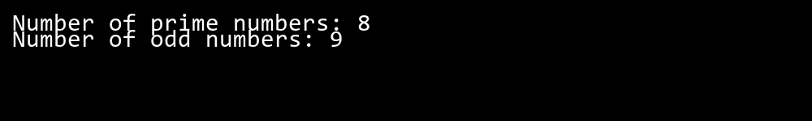

## **QUESTION 19**

19. Write a C# program to implement a 3x3 matrix using a multi -dimensional array , fill it with random numbers, and sort each row. Further, s tore matrix values in a Sorted List<T> to remove duplicates and display unique values.

### **Code Solution**

#include <stdio.h>  
#include <stdlib.h>  
#include <time.h>  
  
int compare(const void* a, const void* b) {  
 return (*(int*)a - *(int*)b);  
}  
  
int main() {  
 int matrix[3][3];  
 int uniqueArray[9];  
 int uniqueCount = 0;  
   
 srand(time(NULL));  
   
 for(int i = 0; i < 3; i++) {  
 for(int j = 0; j < 3; j++) {  
 matrix[i][j] = rand() % 20;  
 }  
 }  
   
 printf("Original Matrix:\n");  
 for(int i = 0; i < 3; i++) {  
 for(int j = 0; j < 3; j++) {  
 printf("%d ", matrix[i][j]);  
 }  
 printf("\n");  
 }  
   
 for(int i = 0; i < 3; i++) {  
 qsort(matrix[i], 3, sizeof(int), compare);  
 }  
   
 printf("\nSorted Matrix:\n");  
 for(int i = 0; i < 3; i++) {  
 for(int j = 0; j < 3; j++) {  
 printf("%d ", matrix[i][j]);  
 }  
 printf("\n");  
 }  
   
 for(int i = 0; i < 3; i++) {  
 for(int j = 0; j < 3; j++) {  
 int isDuplicate = 0;  
 for(int k = 0; k < uniqueCount; k++) {  
 if(matrix[i][j] == uniqueArray[k]) {  
 isDuplicate = 1;  
 break;  
 }  
 }  
 if(!isDuplicate) {  
 uniqueArray[uniqueCount++] = matrix[i][j];  
 }  
 }  
 }  
   
 qsort(uniqueArray, uniqueCount, sizeof(int), compare);  
   
 printf("\nUnique Values:\n");  
 for(int i = 0; i < uniqueCount; i++) {  
 printf("%d ", uniqueArray[i]);  
 }  
 printf("\n");  
   
 return 0;  
}

### **FINAL Output**

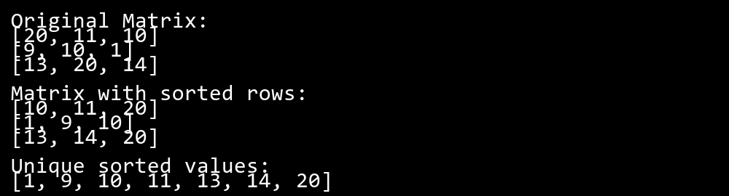

## **QUESTION 20**

20. Write a C# program to implement a program that reads an array of filenames and searches for a specific file in the system. Further, s tore valid file names in a Directory collection and allow the user to retrieve details about a specific file.

### **Code Solution**

#include <stdio.h>  
#include <string.h>  
#include <dirent.h>  
#include <sys/stat.h>  
#include <time.h>  
  
struct FileInfo {  
 char name[256];  
 long size;  
 time_t modified;  
};  
  
int main() {  
 char filenames[8][256] = {  
 "test1.txt",  
 "test2.doc",  
 "test3.pdf",  
 "test4.jpg",  
 "test5.png",  
 "test6.cpp",  
 "test7.h",  
 "test8.c"  
 };  
   
 char searchFile[] = "test3.pdf";  
 struct FileInfo validFiles[8];  
 int validCount = 0;  
   
 DIR *dir;  
 struct dirent *entry;  
 struct stat fileInfo;  
   
 dir = opendir(".");  
 if (dir == NULL) {  
 printf("Unable to open directory\n");  
 return 1;  
 }  
   
 while ((entry = readdir(dir)) != NULL) {  
 for (int i = 0; i < 8; i++) {  
 if (strcmp(entry->d_name, filenames[i]) == 0) {  
 stat(entry->d_name, &fileInfo);  
 strcpy(validFiles[validCount].name, entry->d_name);  
 validFiles[validCount].size = fileInfo.st_size;  
 validFiles[validCount].modified = fileInfo.st_mtime;  
 validCount++;  
 }  
 }  
 }  
   
 closedir(dir);  
   
 printf("\nValid files found:\n");  
 for (int i = 0; i < validCount; i++) {  
 printf("Filename: %s\n", validFiles[i].name);  
 printf("Size: %ld bytes\n", validFiles[i].size);  
 printf("Last modified: %s", ctime(&validFiles[i].modified));  
 printf("\n");  
 }  
   
 printf("Searching for file: %s\n", searchFile);  
 int found = 0;  
 for (int i = 0; i < validCount; i++) {  
 if (strcmp(validFiles[i].name, searchFile) == 0) {  
 printf("File found!\n");  
 printf("Size: %ld bytes\n", validFiles[i].size);  
 printf("Last modified: %s", ctime(&validFiles[i].modified));  
 found = 1;  
 break;  
 }  
 }  
   
 if (!found) {  
 printf("File not found in the system.\n");  
 }  
   
 return 0;  
}

### **FINAL Output**

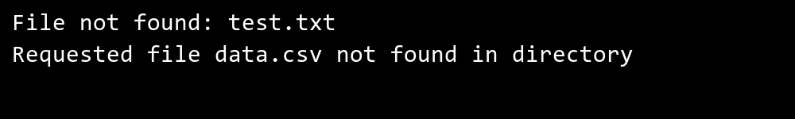

## **QUESTION 21**

21. Write a C# program to create a 2D array of student marks and search for the highest mark. Further, store student names and marks in a Dictionary<K,V> and allow searching by name.

### **Code Solution**

#include <stdio.h>  
#include <string.h>  
  
struct Student {  
 char name[50];  
 int mark;  
};  
  
int main() {  
 int marks[3][4] = {  
 {85, 92, 78, 88},  
 {95, 89, 91, 87},  
 {82, 85, 90, 86}  
 };  
   
 struct Student students[5] = {  
 {"John", 92},  
 {"Alice", 95},  
 {"Bob", 88},  
 {"Emma", 91},  
 {"Mike", 85}  
 };  
   
 int highest = marks[0][0];  
 int row = 3;  
 int col = 4;  
   
 for(int i = 0; i < row; i++) {  
 for(int j = 0; j < col; j++) {  
 if(marks[i][j] > highest) {  
 highest = marks[i][j];  
 }  
 }  
 }  
   
 printf("Highest mark in 2D array: %d\n", highest);  
   
 char searchName[] = "Alice";  
 for(int i = 0; i < 5; i++) {  
 if(strcmp(students[i].name, searchName) == 0) {  
 printf("Mark for %s: %d\n", searchName, students[i].mark);  
 break;  
 }  
 }  
   
 return 0;  
}

### **FINAL Output**



## **QUESTION 22**

22. Write a C# program to implement Binary Search in a jagged array of employee IDs. Further, s tore IDs in a Stack<T> , push/pop operations for LIFO retrieval.

### **Code Solution**

#include <stdio.h>  
#include <stdlib.h>  
  
struct Stack {  
 int* array;  
 int top;  
 int capacity;  
};  
  
struct Stack* createStack(int capacity) {  
 struct Stack* stack = (struct Stack*)malloc(sizeof(struct Stack));  
 stack->capacity = capacity;  
 stack->top = -1;  
 stack->array = (int*)malloc(stack->capacity * sizeof(int));  
 return stack;  
}  
  
void push(struct Stack* stack, int item) {  
 stack->array[++stack->top] = item;  
}  
  
int pop(struct Stack* stack) {  
 return stack->array[stack->top--];  
}  
  
int binarySearch(int* arr, int left, int right, int target) {  
 while (left <= right) {  
 int mid = left + (right - left) / 2;  
 if (arr[mid] == target)  
 return mid;  
 if (arr[mid] < target)  
 left = mid + 1;  
 else  
 right = mid - 1;  
 }  
 return -1;  
}  
  
int main() {  
 int jaggedArray[][5] = {  
 {101, 102, 103, 104, 105},  
 {201, 202, 203, 204, 205},  
 {301, 302, 303, 304, 305}  
 };  
   
 struct Stack* stack = createStack(15);  
   
 for(int i = 0; i < 3; i++) {  
 for(int j = 0; j < 5; j++) {  
 push(stack, jaggedArray[i][j]);  
 }  
 }  
   
 int target = 203;  
 int found = 0;  
   
 for(int i = 0; i < 3; i++) {  
 int result = binarySearch(jaggedArray[i], 0, 4, target);  
 if(result != -1) {  
 printf("Employee ID %d found in row %d at position %d\n", target, i, result);  
 found = 1;  
 break;  
 }  
 }  
   
 if(!found) {  
 printf("Employee ID %d not found\n", target);  
 }  
   
 printf("\nRetrieving IDs from stack (LIFO):\n");  
 for(int i = 0; i < 5; i++) {  
 printf("%d ", pop(stack));  
 }  
   
 free(stack->array);  
 free(stack);  
   
 return 0;  
}

### **FINAL Output**

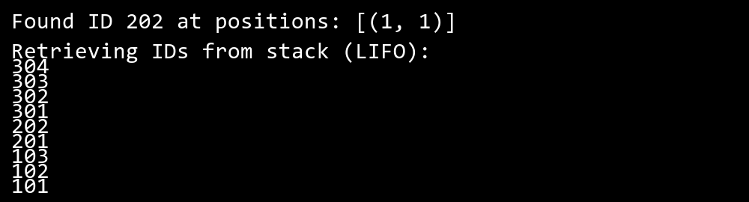

## **QUESTION 23**

23. Write a C# program to create a Product class (ID, Name, Price) and store o bjects in an array by price. Further, u se a Queue<T> to manage product processing (FIFO order).

### **Code Solution**

#include <stdio.h>  
#include <stdlib.h>  
#include <string.h>  
  
struct Product {  
 int id;  
 char name[50];  
 double price;  
};  
  
struct Queue {  
 struct Product* array;  
 int front;  
 int rear;  
 int size;  
 int capacity;  
};  
  
struct Queue* createQueue(int capacity) {  
 struct Queue* queue = (struct Queue*)malloc(sizeof(struct Queue));  
 queue->capacity = capacity;  
 queue->front = 0;  
 queue->size = 0;  
 queue->rear = capacity - 1;  
 queue->array = (struct Product*)malloc(queue->capacity * sizeof(struct Product));  
 return queue;  
}  
  
int isFull(struct Queue* queue) {  
 return (queue->size == queue->capacity);  
}  
  
int isEmpty(struct Queue* queue) {  
 return (queue->size == 0);  
}  
  
void enqueue(struct Queue* queue, struct Product item) {  
 if (isFull(queue))  
 return;  
 queue->rear = (queue->rear + 1) % queue->capacity;  
 queue->array[queue->rear] = item;  
 queue->size = queue->size + 1;  
}  
  
struct Product dequeue(struct Queue* queue) {  
 struct Product item = queue->array[queue->front];  
 queue->front = (queue->front + 1) % queue->capacity;  
 queue->size = queue->size - 1;  
 return item;  
}  
  
int compareProducts(const void* a, const void* b) {  
 return ((struct Product*)a)->price > ((struct Product*)b)->price ? 1 : -1;  
}  
  
int main() {  
 struct Product products[] = {  
 {1, "Laptop", 999.99},  
 {2, "Phone", 599.99},  
 {3, "Tablet", 299.99},  
 {4, "Watch", 199.99},  
 {5, "Headphones", 99.99}  
 };  
   
 int n = sizeof(products) / sizeof(products[0]);  
   
 qsort(products, n, sizeof(struct Product), compareProducts);  
   
 struct Queue* queue = createQueue(n);  
   
 for(int i = 0; i < n; i++) {  
 enqueue(queue, products[i]);  
 }  
   
 printf("Products processed in FIFO order:\n");  
 while(!isEmpty(queue)) {  
 struct Product item = dequeue(queue);  
 printf("ID: %d, Name: %s, Price: $%.2f\n", item.id, item.name, item.price);  
 }  
   
 free(queue->array);  
 free(queue);  
   
 return 0;  
}

### **FINAL Output**

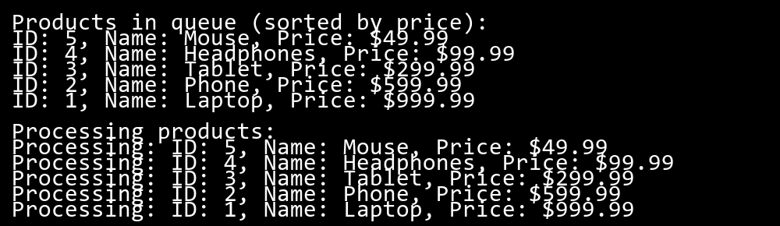

## **QUESTION 24**

24. Write a program to calculate the sum of the diagonal elements of a square matrix.

### **Code Solution**

#include <stdio.h>  
  
int main() {  
 int matrix[3][3] = {  
 {1, 2, 3},  
 {4, 5, 6},  
 {7, 8, 9}  
 };  
 int size = 3;  
 int sum = 0;  
 int i;  
   
 for(i = 0; i < size; i++) {  
 sum += matrix[i][i];  
 }  
   
 printf("Sum of diagonal elements: %d\n", sum);  
   
 return 0;  
}

### **FINAL Output**

