**Assignment**

Name: Tharan  
Register Number: 23215134

________________________________________

## **QUESTION 1**

1.Write a program to print the numbers from 1 to 50 using a for loop.

### **Code Solution**

for i in range(1, 51):  
 print(i)

### **FINAL Output**

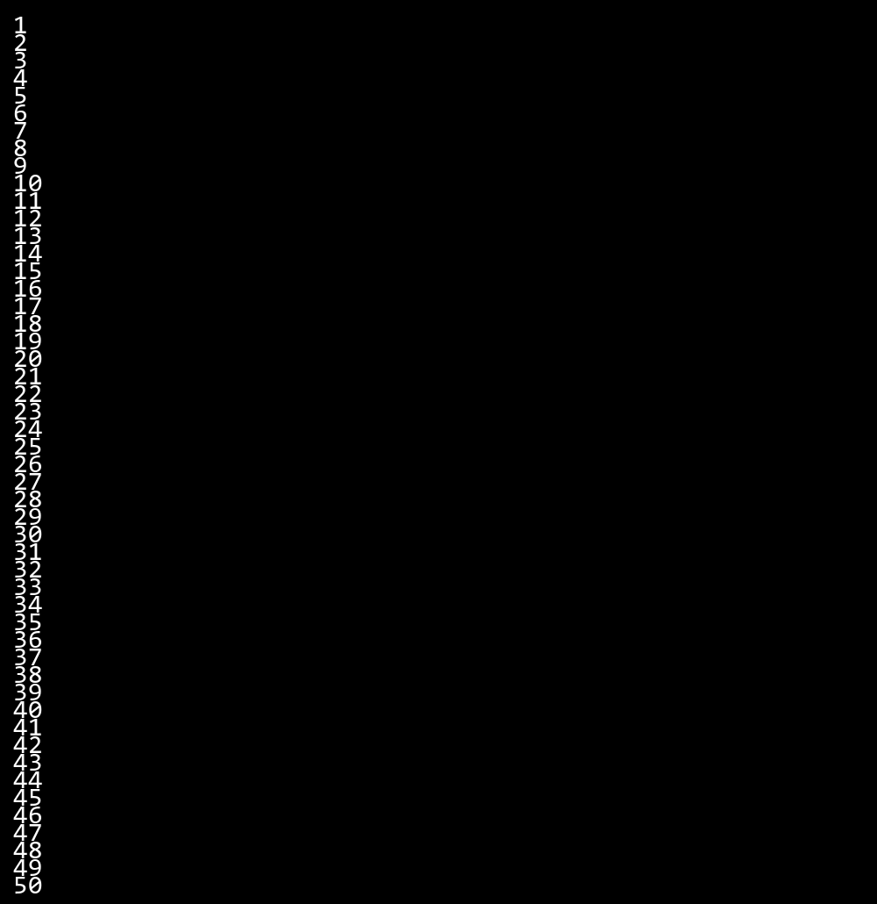

## **QUESTION 2**

2.Write a program that takes an integer as input and checks if it is even or odd.

### **Code Solution**

number = 2  
  
if number % 2 == 0:  
 print("Even")  
else:  
 print("Odd")

### **FINAL Output**

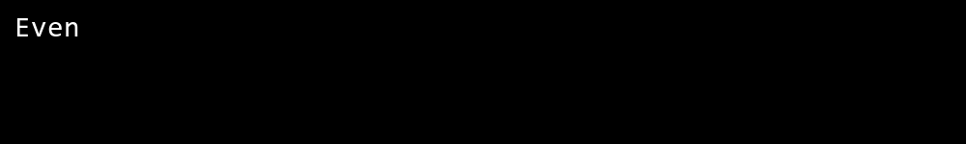

## **QUESTION 3**

3.Create a program that prints a right -angled triangle pattern of * with a height of 5.

### **Code Solution**

for i in range(1, 6):  
 print('*' * i)

### **FINAL Output**

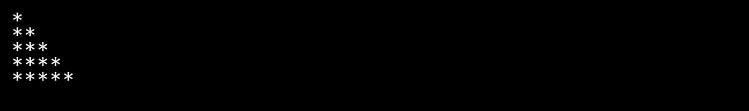

## **QUESTION 4**

4.Write a program that takes a number (1 -7) as input and prints the corresponding day of the week using a switch statement.

### **Code Solution**

n = 10  
sum = 0  
i = 1  
while i <= n:  
 sum = sum + i  
 i = i + 1  
print(sum)

### **FINAL Output**

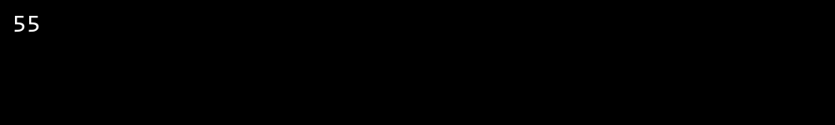

## **QUESTION 5**

5.Write a program to calculate the sum of all numbers from 1 to n using a while loop.

### **Code Solution**

def is_prime(n):  
 if n < 2:  
 return False  
 for i in range(2, int(n ** 0.5) + 1):  
 if n % i == 0:  
 return False  
 return True  
  
number = 17  
result = is_prime(number)  
print(result)

### **FINAL Output**

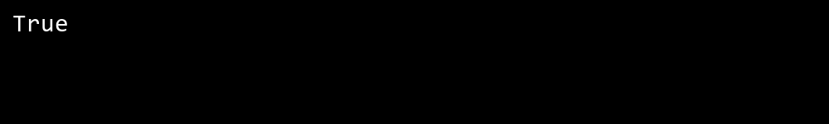

## **QUESTION 6**

6.Write a program to check if a given number is prime or not using a for loop and if conditions.

### **Code Solution**

number = 5  
  
match number:  
 case 1:  
 print("Monday")  
 case 2:  
 print("Tuesday")  
 case 3:  
 print("Wednesday")  
 case 4:  
 print("Thursday")  
 case 5:  
 print("Friday")  
 case 6:  
 print("Saturday")  
 case 7:  
 print("Sunday")  
 case _:  
 print("Invalid day number")

### **FINAL Output**

