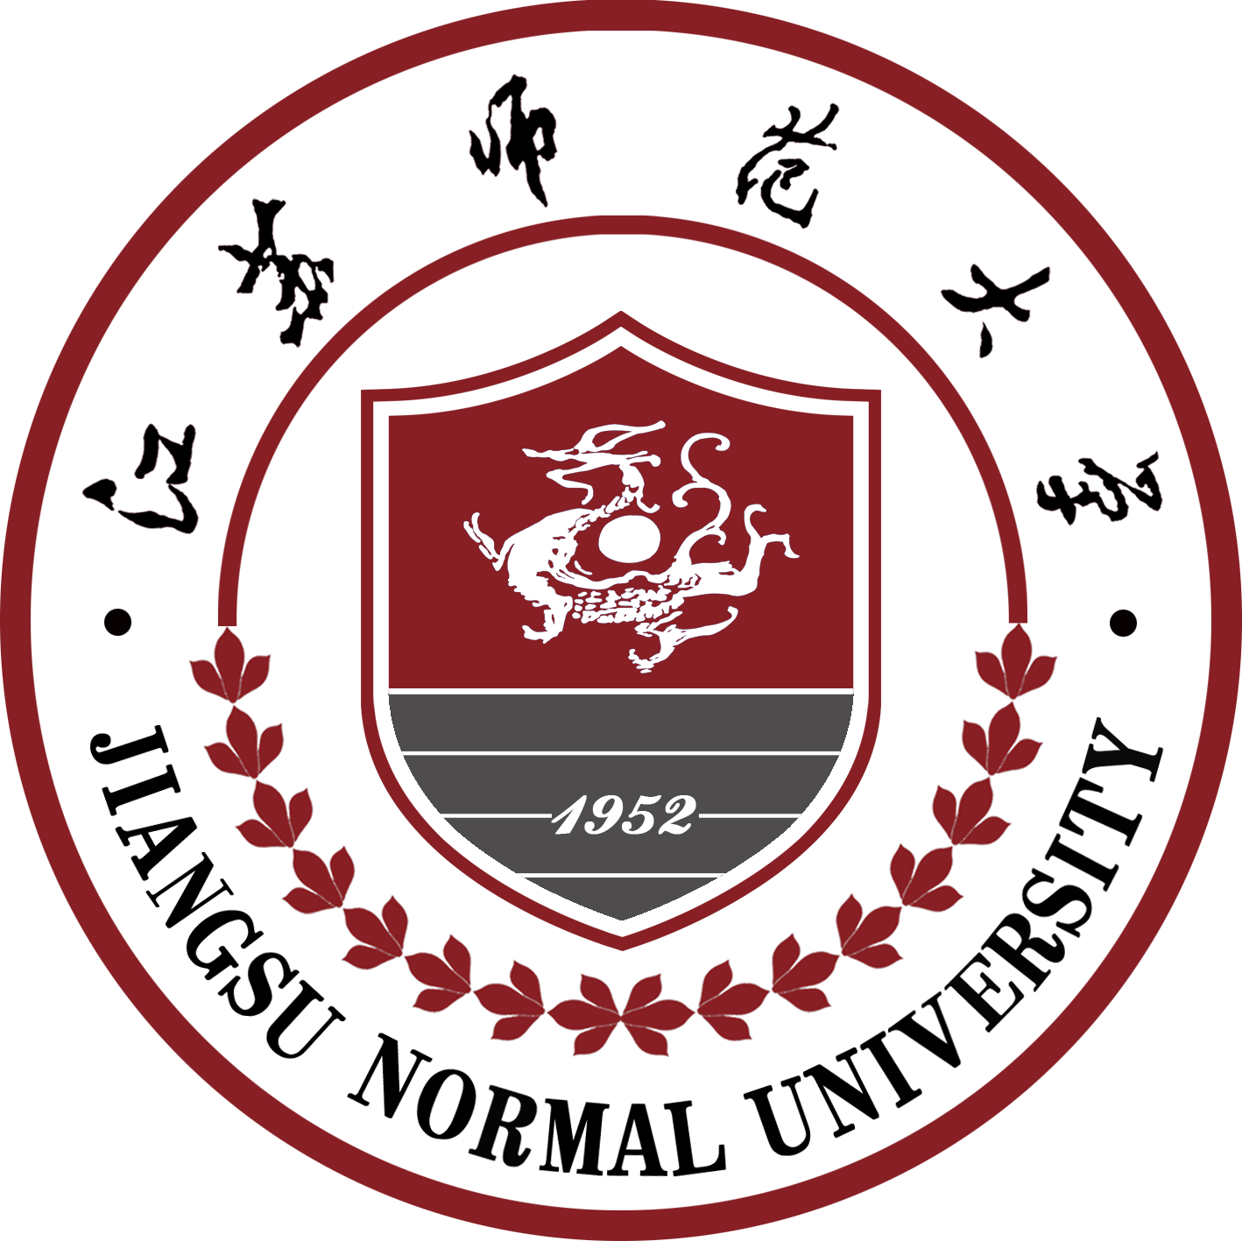

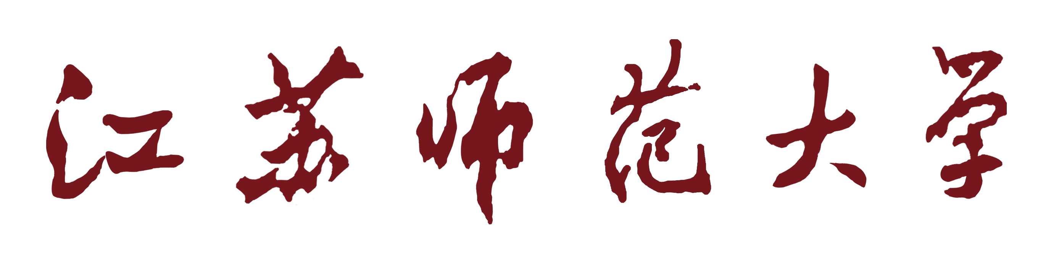
JIANGSU NORMAL UNIVERSITY
本科毕业论文

UNDERGRADUATE THESIS

论 文 题 目：
Research on Computer Remote Teaching System based on MVC

姓 名：
学 院：
专 业：
年 级 、 学 号：
指 导 教 师：

江苏师范大学教务处印制
DECLARATION

I do hereby declare without any reasonable doubt that the submitted graduation thesis is the result of my independent research under the guidance of tutor. All data and pictures are genuine and dependable. In addition to the cited content, the paper doesn’t contain the content of copyright enjoyed by others. The individuals and collectives who have contributed to the research work involved in this paper have been clearly indicated in the paper. The intellectual property of this paper belongs to the education organization.

作者签名/ Author Signature

日期Date： YY年 MM月 DD日

Authorization letter for the use of the copyright of the paper

This thesis (design) “ Research on Computer Remote Teaching System based on MVC ”is an integral part of my studies and completed under the guidance of teachers of Jiangsu Normal University. Therefore, I hereby authorize Jiangsu Normal University to compile all or part of the contents of this thesis into relevant books and databases for preservation and the right to copy, print and make web pages to provide readers with the text of the paper and the edited and annotated paper text for reference, copies and electronic documents can be submitted to relevant academic departments and relevant national departments or institutions. No matter how to deal with this thesis, it must respect my copyright and state my name.

作者签名Author Signature:
导师签名Supervisor Signature：
日期Date： YY年 MM月 DD日

Abstract

The COVID-19 has preceded in schools shut all across the world. Globally, over 1.2 billion children are out of the classroom. As a result, education has changed dramatically, with the typical rise of e-learning, whereby teaching is undertaken remotely and on digital platforms. Research put forward that online learning has been shown to increase conservation of information, and take less time, meaning the changes corona-virus have caused might be here to stay. However, most of the online learning platforms are universal and are not necessarily fit for computer majors.
The system is developed using Django which is a framework that uses python language and SQLite as the database. This system has three types of users, students, teachers and system administrator. Teachers can upload teaching videos and course-ware, arrange home-works, communicate with students through the forum, and test through the system. And Students can select courses through the system, submit homework through the system, ask questions to teachers through the forum, and participate in the system. The system administrator can manage system users, set user permissions, and issue notices or news.
The lack of all these functionalities can present a negative implications for students in computer majors.

Key Words: E-learning, Django, python, SQLite

Table of Contents

1 One Introduction

1.1 Significance of the subject
A learning system based on formalized teaching but with the help of electronic resources is known as E-learning. While teaching can be based in or out of the classrooms, the use of computers and the Internet forms the major component of E-learning. E-learning can also be termed as a network enabled transfer of skills and knowledge, and the delivery of education is made to a large number of recipients at the same or different times. Remote Teaching System is an e-learning system which help teachers to upload teaching videos and course-ware, arrange home-works, communicate with students through the forum, and test through the system. And Students can select courses through the system, submit homework through the system, ask questions to teachers through the forum, and participate in the system. The system administrator can manage system users, set user permissions, and issue notices or news.

1.2 Current research status at home and abroad
technology has influenced practically all parts of our lives, education is the same. In the course of recent years, E-Learning has developed quickly because of its uncommon advantages for the two understudies and educators.

E-Learning gives understudies simple admittance to schooling paying little mind to where they are. What's more, it additionally offers the guarantee of giving ideal learning measure that suits each understudy's necessities.

1.3 Main work
This system has three types of users. students, teachers and system administrator. Teachers can upload teaching videos and course-ware, arrange home-works, communicate with students through the forum, and test through the system. And Students can select courses through the system, submit homework through the system, ask questions to teachers through the forum, and participate in the system. The system administrator can manage system users, set user permissions, and issue notices or news. All the users have to be authenticated before performing any task.

1.4 The research content and main contributions of this article
This plan is the advancement of a far-off educating framework. I need to plan a distance instructing framework that will help understudies in their schooling. The overall substance design of this article is as per the following:

The initial segment is the presentation, which for the most part presents the meaning of the subject and the motivation behind the exploration. By examining the flow research status at home and abroad, it is clear what the framework is utilized for, and can have a superior comprehension of the exploration plan of the subject;

The subsequent part is the working climate of the framework, presenting the improvement language utilized by the framework and the justification used;

The third part is framework investigation. Above all else, it is important to direct an overall investigation of whether the framework configuration can be acknowledged and the trouble of creation from the specialized and operational viewpoints. Solely after plainly the creation of the framework is possible, would it be able to be additionally completed. Framework request investigation, that is, to consider the capacities to be acknowledged by the framework, lastly draw the stream graph, information stream chart, and information word reference of the framework;

The fourth part is the framework configuration interface, which is the part to try thoughts, partition the utilitarian modules, plan information base tables, draw element association graphs, and so forth;

The fifth part is the part that shows the aftereffects of framework work activity, and is introduced through screen captures and center code;

The 6th part is the piece of reflection, synopsis, and viewpoint, contemplating my own deficiencies being developed and plan, and composing assumptions and investigations for the eventual fate of the framework.

2. System operating environment

2.1 Django
Django is a collection of Python libs allowing you to quickly and efficiently create a quality Web application, and is suitable for both front-end and back-end.

2.1.1 introduction to Django
Django is a web application framework written in Python programming language. It is based on MVT (Model View Template) design pattern.
The MVT (Model View Template) is a software design pattern. It is a collection of three important components Model View and Template. The View is used to execute the business logic and interact with a model to carry data and renders a template.

2.2 SQLite

2.2.1 Introduction to SQLite
SQLite is an embedded relational database engine. Its developers call it a self-contained, server-less, zero-configuration and transnational SQL database engine. It is very popular and there are hundreds of millions copies worldwide in use today.

2.2.2 Features of SQLite database
Some of the characteristics of SQLite that are unusual and which make SQLite different from many other SQL database engines

- Zero-Configuration
- Server-less
- Single Database File
- Stable Cross-Platform Database File
- Readable source code
- SQL statements compile into virtual machine code

2.3 Object-oriented programming ideas
Object-oriented design is the main idea of the current popular program development technology. In plain and easy-to-understand terms, the writing method of a process-oriented programming language is a main function, and each process is written in the form of a function, which is called in the main function, and the entire program design is realized through function calls.

The object-oriented design mainly defines the data format, N multiple data items, all operations are performed on the data items, each data item can be abstracted into an object, and the programming idea is to pass and operate in the form of an object. Object-oriented is developed from process-oriented. In the process of development of process-oriented functional coding, there are some drawbacks.

With the development of society and the advancement of science, the demand for software has become more and more complex, and the complexity has increased in geometric forms. Process-oriented When writing a complex project, the readability of the code becomes worse, and the maintainability becomes worse. The number of lines of code in a single file has risen sharply, and the maintenance cost is getting higher and higher. The three main object-oriented categories are encapsulation, inheritance, and polymorphism Face to Both object and process-oriented have their own advantages and disadvantages, and each has its own trial occasions. The main advantages of process-oriented are higher performance than object-oriented and lower system overhead.

Object-oriented code implementation is relatively easy to maintain, easy to reuse and extend. Object-oriented is used to encapsulate and inherit polymorphic characteristics. It is easier to write low-cohesion and high-coupling code through object-oriented programming languages, and the performance is slightly lower than that of process-oriented.

2.4 Summary of this chapter
By introducing their main characteristics and related advantages, to explain why these technologies are used, what kind of interface design, dynamic page effects, and storage of various data they will bring to the system. Because these technologies are currently used relatively frequently, and the related software has a free period of use, it saves the cost of system production to a certain extent, and provides great convenience and potential economy for the development of this design. Benefit.

3. System analysis

3.1 Feasibility analysis

