A Knowledge-Based AI Decision-Support Model for Predicting Digital Transformation Readiness from Enterprise Innovation Data
Harika Tiruveedula
DBA 802 – Data Analytics and Strategic Decision Intelligence
Manuscript status: Research draft with a synthetic proof-of-concept experiment. It is not yet a validated empirical study or journal-ready submission.

Abstract
Organizations increasingly invest in digital technologies, yet readiness for transformation depends on more than technology acquisition. It also reflects data governance, analytical capability, leadership, innovation investment, employee skills, process integration, cybersecurity, and organizational learning. This paper proposes a knowledge-based AI decision-support model that translates multidimensional enterprise indicators into readiness estimates and transparent managerial priorities. The framework combines data preparation, supervised classification, domain rules, interpretable evidence, risk-aware prioritization, and human governance. To demonstrate a reproducible analytical workflow, a synthetic three-class dataset is generated and evaluated using stratified five-fold cross-validation against a majority-class baseline and multinomial logistic regression. Because the data are simulated, the experiment demonstrates code execution and evaluation design rather than enterprise-level predictive validity. The paper contributes a decision-oriented architecture and a transparent validation protocol for future testing with licensed organizational data. Practical implications concern how leaders can use predictive outputs as structured evidence while retaining responsibility for context, resource allocation, and final decisions.
Keywords: artificial intelligence; data analytics; knowledge-based decision support; digital transformation; innovation readiness; explainable AI; strategic decision intelligence

1. Introduction
Digital transformation is a strategic process in which organizations use digital technologies to alter value creation, structures, processes, and organizational capabilities. It is not reducible to technology adoption: leadership, organizational change, capabilities, and ethical considerations shape the transformation pathway [1]. AI can support this process by identifying patterns across organizational indicators, estimating likely readiness levels, and helping managers compare interventions. However, predictive accuracy alone is not sufficient for a consequential business decision. A model must provide context, make uncertainty visible, respect organizational constraints, and remain subject to accountable human review.
Prior work has examined digital transformation as a broad organizational phenomenon [1], AI readiness as a sociotechnical capability [2], and data-driven decision-making readiness in organizational settings [3]. These streams motivate an integrated design that links enterprise indicators to a prediction and then to an actionable, governed decision. The contribution claimed here is a synthesis and testable architecture—not a claim that no similar readiness model exists. A systematic review and empirical comparison are required to establish novelty more strongly.
Research question: How can a knowledge-based AI decision-support architecture convert enterprise innovation and capability indicators into transparent, risk-aware digital-transformation readiness recommendations?
This paper makes three contributions: (1) a layered architecture connecting enterprise data, prediction, knowledge rules, explanation, and managerial action; (2) a reproducible benchmark protocol with simple baselines; and (3) a set of validation requirements for a subsequent real-data study.

2. Literature and theoretical grounding

2.1 Digital transformation as organizational change
Vial's review synthesizes digital transformation as a process involving digital technologies, strategic responses, changes in value creation, and organizational barriers [1]. Consequently, readiness should be represented as a multidimensional organizational condition rather than a proxy for technology spending alone. Warner and Wäger similarly frame digital transformation as ongoing strategic renewal supported by dynamic capabilities [4].

2.2 AI readiness and data-driven decisions
Holmström's AI-readiness framework emphasizes the sociotechnical character of AI deployment and its relationship to digital transformation [2]. Elragal and Elgendy propose a data-driven decision-making readiness assessment based on organizational evidence, illustrating that decision capability includes people, processes, and systems [3]. Together, these studies support assessing readiness across data governance, analytics, leadership, innovation, skills, integration, infrastructure, change capacity, cybersecurity, and collaboration.

2.3 Explainability and knowledge-guided decisions
Explainable AI methods can help users inspect the relationship between model inputs and predictions, but an explanation should not be mistaken for a causal account or a guarantee of correctness. Global feature importance, local explanations, calibration, and error analysis answer different questions and should be reported separately. A knowledge layer can encode transparent business constraints—for example, flagging low data-governance maturity as a prerequisite gap—even when a predictive model assigns a high readiness probability. Such rules should be reviewed by domain experts and documented to prevent hidden assumptions from being treated as universal truths.

3. Proposed framework
The proposed architecture has five operational stages. First, enterprise data are assembled from documented measures of strategy, innovation, data management, technology, workforce, processes, risk, and external collaboration. Second, data quality checks assess missingness, measurement consistency, target leakage, and representativeness. Third, a supervised model estimates readiness categories or calibrated probabilities. Fourth, a knowledge layer maps model outputs to transparent rules, constraints, and suggested next steps. Fifth, decision-makers review the evidence, risk, feasibility, and local context before acting. Outcomes and overrides are logged to support later model monitoring.
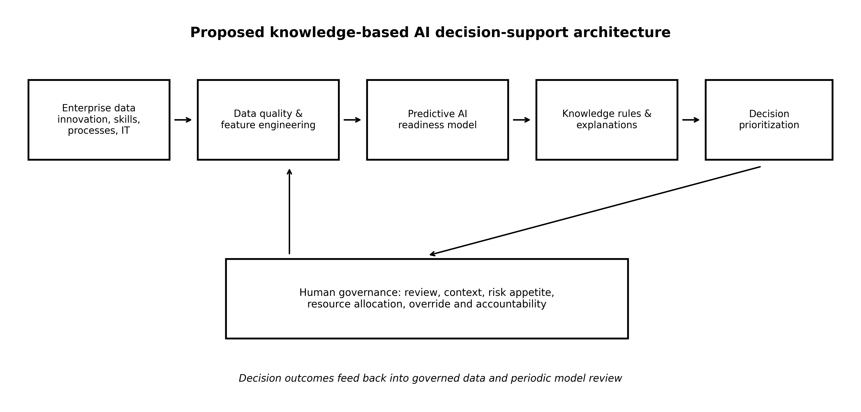
Figure 1. Proposed knowledge-based AI decision-support architecture. Author-generated diagram; conceptual, not an empirical finding.

3.1 Knowledge and decision logic
Let x denote the vector of enterprise indicators and y the readiness class. A predictive model estimates p(y|x). A separate knowledge function K(x,p) applies documented business rules and risk constraints to produce a decision-support record d. The system therefore does not equate the highest predicted class with an automatic recommendation. Instead, it returns the estimated class, probability distribution, data-quality warnings, important indicators, rule-triggered gaps, and candidate actions for human review.
Formally: p(y|x) = fθ(x); d = gK(x, p(y|x), r, c), where fθ is the fitted predictive model, r represents risk constraints, and c represents organizational context. The function gK is a governed decision mapping, not a claim of causal inference.

4. Methodology and reproducibility
This draft includes a synthetic proof-of-concept experiment solely to verify that the modelling and reporting pipeline runs end to end. A reproducible three-class dataset of 600 rows and ten numerical features was generated with a fixed random seed (802). The feature names represent plausible enterprise capabilities, but their values are artificial and do not correspond to surveyed firms. Models were evaluated using stratified five-fold cross-validation. The majority-class baseline predicts the most frequent class in each training fold. Multinomial logistic regression and random forest are evaluated using accuracy, macro-F1, and balanced accuracy.
Preprocessing is encapsulated in scikit-learn pipelines to reduce leakage. The current synthetic demonstration has no external test set, no temporal validation, and no enterprise sampling frame. Feature importance calculated on the fitted synthetic model is illustrative only. A publication-grade study should use a documented real dataset, pre-register the target and split strategy where feasible, compare against appropriate baselines, quantify uncertainty, and report subgroup performance.

4.1 Evaluation metrics
Accuracy is the fraction of correctly classified cases. Macro-F1 is the unweighted mean of class-specific F1 scores and is informative when class performance differs. Balanced accuracy averages recall across classes. No single metric establishes usefulness; calibration, confusion matrices, decision costs, subgroup error rates, and the value of recommendations should also be assessed in a real deployment study.

5. Results: synthetic demonstration only
Table 1 reports mean scores from the reproducible synthetic experiment. These values are generated by the bundled code and should be interpreted only as a software and protocol demonstration. They are not evidence that the model predicts real enterprise readiness.
Model | Accuracy | Macro-F1 | Balanced accuracy
Majority-class baseline | 0.375 | 0.182 | 0.333
Multinomial logistic regression | 0.562 | 0.563 | 0.573
Random forest | 0.717 | 0.716 | 0.719
Table 1. Five-fold cross-validation metrics on a synthetic dataset. Results are reproducible from run_experiment.py; they are not real-world enterprise findings.
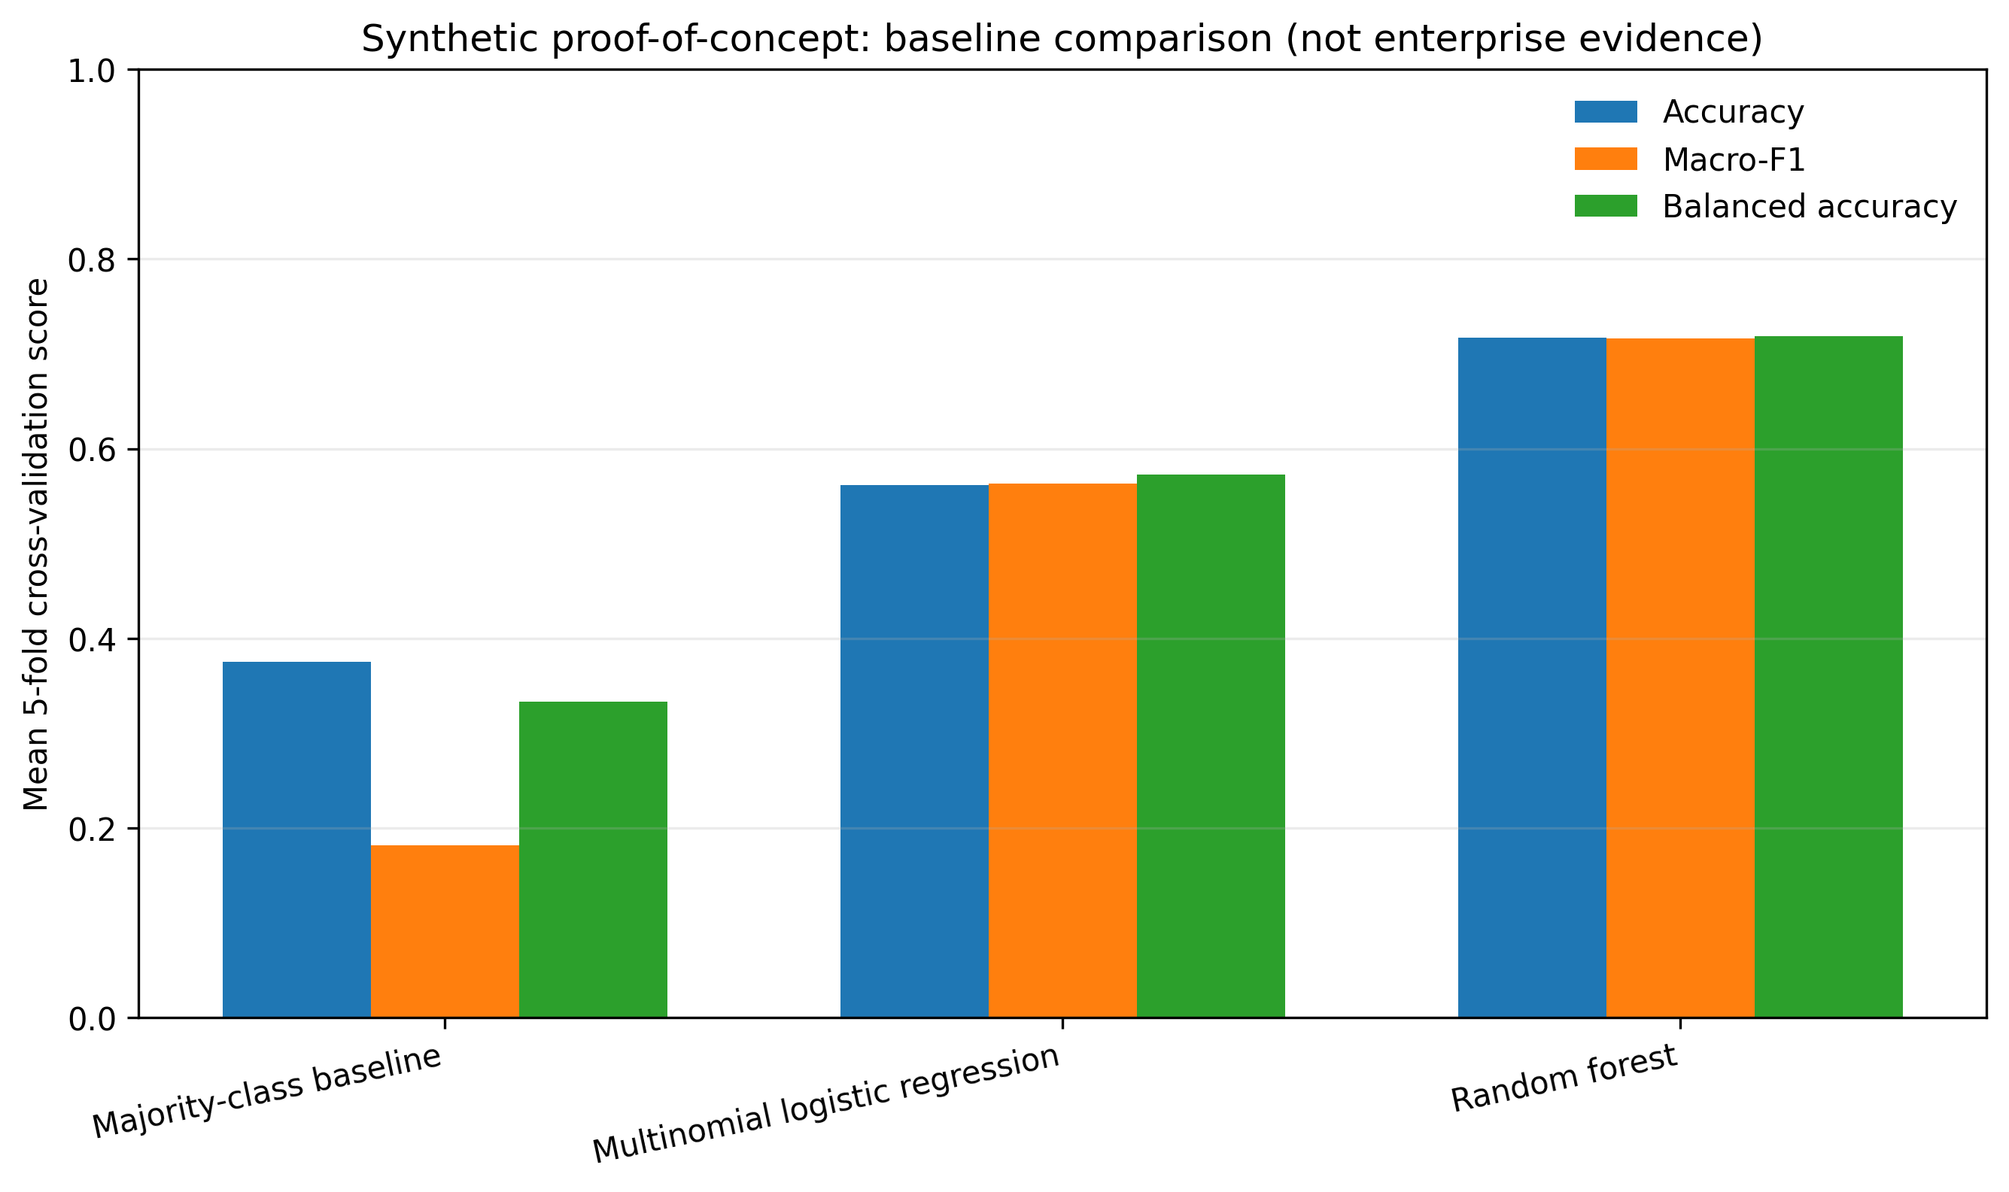
Figure 2. Baseline comparison on simulated data. Scores illustrate evaluation outputs only and must not be generalized to actual organizations.

5.1 Framework operationalization
Layer | Input / function | Output | Governance requirement
Enterprise data | Readiness measures, innovation activity, workforce and process indicators | Validated feature matrix | Consent/licence, provenance, missingness review
Predictive model | Supervised classifier and validation pipeline | Class probabilities and performance estimates | Leakage checks, calibration, drift monitoring
Knowledge layer | Reviewed rules, constraints and capability dependencies | Gap flags and candidate actions | Versioned rules and expert approval
Explanation layer | Feature attribution and uncertainty information | Evidence for each recommendation | Do not imply causality; disclose limitations
Human decision | Context, budget, risk appetite and strategic goals | Prioritized intervention plan | Named decision owner, override log, periodic review
Table 2. Proposed framework operationalization. This is a design table, not a table of measured enterprise outcomes.

6. Discussion and managerial implications
The synthetic demonstration verifies that a compact modelling workflow can compare a naive baseline with two standard classifiers and emit reproducible metrics. It does not establish which model is superior for real organizations. A more capable model may perform well on artificial data yet fail under real measurement error, sector differences, changing conditions, or class imbalance. Accordingly, the central managerial contribution is the decision architecture and its validation discipline rather than the synthetic scores.
For executives, the framework can organize readiness discussions around specific capability gaps instead of a single opaque maturity score. For analytics leaders, it clarifies the need to document data provenance, target construction, preprocessing, model versions, and uncertainty. For innovation managers, linking readiness indicators to candidate interventions may help sequence investments—for example, strengthening data governance before scaling advanced AI—provided the rules are locally validated. Cybersecurity and privacy should be treated as constraints on data use and deployment, not merely as additional features.
Human review is essential because a readiness prediction is not a strategy. Managers must consider competitive positioning, regulatory requirements, resource limits, organizational culture, and the consequences of false positives and false negatives. The system should be used as decision support, with clear ownership and an auditable override process, rather than as an automated authority.

7. Limitations and future research
The primary limitation is that the experiment uses synthetic data. It cannot support conclusions about enterprise readiness, causal relationships, business value, or deployment performance. The feature set is illustrative; the target labels are generated by a generic simulation mechanism rather than a validated readiness instrument. The experiment also lacks independent external validation, human-subject evaluation, cost-sensitive decision analysis, and subgroup fairness assessment.
Future work should replace the synthetic data with a licensed dataset whose sampling process, measurement instruments, and target labels are documented. Researchers should compare linear and nonlinear baselines, conduct nested or repeated validation when sample size permits, assess calibration and uncertainty, and test transfer across sectors or firm sizes. A subsequent field study could compare manager decisions with and without explanations, measuring decision quality, time, confidence calibration, and intervention outcomes. The novelty claim should be revisited after a systematic review of closely related readiness and AI decision-support models.

8. Conclusion
This paper proposes a knowledge-based AI decision-support architecture that connects enterprise capability data, predictive modelling, explicit rules, explanations, risk constraints, and accountable human action. The synthetic experiment demonstrates a reproducible pipeline and reporting structure, but it is not empirical validation of the proposed model in real enterprises. The next scientifically meaningful step is to evaluate the framework on documented organizational data and determine whether its predictions and recommendations improve decision quality beyond existing assessment practices.

References
[1] G. Vial, “Understanding digital transformation: A review and a research agenda,” The Journal of Strategic Information Systems, vol. 28, no. 2, pp. 118–144, 2019, doi: 10.1016/j.jsis.2019.01.003.
[2] J. Holmström, “From AI to digital transformation: The AI readiness framework,” Business Horizons, vol. 65, no. 3, pp. 329–339, 2022, doi: 10.1016/j.bushor.2021.03.006.
[3] A. Elragal and N. Elgendy, “A data-driven decision-making readiness assessment model: The case of a Swedish food manufacturer,” Decision Analytics Journal, vol. 10, art. 100405, 2024, doi: 10.1016/j.dajour.2024.100405.
[4] K. S. R. Warner and M. Wäger, “Building dynamic capabilities for digital transformation: An ongoing process of strategic renewal,” Long Range Planning, vol. 52, no. 3, pp. 326–349, 2019, doi: 10.1016/j.lrp.2018.12.001.
[5] F. Doshi-Velez and B. Kim, “Towards a rigorous science of interpretable machine learning,” arXiv:1702.08608, 2017. doi: 10.48550/arXiv.1702.08608.
[6] S. M. Lundberg and S.-I. Lee, “A unified approach to interpreting model predictions,” in Advances in Neural Information Processing Systems 30, 2017, pp. 4765–4774.

Submission-readiness note
This file is an initial research draft, not a journal-formatted final manuscript. The reference list is a starting bibliography and must be checked against the target journal's citation style and full metadata. Before submission, replace the synthetic experiment with real, properly licensed data or explicitly reposition the work as a conceptual paper and follow the target journal's article-type rules. Do not describe the synthetic experiment as evidence of real-world prediction performance. The accepted reference paper and official journal template have not yet been verified in this draft.

