**Team Members**

**Eranga M.S.D (E/11/113)**

**Why do we need an automated watering system**

As the population increases, the demand for water increases. Outdoor water is very limited. Homeowners who have irrigation systems often apply too much water to plants too frequently. Then water is wasting. But from our system, we are watering when plants need water. It is very useful to protect water.

Today people are very busy. Then they do not have enough time to water plants every day. If they have this kind of system, it will be very useful.

**How to make**

Our project is to make an automatic watering system using Arduino, soil humidity sensor and a water pump. Humidity sensor takes constant readings of the soil moisture and transfers to Arduino. The system amount of moisture needed simply turning the potentiometer. Then the system opens and closes the water valve of the pump if the soil is below your specified level of moisture. 

Parts needed:  
- Soil humidity sensor   
- Arduino Board  
- DC water pump  
- 10K potentiometer  
  
First the humidity sensor connect to A0 and 10K pot to A1 pins of Arduino. Then connect the components as follow diagram. Then upload the sketch to arduino and run the code. We can adjust the level of watering needed anytime by the potentiometer. Then it will automatically do everything.

**Circuit Diagram**

Water

Pump

Ardiuno Board

Moisture Sensor

+12V

A0

GND

**Flow Chart**

Yahoo weather report

Take the value of the soil moisture sensor

Soil moisture level is low?

Pump water

It’ll not rain today?

yes

no

yes

**Photos**

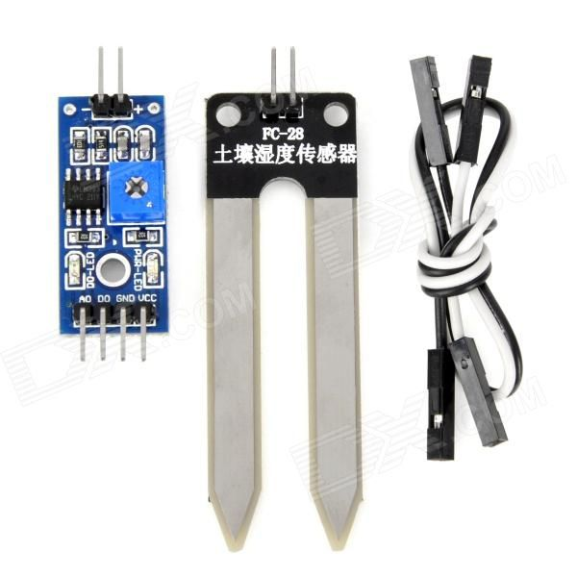

Soil Moisture Sensor