Cloud-Based IoT Energy Monitoring and Automation Platform
  - Project Report
LMU IoT Portal Project Team
25 February 2026
Table of Contents

List of Figures

1 Executive Summary
This report presents the design, implementation, and evaluation of a cloud-based Internet of Things (IoT) energy monitoring and automation platform developed around a practical single-phase monitoring scenario. The project demonstrates an end-to-end operational loop in which energy telemetry is collected from field hardware, processed in near real time, evaluated against a 15-minute consumption rule, and translated into an automated actuator response on an independent RGB LED device. The technical objective was not only to display data, but to prove that telemetry-producing and actuator devices can be coordinated through one platform contract with traceable, auditable runtime behavior.
The initial proposal outlined a conventional stack made of MQTT messaging, Node-RED workflow composition, TimescaleDB storage, and Grafana dashboards. During delivery, the architecture was intentionally consolidated into a unified open-source platform model where ingestion, validation, workflow execution, command dispatch, state reconciliation, visualization, and reporting are handled under a single application boundary. This change did not reduce functional scope. Instead, it addressed maintainability, governance, and scalability constraints that become critical when moving from pilot demonstrations to larger fleets.
The final implementation remains cloud-agnostic. It is built around portable components and containerized services that can be deployed across public cloud, private cloud, or hybrid environments without rewriting core domain logic. The same design is Kubernetes-ready and supports horizontal scaling of ingestion workers, automation workers, realtime services, and reporting jobs. Deployment on Azure Kubernetes Service (AKS) is therefore an operational choice, not a vendor lock-in requirement.
Evidence from the implemented workflow indicates that the system can reliably detect short-window consumption patterns and dispatch control actions with end-to-end observability. The reporting subsystem extends this value by converting telemetry history into asynchronous CSV exports for operations and analytics. Overall, the project establishes a defensible technical foundation for managing heterogeneous energy devices at scale while preserving schema-driven onboarding, tenant isolation, and automation traceability.

2 Introduction
Energy systems in commercial and institutional settings increasingly require continuous visibility rather than periodic meter reads. However, visibility alone is insufficient when operating conditions change quickly and when engineering teams must coordinate telemetry, alerts, and device control across multiple assets. An energy platform that only stores data or plots charts shifts the burden of interpretation and response to human operators, introducing latency, inconsistency, and avoidable operational risk. Modern IoT systems therefore need to support an integrated cycle of sensing, interpretation, and action.
This project addresses that operational requirement through a cloud-based IoT platform centered on a concrete demonstration scenario. A single-phase energy monitoring hardware path transmits telemetry through an ESP32-class communication path. The platform computes energy consumed within the most recent 15-minute window and evaluates a threshold rule. When the condition is true, the platform automatically sends a control command to an RGB LED actuator. The LED then acts as an immediate, physical state indicator for abnormal consumption. This compact scenario was selected because it is technically meaningful while remaining explainable: it demonstrates ingestion, time-window analytics, workflow execution, command dispatch, and feedback reconciliation in one reproducible pipeline.
The project also includes operator-facing dashboards and a report-generation module so that the same data supports realtime decisions and historical analysis. This dual-mode requirement is important in practical deployments where teams need low-latency feedback for incidents and structured exports for planning and audits.
A key part of this report is the architectural pivot that occurred during implementation. The submitted proposal referenced a multi-tool stack approach. The delivered platform consolidated those concerns into an integrated, schema-driven runtime. That decision was not made for novelty. It was made because the team’s learning objectives expanded from feature delivery to platform mechanics: onboarding diverse devices quickly, enforcing consistent contracts, and retaining control over scaling behavior as the fleet size increases.
The report is organized to explain the technical rationale and outcomes of that journey. The main body sets out the problem framing, implementation architecture, automation logic, reporting design, deployment strategy, and evaluation evidence. It then critically analyzes why the final architecture is more suitable for multi-device operations than the originally proposed assembly of loosely coupled tools.

3 Main Body

3.1 Project Aim, Objectives, and Scope
The project aim was to design and implement an energy monitoring and automation platform that can ingest IoT telemetry, evaluate near-real-time conditions, and trigger device actions without manual intervention. Beyond demonstrating a single use case, the broader aim was to test whether a general-purpose open-source platform can support scalable, multi-tenant IoT operations with less integration overhead than a fragmented toolchain.
The implementation was guided by six objectives:
- Build a reliable telemetry ingestion path for single-phase energy meter data over MQTT-compatible messaging.
- Persist telemetry in a time-oriented storage model suitable for bounded-window analytics and historical querying.
- Implement a workflow engine that supports trigger-condition-action automation with deterministic execution traces.
- Configure and validate a 15-minute consumption rule that controls an RGB LED indicator.
- Provide realtime and historical user interfaces for monitoring, investigation, and control.
- Implement asynchronous reporting to produce operational CSV exports with queue visibility, lifecycle tracking, and governed downloads.
In scope, the project includes end-to-end data flow from telemetry ingress to actuator response, dashboard visualization, and report export behavior. It also includes architectural analysis of portability and scaling options, with a specific deployment path toward AKS. Out of scope are advanced predictive models, full enterprise compliance hardening, and long-horizon stress campaigns. Those exclusions are deliberate: the project prioritizes verified correctness of platform behavior over speculative performance claims.

3.2 Problem Framing and Design Requirements
In many practical deployments, energy solutions fail to scale because they are assembled as disconnected layers with weak governance across boundaries. Messaging may be configured in one tool, transformations in another, dashboards elsewhere, and automation rules in ad hoc scripts. Such arrangements can work for pilots but become fragile when multiple teams, organizations, and device types are introduced. Configuration drift, duplicate logic, inconsistent access controls, and unclear ownership of failures are common outcomes.
The technical requirement in this project was therefore twofold. First, the platform had to process telemetry with low enough latency to support actionable automation in a 15-minute windowing context. Second, it had to preserve operational traceability so that each stage of execution could be inspected when outcomes are disputed or unexpected. The design requirements that follow from this were clear: explicit schema contracts, staged ingestion, durable event/state records, deterministic rule execution, command lifecycle tracking, and controlled user-facing access.
An additional requirement was device independence. The energy meter and the RGB indicator are functionally unrelated devices. The platform needed to orchestrate their interaction through contracts rather than hardcoded coupling. This principle is central to long-term extensibility because future workflows may involve different sensors and actuators while reusing the same orchestration patterns.

3.3 High-Level Architecture and Flow
The implemented architecture is event-driven and domain-partitioned. Telemetry and control pathways are separated conceptually but linked through workflow runtime and shared metadata. Messaging uses subject-style routing compatible with MQTT semantics (MQTT.org, 2024; NATS, n.d.-a; NATS, n.d.-b). Broker durability and replay behavior leverage stream persistence concepts aligned with JetStream capabilities (NATS, n.d.-c). Time-oriented persistence and flexible payload querying rely on PostgreSQL/Timescale design patterns (Tiger Data, n.d.; PostgreSQL Global Development Group, 2025).
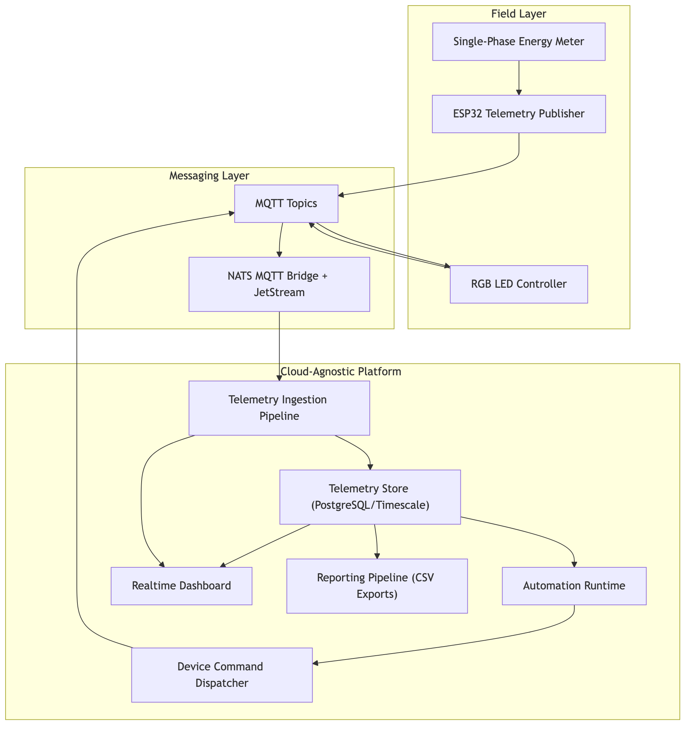
In operational terms, the flow begins when meter telemetry is published by the edge path and received by the broker. The ingestion layer resolves the device/topic contract, validates field values, applies mutations or derived mappings where required, and persists telemetry logs. Persisted events are then matched against automation triggers. If a workflow is activated, query and condition nodes evaluate state against configured rules. When conditions are met, command nodes publish actuator payloads to target control topics. Device feedback messages are captured and reconciled against command lifecycle state so that the platform can distinguish intended command intent from observed device state.
The same persisted telemetry supports dashboard widgets for near-real-time visualization and asynchronous report generation for historical extraction. This is an important architectural property: one canonical telemetry substrate serves automation, observability, and reporting, reducing duplication and conflicting data interpretations between tools.

3.4 Hardware Context and Edge Connectivity
The demonstration uses a single-phase energy monitoring stack with an ESP32-linked communication path and an RGB LED target device. The edge layer is intentionally lightweight because the platform’s architectural emphasis is on contract-driven backend orchestration rather than custom firmware complexity. The ESP32 family is appropriate for this role due to widespread IoT adoption, low power profile, and flexible connectivity options (Espressif Systems, n.d.).
From a systems perspective, the hardware arrangement proves an important point: high-value automation does not require tightly coupled proprietary device ecosystems. As long as devices can publish and subscribe through stable topic contracts and payload schema definitions, they can be composed into workflows regardless of their manufacturer or local interface details. This creates a practical pathway for incremental modernization in energy estates where legacy and modern assets must coexist.

3.5 Ingestion, Validation, and Persistence Design
The ingestion subsystem was implemented as staged processing rather than monolithic parsing. This allows each stage to fail, retry, or be observed independently. At a conceptual level, the stages are envelope reception and deduplication, contract resolution, field-level validation, mutation/derivation, persistence, and downstream event emission. Staging is critical for quality because telemetry streams are rarely clean in production conditions. Schema drift, incomplete payloads, and transient broker/network faults are expected realities.
Worker execution follows queue-based orchestration patterns aligned with Laravel queue and Horizon operational models (Laravel, n.d.-a; Laravel, n.d.-b). This supports back-pressure control and separates ingress spikes from downstream compute load. In other words, the system can absorb temporary bursts without forcing synchronous coupling between broker ingress and workflow execution.
Telemetry records are stored in a time-series-aware relational model. This enables bounded-range queries such as 15-minute window calculations while retaining relational governance and JSON flexibility for heterogeneous payloads (Tiger Data, n.d.; PostgreSQL Global Development Group, 2025). This was a deliberate tradeoff. The architecture avoids introducing a second specialized analytics store at this stage, reducing operational complexity while still supporting the required query patterns.

3.6 Automation Workflow: 15-Minute Consumption Logic
The central demonstration workflow maps directly to a real operational requirement: determine whether recent consumption behavior indicates an alert condition and surface that condition physically through an indicator device. The workflow uses a telemetry trigger, a query node, a condition node, and a command node.
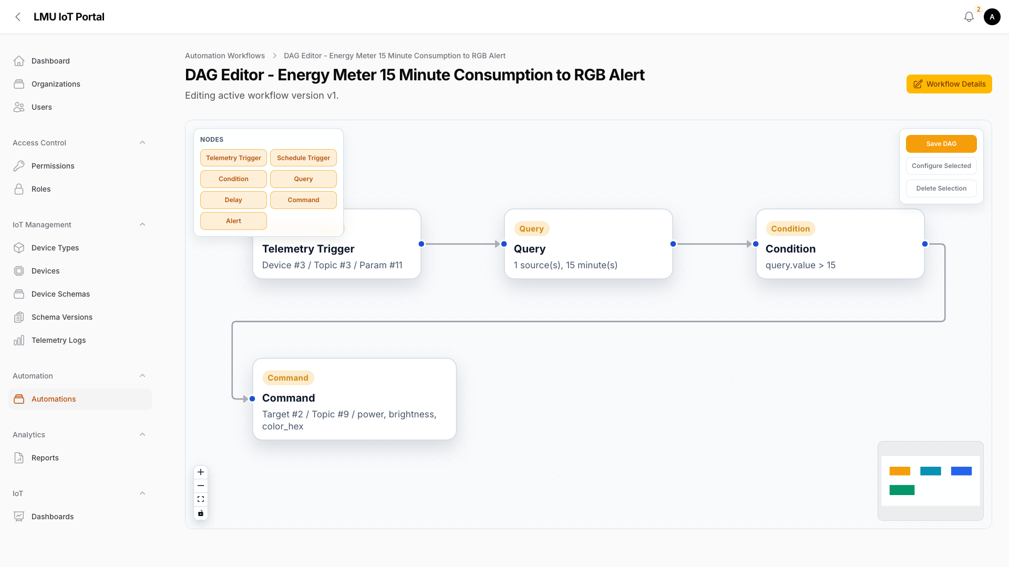
The query node computes energy consumed over a rolling 15-minute window using cumulative meter values. Conceptually, the calculation is max(total_energy_kwh) - min(total_energy_kwh) across records in the selected window. The condition node compares that delta against a configured threshold. If the threshold is exceeded, the command node publishes an RGB control payload that sets the device to an alert state such as red blink.
The analytic rationale behind this design is important. Thresholding on single samples can generate false signals due to noise, transient spikes, or meter jitter. A bounded-window delta is more stable and aligns better with short-cycle operational interpretation. It captures consumption behavior over a relevant period rather than overreacting to isolated measurements.
The workflow model also supports explainability. Each node has explicit configuration and run-step status, so investigators can identify whether a missed alert came from trigger mismatch, query output, condition logic, command dispatch, or downstream device behavior. That level of traceability is essential when automation outcomes need to be defended in operational reviews.

3.7 Device Control and State Reconciliation
Command dispatch alone does not prove automation success. A robust platform must verify that device state changed as expected. For that reason, the control subsystem tracks command lifecycle states such as pending, sent, completed, timed out, or failed, and associates each command with correlation metadata that can be linked back to workflow runs.
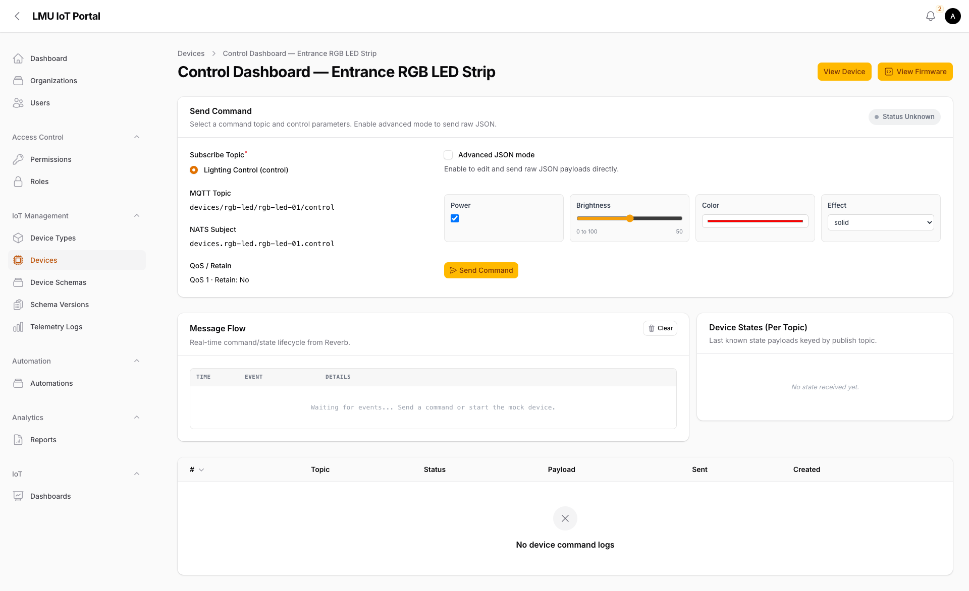
The RGB device publishes feedback messages on state topics. The platform reconciles those messages with command intent and updates the operator interface accordingly. This design prevents a common failure mode in IoT systems where UIs display “success” based solely on publish acknowledgement rather than observed device state. By distinguishing transport-level events from state-level confirmation, the platform provides more trustworthy control semantics.
In multi-device estates, this distinction becomes even more valuable because network variability, intermittent connectivity, and device-level faults are common. Reconciliation allows operations teams to identify where failures occur and whether remediation should focus on broker, network, firmware, or platform-side orchestration.

3.8 Dashboard and Realtime Visualization
The monitoring interface combines historical charts and realtime updates to support both trend interpretation and immediate incident awareness. Widget types include line, bar, and gauge views so that voltage trends, hourly consumption, and instantaneous current can be read in forms appropriate to each variable.
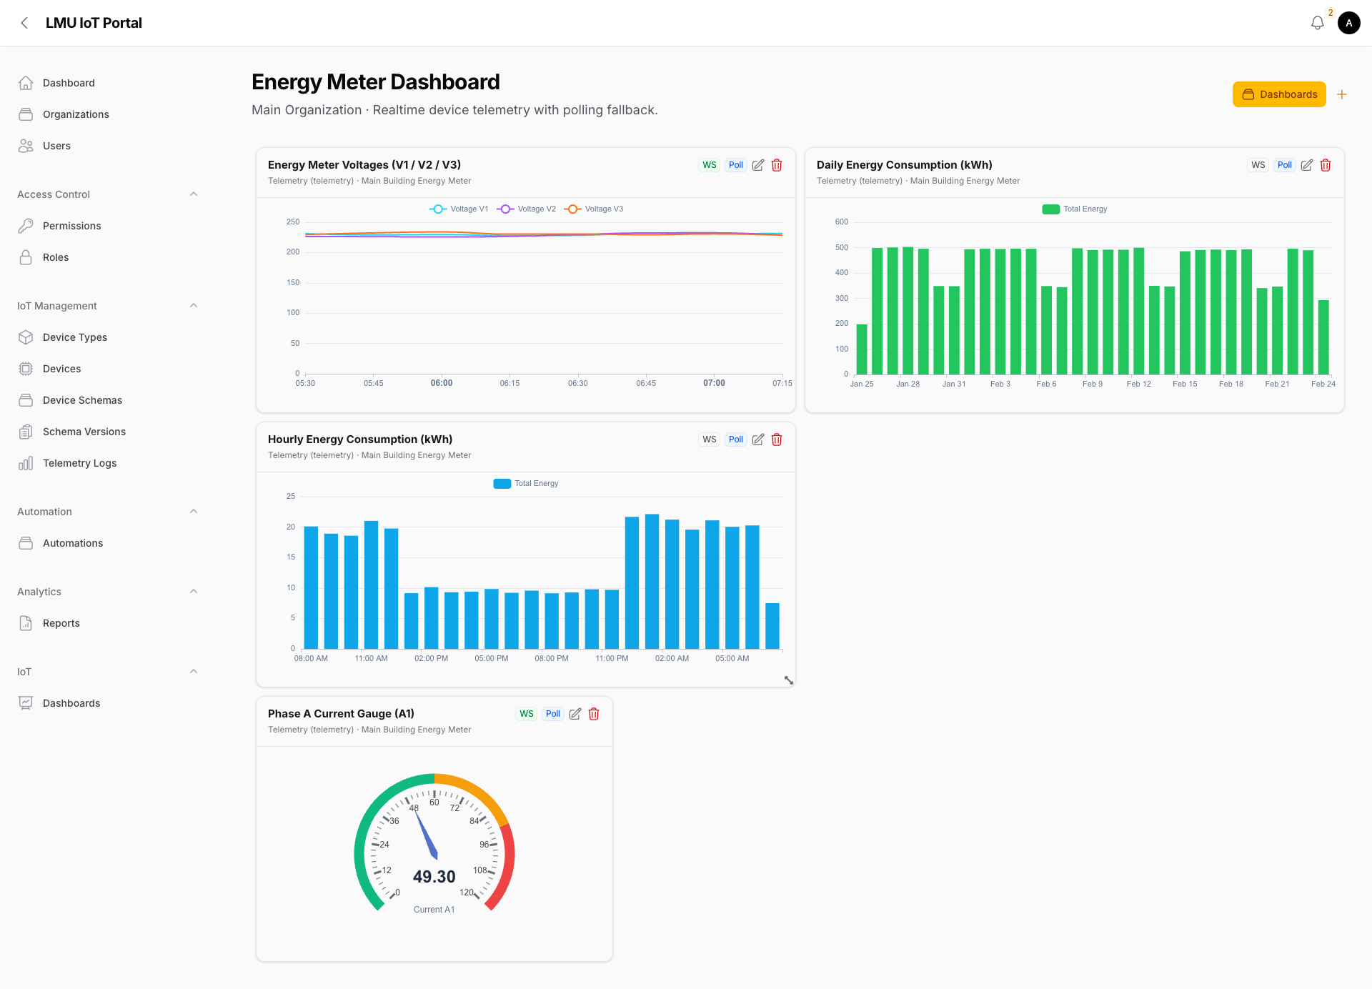
Realtime data delivery is provided through broadcast channels with fallback polling where websocket paths are unavailable (Laravel, n.d.-c; Laravel, n.d.-d). This hybrid model is operationally pragmatic. It preserves responsiveness in stable conditions while maintaining continuity in constrained networks or restrictive environments where websocket transport may be degraded. As a result, dashboards remain usable rather than failing closed when realtime transport is interrupted.
From a governance perspective, dashboard access is organization-scoped. This supports multi-tenant safety and reduces the risk of accidental cross-organization visibility in shared platform environments.

3.9 Reporting Architecture and Governance Value
A major enhancement over a dashboard-only system is the inclusion of asynchronous reporting. Realtime views are excellent for monitoring but are not sufficient for audit trails, offline analysis, and structured handover across teams. The reporting subsystem addresses this gap by queuing report-generation jobs, persisting run state, and storing downloadable CSV outputs with metadata.
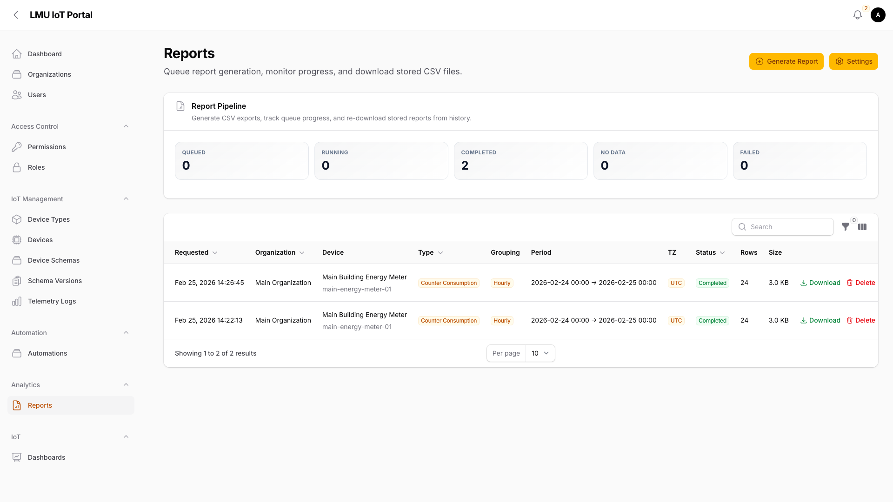
Report runs are classified into lifecycle states such as queued, running, completed, no data, and failed. This state model gives operations teams visibility into processing progress and allows safe recovery or retry behavior. The subsystem supports different report types, including raw parameter exports, counter-consumption aggregation, and state utilization summaries. It also supports grouping windows such as hourly, daily, monthly, and shift-based intervals, with organization-level timezone and range constraints.
The governance value of this design is substantial. First, it separates interactive dashboard workloads from heavier export tasks, improving overall user experience under load. Second, it provides a clear audit trail of who requested which report and when it was produced. Third, it enforces organization boundaries at the export layer, which is often overlooked when analytics are handled by loosely integrated third-party tooling.
Technically, the reporting pipeline reuses the same queueing and worker control patterns as other asynchronous workloads (Laravel, n.d.-a; Laravel, n.d.-b). This operational consistency reduces cognitive load for platform operators and simplifies deployment and scaling decisions.

3.10 Proposal-to-Implementation Pivot and Justification
The original proposal referenced MQTT, Node-RED, TimescaleDB, and Grafana as a plausible implementation stack. Each of these tools is valid in isolation and widely adopted. The pivot during implementation was not a rejection of those technologies; it was a strategic consolidation of responsibilities to align with long-term maintainability and fleet-scale operations.
The first change was replacing external flow tooling with a native workflow runtime. This reduced duplication between external flow definitions and internal domain contracts. The second change was replacing dashboard-centric external visualization with integrated dashboard modules tied directly to platform authorization and schema metadata. The third change was unifying telemetry and control behavior under one policy boundary so that automation, command lifecycle, and auditability could be managed consistently.
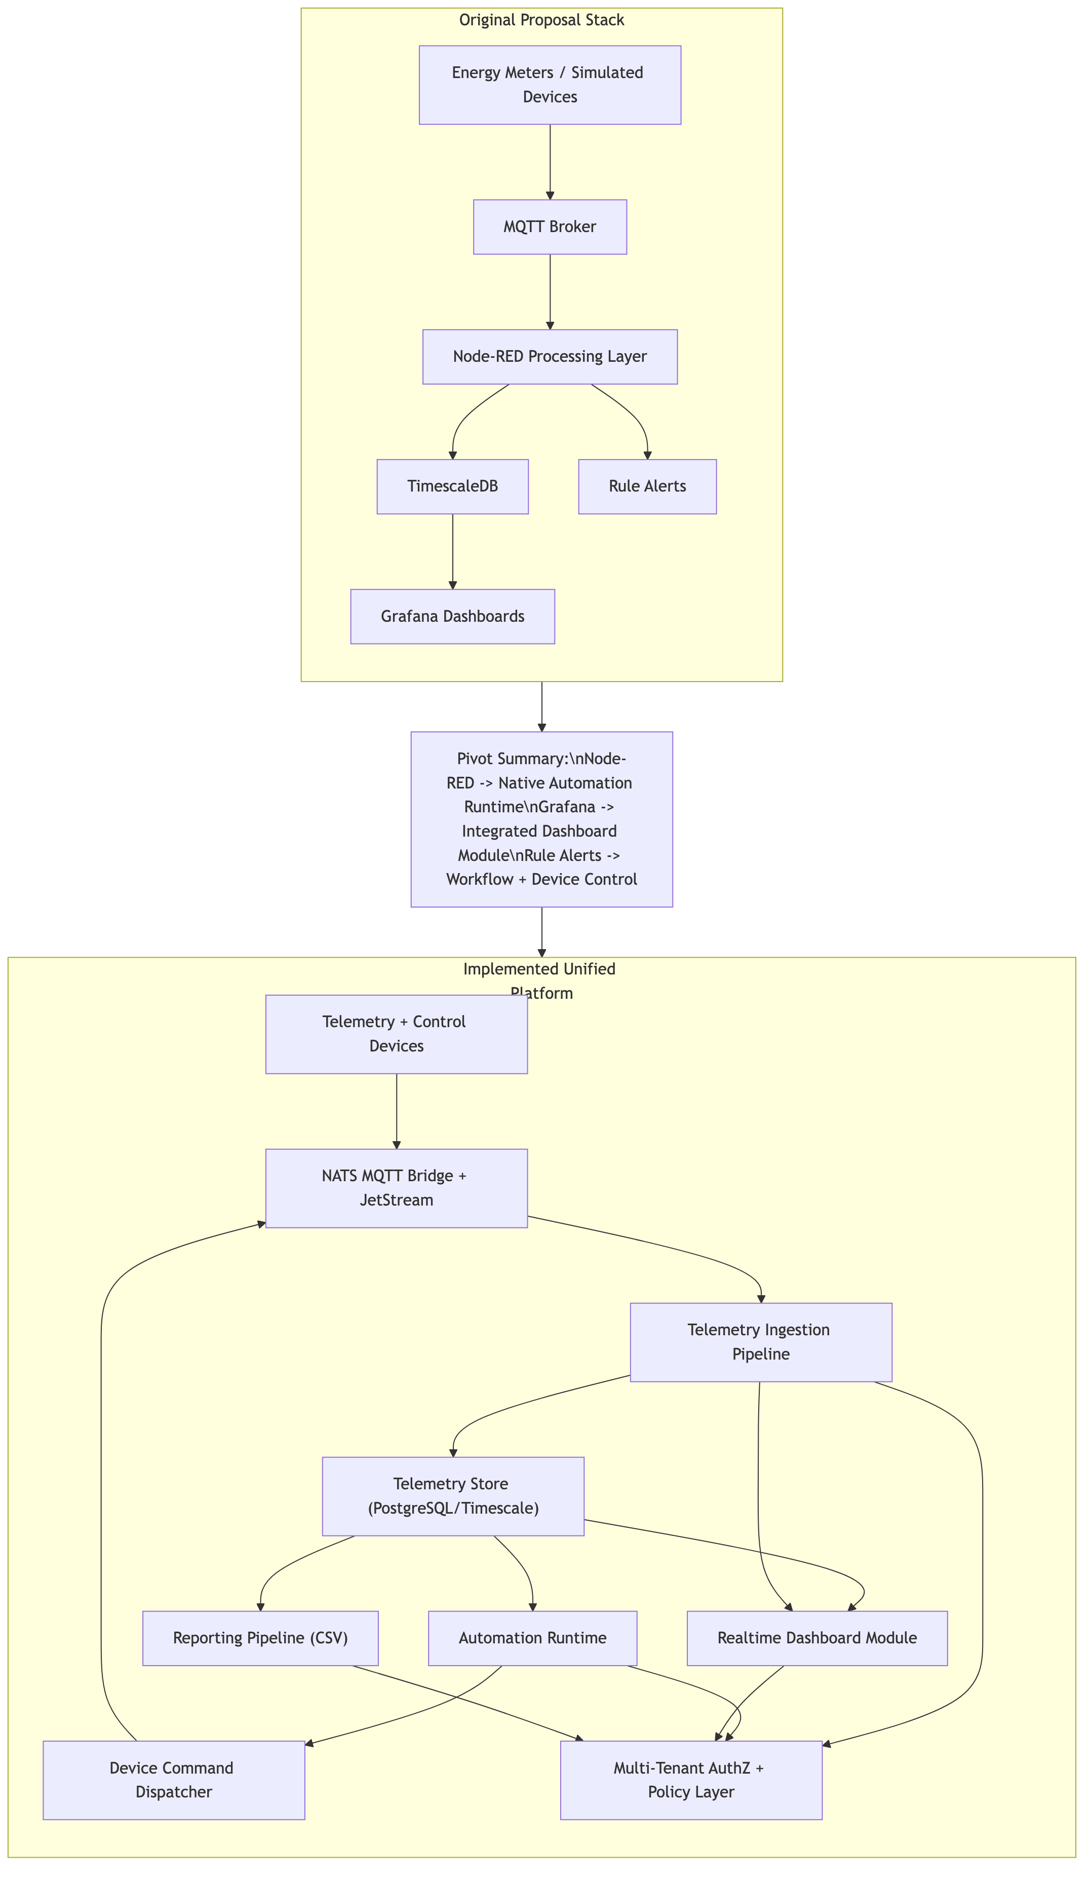
The key technical argument for this pivot is control of complexity. In a fragmented architecture, each cross-tool integration introduces synchronization requirements, operational dependencies, and potential security gaps. At small scale this can be tolerated. At larger scale it becomes a recurring source of defects and ownership ambiguity. By contrast, a unified platform model allows shared contracts, shared tenancy controls, shared observability, and shared deployment strategy.
This does involve tradeoffs. Consolidation increases responsibility within the core platform codebase and requires stronger engineering discipline around module boundaries. However, for the objective of onboarding heterogeneous devices and managing growing fleets, the tradeoff is favorable. Complexity is moved from integration edges to governed internal abstractions where it can be versioned and operated more predictably.

3.11 Cloud-Agnostic Design and Kubernetes Scalability
Cloud-agnosticity in this project is a structural property rather than a branding statement. The runtime is containerized, uses open messaging and database interfaces, and avoids proprietary cloud-bound logic in core processing paths. This means the same workloads can run on local clusters, private cloud, or public cloud with environmental adaptation at infrastructure level rather than domain rewrite.
Kubernetes is the natural orchestration layer for this model because it provides declarative workload management, service abstraction, and autoscaling primitives (Kubernetes Authors, n.d.-a; Kubernetes Authors, n.d.-b). The platform can be decomposed into independently scalable components: ingestion workers by telemetry throughput, automation workers by trigger volume, realtime nodes by concurrent connections, and report workers by export queue depth.
For Azure deployment, AKS offers a managed Kubernetes implementation that reduces control-plane operational burden while preserving standard Kubernetes portability (Microsoft, n.d.). This is an important distinction. Selecting AKS does not require abandoning cloud-agnostic architecture. It simply provides a managed operational substrate for Kubernetes workloads.
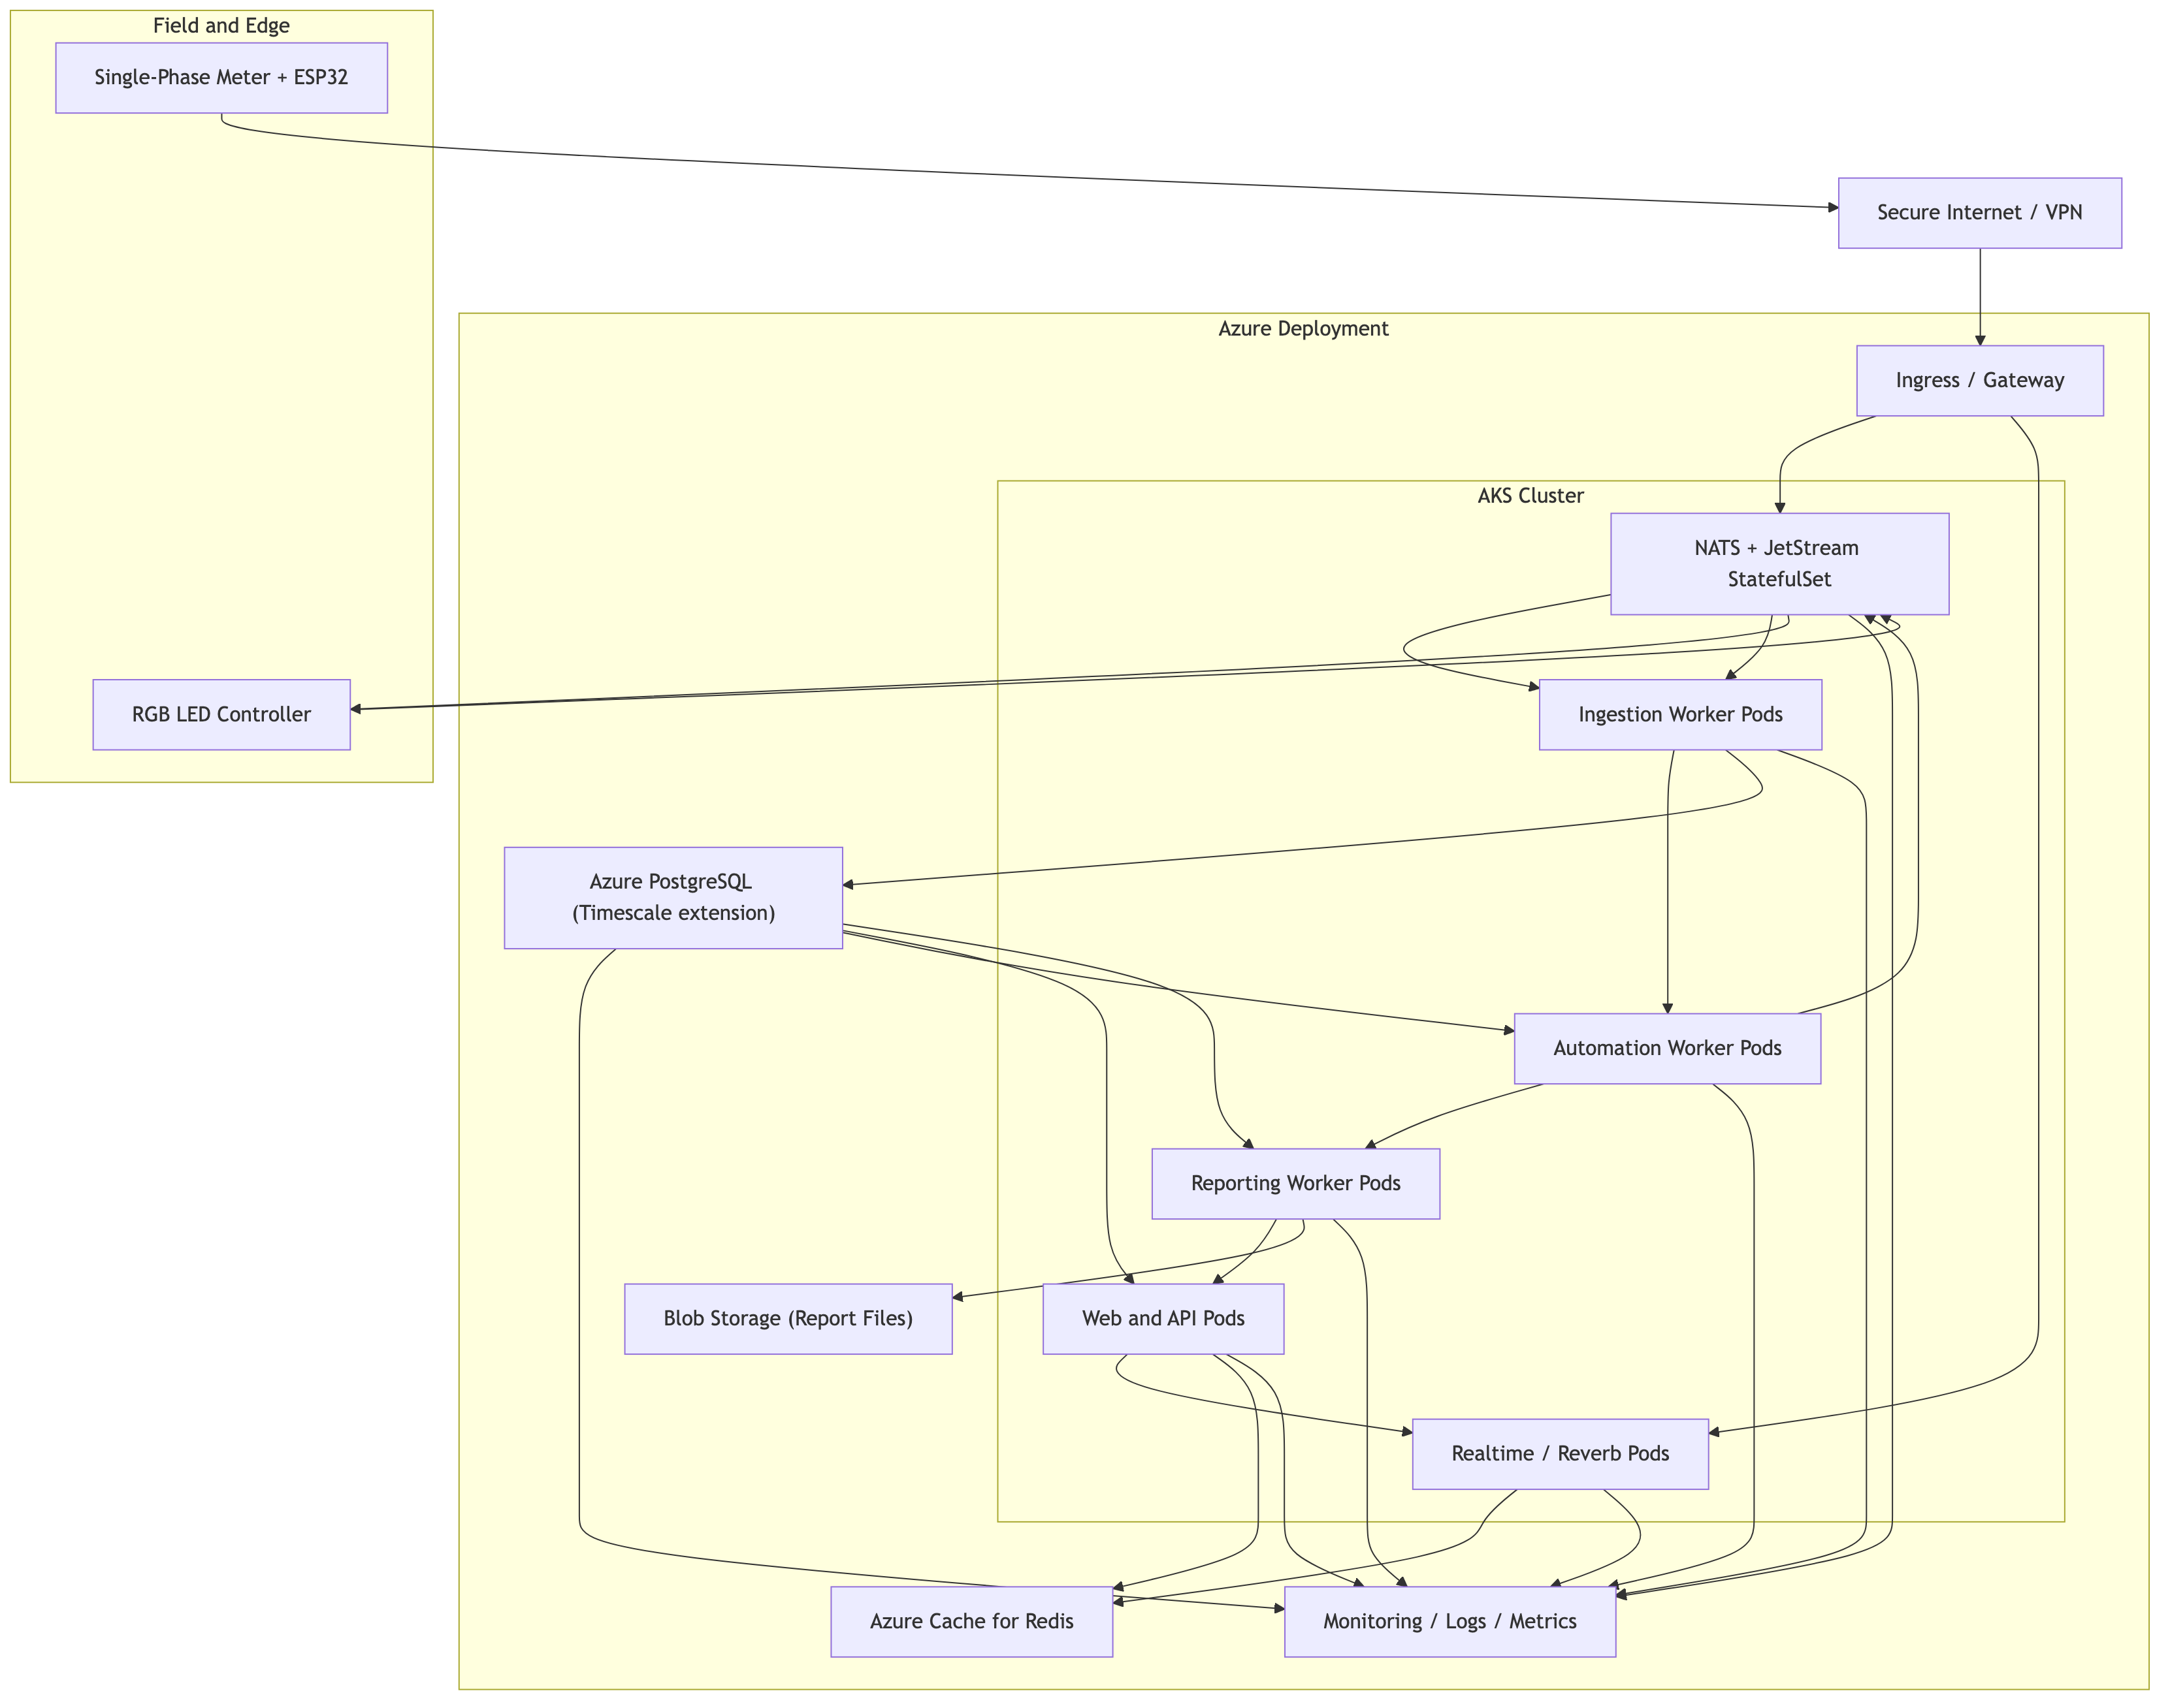
In practical terms, this deployment path supports phased scale-up. Early environments can run with conservative resource profiles while preserving the same service decomposition used in larger production footprints. As telemetry volume and tenant count grow, horizontal scaling can be applied selectively rather than through expensive vertical scaling of a monolithic process.

3.12 Evaluation and Validation
Evaluation in this report is evidence-based and avoids fabricated benchmark claims. Validation focuses on deterministic workflow behavior, observability of execution, and correctness of branching outcomes under defined conditions.
In the threshold-exceeded scenario, telemetry is ingested and persisted, the 15-minute query returns a value above the configured threshold, the condition node evaluates true, and the command node dispatches an RGB alert payload. Run-step records and command lifecycle entries provide trace evidence for each stage.
In the threshold-not-exceeded scenario, telemetry is still ingested and query execution still occurs, but the condition evaluates false. No actuator command is dispatched, and the workflow completes without side effects. This confirms that automation logic is selective and does not trigger on non-qualifying windows.
Reporting behavior was validated through lifecycle outcomes. Completed runs produce downloadable CSV files with recorded row counts and file size metadata. No-data runs terminate safely without synthetic outputs. Failed runs preserve failure state and timestamp, enabling troubleshooting. These behaviors are operationally significant because report generation often occurs outside active operator sessions and must remain observable when asynchronous faults occur.
The broader practical outcome is that the platform demonstrates a complete sense-decide-act loop with governance. Telemetry is interpreted, conditions can drive controlled actions, and outcomes are recorded with sufficient context for inspection.

3.13 Critical Discussion
The project demonstrates that a general-purpose open-source platform can deliver specialized energy-monitoring value when domain contracts are modeled carefully. First, specialization can be achieved at configuration and schema layers rather than by building bespoke infrastructure for each use case. Second, platform teams can maintain a consistent operational model while onboarding new device classes.
At the same time, the current implementation is intentionally bounded. The 15-minute threshold rule is deterministic and explainable, but it does not capture all energy anomalies. Complex behaviors such as occupancy-linked consumption drift, seasonal baselines, or equipment-specific signatures would require additional modeling. The present design nevertheless provides a reliable baseline for such extensions because it already includes query nodes, workflow branching, and asynchronous processing foundations.
Another tradeoff concerns governance centralization. Consolidating capabilities into one platform strengthens policy consistency but increases the importance of internal architecture quality. Poor module boundaries could recreate complexity inside the codebase. The current domain partitioning and queue-based decoupling mitigate that risk, but sustained discipline remains necessary as features expand.
Finally, while the architecture is cloud-agnostic, portability should not be confused with zero migration effort. Differences in managed services, networking defaults, and observability tooling across clouds still require environment-specific implementation work. The advantage is that this work is primarily infrastructural, not a rewrite of core business logic.

4 Conclusion
This project delivered a complete IoT energy monitoring and automation platform that extends beyond passive telemetry visualization. The implemented system ingests single-phase meter data through an ESP32-linked path, computes 15-minute consumption behavior, evaluates threshold conditions, dispatches actuator commands to an RGB indicator, reconciles observed device state, and exposes both realtime dashboards and asynchronous reporting outputs.
The most significant technical outcome is architectural consolidation around a unified, schema-driven platform model. Compared with a fragmented multi-tool approach, the final design improves contract consistency, operational traceability, tenant governance, and scaling control. The proposal-to-implementation pivot therefore represents a strategic improvement in platform suitability for larger device fleets rather than a deviation from core project objectives.
The cloud-agnostic and Kubernetes-ready nature of the solution provides a credible path from prototype to production-grade deployment. Running on AKS is fully compatible with this portability strategy, allowing managed operations without hard-coding domain logic to a single provider. Overall, the project establishes a defensible foundation for energy-focused IoT operations that require reliable automation, auditable reporting, and extensible device onboarding.

5 Recommendations
The next stage of development should prioritize the following actions:
- Establish a formal performance and resilience test campaign that measures ingestion latency, workflow execution time, websocket fan-out behavior, and reporting throughput under sustained load.
- Introduce adaptive threshold and anomaly-detection extensions on top of the existing rule engine while preserving deterministic fallback logic for critical workflows.
- Harden production governance controls by expanding role policies, secret-management practices, and security monitoring to support enterprise deployment expectations.
- Implement tenant-aware workload policies in Kubernetes, including quotas and autoscaling guards, to maintain fair resource allocation as organizational usage grows.
- Expand reporting outputs with standardized operational templates that align with facility management and compliance review processes.
- Develop a controlled firmware/device simulation harness to improve repeatable end-to-end regression testing of telemetry and control workflows.

6 Limitations
The current report and implementation have several explicit limitations:
- Validation evidence focuses on correctness and traceability of workflow behavior, not on full-scale long-duration performance benchmarks.
- Automation logic currently relies on rule-based thresholds and does not yet include advanced predictive or context-aware anomaly models.
- The deployment discussion defines a Kubernetes/AKS-ready strategy but does not provide a finalized production runbook with complete SRE and compliance controls.
- The hardware demonstration is intentionally narrow (single-phase scenario and RGB indicator) and therefore does not represent the full variety of industrial device integration cases.

7 Reflection
This project provided substantial technical learning in three areas: platform architecture, operational engineering, and scope management. The initial expectation was that combining established tools would be sufficient for rapid delivery. In practice, the team learned that delivery speed in a pilot is not the same as sustainability in a growing platform.
A major learning outcome was the value of schema-driven design. By treating topic definitions, parameter metadata, and workflow node contracts as first-class artifacts, the platform became easier to reason about and easier to extend. This reduced the temptation to solve short-term problems with one-off transformations that would later be difficult to govern. The process also reinforced that “automation” is not only about sending commands; it is about proving that command outcomes can be traced and verified.
Another reflection concerns reporting. At the beginning, reporting might have been seen as a secondary feature compared with realtime dashboards. During implementation, it became clear that reporting is central to operational trust. Teams need exportable, inspectable data products for decisions that happen outside the dashboard context, especially when collaborating across technical and non-technical stakeholders.
The cloud-agnostic and Kubernetes-oriented strategy also reshaped the team’s understanding of scalability. Scalability is not achieved by selecting Kubernetes alone. It depends on workload decomposition, queue discipline, state management boundaries, and observability design.
Most importantly, the project clarified a practical engineering principle: reducing architectural fragmentation often creates better long-term outcomes than optimizing individual tools in isolation. The integrated platform model required more careful upfront design, but it yielded clearer governance and stronger traceability.

8 References
Espressif Systems (n.d.) ESP32-S3 series. Available at: https://www.espressif.com/en/products/socs/esp32-s3 (Accessed: 25 February 2026).
Kubernetes Authors (n.d.-a) Overview: What is Kubernetes? Available at: https://kubernetes.io/docs/concepts/overview/what-is-kubernetes/ (Accessed: 25 February 2026).
Kubernetes Authors (n.d.-b) Autoscaling workloads. Available at: https://kubernetes.io/docs/concepts/workloads/autoscaling/ (Accessed: 25 February 2026).
Laravel (n.d.-a) Queues (Laravel 12.x documentation). Available at: https://laravel.com/docs/12.x/queues (Accessed: 25 February 2026).
Laravel (n.d.-b) Horizon (Laravel 12.x documentation). Available at: https://laravel.com/docs/12.x/horizon (Accessed: 25 February 2026).
Laravel (n.d.-c) Broadcasting (Laravel 12.x documentation). Available at: https://laravel.com/docs/12.x/broadcasting (Accessed: 25 February 2026).
Laravel (n.d.-d) Reverb (Laravel 12.x documentation). Available at: https://laravel.com/docs/12.x/reverb (Accessed: 25 February 2026).
Microsoft (n.d.) What is Azure Kubernetes Service (AKS)? Available at: https://learn.microsoft.com/en-us/azure/aks/what-is-aks (Accessed: 25 February 2026).
MQTT.org (2024) MQTT specifications. Available at: https://mqtt.org/mqtt-specification/ (Accessed: 25 February 2026).
NATS (n.d.-a) Subject-based messaging. Available at: https://docs.nats.io/nats-concepts/subjects (Accessed: 25 February 2026).
NATS (n.d.-b) MQTT configuration. Available at: https://docs.nats.io/running-a-nats-service/configuration/mqtt (Accessed: 25 February 2026).
NATS (n.d.-c) JetStream concepts. Available at: https://docs.nats.io/nats-concepts/jetstream (Accessed: 25 February 2026).
PostgreSQL Global Development Group (2025) JSON functions and operators. Available at: https://www.postgresql.org/docs/current/functions-json.html (Accessed: 25 February 2026).
Tiger Data (n.d.) Hypertables. Available at: https://docs.timescale.com/use-timescale/latest/hypertables/ (Accessed: 25 February 2026).

9 Appendices

9.1 Appendix A: Figure Inventory
The report currently embeds seven figures sourced from docs/report-images/:
- figure2-end-to-end-architecture.png
- figure3-automation-dag.png
- figure4-iot-dashboard.png
- figure5-device-control-feedback.png
- figure6-reports-page.png
- figure7-proposed-vs-implemented-architecture.png
- deployment-architecture-aks.png

9.2 Appendix B: DOCX Field Update Note
After exporting the report to DOCX, update fields once in Word to refresh page references in the Table of Contents and List of Figures.

