7SENG013W Software Development Project

**Project Proposal (PP)**

**Requirement based academic matchmaking platform for academic institutes**

**Student:** TMTCB Thennakoon (W2052836)

**Supervisor:** Mr. Pumudu Fernando

**Date:** 26/11/2024

MSc Software Engineering (Conversion)

School of Computer Science & Engineering

University of Westminster

**Table of Contents**

1. Introduction to the project 4

1.1 Background 4

1.2 Rationale 4

1.3 Intention of the application 5

1.4 Expected Users 5

1.4.1 Academic Institutes 5

1.4.2 Visiting Lecturers 5

2. Project aims and objectives 5

2.1 Aim 5

2.2 Objectives 6

3. Project system architecture diagram 6

3.1 High-level architectural Diagram 6

3.2 Components involved 7

3.2.1 Frontend Client App 7

3.2.2 Institute Service: 8

3.2.3 Program Service 8

3.2.4 Subject Service 8

3.2.5 Lecturer Service 8

3.2.6 Qualification Service 9

3.2.7 Admin Service 9

3.2.8 Firebase Bucket and OAuth Service 9

3.2.9 MySQL Database 9

3.2.10 Unit test cases 10

4. Project research 10

4.1 Review of similar systems 10

4.1.1. Find a Teacher (FAT) 10

4.1.2. TeacherOn 13

4.1.3. LinkedIn 15

4.1.4. Fiverr 17

4.1.5. Necessity of a specialized match making platform 18

4.2 Research topics 19

4.2.1. Academic recruitment procedure 19

4.2.2. Key qualities and competencies that academic institutions seek in lecturing professionals 19

4.2.3. Employer employee match making algorithms 19

4.2.4. Methodologies used to analyze educational quality of an institute 20

4.2.5. Methodologies used to measure workload on academic staff 20

4.2.6. Java Spring and React full-stack development life cycle 20

4.2.7. How to use Firebase to enhance a web application 20

4.2.8. Best practices in prompt engineering to take the best out of generative AI 20

5. Initial list of requirements 20

5.1. Functional 21

5.2. Non-Functional 22

5.3. User Interface Requirements 22

5.4 Requirement gathering 22

5.4.1. Questionnaire 23

5.4.2. Formal Interviews 23

6. Tools and skills 24

6.1. Software Tools 24

6.2. Hardware Tools 24

6.3. Other Skills 25

7. Challenges 25

7.1. Legal Challenges 25

7.2. Social Challenges 25

7.3. Ethical Challenges 26

7.4. Financial Challenges 26

7.5. Technical Challenges 26

8. Project timeline 27

9. References 28

**List of Figures**

Figure 1: High Level Architectural Diagram 7

Figure 2: Find a Teacher UI District Filter 11

Figure 3: Find a Teacher UI Service Filter 11

Figure 4: FAT - Lecturer Details Page 12

Figure 5: FAT- Mobile view 12

Figure 6: TeacherOn Landing Page 13

Figure 7: TeacherOn Lecturer Details Page 14

Figure 8: TeacherOn find jobs page 14

Figure 9: TeacherOn Mobile view 15

Figure 10: LinkedIn Job Search 16

Figure 11:LinkedIn lecturer profile 16

Figure 12: Fiver Landing Page 17

Figure 13: Fiverr gig of a lecturer 18

Figure 14: Limitations of Existing platforms 19

Figure 15: Gantt chart 27

**List of Tables**

Table 1: Functional requirements for Institute 21

Table 2: Functional requirement for visiting lecturer 22

Table 3: Non-Functional Requirements 22

Table 4: User Interface Requirements 22

Table 5: Risks and Mitigation for Software Tools 24

Table 6: Risks and Mitigation for Hardware Tools 25

Table 7: Risks and Mitigation for Other Skills and Tools 25

Table 8: Project milestones and deadlines 27

# Introduction to the project

## Background

The academic sector in Sri Lanka includes both public and private universities, which together cater to a diverse student population. Public universities, predominantly funded by the government, are known for their rigorous admission processes and are highly competitive, admitting only the top-scoring students from national examinations. (Tharmaseelan, 2007) These universities hold high prestige, particularly in fields such as engineering, medicine, and law, and tend to focus on research and theory-based learning. However, their limited capacity means many qualified students cannot gain admission, leading them to private universities, which are gaining popularity for their accessibility and focus on fields like business and information technology. Private institutions, some of which are affiliated with international universities, offer alternative pathways for higher education but vary significantly in quality. Although some maintain robust academic standards, others struggle to deliver high-quality education consistently due to factors like resource limitations and regulatory challenges. (Gunawardena, 2017)

Academic institutions cater to diverse academic and professional needs through programs such as Bachelor of Science (BSc), Master of Science (MSc), Postgraduate Diploma (PGD), and Higher National Diploma (HND), among others. Programs are structured to address both foundational and advanced learning across various levels, helping students achieve the necessary qualifications for career advancement or further studies. Disciplines offered in these institutions cover a broad spectrum to meet the demands of different industries, including fields like Business Management, Computer Science, Information Technology (IT), Economics, Marketing, and Health and Safety. (Wickramasinghe, 2018) This diversity allows students to pursue specialized fields of interest that align with their career goals. Further, this demands academic staff to bring their interdisciplinary knowledge to their teaching.

## Rationale

In Sri Lanka, both the academic sector and the broader industrial sector have talented lecturing professionals. These individuals possess not only strong academic knowledge but also valuable real-world experience. However, there is a notable gap between the availability of these skilled professionals and the ability of academic institutions to recruit them, particularly in private universities. Many private academic institutions face challenges in sourcing quality lecturers who can bring both academic and industry relevance to the classroom. Due to this shortage, these institutions often struggle to deliver content that meets high educational standards, affecting the quality of student learning and their preparedness for future careers. (Ariyawansa, 2013)

This shortage of qualified lecturers also places a heavy burden on full-time academic staff, who often end up overworked and exhausted. Many lecturers are stretched out, juggling extensive teaching hours, administrative tasks, and research responsibilities, which can lead to burnout and reduced teaching effectiveness. To address these issues, a dedicated tool or platform that connects academic institutions with top-quality lecturing professionals from both academic and industry backgrounds could make a significant impact. (Asian Development Bank, 2016) Such a tool would allow institutions to access a pool of qualified, skilled lecturers on demand, improving the overall quality of education while relieving the workload of full-time academic staff.

## Intention of the application

The application aims to bridge the gap between academic institutions and qualified lecturers by providing a specialized platform for efficient lecturer matching. Thereby, addressing recruitment challenges, improving teaching quality, and ensuring access to skilled professionals for enhanced education delivery.

## Expected Users

### Academic Institutes

Academic institutes use the application to find and recruit qualified visiting lecturers with relevant expertise, to enhance lecturing quality to prevent burnout of inhouse lecturers.

### Visiting Lecturers

Visiting lecturers use the application to showcase their qualifications, connect with academic institutions their teaching engagements, and access opportunities to contribute to diverse educational programs.

# Project aims and objectives

## Aim

PA1 - Aim of this project is to research, design, develop, test and evaluate a platform that connects private academic institutions with qualified lecturing professionals from both academia and industry, with the goal of enhancing educational quality and reducing the workload on full-time lecturers in resource-constrained environments.

By creating a platform that connects institutions with skilled lecturers from both academia and industry, the research seeks to address these challenges by providing institutions with access to a broader network of qualified professionals. This platform has the potential to improve the delivery of course content, reduce the strain on full-time staff, and ultimately raise the standard of education. (Ariyawansa, 2013) The research is motivated by the potential impact of such a tool in bridging the gap between academia and industry expertise, creating a more dynamic, sustainable, and effective educational ecosystem.

## Objectives

* PO1.1 - To identify the key qualities and competencies that academic institutions seek in lecturing professionals, including both academic and industry expertise.
* PO1.2 - To analyze the current challenges faced by private academic institutions in sourcing and retaining qualified lecturers
* PO1.3 - To incorporate features that address the needs of both academic institutions and qualified lecturing professionals.
* PO1.4 - To design a platform that facilitates the connection between academic institutions and qualified lecturing professionals.
* PO1.5 - To implement the platform with a robust subject to lecturer match making algorithm
* PO1.6 – To test and de-bug the software platform to make it robust
* PO1.7 - To evaluate the effectiveness of the developed platform in improving educational standards, reducing full-time-staff workload, and enhancing student satisfaction in academic institutions.

# Project system architecture diagram

## High-level architectural Diagram

The layered architecture diagram of the project, depicted in figure-1 includes entities like Institute, Program, Subject, Lecturer, Qualification, and Admin. In a layered architecture, the API layer, Service layer, Repository layer, and Database layer work together to organize application functionality, ensuring scalability, maintainability, and separation of concerns.

The API layer acts as the interface between the client and the backend system. It handles HTTP requests, routes them to the appropriate service, and returns responses to clients in a structured format. It ensures that external entities interact with the application securely and efficiently.

Service layer contains the core business logic of the application. It processes data received from the API layer, applies business rules, and coordinates interactions with other components, such as the repository layer. By isolating business logic, the service layer enhances reusability and makes the application easier to test.

The repository layer interacts with the database, encapsulating the data access logic. It translates service-layer requests into database queries and maps database records to application objects. This abstraction reduces the coupling between the database and business logic, making it easier to change the database structure.

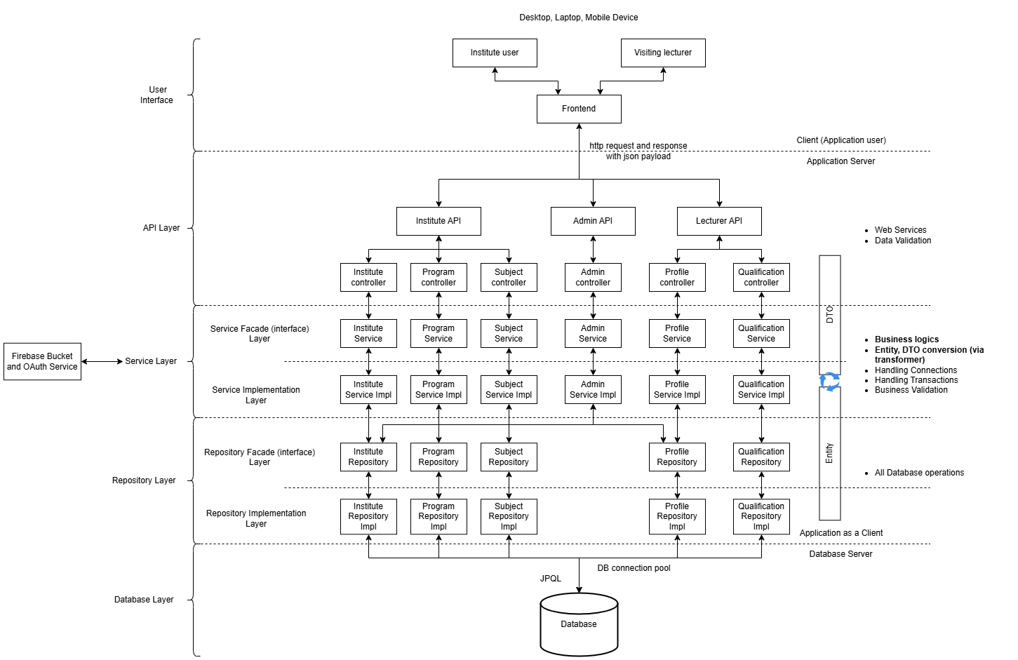

Figure 1: High Level Architectural Diagram

## Components involved

### Frontend Client App

The frontend client app for institutes and lecturers provides an intuitive interface for user interactions, allowing institutes to manage programs, subjects and post opportunities while enabling lecturers to showcase profiles and apply for suitable subjects. Built with React, it ensures responsiveness, real-time updates, and user-friendly navigation, enhancing engagement and accessibility across devices.

### Institute Service:

The **Institute Service** facilitates the management of institutional data on the platform, enabling seamless interaction between academic institutions and the system. It provides functionality for adding, updating, and deleting institute records, ensuring accurate and reliable information. The service also supports retrieving details of all registered institutes or specific ones, enhancing visibility and user accessibility. Additionally, it incorporates a rating mechanism to evaluate institutes based on their performance, promoting accountability and quality assurance. A validation process ensures that all institute-related data meet required standards, maintaining the platform’s data integrity and overall credibility.

### Program Service

The Program Service manages academic programs offered by institutions on the platform. It enables the addition of new programs to the system, capturing essential details such as program name, description, and associated institution. The service also supports updating existing programs, ensuring that information remains accurate and reflects current offerings. It allows the removal of programs when they are no longer active or relevant. Users can retrieve a comprehensive list of all programs available on the platform or access details of a specific program as needed.

### Subject Service

The Subject Service handles the management of subjects within the platform, enabling academic institutions to maintain comprehensive subject data for their programs. It allows for adding new subjects with relevant details, updating existing subject information to ensure accuracy, and removing outdated or irrelevant subjects. The service provides functionality to retrieve all subjects or specific ones, facilitating access to subject details as needed. Additionally, it supports advanced sorting options to organize subjects based on specific criteria, improving user experience. Progress tracking features enable monitoring of subject-related activities or milestones, adding value to academic oversight. For bulk operations, the service supports importing multiple subjects via CSV files, streamlining data management processes for institutions.

### Lecturer Service

The Lecturer Service manages the operations related to lecturers on the platform, ensuring seamless interaction between academic institutions and teaching professionals. It provides functionality to add and update lecturer profiles, capturing critical details such as qualifications, experience, and subject expertise. The service also allows for the deletion of lecturer profiles when necessary. Users can retrieve a comprehensive list of all registered lecturers or specific profiles as needed. Advanced sorting capabilities enable institutions to filter lecturers based on various criteria for targeted searches. The smart matching feature identifies lecturers best suited to specific institutional needs, enhancing efficiency in recruitment. Additionally, it supports lecturer rating to maintain quality and transparency, subject assignment for proper allocation of teaching responsibilities, and payment processing to ensure timely compensation. This service ensures effective lecturer management and smooth operations for all stakeholders.

### Qualification Service

The Qualification Service manages the qualifications of lecturers, ensuring their credentials are accurately recorded and easily accessible on the platform. It allows for adding new qualifications, capturing essential details such as degree type, field of study, and awarding institution. The service also supports updating existing qualification records to reflect any new achievements or corrections. Users can delete outdated or irrelevant qualifications as needed. It provides functionality to retrieve a complete list of all qualifications or details of a specific qualification, enabling institutions to verify lecturer expertise effectively.

### Admin Service

The Admin Service handles core administrative functions for managing access and platform operations. It enables the registration of new users by securely capturing and storing their credentials, ensuring only authorized users manage the system. The service provides a secure login mechanism for registered users, allowing them to access and oversee platform activities. Additionally, it facilitates subscription management, enabling users to activate platform features based on institutional needs.

### Firebase Bucket and OAuth Service

The Firebase Bucket and OAuth Service facilitates secure storage of lecturer profile pictures and institute logos and access management for the system. Firebase Buckets store these images efficiently, ensuring scalability. OAuth handles authentication, ensuring only authorized users can upload or retrieve files, protecting sensitive data and maintaining a streamlined integration with the app architecture.

### MySQL Database

The MySQL database serves as the backbone of the app's architecture, managing structured data for entities like institutes, lecturers, qualifications, programs, and subjects. It ensures efficient data storage, retrieval, and relationships using relational tables. With its scalability and reliability, MySQL supports seamless data integration and robust querying for application functionality.

### Unit test cases

Unit test cases will be created for each component which ensures that individual components of the project, such as services, APIs, and algorithms, operate as expected. They validate critical functionalities like lecturer-institute matchmaking, data validation, and profile management. By identifying bugs early, unit tests enhance reliability and maintainability, fostering seamless integration and future scalability of the platform.

# Project research

## Review of similar systems

### Find a Teacher (FAT)

The Find a Teacher platform connects Sri Lankan lecturers and academic institutions by allowing both parties to create accounts and post advertisements. Lecturers can advertise their availability, expertise, and subjects they can teach, while institutions can post their requirements for specific subjects or teaching roles. The platform also enables users to filter ads based on criteria like district, type of service, subject, or institute.

The Find a Teacher (FAT) platform has several weaknesses that hinder its overall functionality. While it allows users to post and filter advertisements, it lacks a specialized matchmaking tool to align lecturers and institutes effectively, reducing efficiency in finding the best fit. Its simple interface prioritizes advertisement displays over user experience, which detracts from usability and engagement. As depicted in figure 5, the platform exhibits weak responsiveness across different devices, making it less accessible for mobile or tablet users. These limitations compromise its ability to meet the needs of both lecturers and institutions, emphasizing the need for more advanced and user-focused solutions.

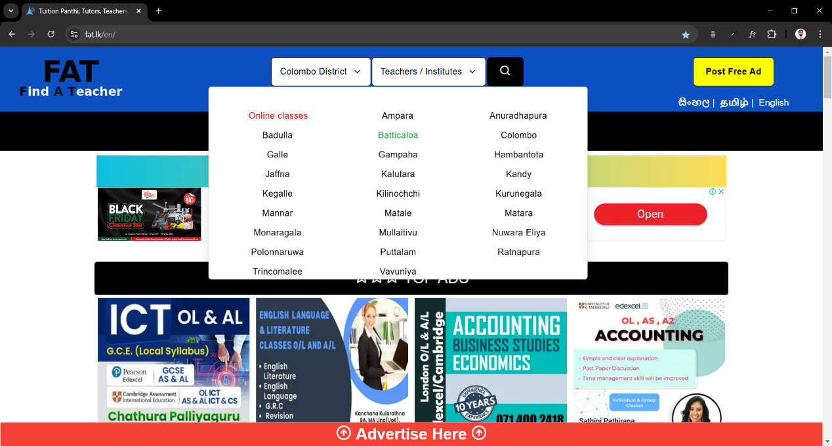

Figure 2: Find a Teacher UI District Filter

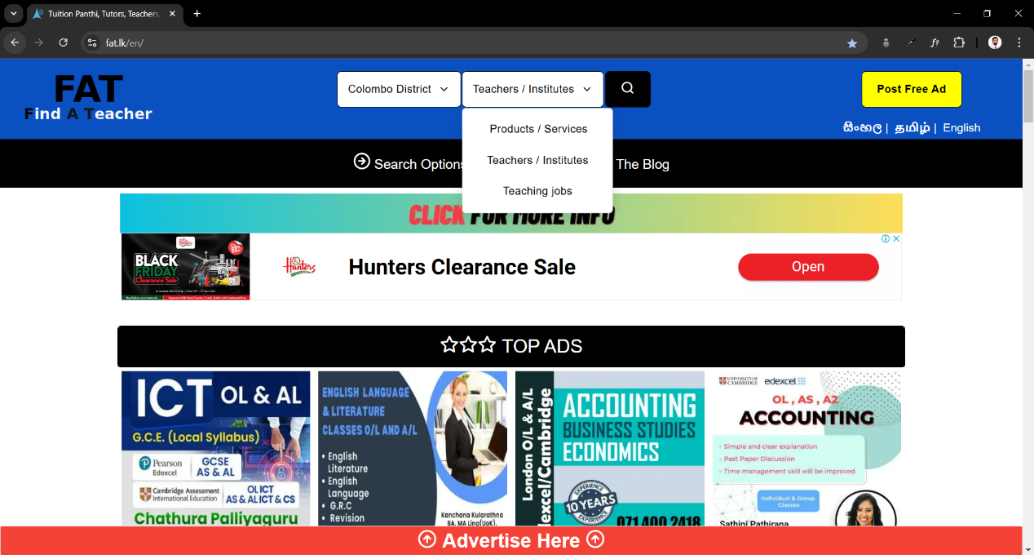

Figure 3: Find a Teacher UI Service Filter

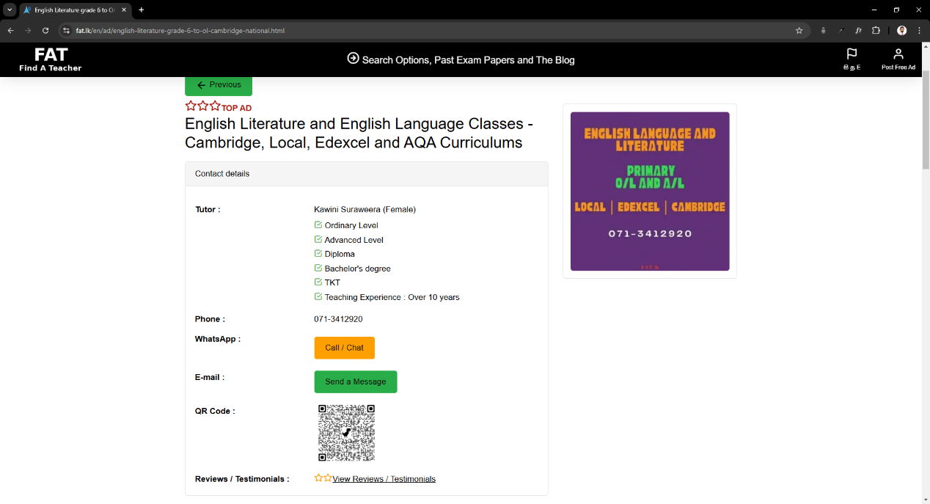

Figure 4: FAT - Lecturer Details Page



Figure 5: FAT- Mobile view

### TeacherOn

TeacherOn is a global platform that facilitates connections between tutors and learners. It enables users to find tutors for various subjects and academic needs, including assistance with assignments. Tutors can also browse and apply for jobs posted. The platform provides filtering options based on country and subject, allowing users to narrow down results to match their requirements.

The interface is equipped with features such as create accounts, post jobs, search for tutors, direct communication between tutors and learners. It supports both mobile and desktop platforms. Sample screenshots are displayed from figure 6 to 9.

The TeacherOn platform, while global, is not tailored to specific countries like Sri Lanka, limiting its relevance for local academic needs. The absence of a specialized matchmaking tool further reduces its efficiency in connecting tutors and learners based on precise qualifications or requirements. Additionally, its user interface lacks visual appeal and sophistication, making it less engaging and harder to navigate for users. These limitations affect the platform’s usability and effectiveness in creating meaningful academic connections, highlighting the need for localized, user-centric platforms with enhanced features and design.

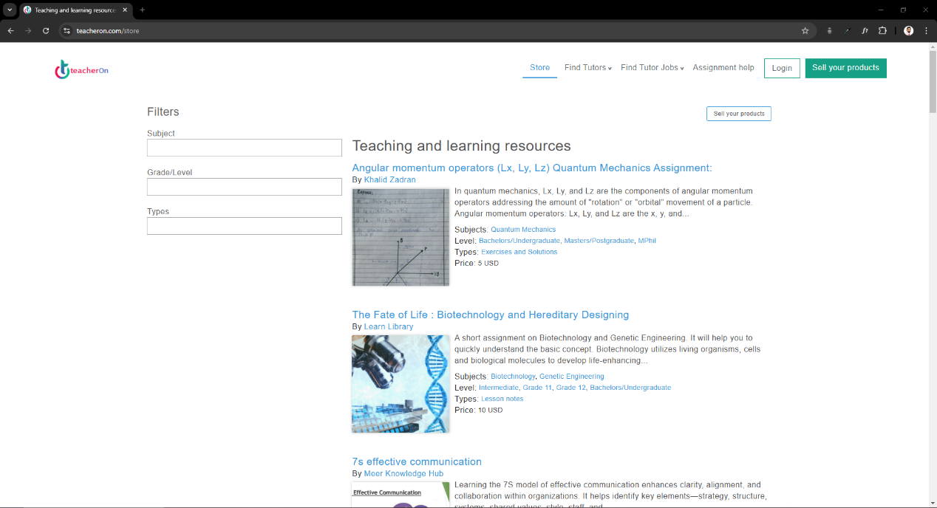

Figure 6: TeacherOn Landing Page

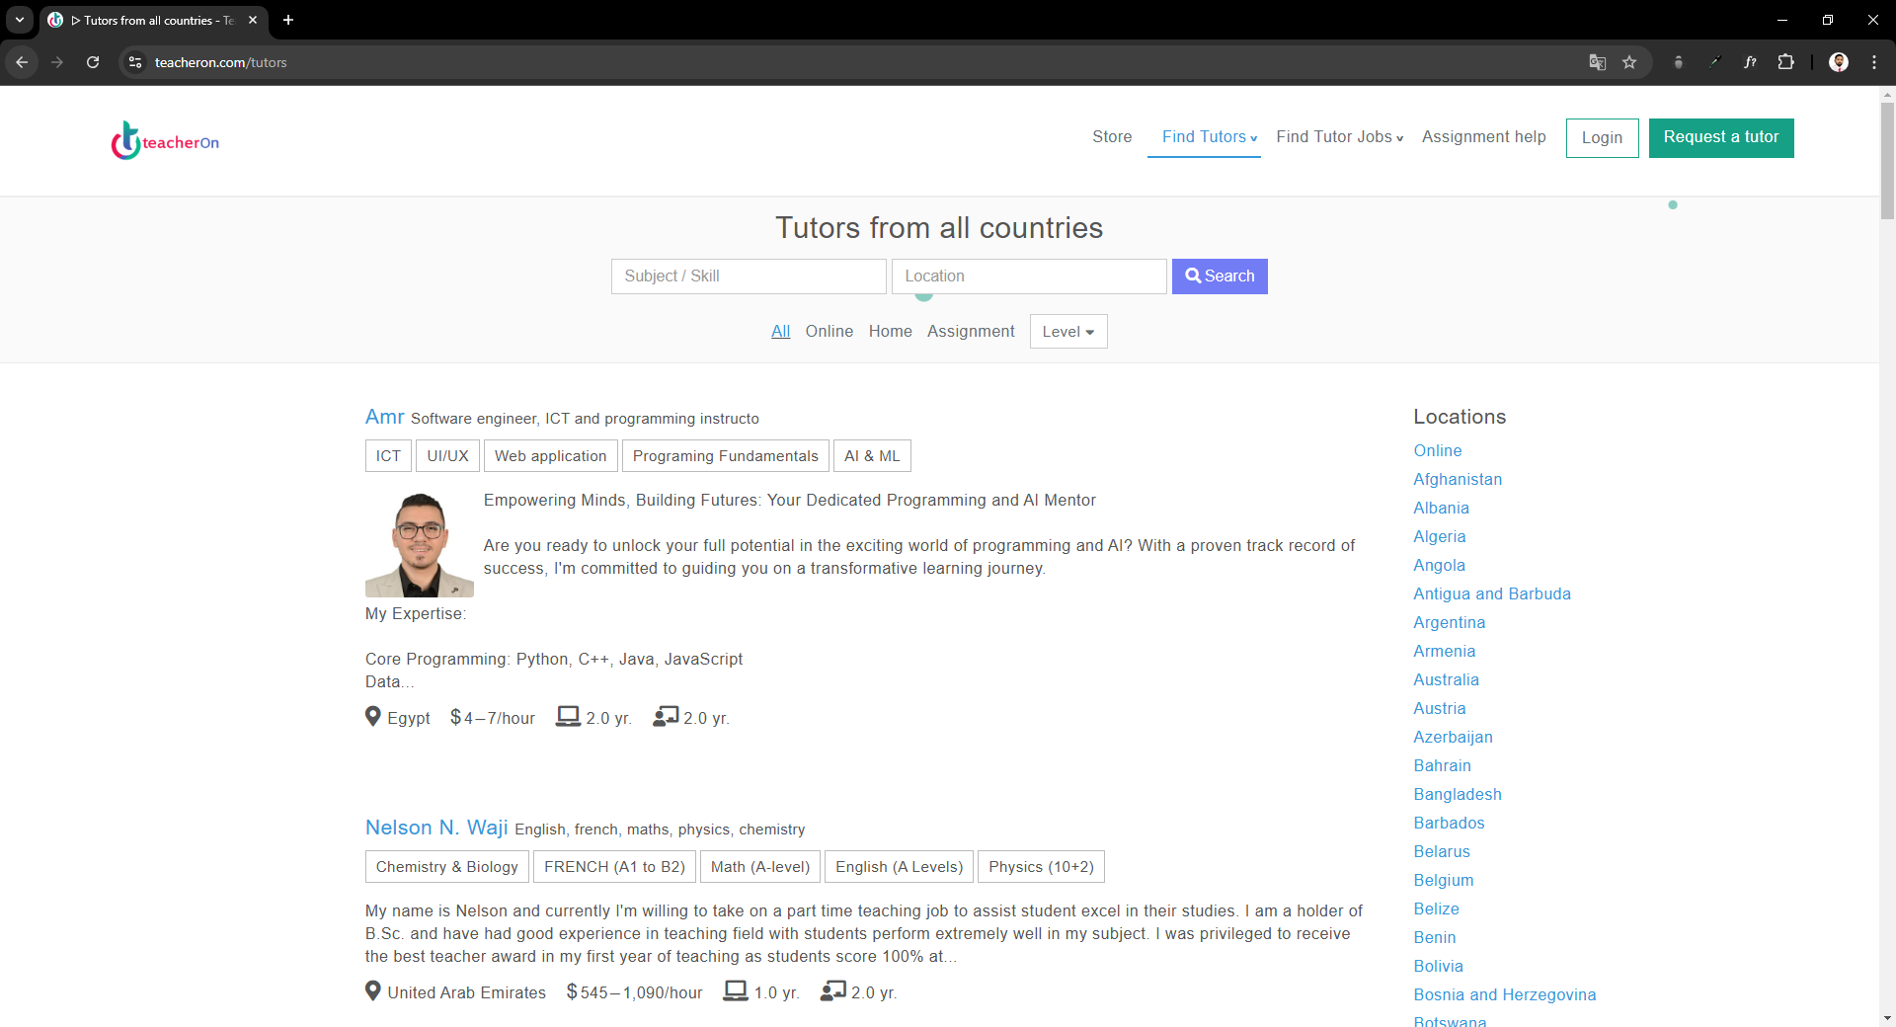

Figure 7: TeacherOn Lecturer Details Page

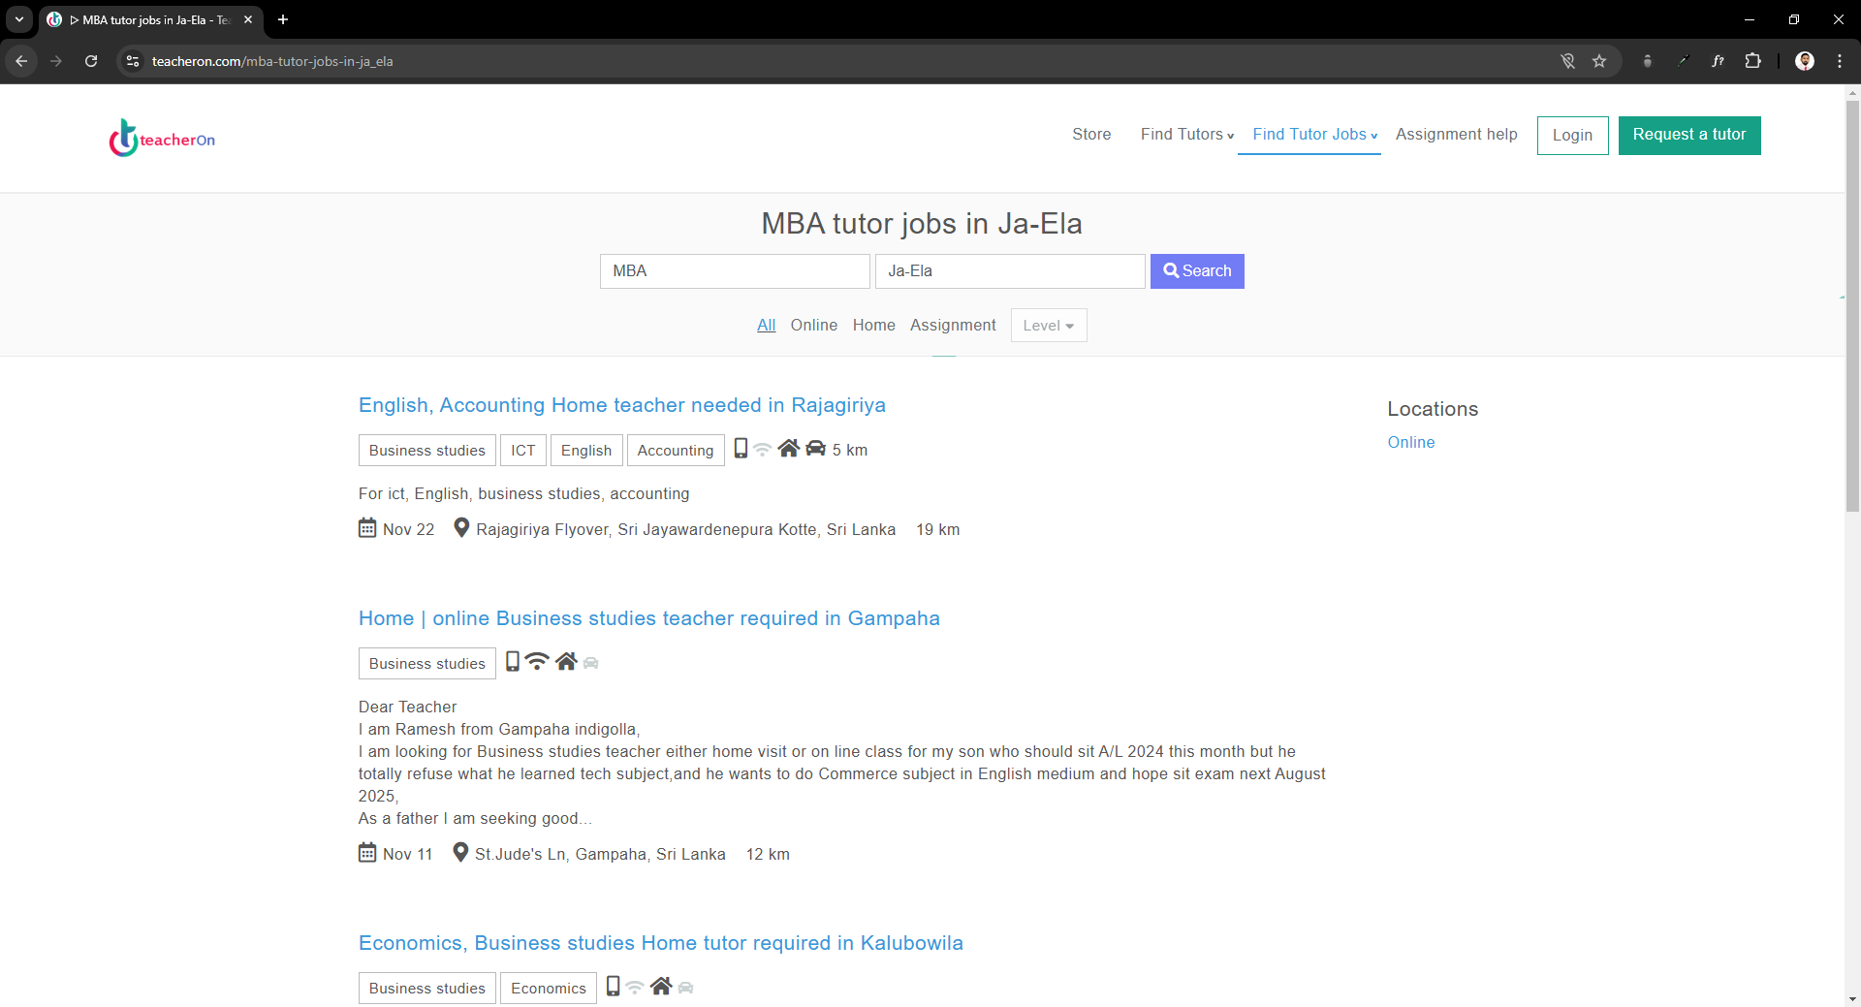

Figure 8: TeacherOn find jobs page

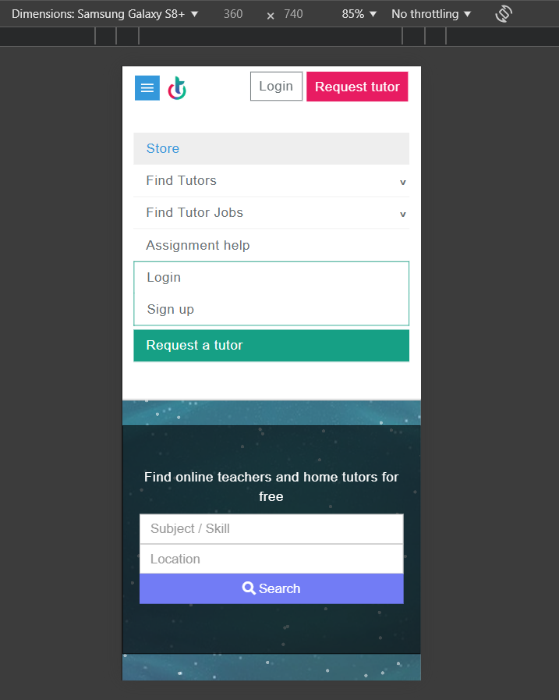

Figure 9: TeacherOn Mobile view

### LinkedIn

LinkedIn is a global professional networking platform that connects individuals, businesses, and organizations across industries. It offers functionality for job searches, professional branding, and networking. (Claybaugh, 2013) Users can create detailed profiles showcasing their skills, experience, and achievements as shown in figure 11. Can be used to source lecturing talent as well as to find lecturing job opportunities.

LinkedIn, while a powerful global platform, has several limitations when considered for the specific needs of the Sri Lankan academic industry. First, it is not tailored to a specific country like Sri Lanka, which affects its ability to address local academic requirements and institutional practices effectively. Secondly, LinkedIn is a general-purpose professional networking site and is not specialized for the academic sector, missing critical features like academic workload management or subject-specific matchmaking for lecturers and institutes. Lastly, Sri Lankan academic institutions have no control over making suggestions to LinkedIn's matchmaking algorithm, and get it customized to address their unique, evolving needs. These weaknesses, highlights the need for a specialized platform designed to address the Sri Lankas's academic challenges and institutional requirements.

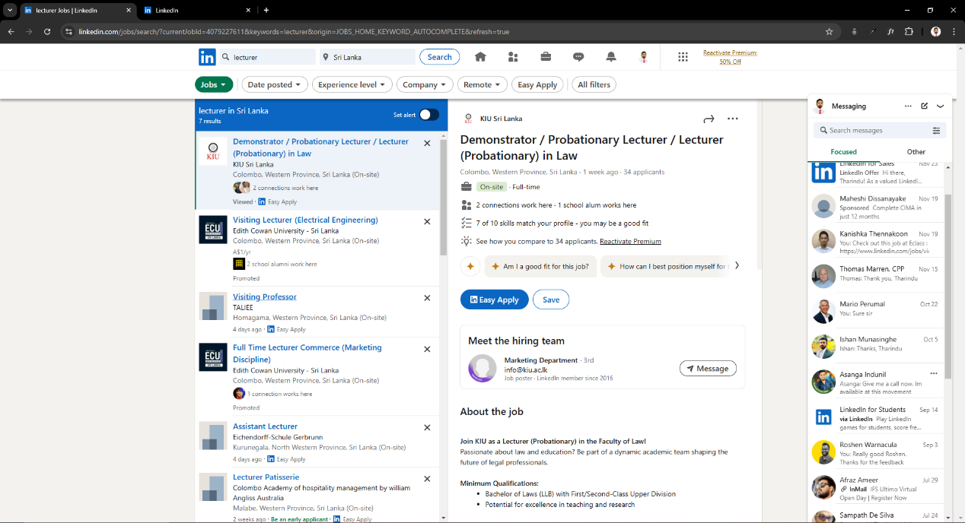

Figure 10: LinkedIn Job Search

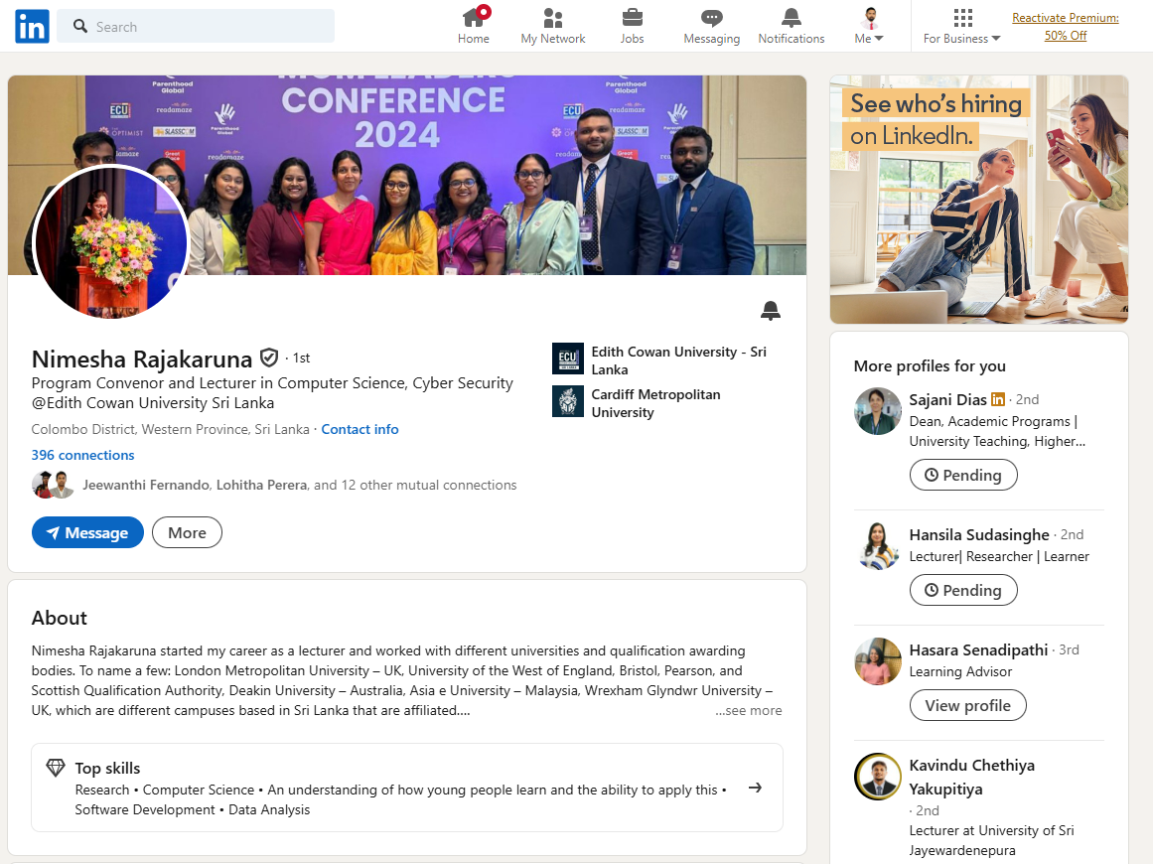

Figure 11:LinkedIn lecturer profile

### Fiverr

Fiverr is a global freelancing platform that connects service providers known as sellers, with clients or buyers, offering a wide variety of services through gigs. (Green, 2018) These gigs range across categories like digital marketing, graphic design, writing, programming, consulting and lecturing.

Fiverr, enables easy navigation for both sellers and buyers. Sellers can create detailed profiles and offer services with clear pricing and descriptions, while buyers can search and filter gigs based on categories, ratings, or keywords. The platform also supports multimedia gig presentations, including images and videos.

Although Fiverr is a popular global freelancing platform, it has limitations when applied to academic matchmaking in Sri Lanka. It is not specialized for a specific country like Sri Lanka, which limits its ability to cater to local academic institutions and regional challenges. Additionally, Fiverr is designed for general freelancing services and lacks features tailored to the academic industry, such as matching lecturers with institutions based on subject expertise, qualifications, or institutional needs. These weaknesses make Fiverr unsuitable for addressing the specific demands of academic institutions in Sri Lanka, emphasizing the need for a more focused and locally relevant solution.

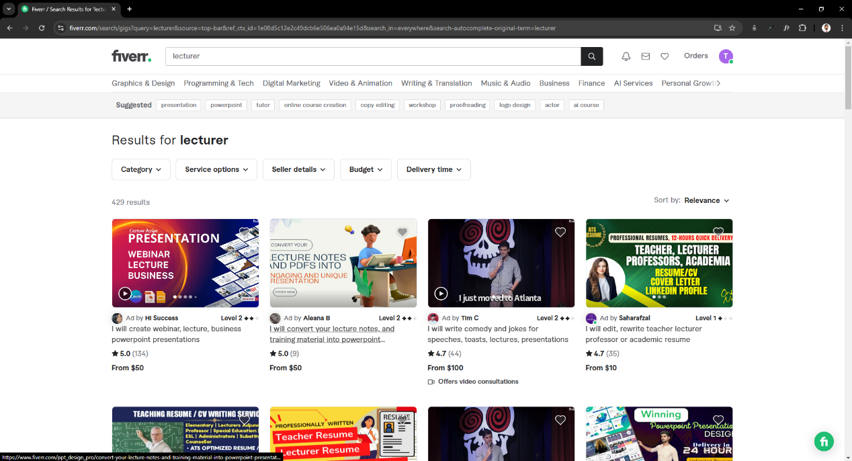

Figure 12: Fiver Landing Page

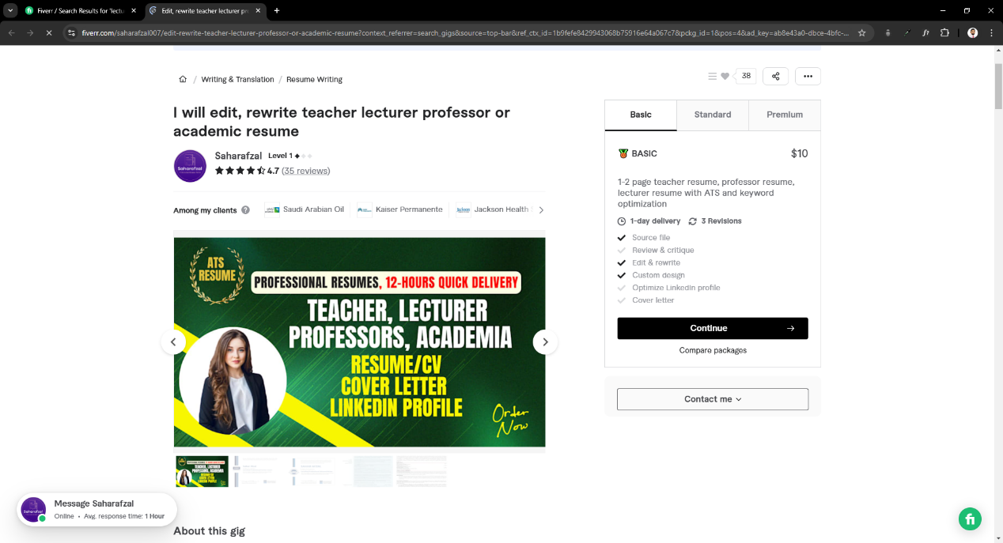

Figure 13: Fiverr gig of a lecturer

### Necessity of a specialized match making platform

As shown in figure 14, the limitations of existing platforms like Find a Teacher (FAT), TeacherOn, LinkedIn, and Fiverr, there is a clear need for a specialized matchmaking platform tailored to Sri Lanka's academic sector. It would address local requirements, provide targeted features for connecting lecturers with institutions, and incorporate customizable algorithms to meet evolving educational demands.

|  |  |
| --- | --- |
| Existing Platform | Limitation |
| Find a Teacher (FAT) | * Does not provide a specialized match making tool. * Interface is simple but lacks user experience. * More focus is given to advertisement display rather than user services. * Application device responsiveness has weaknesses. |
| TeacherOn | * It is not specialized to a specific country, such as Sri Lanka. * Does not provide specialized match making tool. * UI is not attractive. |
| LinkedIn | * Match making algorithm cannot be customized as per the needs of Sri Lankan academic institutes. * Not specialized to Sri Lanka. * Not specialized on academic industry. |
| Fiverr | * Not specialized to Sri Lanka. * Not specialized on academic industry. |

Figure 14: Limitations of Existing platforms

## Research topics

Similar Research Topics focus on studies and applications related to academic recruitment, workload management, educational quality analysis, and software solutions for matchmaking and optimization. These topics provide valuable insights for designing and implementing this software project.

Therefore, additional research must be done on undermentioned topics,

### Academic recruitment procedure

Researching how academic institutions recruit lecturing professionals is critical to align the platform's functionalities with standard practices. This includes job posting methods, selection criteria, and evaluation processes.

### Key qualities and competencies that academic institutions seek in lecturing professionals

Identifying the skills and qualifications institutions prioritize, such as subject expertise, teaching experience, and certifications, ensures the platform finds accurate matches.

### Employer employee match making algorithms

Exploring algorithms used in similar platforms such as LinkedIn, Fiverr will help design an algorithm to connect lecturers and institutes efficiently based on lecture qualifications and subject requirements. (Zhang, 2022)

A widely used algorithm in the recruitment industry for employer-employee matchmaking is the Gale-Shapley algorithm or Stable Matching algorithm. Initially developed for solving the "stable marriage problem," this algorithm ensures that all pairings between employers and employees are stable, meaning no employer-employee pair would prefer each other over their current matches. (Mendoza, 2022)

In recruitment industry, this algorithm is adapted to match job seekers and job openings based on mutual preferences. Employers rank candidates based on qualifications, skills, and experience, while candidates rank jobs based on factors like salary, location, and growth opportunities. The algorithm iteratively matches employers and employees, optimizing for preferences while ensuring no better pairings exist.

### Methodologies used to analyze educational quality of an institute

Understanding techniques for evaluating academic delivery quality, such as student feedback and peer reviews, will help to assess platform effectiveness. Same information can be used as a marketing tool for the application. (Madani, 2019)

### Methodologies used to measure workload on academic staff

Investigating tools to quantify and analyze academic staff workload helps to measure the impact of this software application in preventing burnout of inhouse academic staff’s effort.

### Java Spring and React full-stack development life cycle

Researching the lifecycle of building web applications with Java Spring Boot and React ensures seamless implementation of backend, frontend, and integrations.

### How to use Firebase to enhance a web application

Learning Firebase's capabilities, such as secure file storage and authentication, ensures enhanced functionality and scalability for the platform.

### Best practices in prompt engineering to take the best out of generative AI

Studying how to craft effective prompts for generative AI ensures optimized interactions and support features for users through AI-driven solutions. (Work Life by Atlassian, 2024)

# Initial list of requirements

The Initial List of Requirements provides a foundational overview of the system's needs, organized to ensure clarity and comprehensive coverage. These requirements will be divided into key categories: functional (detailing core system operations), non-functional (focusing on performance and scalability), user interface (addressing design and usability), and classifications such as essential, desirable, and luxury features. This categorization helps prioritize development efforts, ensuring critical functionalities are addressed while leaving room for enhancements. The structured approach aims to capture all stakeholder expectations, laying the groundwork for a robust and user-centric solution.

## Functional

|  |  |  |
| --- | --- | --- |
| **User** | **Classification** | **Requirement** |
| Institute | Essential | Register to LectureLink |
| Login to LectureLink |
| Subscribe to LectureLink |
| Create profile/institute |
| Add programs, subjects |
| Update institute, program, subject |
| Delete institute, program, subject |
| Get Lecturer, qualifications |
| Get All Lecturers, all qualifications |
| Smart match subject with lecturer |
| Assign Lecturer to a Subject |
| Desirable | Track subject progress |
| Add institute, program, subject via CSV |
| Search Lecturer by keyword |
| Get sorted lecturers |
| Luxury | Give review to Lecturer |
| Validate Lecturer using NID |
| Make Payment to Lecturer |

Table 1: Functional requirements for Institute

|  |  |  |
| --- | --- | --- |
| **User** | **Classification** | **Requirement** |
| Visiting Lecturer | Essential | Register to LectureLink |
| Login to LectureLink |
| Subscribe to LectureLink |
| Create profile / Lecturer |
| Add qualifications |
| Update Lecturer, qualifications |
| Delete Lecturer, qualifications |
| Get institute, program, subject |
| Get all institute, all program, all subject |
| Desirable | Mark interest to a Subject |
| Search Subjects by key word |
| Get sorted subjects |
| Luxury | Give review to institute |
| Validate Institute via UGC |

Table 2: Functional requirement for visiting lecturer

## Non-Functional

|  |  |
| --- | --- |
| **Classification** | **Requirement** |
| Essential | Enable Device responsiveness |
| Desirable | Re-Write the application in Flutter |
| Luxury | Re-Write the application in IOS |
| Integrate an AI chat bot for customer assistance |

Table 3: Non-Functional Requirements

## User Interface Requirements

|  |  |
| --- | --- |
| **Classification** | **Requirement** |
| Essential | Create an OAuth authentication login page |
| Add breadcrumbs to each page |
| Add tooltips to each functionality |
| Add confirmation dialog boxes before performing critical operations |
| Desirable | Add dark and light color schemes based on system color scheme |

Table 4: User Interface Requirements

## Requirement gathering

Requirement gathering for this research will be conducted using questionnaires and formal interviews. Questionnaires will gather quantitative data from a larger sample, while formal interviews will provide in-depth qualitative insights. These methods will help identify the key challenges faced by academic institutions and lecturers in Sri Lanka.

### Questionnaire

Questionnaires will be used in this project to gather detailed requirements from both academic institutions and lecturers. They allow for standardized data collection, providing insights into the needs, challenges, and expectations of both parties. By capturing a wide range of responses, questionnaires will help in designing a platform that addresses the core issues faced by both groups. Here are five key points to include:

* Lecturer Availability and Expertise: Questions will focus on the types of subjects lecturers are available to teach, their qualifications, professional experience, and preferred working hours. This helps identify the pool of qualified professionals available for different academic disciplines.
* Recruitment Challenges for Institutions: Institutions will be asked about the difficulties they face in sourcing qualified lecturers, such as lack of expertise in specific subjects, limited availability, and the challenge of balancing full-time staff with industry-experienced professionals.
* Platform Feature Expectations: Both lecturers and institutions will be asked about their expectations from a platform, such as ease of use, filtering, searching, validating and payment methods.
* Impact on Teaching Quality: Questions will explore how lecturer workload and qualifications influence educational outcomes, and how a platform might help improve teaching quality.
* Technological and Adoption Barriers: The questionnaire will investigate potential obstacles in adopting the platform, such as technological limitations, concerns over usability, or reluctance from institutions or lecturers to engage with new systems.

### Formal Interviews

Formal interviews will be an essential tool for gathering in-depth qualitative insights from both academic institutions and lecturers, providing a more nuanced understanding of their needs, challenges, and expectations. While questionnaires collect broad data, interviews offer the opportunity for open-ended discussions that can reveal complex issues and provide detailed context. Here are three key points to include in the interviews:

* In-depth Challenges in Lecturer Recruitment: Interviews with institutional administrators will explore the specific challenges they face in recruiting qualified lecturers, such as difficulty finding professionals with both academic credentials and industry experience. This can uncover deeper issues such as competition with other institutions, financial constraints, or the limitations of existing recruitment channels.
* Lecturer Workload and Impact on Quality: Interviews with lecturers will focus on understanding their workload, including how overutilization affects their teaching quality and job satisfaction. This allows for identifying pain points that the platform can address, such as providing more flexible working arrangements or helping them balance teaching with industry commitments.
* Platform Usability and Features: Both lecturers and institutions will be asked about their expectations for the platform, delving into desired features like ease of scheduling, payment systems, communication tools, and customization options. These insights will directly inform platform design, ensuring it meets the practical needs of users.

# Tools and skills

## Software Tools

Software tools like Java, Spring Boot, MySQL, React, and TypeScript are essential for building scalable, secure, and interactive applications. Git ensures version control, while Node.js and NPM manage dependencies. Tools like SCSS and HTML refine front-end development, and APIs enable seamless data interaction across services.

|  |  |
| --- | --- |
| **Risks** | **Mitigation Strategies** |
| Access issues to proprietary software or paid versions. | Use open-source alternatives or free-tier versions like PostgreSQL for MySQL or React alternatives like Vue.js. |
| Compatibility issues with system configurations. | Maintain system updates and compatibility checks. |
| Lack of familiarity with some tools. | Undergo training sessions or tutorials for less familiar tools. |

Table 5: Risks and Mitigation for Software Tools

## Hardware Tools

High-performance hardware, including 16GB RAM, an 11th Gen Intel® Core™ i5 Processor, and a 64-bit system, supports efficient coding, testing, and debugging. These specifications ensure smooth handling of complex processes like database operations and API simulations.

|  |  |
| --- | --- |
| **Risks** | **Mitigation Strategies** |
| Insufficient hardware specifications for intensive tasks like database testing or API load simulations. | Utilize cloud computing services (e.g., AWS or Azure) to offload resource-intensive tasks. |
| Hardware failures or system crashes. | Regular hardware maintenance and backups. |

Table 6: Risks and Mitigation for Hardware Tools

## Other Skills

Diagramming tools like Draw.io simplify the representation of system workflows (e.g., Use case diagram, Sequence Diagram, Class Diagram, Activities Diagram and Architecture). Canva visual suite enhances visualizations like wireframes, UI /UX designs ensuring effective communication of design concepts among stakeholders and developers.

|  |  |
| --- | --- |
| **Risks** | **Mitigation Strategies** |
| Difficulty accessing online tools due to internet connectivity or restrictions. | Download offline versions or use alternative tools like Microsoft Visio or Figma. |
| Limited features in free versions of tools. | Combine several free services together and get the desired result. |

Table 7: Risks and Mitigation for Other Skills and Tools

# Challenges

Challenges are inherent in developing innovative systems, encompassing technical, operational, and user-specific obstacles that require strategic solutions to ensure success. Mentioned below are the challenges identified for this software project.

## Legal Challenges

* The system must comply with data privacy regulations like GDPR or local equivalents when storing and managing user information.
* Intellectual property laws must be adhered to, avoiding unauthorized use of third-party code or tools.
* Employment laws could pose challenges in structuring contracts or relationships between lecturers and institutions.

## Social Challenges

* Cultural differences across user demographics may impact expectations and usage patterns of the platform.
* Some institutions or lecturers may resist adopting the platform due to a preference for traditional methods.
* Users might misuse the platform, leading to fraudulent activities or fake accounts.

## Ethical Challenges

* Matchmaking algorithms must be carefully designed to avoid biases or favoritism in recommendations.
* The project must prevent data exploitation, ensuring user information is not used for profit without consent.
* Ensuring ratings and reviews are authentic and unbiased is critical for platform credibility.
* The platform must manage workloads fairly to avoid overburdening users.

## Financial Challenges

* Budget constraints might limit the scope of development, testing, and scaling the platform.
* Designing a sustainable revenue model, such as subscription fees, could be challenging to implement.
* Dependence on funding sources poses risks if investors withdraw or funding falls short.
* Convincing users to pay for premium features may be difficult, especially in competitive markets.

## Technical Challenges

* Scaling the system to handle growing user numbers and data volume without degrading performance is essential.
* Minimizing downtime is crucial to provide reliable service to users.
* Integrating third-party APIs and external services seamlessly can introduce compatibility issues.
* Robust cybersecurity measures are needed to protect the platform from data breaches and cyberattacks.

# Project timeline

Figure 15: Gantt chart

|  |  |
| --- | --- |
| **Milestone** | **Dead line** |
| Submission of project topic and supervisor selection from | 14 Nov 2024 |
| Submission of project proposal and ethics form | 9 Dec 2024 |
| Submission of SRS | 16 Jan 2025 |
| Submission of final report draft | 2 Apr 2025 |
| Submission of Final report, software, video submission | 28 Apr 2025 |

Table 8: Project milestones and deadlines

# References

Ariyawansa, R., 2013. Employability of Graduates of Sri Lankan Universities. *Sri Lankan Journal of Human Resource Management,* Volume 2.

Asian Development Bank, 2016. *Innovative strategies in higher education for accelerated human resource development in South Asia,* Mandaluyong City: s.n.

Claybaugh, C., 2013. Understanding Professional Connections in Linkedin — A Question of Trust. *Journal of Computer Information Systems,* Volume 54.

Green, D., 2018. Gig Economy and the Future of Work: A Fiverr.com Case Study. *Management and Economics Research Journal,* Volume 4.

Gunawardena, C., 2017. Improving the quality of university education in Sri Lanka: An Analysis of quality Assurance Agency council's Reviews. *Sri Lanka Journal of Social Sciences,* Volume 40.

Madani, R., 2019. Analysis of Educational Quality, a Goal of Education for All Policy. *Higher Education Studies,* Volume 9, p. 100.

Mendoza, A. a. B. L. a. C. D. M. a. D. R. a. A. V. a. R. R., 2022. Enhancement Of Gale-Shapley algorithm with imbalanced sets for hiring and job finding applications. *Indonesian Journal of Electrical Engineering and Computer Science,* Volume 27, p. 954.

Tharmaseelan, N., 2007. Tertiary Education in Sri Lanka: Issues and Challenges. *Bulgarian Journal of Science and Education Policy,* Volume 1.

Wickramasinghe, V., 2018. Higher education in state universities in Sri Lanka: Review of higher education since colonial past through international funding for development. *International Journal of Educational Management,* Volume 32.

Work Life by Atlassian, 2024. *Best practices for generating AI prompts.* [Online]   
Available at: https://www.atlassian.com/blog/announcements/best-practices-for-generating-ai-prompts  
[Accessed 5 December 2024].

Zhang, L., 2022. Examining perceptions towards hiring algorithms. *Technology in Society,* Volume 68.