Assignment 1

Micro-Kernal architecture

SE3030 - Software Architecture

|  |  |
| --- | --- |
| IT21030680 | De Costa M.T.N. |
| IT21270406 | Jayasinghe H.D.D.R. |
| IT21334238 | Sembakutti S.C. |
| IT21187100 | Jayawardana W.G.L.P. |

The members are from Group -Y3.S2.WE.SE.02.02

# Member contributions

|  |  |  |
| --- | --- | --- |
| IT21030680 | De Costa M.T.N. | Supplier Management |
| IT21270406 | Jayasinghe H.D.D.R. | Customer Management |
| IT21334238 | Sembakutti S.C. | Product Management |
| IT21187100 | Jayawardana W.G.L.P. | Employee Management |

# Introduction

This report details the application of a producer-consumer scenario within the OSGi (Open Service Gateway Initiative) framework. The central principle revolves around the producer's responsibility to generate and publish a service, while the consumer's role entails consuming and subscribing to said service.

The primary goal of this system is to manage the procedures PC store using four functions according to the publisher-subscriber design approach. The four functions are as follows,

* Customer management
* Product management
* Employee management
* Supplier management

The system was implemented in the Eclipse Enterprise IDE using OSGi framework and Java as the programming language.

Publisher bundles

1. Customer Publisher
2. Product Publisher
3. Employee Publisher
4. Supplier Publisher

Subscriber bundles

1. Customer Subscriber
2. Product Subscriber
3. Employee Subscriber
4. Supplier Subscriber

# Scenario

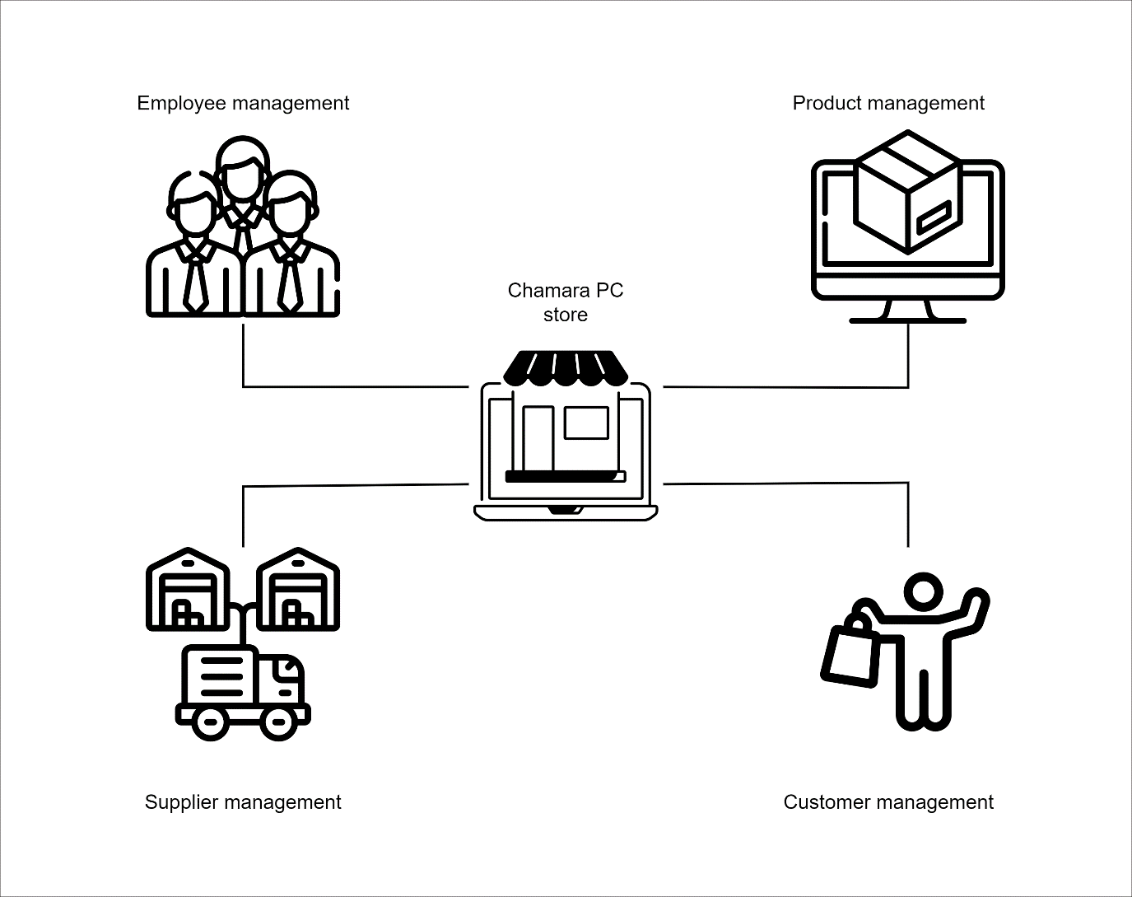

# Overall system

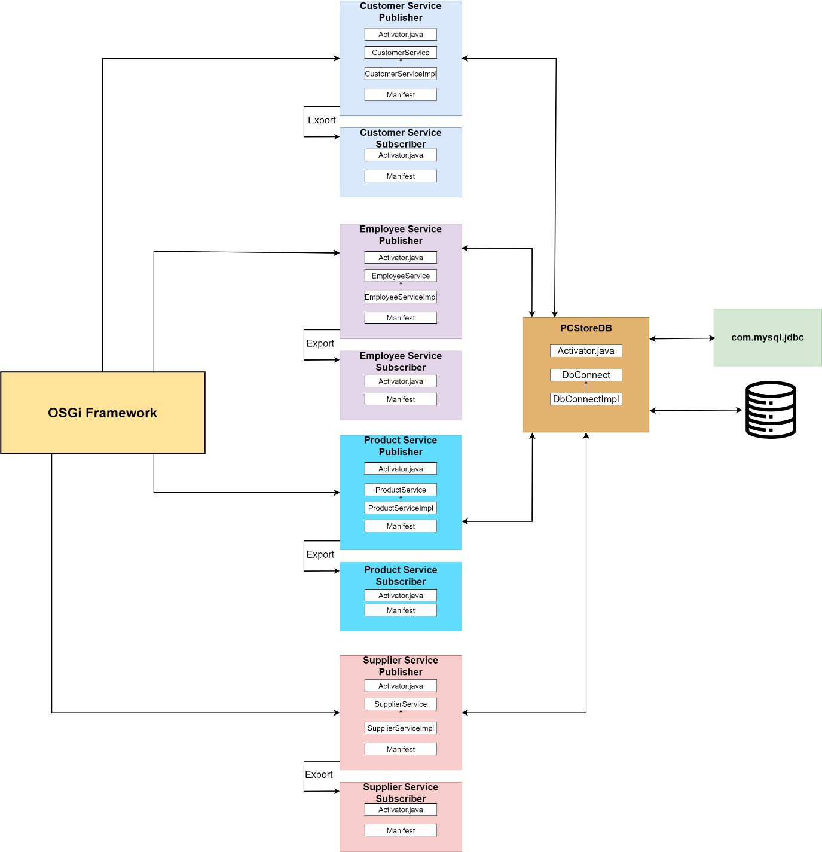

# Manifest implementations

## Customer service manifest

### Customer Subscriber

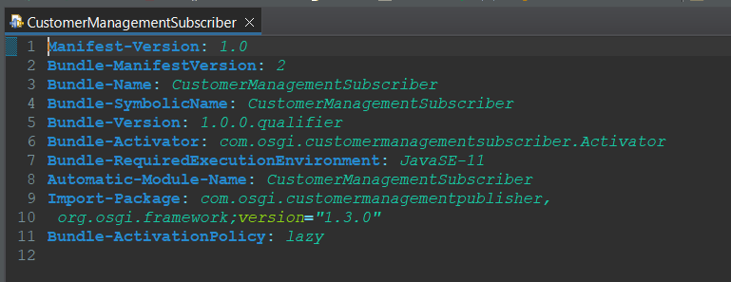

### Customer Publisher

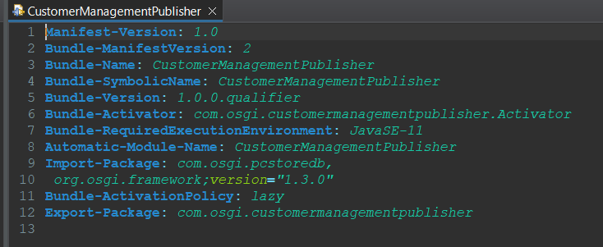

## Employee service manifest

### Employee Subscriber

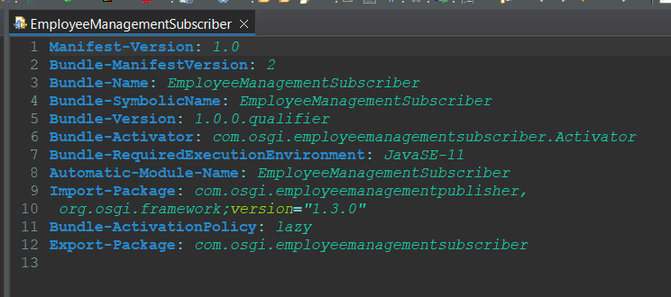

### Employee Publisher

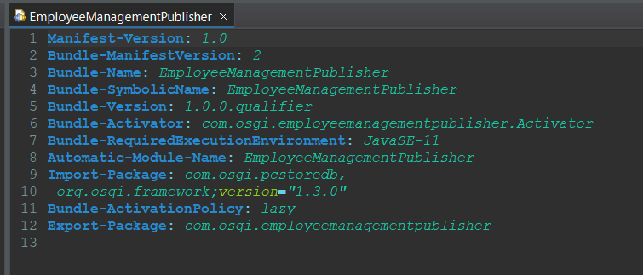

## Products service manifest

### Product Subscriber

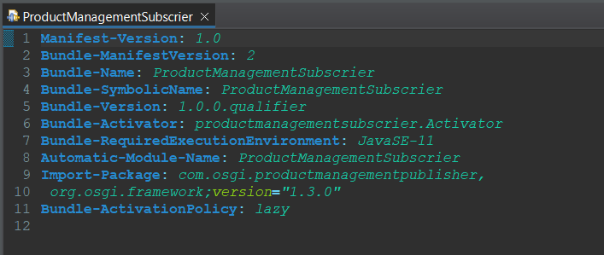

### Product Publisher

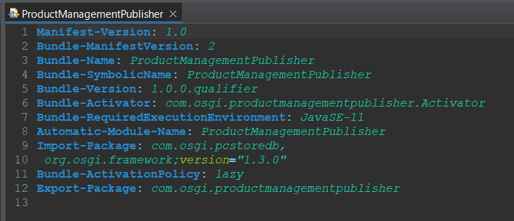

## Supplier service manifest

### Supplier Subscriber

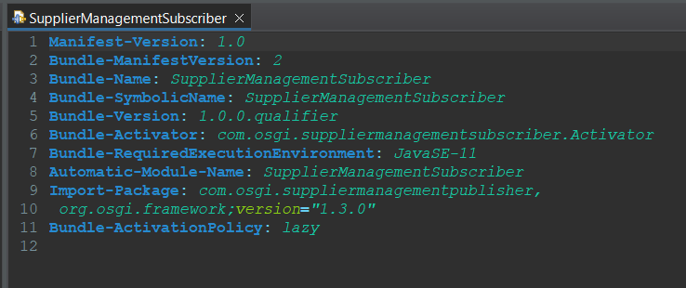

### Supplier Publisher

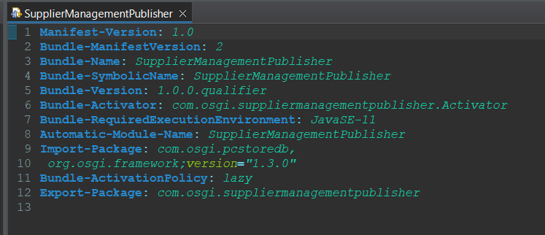

# Sample screenshots

## Customer

### Customer dashboard

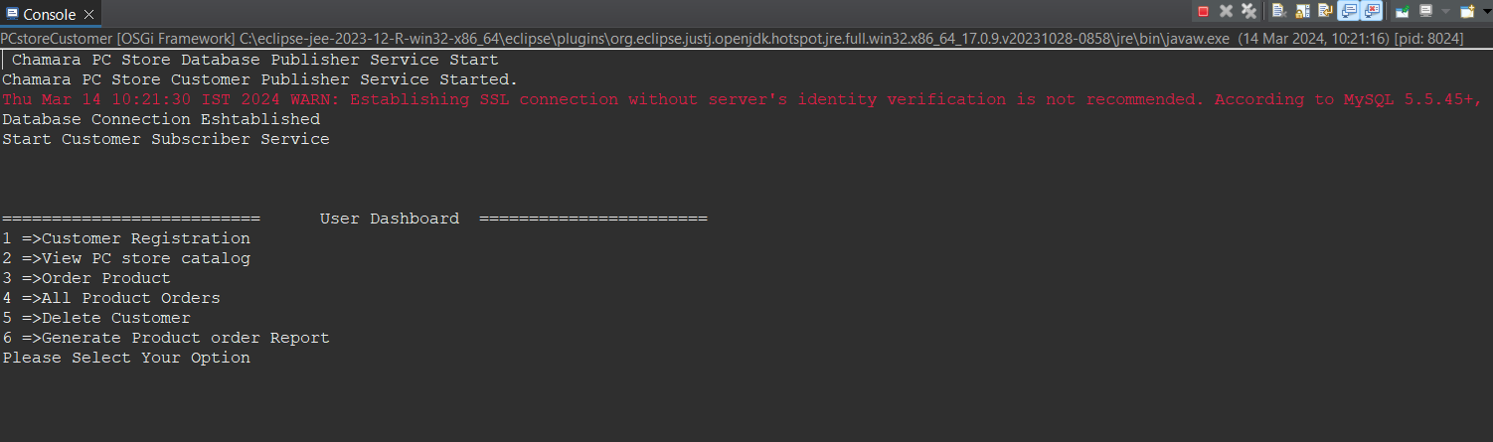

## Customer signUp

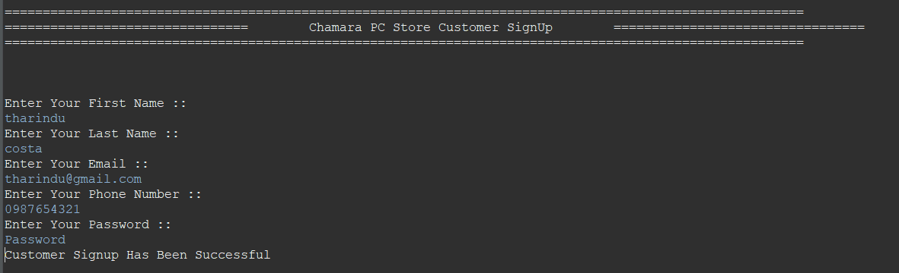

## Store product catalogue

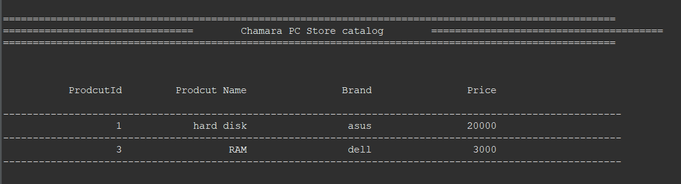

### Place order

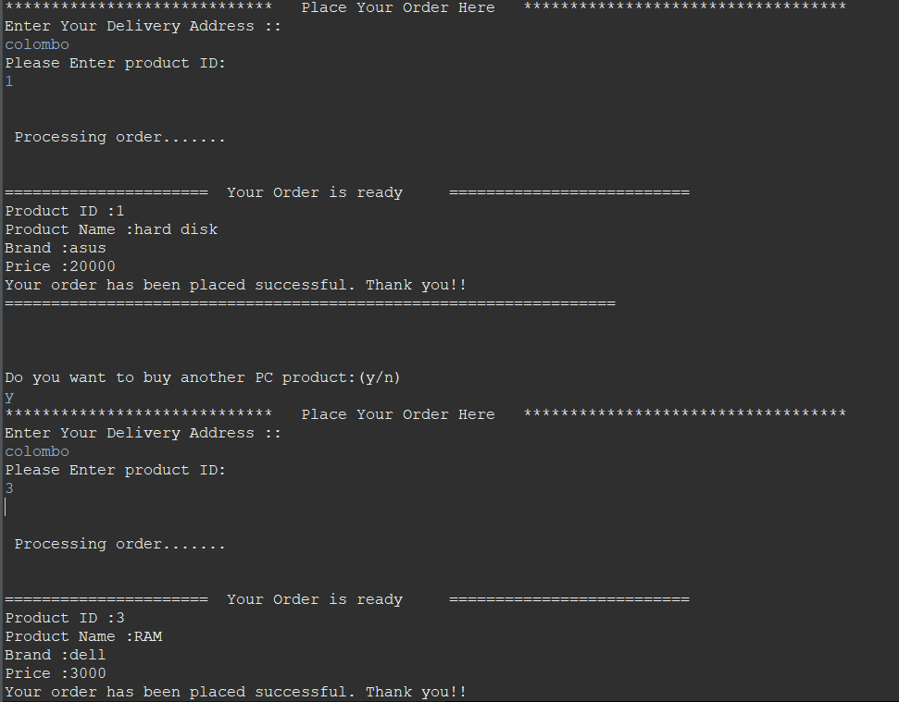

### All orders

### Remove customer

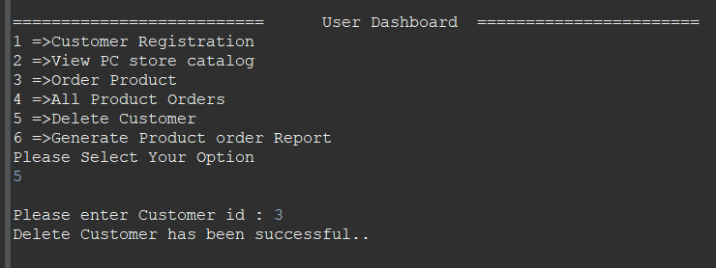

### Order Report

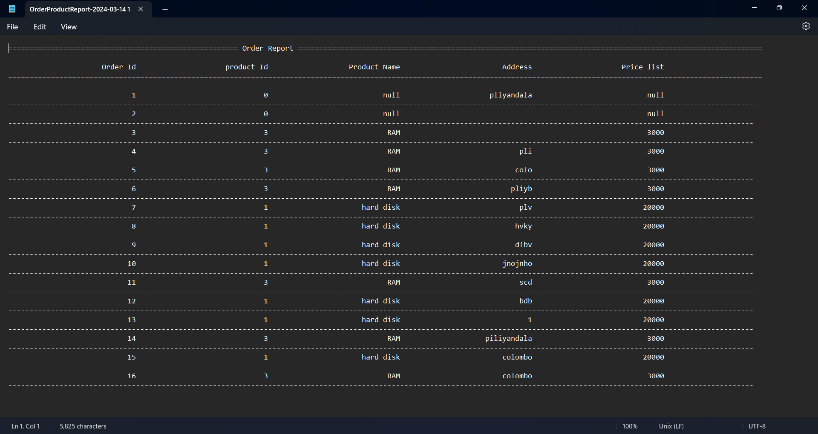

## Employee

### Employee dashboard

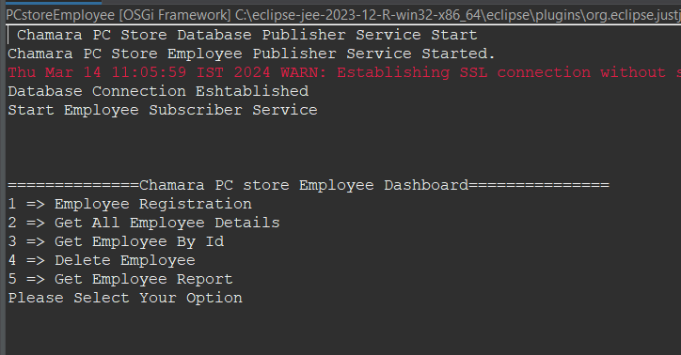

### Register employee

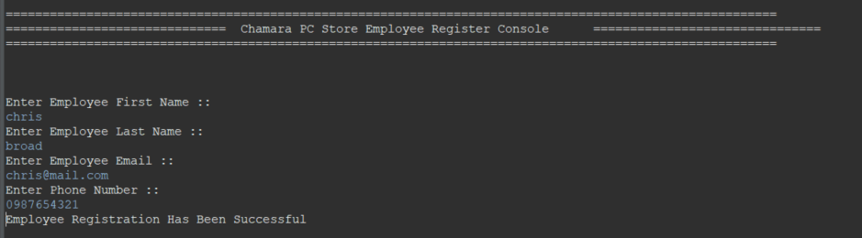

### All active employees

### Get Employee details

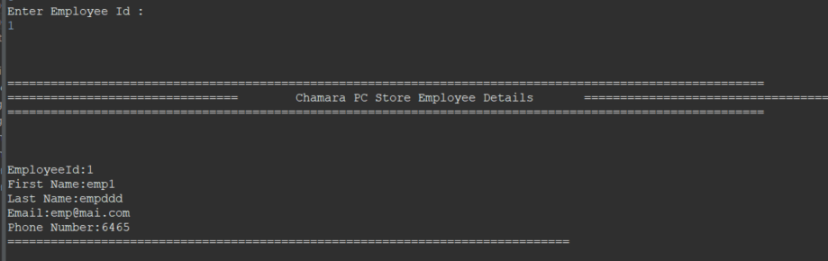

### Remove employee

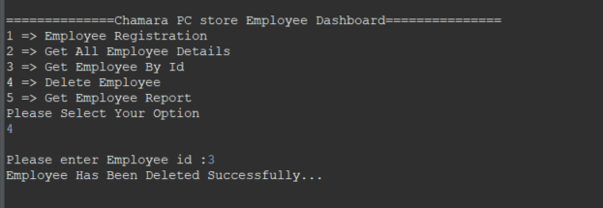

### Employee report

## Product

### Product dashboard

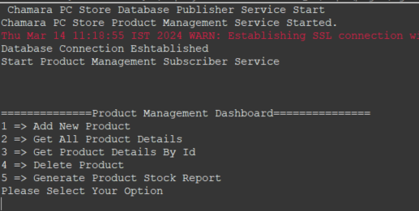

### Product register

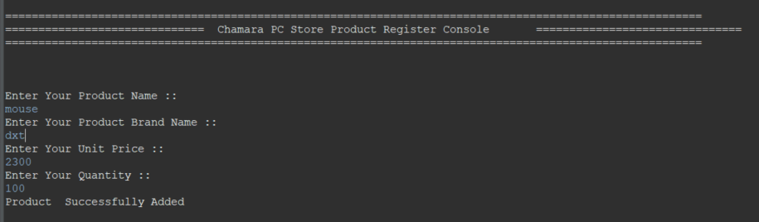

### Product catalogue

### Product details

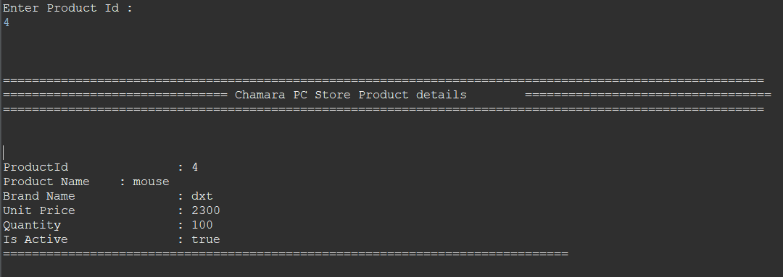

### Remove product

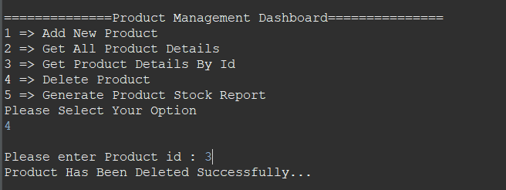

### Product stock report

## Supplier

### Supplier dashboard

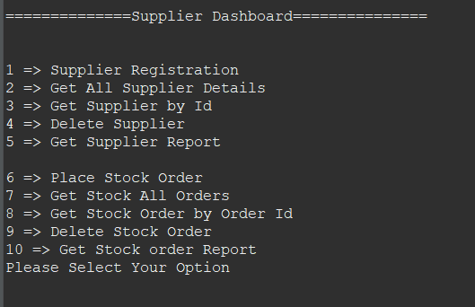

### Supplier register

### Supplier roster

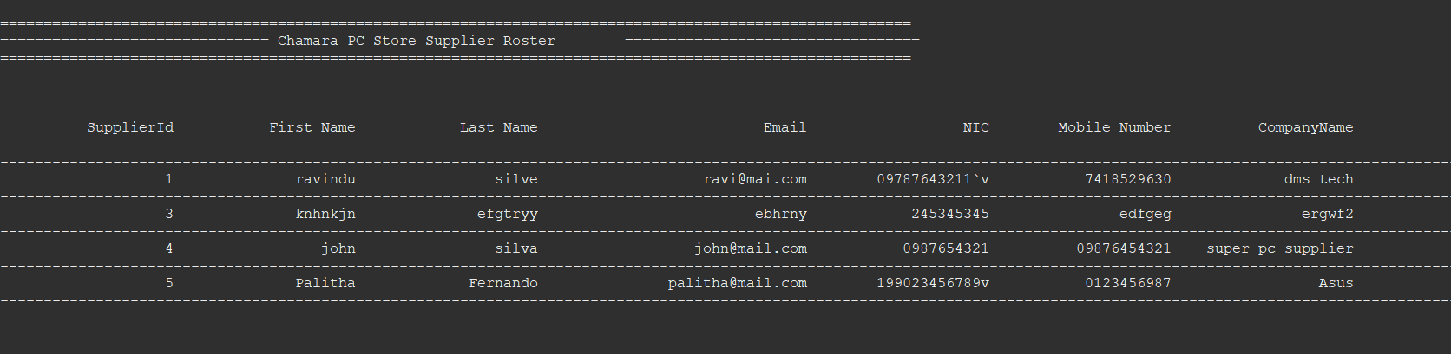

### Remove supplier

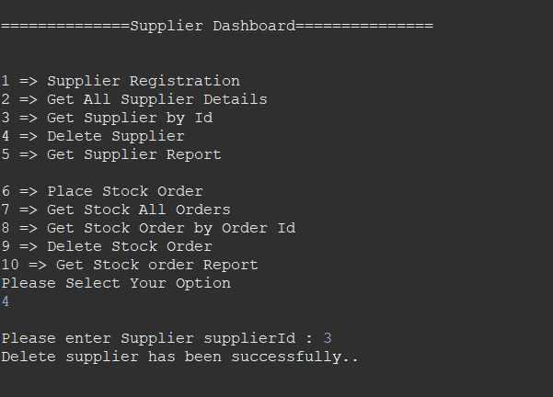

### Supplier report

### Place stock order

### All stock orders

### Stock order details

### Delete stock order

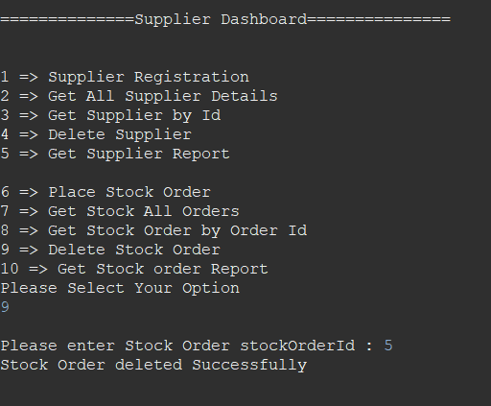

### Stock order report

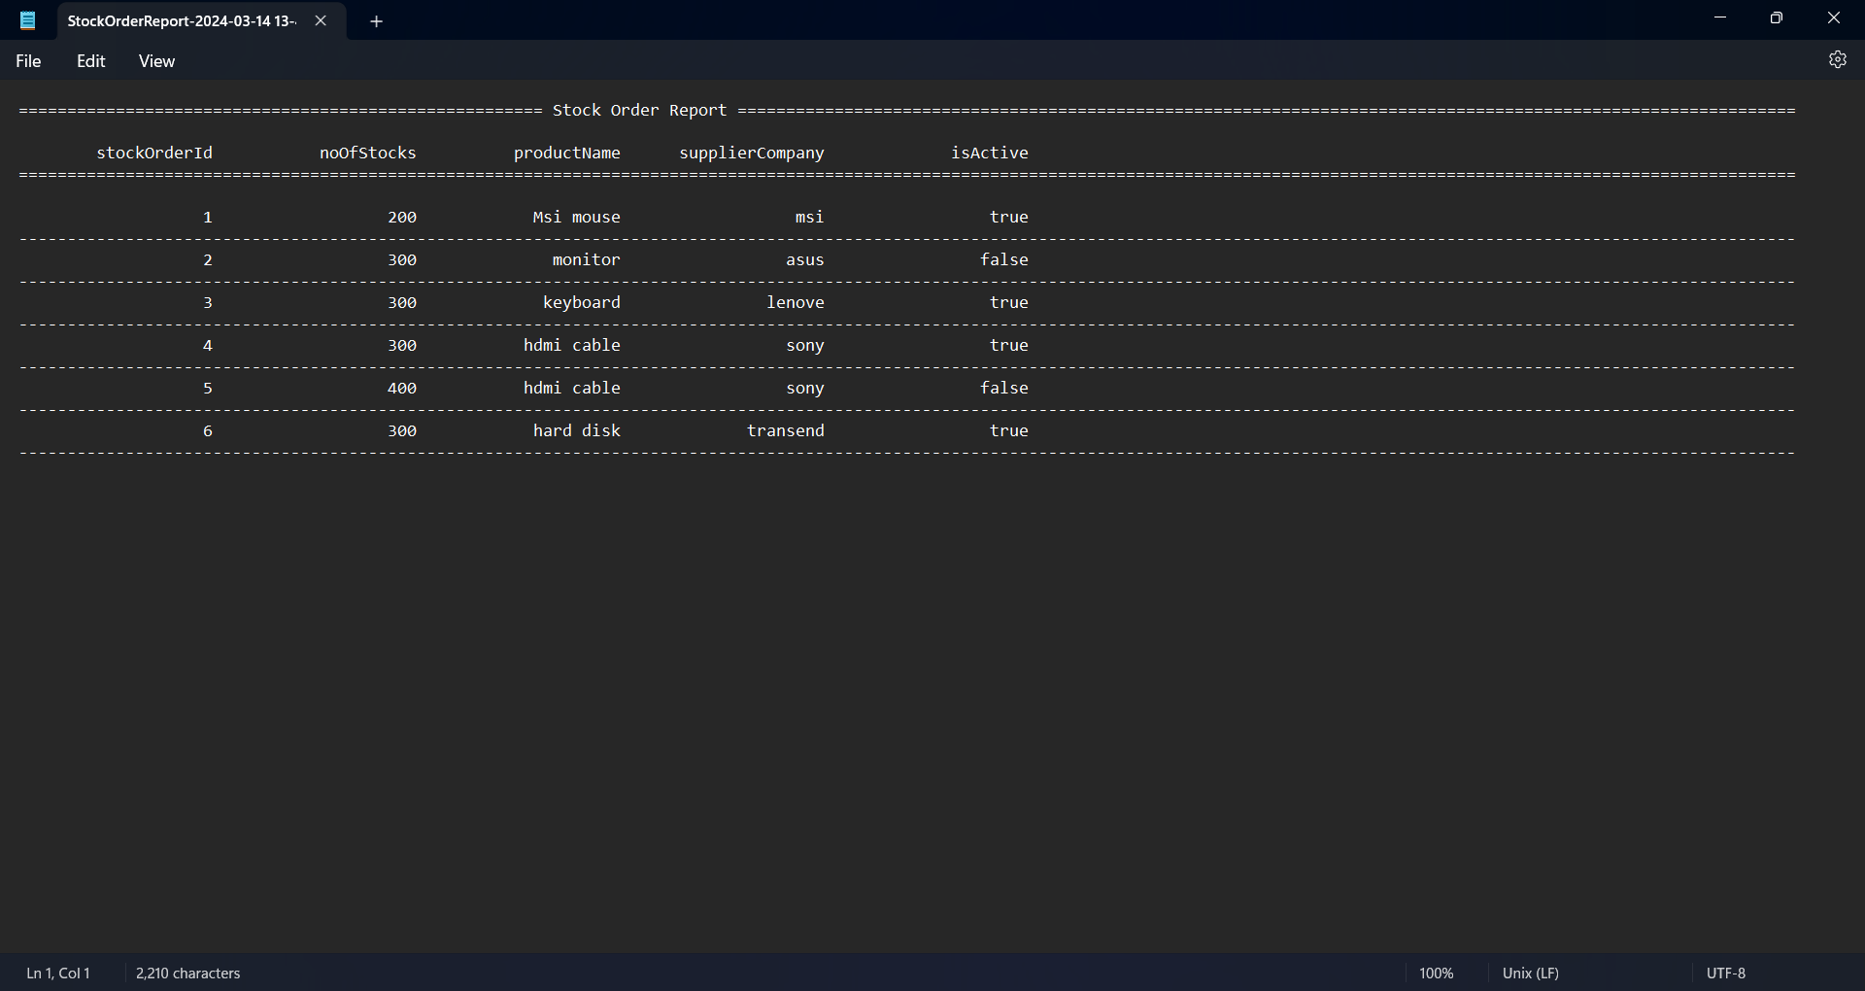

# Instructions

Step 1: Configure build path of PC store DB. To do so add mysql connector jar file to class path. Jar file will be provided.

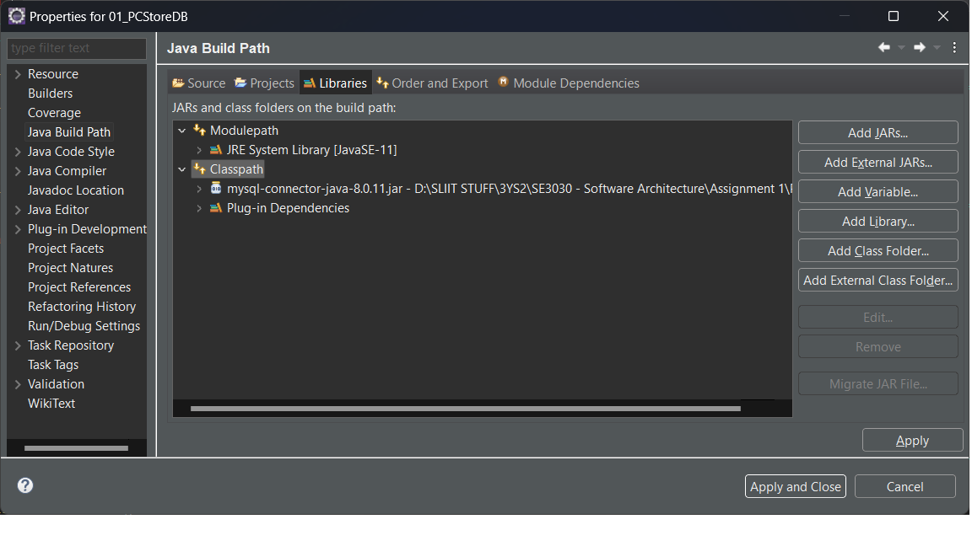

Step 2: Run the SQL commands that will be provided in mysql for the system to work

Step 3: Change the connection string in DBConnectImpl file in the “01_PCStoreDB” project according to your data base

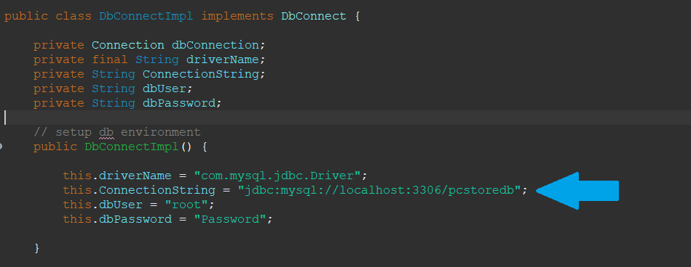

Step 4: Create OSGi framework run configurations. One configuration can be created for all four sections, but it would be easier to have four separate configurations for the four sections as shown below.

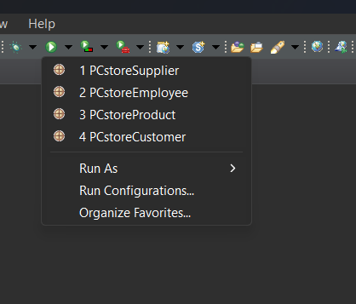

Customer Configuration

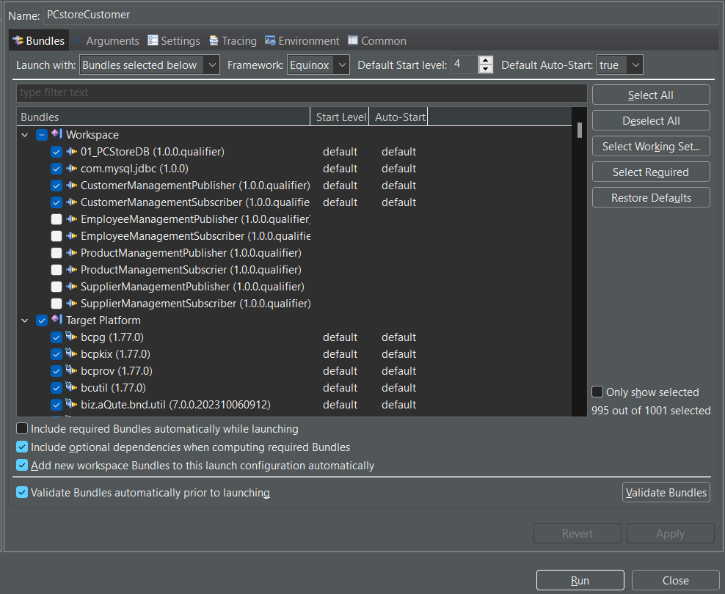

Employee configuration

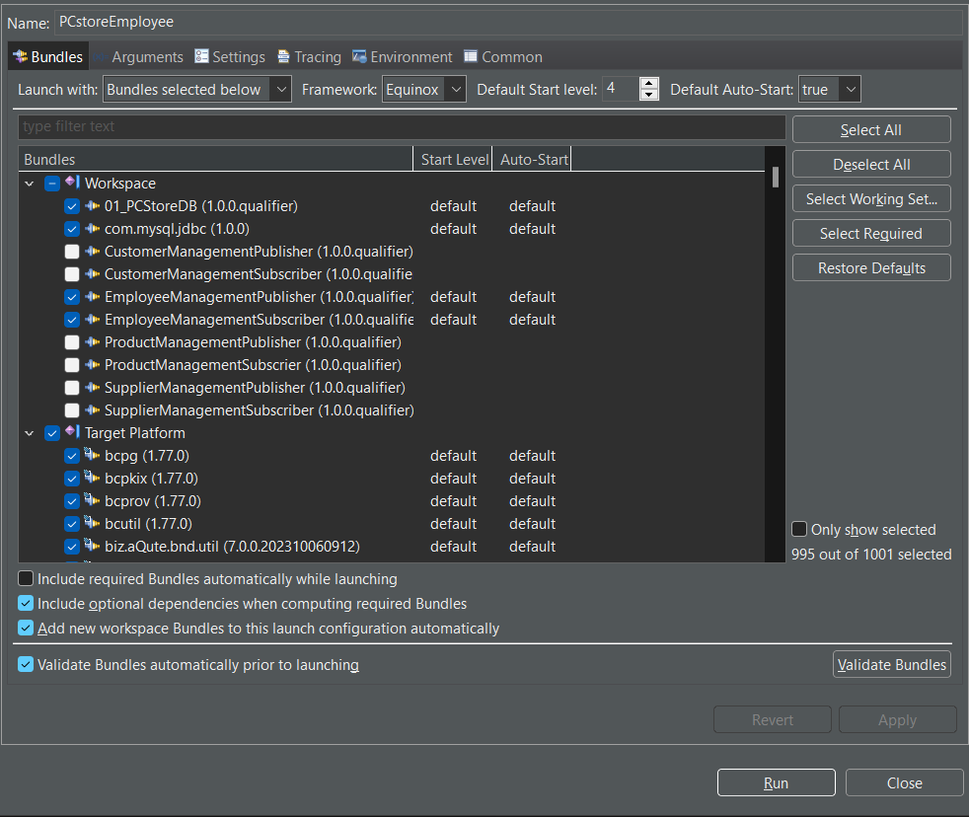

Product configuration

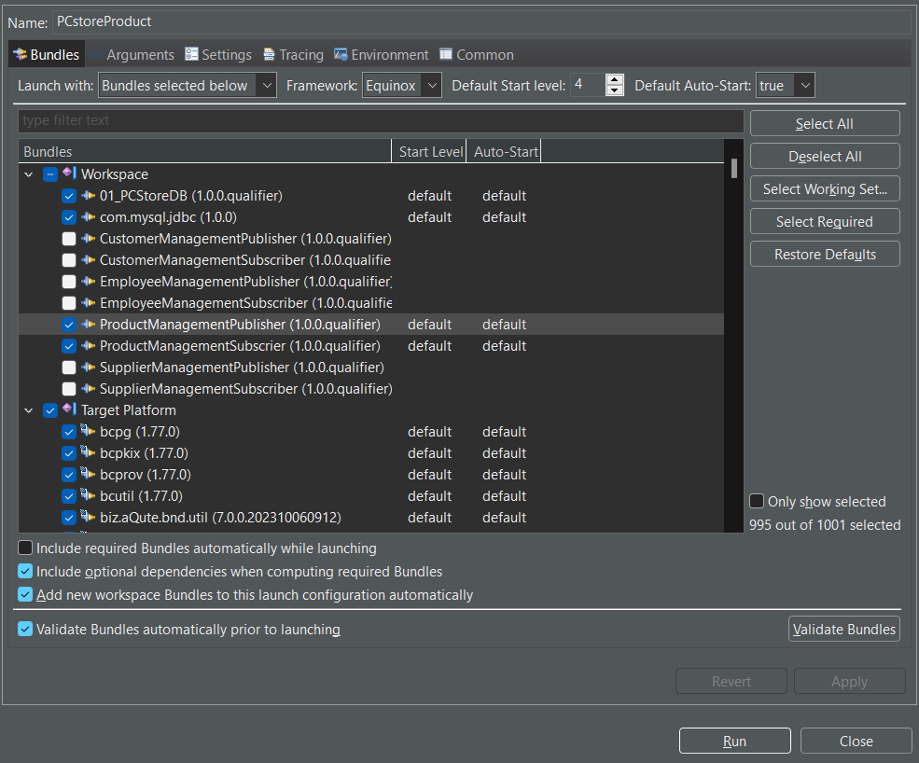

Supplier configuration

