Terraform made simple
Lanka Cinema project • Learning and interview guide
Let’s keep it simple. Learn one page at a time. Then explain it in your own words; no need to memorise everything today.

1 | Understand the basic idea
Terraform is an Infrastructure as Code tool. You describe the AWS setup in files. Terraform works out the changes and asks AWS to make them.
Think of a building plan: code describes what should exist. State records which AWS objects belong to the code. It is not a database backup.
Word | Simple meaning
Provider | Plugin that talks to AWS
Data source | Reads an existing object, such as an EC2 key pair
Variable / tfvars | An input / the values you give those inputs
Local / output | A value calculated in code / a result you can read
Workspace | A separate state for the same configuration

2 | Read one small piece of your code
Shortened extract from ecr.tf:
HCL / EXAMPLE
resource "aws_ecr_repository" "web" {
name = local.ecr_repository_name
}
resource means “manage this object”. aws_ecr_repository is its type; web is a local label. name comes from locals. Its Terraform address is aws_ecr_repository.web.
Your file map: providers.tf → AWS connection; variables.tf → inputs; lanka-cinema-prod.tfvars → client values; locals.tf → names; network.tf / rds.tf / ecs.tf → resources; api-*.tf → API; outputs.tf → results.
Terraform reads all .tf files together. Resource references control creation order, not filenames.

3 | Explain your AWS project
The code defines infrastructure for separate cinema web and API workloads. It includes a VPC, EC2, a MySQL database, container infrastructure and shared storage. The diagram shows the configuration, not proof that everything is running.
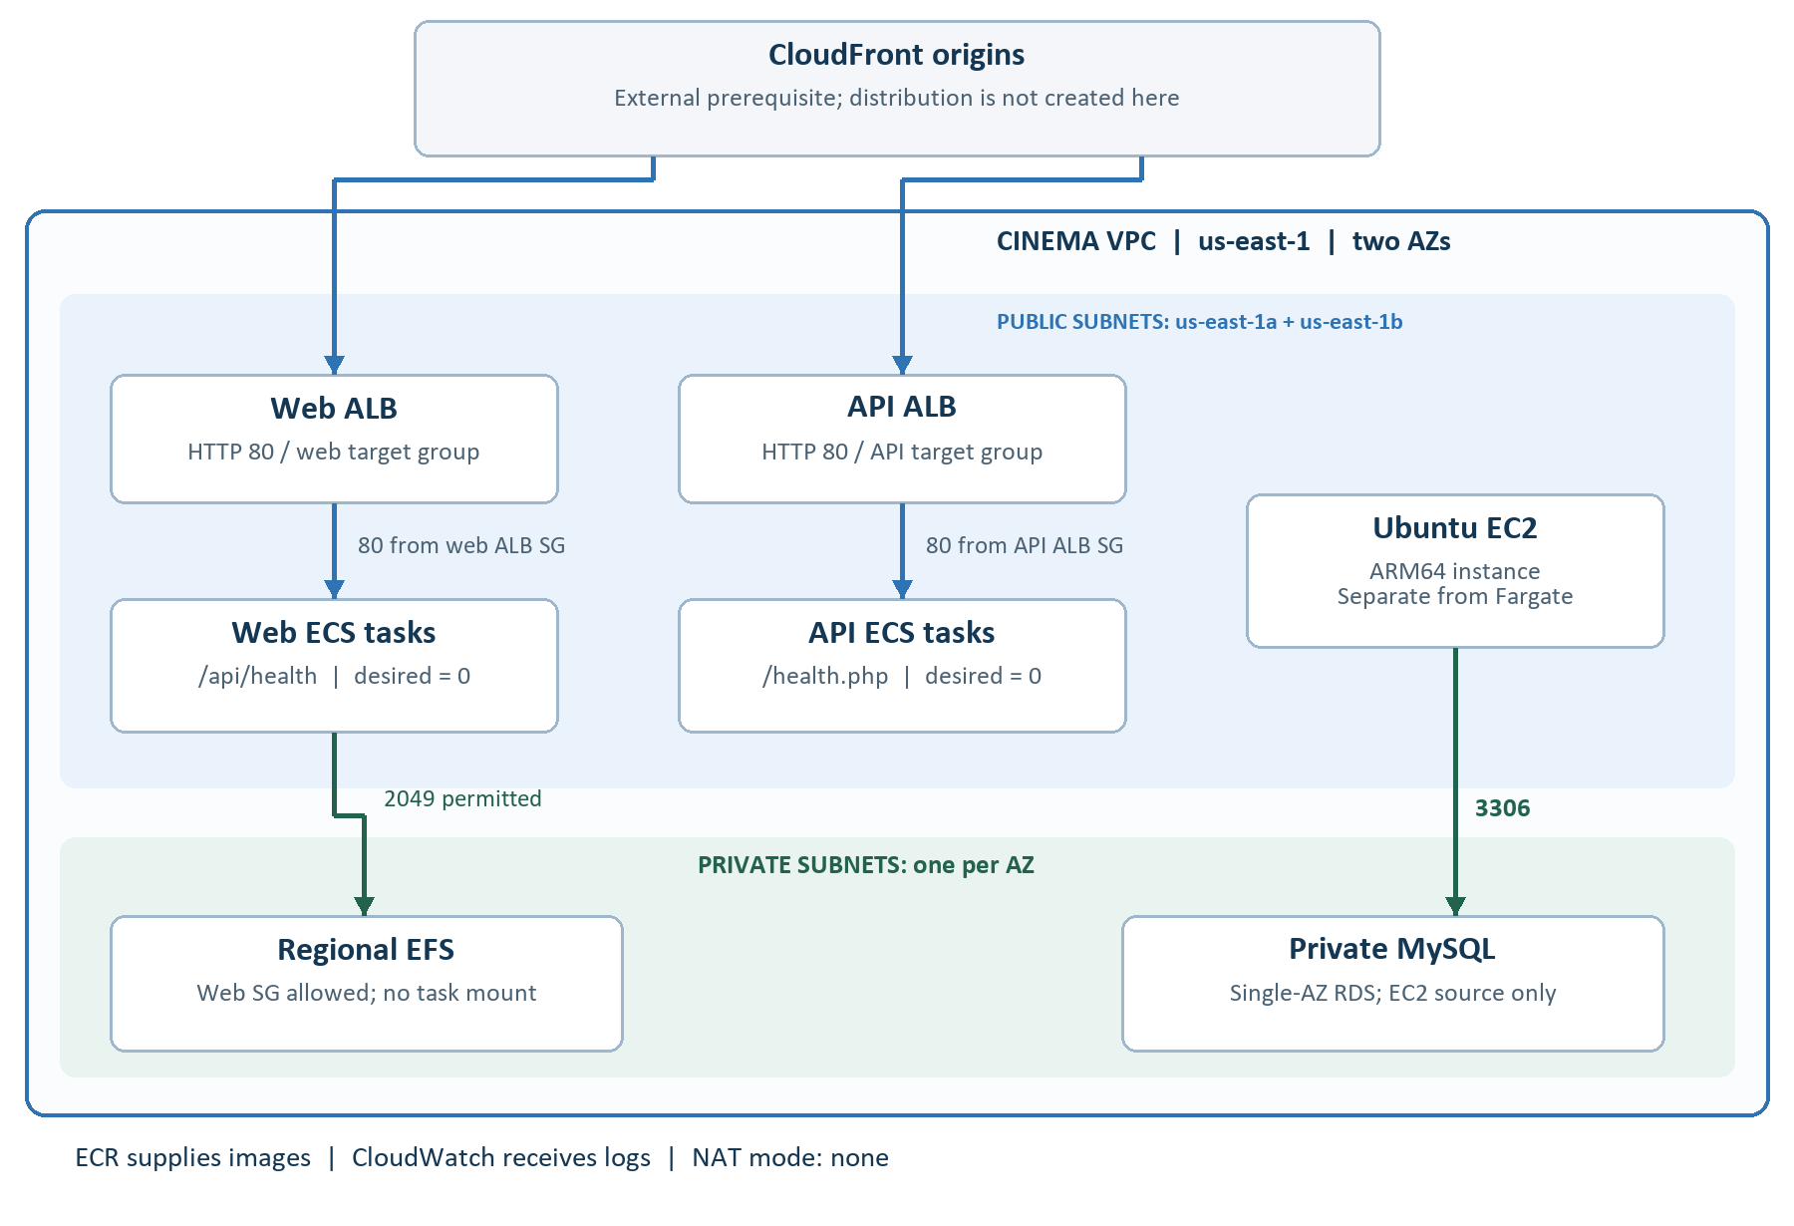
Remember the service names: ECR stores container images. ECS on Fargate runs containers. An ALB sends requests to healthy containers. RDS runs MySQL. EFS provides shared files. CloudWatch stores logs.
Your current settings: us-east-1, two Availability Zones, two public and two private subnets, no NAT gateway, and zero desired tasks for both ECS services. Images and a positive task count are needed before the applications can run.
Be clear in an interview: CloudFront is not created here. ALBs have HTTP listeners. RDS is Single-AZ, and only EC2 currently has MySQL access. API tasks do not. EFS exists, but the web task definition does not mount it. This is infrastructure preparation; it is not a fully finished production application.

4 | Run it step by step
Run these in PowerShell, one step at a time. Stop if a command fails. These are deployment instructions; do not run apply while you are still trying to finish a teardown.

Step 1 — Open the folder and check your AWS login
POWERSHELL / EXAMPLE
Set-Location C:\Data\terraform-iac\terraform
$env:AWS_PROFILE = "lanka-deploy"
aws sts get-caller-identity
Check that the returned account is yours. This selects your already configured profile. If login fails, fix it before running Terraform. Do not paste access keys or passwords into chat.

Step 2 — Initialise and select the right state
POWERSHELL / EXAMPLE
terraform init
terraform workspace select lanka-cinema-production
terraform workspace show
If this is a genuinely new deployment and the workspace does not exist, use terraform workspace new lanka-cinema-production. If resources already exist, find their original state first. A new empty workspace cannot manage them automatically.

Step 3 — Check the files and preview changes
POWERSHELL / EXAMPLE
terraform validate
terraform plan "-var-file=lanka-cinema-prod.tfvars"
Enter the MySQL password when prompted. It is separate from your AWS credentials. Keep it private: state and saved plans can contain it. Validate checks the configuration; it does not prove that AWS login, permissions or quotas are correct.
Read the plan: + create, ~ update, - delete, -/+ replace. A replacement recreates a resource. Stop if the plan proposes something you did not expect.

Step 4 — Apply only the changes you want
POWERSHELL / EXAMPLE
terraform apply "-var-file=lanka-cinema-prod.tfvars"
terraform output
Apply shows a fresh plan. Review it, then type yes. After it succeeds, check the resources and application health in AWS. Infrastructure creation alone does not build or publish your application image.
Before starting ECS tasks: build a linux/amd64 image, push it to the correct ECR repository, set its tag in tfvars, then change the relevant desired count from 0 to 1. Review the new plan before applying.

5 | Delete and troubleshoot calmly
Destroy removes resources tracked by the selected state. It does not remove everything in your AWS account. Keep the original state files until the work is complete.

Before deletion
Confirm the account and workspace. Decide whether database data must be kept. Your current tfvars has deletion_protection = false and skip_final_snapshot = true. That means no final database snapshot will be created. Existing backups are a separate matter.
If you need a final snapshot, set skip_final_snapshot = false and choose a unique final_snapshot_identifier before planning deletion. The live database must also have deletion protection disabled. Changing the file alone does not disable protection in AWS.

Preview, then delete
POWERSHELL / EXAMPLE
terraform workspace show
terraform plan -destroy "-var-file=lanka-cinema-prod.tfvars"
terraform destroy "-var-file=lanka-cinema-prod.tfvars"
Review the deletion plan and type yes only when ready. If deletion fails halfway, fix the reported blocker and rerun destroy. A normal apply at this point could recreate resources already deleted.

Your common errors, in simple words
InvalidClientTokenId: AWS could not accept the credentials. Check the selected profile and whether old AWS environment credentials are overriding it. Test aws sts get-caller-identity first.
Wrong workspace or AZ: the workspace must match lanka-cinema-production. Availability Zones must belong to the Region in tfvars.
Saved plan is stale / missing: make a fresh plan. A file appears only after a successful plan with -out. The simple commands on page 3 avoid saved plan files.
Cannot delete protected DB: in the correct AWS account and Region, modify the RDS instance to disable deletion protection; wait for the change, then retry destroy.
Option group is in use: check RDS → Option groups → Associated Instances and Snapshots. Wait for database deletion to finish. Keep any backup you still need; do not delete it just to clear the error. An associated snapshot can block option-group deletion. [R3]
After success: run terraform state list. An empty result means this state tracks no resources. Check AWS separately for retained snapshots or manually created resources.

6 | Practise these interview answers
Practise aloud. Adjust these examples to what you understand and have done. Explain more when the interviewer asks.

Why did you use Terraform?
“It gives me a repeatable AWS setup. I can review the code in Git and preview changes before applying them.”

What do init, plan and apply do?
“Init prepares the folder and providers. Plan previews changes; apply makes them. Validate checks the code. Destroy removes resources managed by the selected state.” [R1]

What is Terraform state?
“State connects my code to real AWS resource IDs. It can contain secrets, so I must protect it. This project uses local state.” [R2]

What is the difference between EC2 and Fargate?
“EC2 gives me a virtual machine. Fargate runs containers without me managing host servers. Our EC2 instance is separate from the Fargate tasks.”

How does traffic reach the application?
“Each workload has its own ALB and ECS service. The ALB forwards requests to healthy tasks on port 80. CloudFront addresses are allowed, but its distribution is outside this code.”

What happens if someone changes AWS manually?
“That can cause drift. Plan shows differences; apply may restore the coded value. I first decide which setting is correct, then update the code.”

Why can deletion fail?
“Protection or dependencies can block it. I encountered RDS deletion protection and an option group still in use. I check the blocker before retrying.”

Is this fully production-ready?
“Not yet. I would improve HTTPS, application connectivity, backups, monitoring, remote state and high availability, and restrict administrative access.”

7 | Tell your story and practise

Your project explanation — about one minute
“This is an AWS infrastructure learning project for a cinema web application and API. Codex generated the Terraform code. I am learning to review and operate it.
It includes networking, EC2, MySQL RDS, and separate web and API workloads using ECR, Fargate and load balancers. A client tfvars file holds settings; a workspace separates its state.
I have run Terraform commands and worked through credential and deletion errors. I learned to check the account, state and plan before changes. Application deployment and production improvements are still needed.”

If they ask, “Did you write all this yourself?”
“Codex generated the code from my requirements. I do not claim I wrote every line. I am learning to understand the resources, review changes and verify results.”
If you do not know an answer: “I have not implemented that yet. I understand the basic idea, and I would check the documentation and test it before using it.” This is better than guessing.

A simple three-day practice plan
Day 1 — 20 minutes: read pages 1–2. Open ecr.tf and explain the small resource block without reading the answer. Draw the web and API paths on paper.
Day 2 — 20 minutes: read pages 3–4. Say what each command does. Explain why state matters and why your RDS deletion failed. You do not need to deploy again just to practise.
Day 3 — 20 minutes: answer page 5 aloud. Record your one-minute project explanation. Listen once, shorten unclear parts, and try again.
Learn next: modules for reusable code, secured remote state for teams, and CI/CD for automated checks and deployments. These are future improvements.

Reference and scope
Repository checked: 29 September 2026. Live AWS status not checked. Keep the longer guide for deeper reading.
[R1] Terraform plan and apply workflow
[R2] Terraform state
[R3] AWS RDS option-group dependencies

