Project Proposal

TutorHere

Name : Sathischandra M.K.D.T.M.

Registration No. : EN82722

Index No. : 16/ENG/093

Course Code : CO3302

Field of Specialization: Computer Engineering

Table of Content

Executive Summary 1

Background 2

Objectives 3

Methodology 4

Timeline 5

Cost Analysis/Budget 6

Risk 7

Appendix 8

Executive Summary

As the name suggests “TutorHere” is a tutor hiring online service which provides facilities for the students or the learners to find the tutors for a required subjects of study and hire them for tutoring. In the same time, this platform provides the ability for the tutors to connect to the tutor seekers with less effort and find tutoring opportunities. TutorHere provides ranked tutors based on set of criteria for the user request and the user will be able to hire the tutor. Based on the hourly rate defined by the tutor and the time of work, the fee is calculated and payment can be done via application or manually.

Background

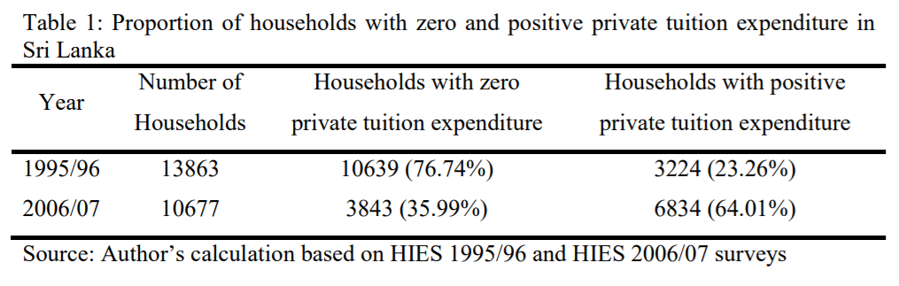In present, the demand for private tutoring is highly increased in many countries including Sri Lanka. Based on survey conducted about private tutoring in Sri Lanka, it can be clearly seen a considerable increase of the proportion of households that spend money on private tutoring over time, as following table shows, only 23% of households have used money on children’s private tutoring in 1995-1996 and it has increased to 64% in 2006-2007.

Figure 1: Demand increment of private tutoring in Sri Lanka (Pallegedara, 2011)

Private tuition institutes have become the main tuition providers for this increasing demand of the private tutoring. Part-time tutors who provide on-demand home-visit tuitions can be seen as the next main set of tuition providers, except to those private tuition institutes.

The main problem that those part-time tutors are facing is, medium of connecting with the clients. As general practice, it can be seen the use of traditional methods like posters, paper advertisements etc, which makes the process harder for both tutor and learner. These traditional methods also make it harder to show how qualified the tutor, how the previous clients recommend or discommoded the tutor, is the tutor available in the required time period etc. For providing the solutions to these matters, a platform is needed which makes it efficient and easier for the both learners to obtain a good service and the tutors to provide a good service.

Objectives

* To provide a platform to the learners (including students, the parents of students or other learners), for finding suitable tutors for their relevant subjects or topics and hire them for tuition, including features such as finding tutors based on locations, qualification level, hourly rate etc. and contact the tutors.
* To provide a platform to the tutors for finding learners who are requesting tuitions for their subjects, with less effort and high efficiency relative to traditional methods.
* To provide a “pay as you learn” and “pay as you teach” service: Both learners and tutors are able to get and provide the part-time service respectively (In contrast to ordinary tuition system, this service is not limited only to permanent or long term classes). E.g.: The learners can get the service from a one particular tutor for a one particular topic or even for a one time-slot only.
* To make it easier for the learners to find tutors who are available in the time periods that they can afford.
* Giving the option to tutors to allocate their non-busy time periods to be shown as available, so the distraction occurs in the other work times are minimized.
* To provide a tutor rating system based on learners reviews for different criteria which helps the learners to find more appropriate tutors for their purpose.
* To provide an easy to use and easy to access service.
* To minimize the negative effect for the environment caused due to traditional methods such as posters, banners and other paper/plastic based advertising.

Methodology

The methodology of the project is consisted of mainly 5 phases which can be stated as analysis, design, implementation, testing and deployment.

**Analysis**

A requirements analysis will be conducted to be sure that the needs of the solution for the background problems and above mentioned objectives are addressed, and also to identify deficiencies and address tools and features the users can benefit from.

**Design**

In the design phase of the development process, an abstract representation of how the application works will be studied. The database is designed in this phase. Every requirement is taking into the consideration here. Then the problems such as, what are the views of the application and how the views are interacting with each other will be studied. Then prototypes of user interfaces are designed. Tools such as MySQL Workbench (For creating ER diagrams) and Adobe XD (For creating prototypes of user interfaces) are proposed to be used here.

**Implementation**

In this phase, the designed project will be coded and developed. The project is a web based application and therefore, this phase is consisted of two main tasks.

1. Front-end development and UX/UI design.

2. Back-end development (Server-side).

These two tasks will be executed in parallelly. For front-end development HTML, CSS and JavaScript will be used and frameworks like Bootstrap and VueJS are proposed to be used. For back-end development PHP will be used and Laravel framework is proposed to be used here. For managing database MySQL language is used. Tools such as VS Code will be used as the text editor for development.

**Testing**

After the development process is completed, the application will be tested and debugged. Alpha testing is done by using some dummy data and dummy users. For the beta testing few selected tutors and learners will be contacted. They will be provided a good understanding of the service and beta round will be conducted.

**Deployment**

After completely finalizing the initial release of the application, this application will be published and available on a website that anyone can access.

Timeline



Cost Analysis

As this project is a web based application, following main things have to be considered in the budget.

Registering a domain name is required to successfully displaying a web application on the Internet. For this, a domain name has to be purchased from a recognized domain registrar such as GoDaddy.com, Google Domains and Register.com etc. Purchasing a domain name is done on an annual basis and purchasing for one year can cost anywhere from $15 to $50 per year.

Next, the website have to be hosted. From the web hosting service provider some essential services will be needed: Storing website files, Service availability, Database compatibility, Basic backup/restoration. Hosting will be costed for both storing and transferring of data.

As this web application may utilize online transactions, SSL (Secure Sockets Layer) will be required. SSLs range in cost from $45 per year to $500 per month depending on the level of needed security. Most common SSLs cost about $50 – $75 per year.

Estimated budget report is shown below for a year basis plan (based on Google Firebase, Google Domains and GoDaddy's Standard SSL pricing. )

|  |  |  |  |
| --- | --- | --- | --- |
| Description | Pricing | Quantity / 1 month | Total Price ($) / 1 year |
| **Real-time Database**  Storing  Transferring | $5/GB  $1/GB | 2 GB  5 GB | 120.00  60.00 |
| **Storage**  Storing  Transferring | $0.026/GB  $0.12/GB | 20 GB  20 GB | 6.24  28.80 |
| **Hosting**  Storing  Transferring | $0.026/GB  $0.15/GB | 40 GB  100 GB | 12.48  180.00 |
| **Domain**  Domain name  SSL | $12/Year  $69/Year | 1 Domain Name  1 SSL Certificate | 12.00  69.00 |
| **Total** | | | 488.52 |

**Risks**

The risks which could be arisen in this project can be categorized to two main parts,

1. Risks during the project development

2. Risks after the project deployment

**Risks during the project development**

|  |  |
| --- | --- |
| Risk | Possible paths to avoid / Alternatives |
| Incapability of finding monetary resources for establishing web application | * Use free or partially free services like Google Firebase which provide free web based storage and services for a limited amount of storage and operations quantity. * Purchase web services monthly instead of annual basis. |
| Incapability of delivering the project on right time | * Increase the number of parallel tasks * Use tools for speeding up the tasks   (E.g.: Use drag-n-drop GUI tools for design web views instead of manual coding) |

**Risks after the project deployment**

|  |  |
| --- | --- |
| Risk | Possible paths to avoid / Alternatives |
| Failure of the Web hosting services | * In addition to the backup/restore system of the web hosting service provider, keep a secondary backup service. * Frequently get local backups |
| Change of requirements | * Continuously monitor whether about needs of new requirements and develop the system accordingly while making sure the previous version is active well until new version is deployed |
| It may become harder to market | * Contact and explain the tutors and students the benefits of such a new system * Give promotions to market the web application |
| Website may have unresolved/hidden bugs and security issues still after deployment | * Continuously get user feedback * Monitor and analyze the behavior of web application regularly * Update the plug-ins and other third-party tools regularly |

Appendix

**References**

* Pallegedara, A. (2011). *Demand for private tuition classes under the free education policy. Evidence based on Sri Lanka.* [pdf] Available at: https://mpra.ub.uni-muenchen.de/31969/1/MPRA_paper_31969.pdf [Accessed 28 Jan. 2019].
* “Firebase,” *Google*. [Online]. Available: https://firebase.google.com/pricing/. [Accessed: 06-Feb-2019].
* “Google Domains pricing and supported domain endings,” *Google*. [Online]. Available: https://support.google.com/domains/answer/6010092?hl=en&_ga=2.195692524.1701224824.1549443726-631998583.1549443726. [Accessed: 06-Feb-2019].
* “SSL Certificate Comparison,” *SSL Certificate Comparison and Reviews*. [Online]. Available: https://www.sslshopper.com/ssl-certificate-comparison.html?ids=60,39,37,43,81. [Accessed: 06-Feb-2019].