Database Access Description for Attributes in Sandbox

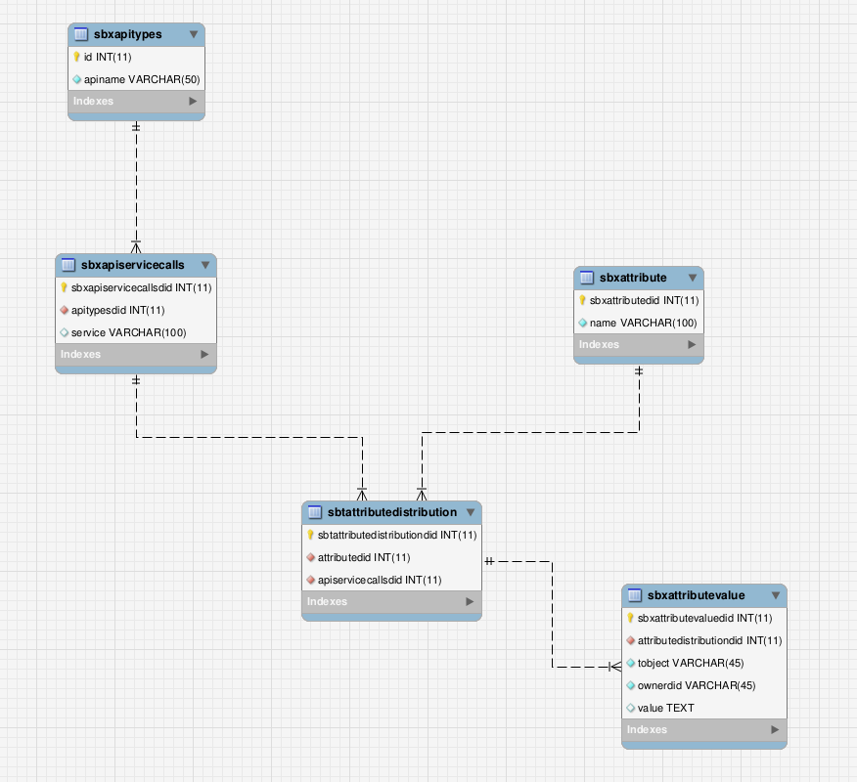
ERD for model

- sbxapitypes
Contains all the APIs eg: CustomerInfo

- sbxapiservicecalls
Contains all the available rest service callls for particular Api
eg: Get Attribute of CustomerInfo Api

- sbxattribute
Contains the attribute group eg: basic,billing,firstname,lastname

- sbtattributedistribution
All the api call specific mappings goes here.

ServiceCalls | Attributes
Get Attribute | basic, billing
Get Profile | firstname,lastname

- Sbxattributevalue
Contains the values for the attribute distribution records eg: firstname:”Malar”

