Data Visualization In Power BI

* **Analysis of Streaming Platforms and User Preferences**

**Introduction:**

This report presents the findings of a data visualization project conducted using Power BI, focusing on the analysis of popular movie streaming platforms: Netflix, Prime Video, Disney+, and Hulu. The objective was to gain insights into user behavior, demographics, and platform usage trends. The dashboard created provides an intuitive interface to explore the data, utilizing various visualizations such as pie charts and interactive filters.

* **Movies On Streaming Platforms**

the COVID-19 pandemic led lockdown made way for various brands to announce their entry into the OTT industry with their own set of channels, content and shows. The year 2020 witnessed an exponential growth in the addition of these platforms due to the remarkable increase in viewership as well as audience demand for online content.

As the country followed the lockdown guidelines strictly to avoid the spread of the virus, they mostly stayed indoors and worked from homes. This provided them with more time and unused data to explore other options of entertainment and information. People turned to OTT platforms due to their easy accessibility in sync with the developed internet infrastructures. The platforms had added advantages over the cable operated television networks as one could play and pause as per choice and select what and when to watch content.

In the project's data visualization using Power BI, Prime Video was one of the streaming platforms analyzed alongside Netflix, Disney+, and Hulu. The dashboard created allows for a detailed examination of user behavior and platform performance specific to Prime Video. It provides insights into user demographics, popular content genres, viewership trends, and comparisons with other streaming platforms.

* **Netflix –**

Netflix is a streaming service that offers a wide variety of award-winning TV shows, movies, anime, documentaries, and more on thousands of internet-connected devices. Netflix is one of the key streaming platforms analyzed in this project. Through data visualization in Power BI, we examined user demographics, popular content, and viewership trends on Netflix. The analysis provides valuable insights into user preferences, platform performance, and the success of Netflix's original content.

* **Prime Video –**

Prime Video is a streaming video service by Amazon. Prime Video benefits are included with an Amazon Prime membership and if Amazon Prime isn't available in your country/region, you can join Prime Video to watch. With your membership, you can watch hundreds of TV shows and movies on your favorite devices.

* **Disney+ -**

Disney+ Hotstar is India’s largest premium streaming platform with more than 100,000 hours of drama and movies in 17 languages, and coverage of every major global sporting event.

* **Hulu –**

the Hulu streaming library with limited ads. Enjoy full seasons of exclusive series, hit movies, Hulu Originals, kids shows, and more. Stream 60+ top Live and On Demand TV channels including sports, news, and entertainment.

**Methodology:**

The project involved collecting data on user demographics, streaming platform preferences, and viewing patterns. The data was then cleaned, transformed, and loaded into Power BI. Various visualizations, including pie charts and interactive filters, were implemented to present the insights effectively

* Download the data from Kaggle that is “movies on steaming platforms”

Link of the dataset - <https://www.kaggle.com/datasets/ruchi798/movies-on-netflix-prime-video-hulu-and-disney>

* Install power bi Desktop
* Open power bi desktop
* Import the data from csv file “movies on streaming platform”

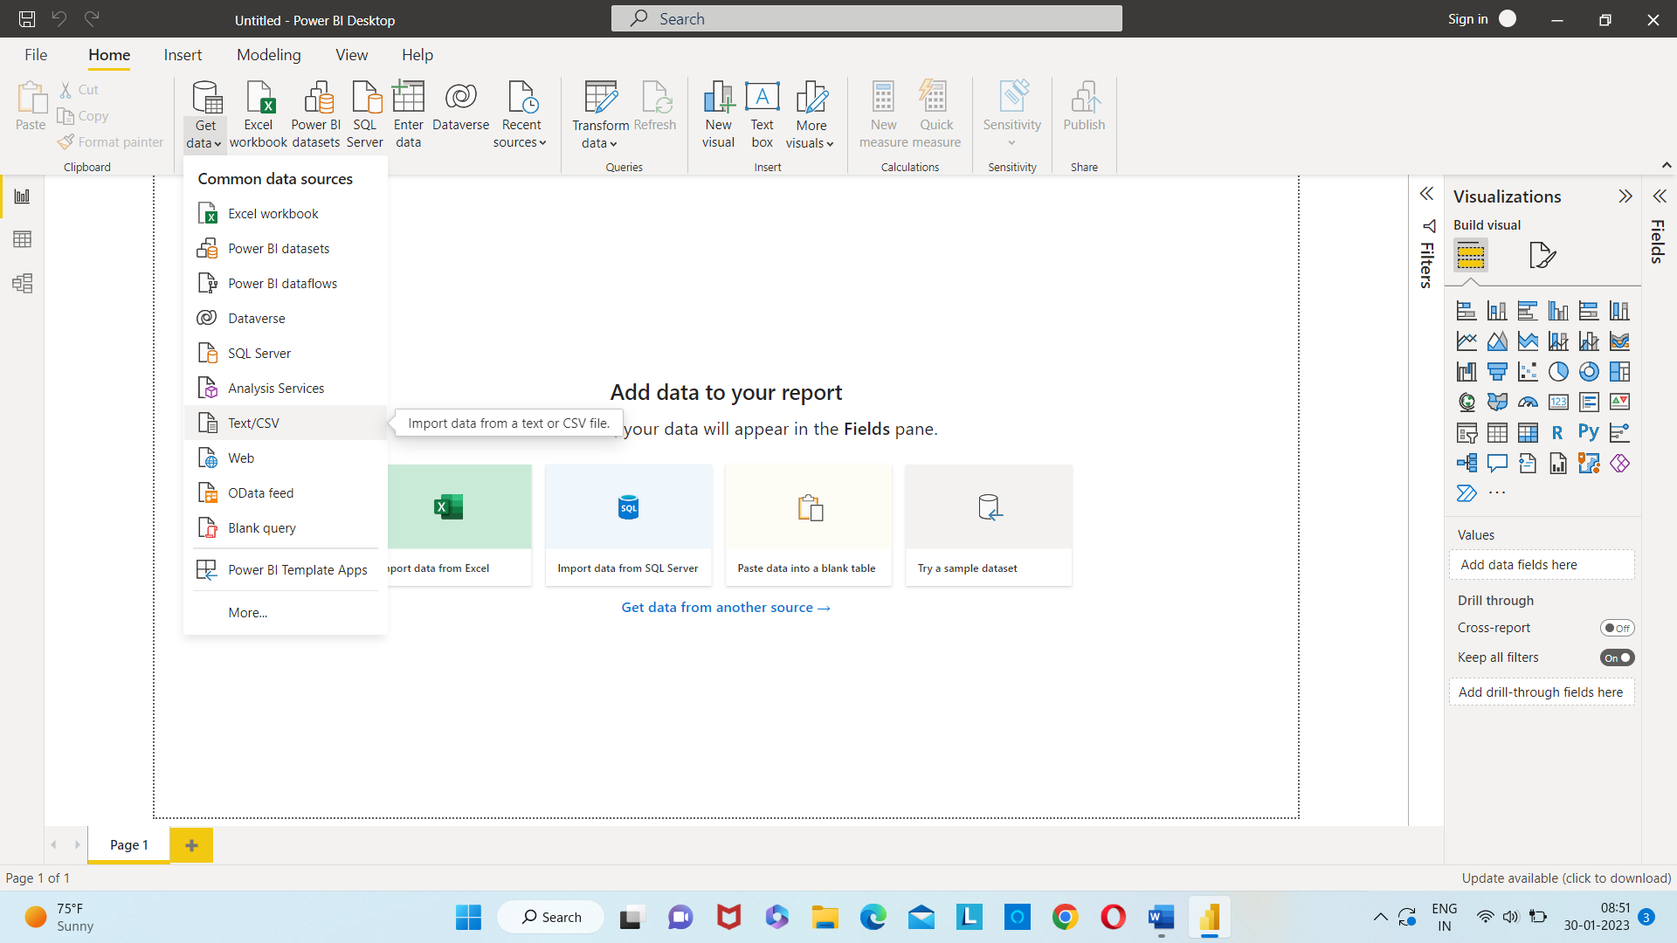

* After the file is opened click on transform data
* Data cleaning , selected the required data , removed errors and unwanted data
* Transform data into load data

Get data 🡪 CSV file 🡪 choose the file 🡪 click on okay

**Elements of a dashboards –**

* **Card –**

In data visualization click on cards and select the data which you want to keep in cards



* **Table –**

in data visualization click on table and select the data which you want to keep in table

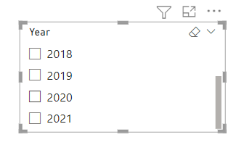

* **Pie chart –**

in data visualization click on pie chart and select the data which you want to keep in table

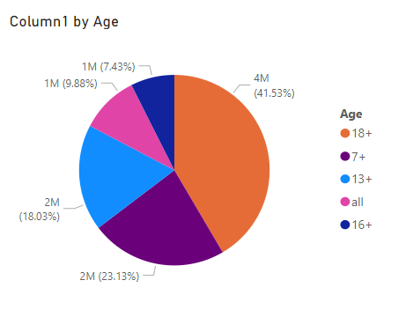

* **Bar chart –**

in data visualization click on bar chart and select the data which you want to keep in table

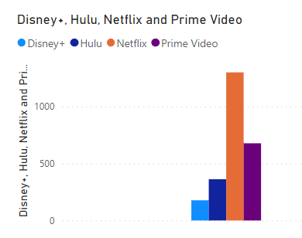

**Dashboards in power BI –**

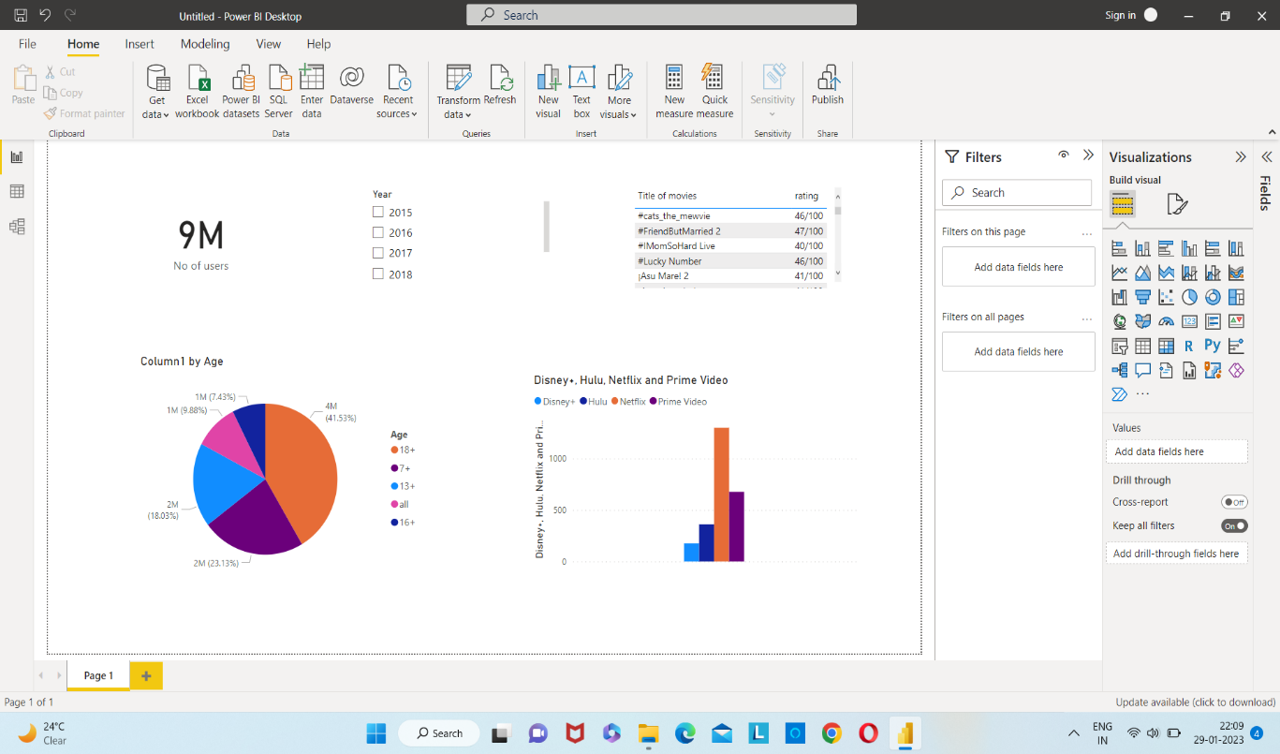

**User Demographics:**

Through the dashboard, users can easily identify the distribution of viewers across different age groups for each streaming platform. Pie charts provide a visual representation of the percentage of users within specific age brackets, enabling quick comparisons between platforms.

**Platform Popularity:**

The dashboard allows users to explore the popularity of each streaming platform based on the number of users. By selecting the desired year, users can gain insights into the platform that experienced the highest usage. Interactive filters facilitate the exploration of data by year, empowering users to identify trends and patterns.

**Yearly Trends:**

Using interactive elements, users can observe the yearly trends in platform usage. By selecting a specific year, the dashboard dynamically updates the visualizations to showcase the platform with the highest user engagement for that year. This feature assists in understanding the changing preferences of viewers over time.

**Conclusion:**

The data visualization project successfully analyzed user demographics and platform usage patterns for Netflix, Prime Video, Disney+, and Hulu. The Power BI dashboard offers an intuitive interface, allowing users to identify the age groups with the highest viewership and determine the most popular streaming platform based on yearly trends. These insights can be utilized by stakeholders to make informed decisions and tailor their strategies to target specific demographics.

**Recommendations:**

Based on the findings, it is recommended to focus on understanding the preferences of the age groups that show the highest viewership for each platform. Additionally, continuous monitoring of yearly trends will enable platforms to adapt and optimize their content offerings to stay competitive in the dynamic streaming industry.

In conclusion, the data visualization project provides valuable insights into user demographics and platform preferences for Netflix, Prime Video, Disney+, and Hulu. The Power BI dashboard serves as a powerful tool to analyze the data efficiently and make data-driven decisions in the streaming industry.