MONGO DB – CRUD Tasks

Task 1 — Student Management System
Objective
Create a MongoDB database to manage students and perform CRUD operations.
Collection Name
students
Document Structure
{
"student_id": 101,
"name": "Arun Kumar",
"department": "CSE",
"year": 3,
"skills": ["Java", "MongoDB", "Python"],
"marks": {
"dbms": 85,
"java": 90,
"python": 88
},
"active": true
}

Tasks
CREATE

1 Create database college_db
2. Insert 10 student documents

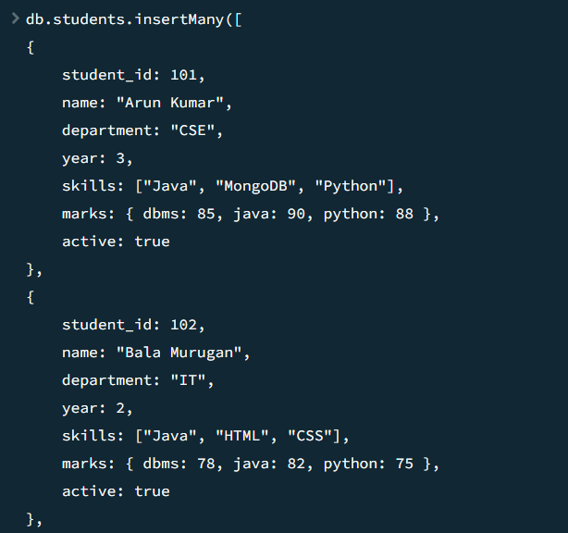

3.Insert one student with multiple skills and nested marks object
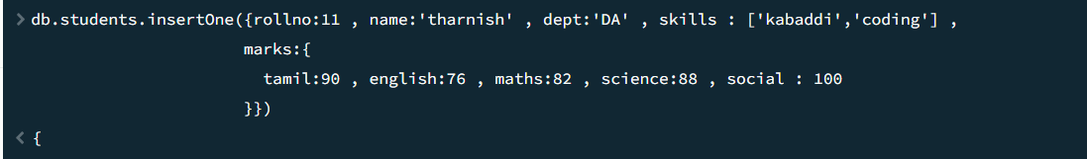
4.Insert many students at once

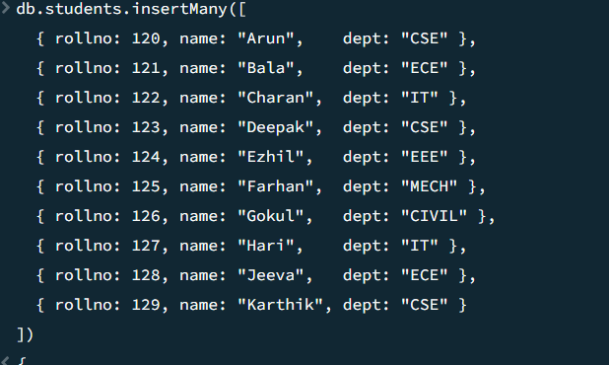

READ
- Display all students
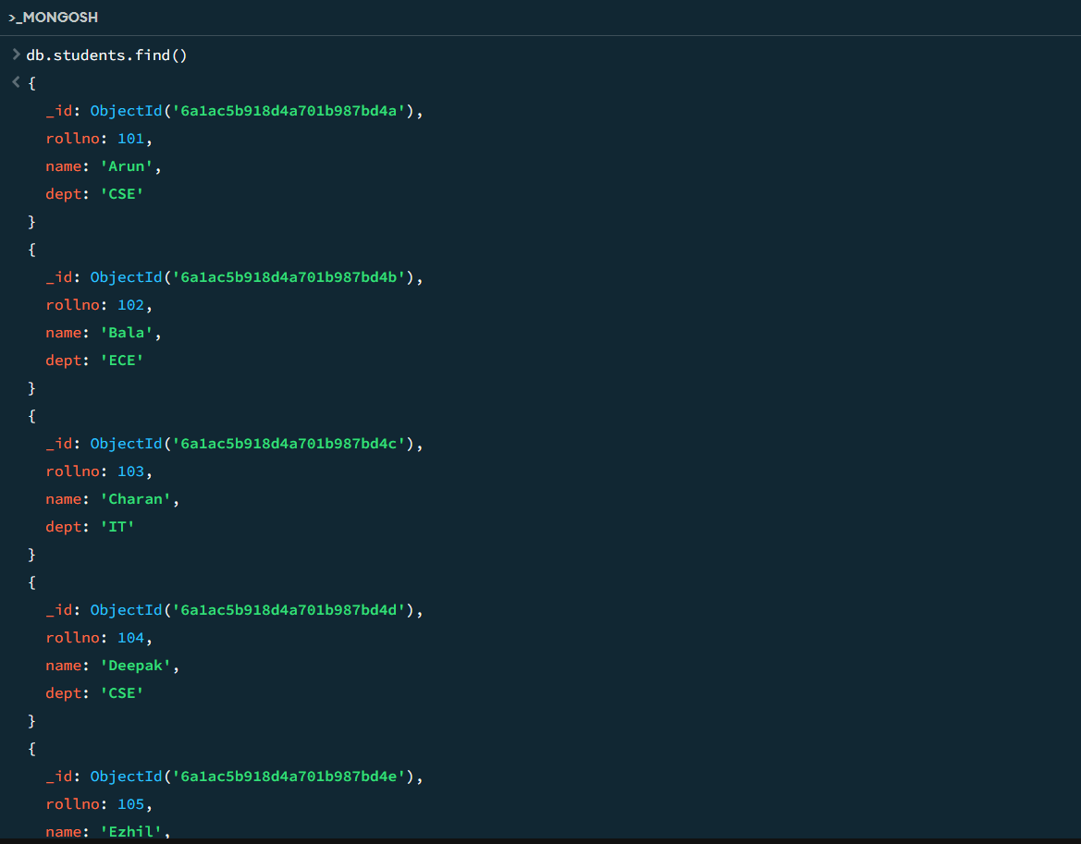

- Find students from CSE
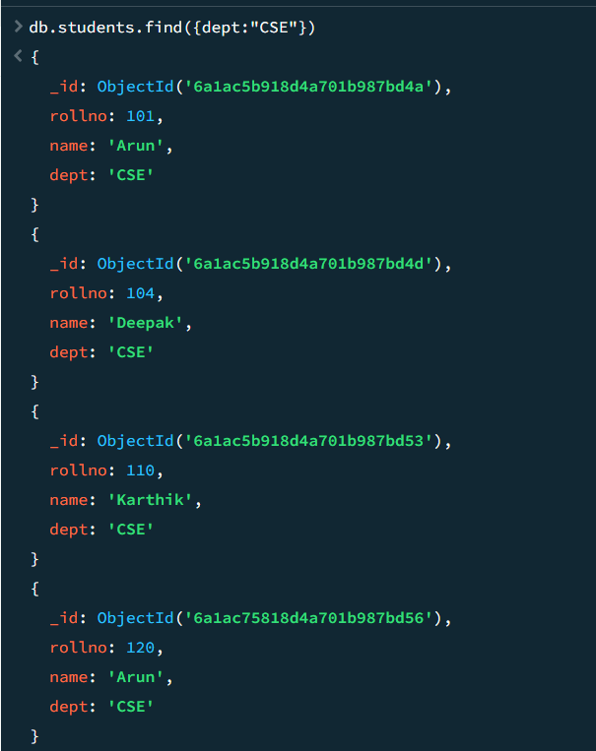
- Find students whose year is greater than 2
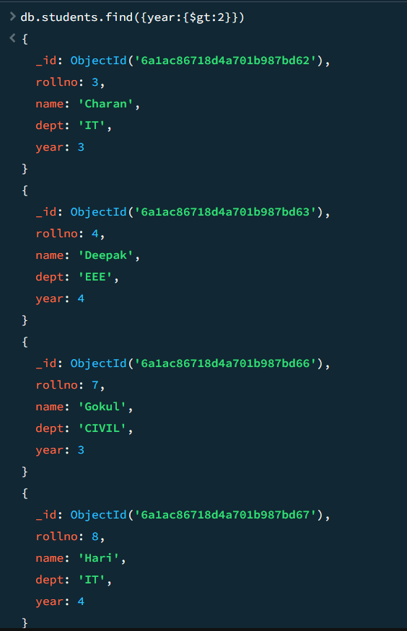
- Find students having skill MongoDB

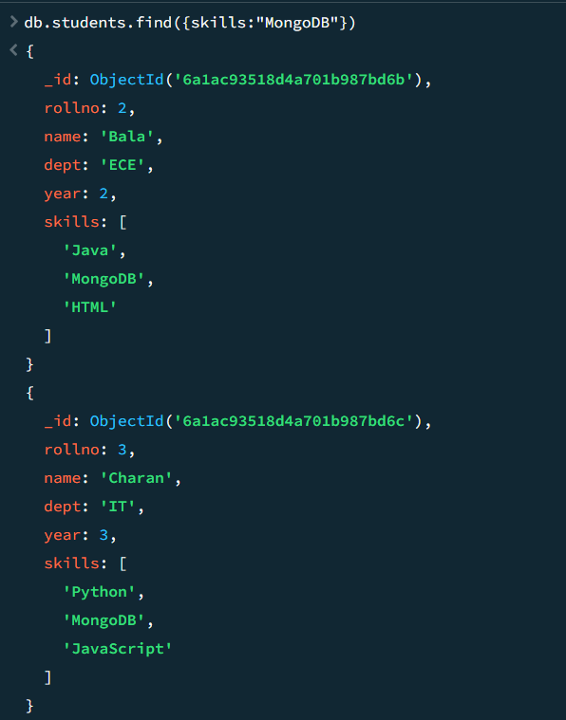

- Display only name and department
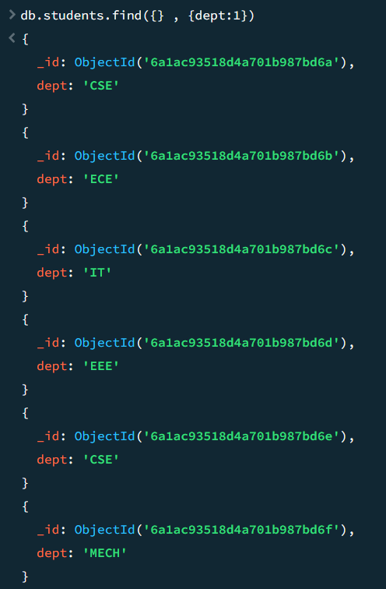
- Find students whose python mark is greater than 80
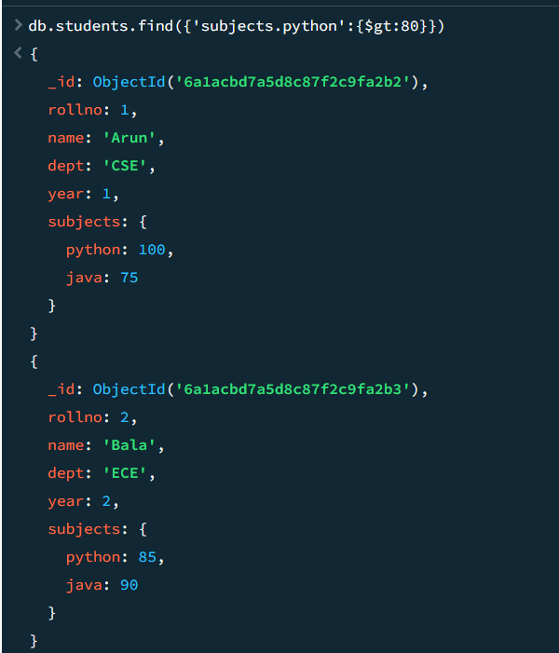

- Sort students by name ascending
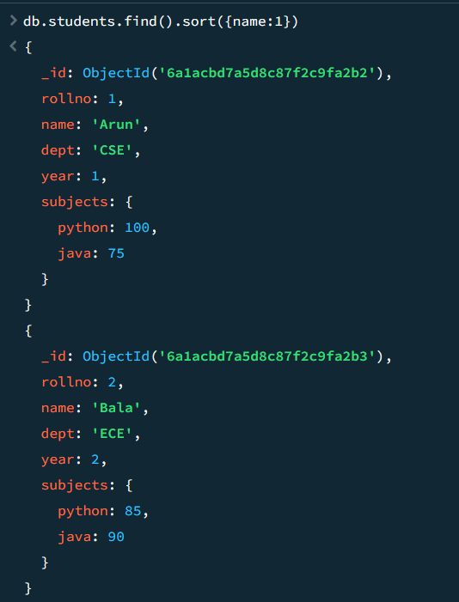
- Display top 3 students based on java mark
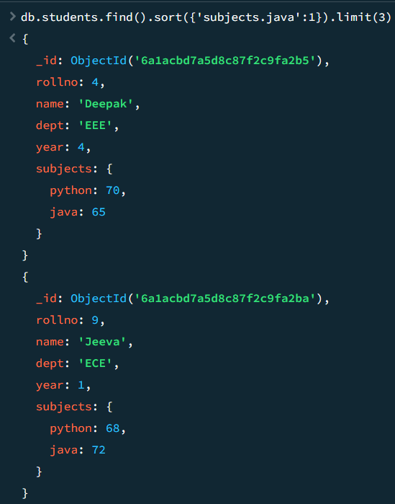

UPDATE
- Update department of a student
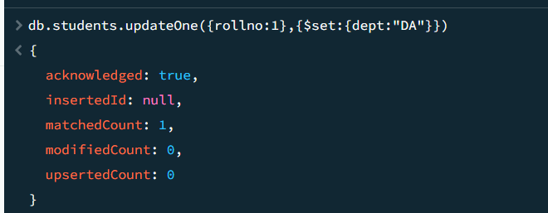
- Add new skill NodeJS
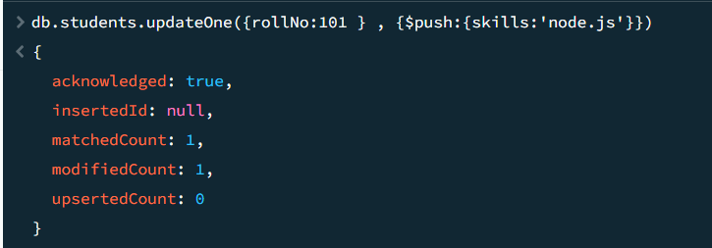
- Increase python marks by 5
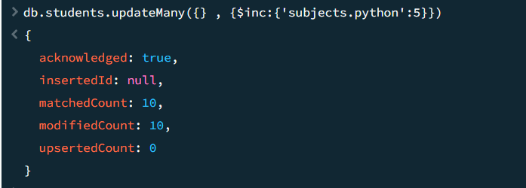

- Rename field active to status
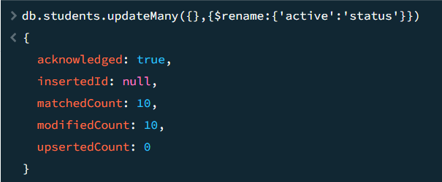
- Remove one skill from skills array
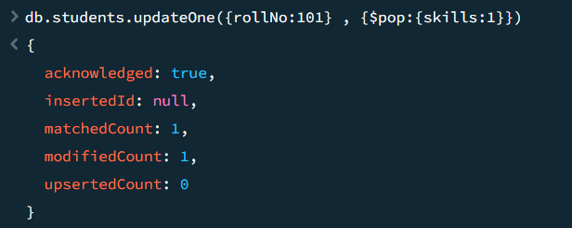
- Update multiple students of same department
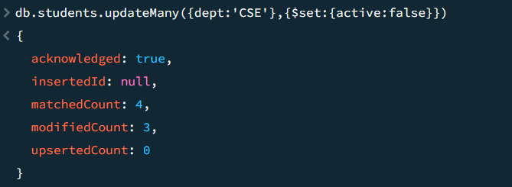

DELETE
- Delete one inactive student
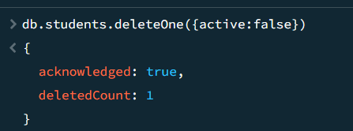
- Delete students whose year is 1
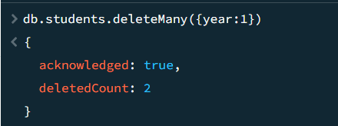
- Delete all students from a specific department
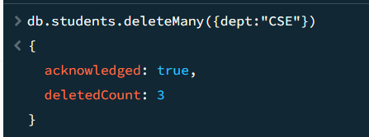

Task 2 — Online Shopping Cart
Collection Name
products
Document Structure
{
"product_id": 1001,
"product_name": "Laptop",
"category": "Electronics",
"price": 65000,
"stock": 15,
"brand": "Dell",
"ratings": [4, 5, 5, 3],
"supplier": {
"name": "ABC Traders",
"city": "Chennai"
}
}
Tasks
CREATE
- Create database shopping_db
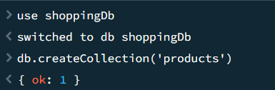
- Insert 15 product documents
- Insert products with embedded supplier details
- Insert products with array field ratings
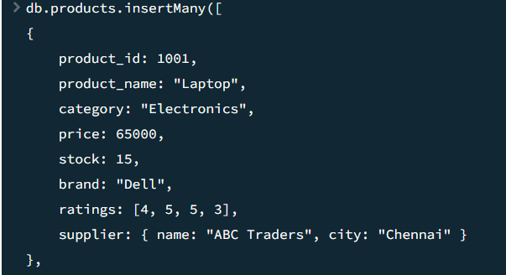

READ
- Find all electronics products
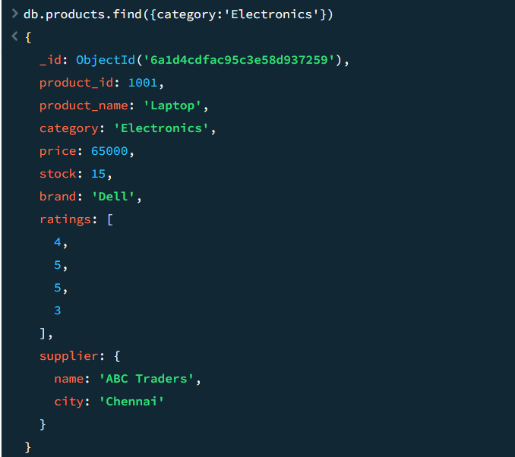
- Find products price greater than 50000
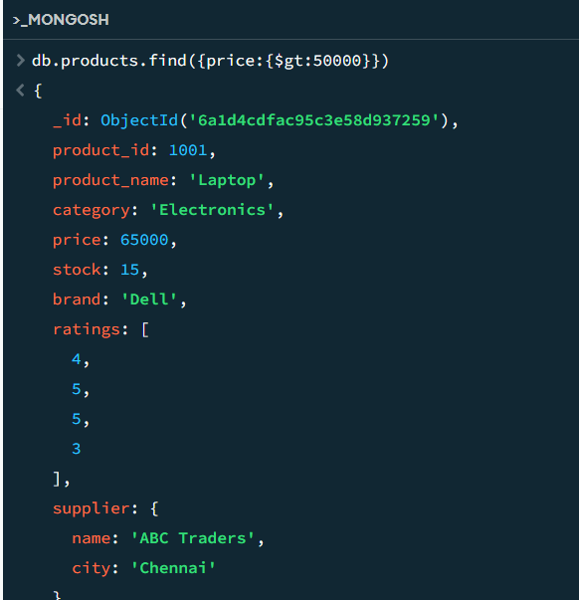
- Find products with stock less than 10
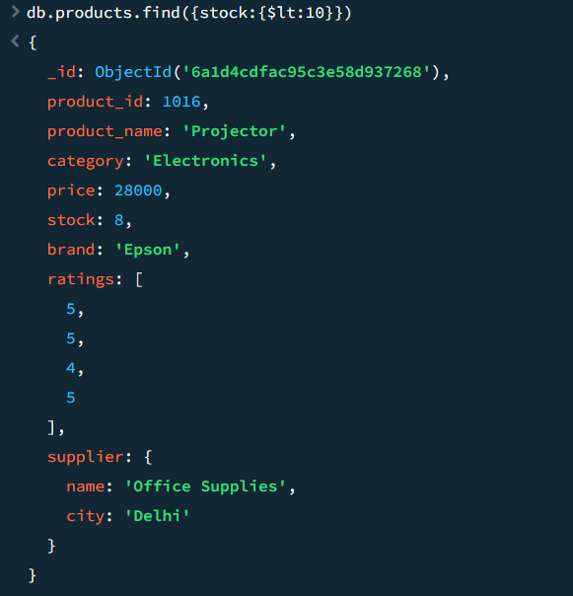
- Find products supplied from Chennai
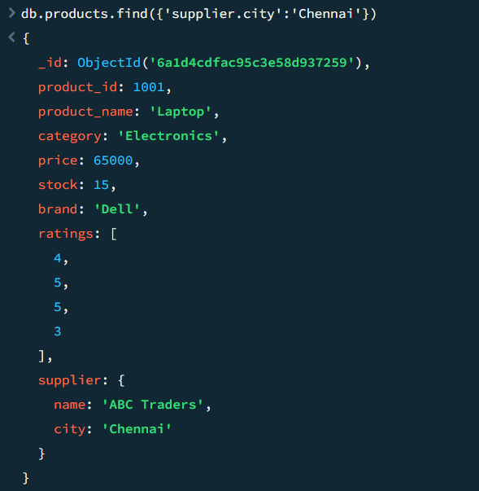

- Display only product name and price
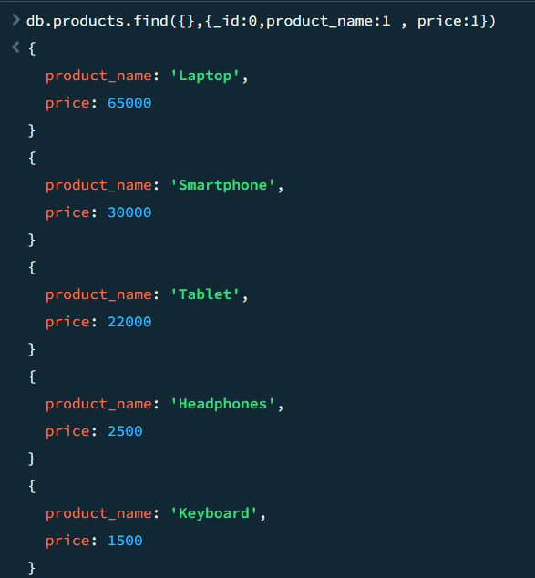
- Find products having rating 5
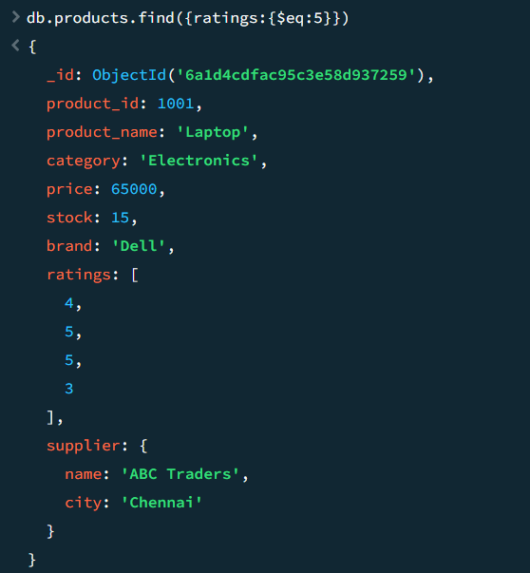
- Sort products by price descending
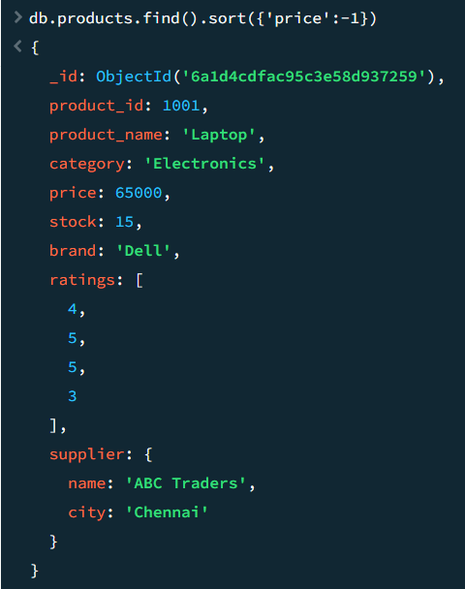
- Find top 5 costly products
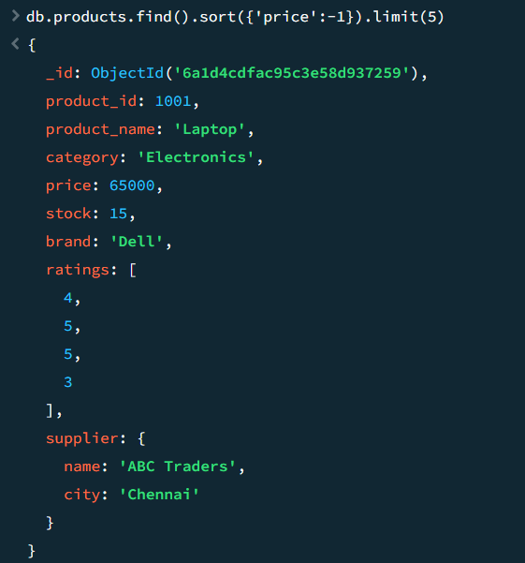
UPDATE
- Increase stock by 10
- Update supplier city
- Add new rating to ratings array
- Reduce price by 5%
- Rename field brand to company
- Update multiple products category-wise

DELETE
- Delete products with zero stock
- Delete all products from a category
- Delete products whose price is below 1000

