WEEK 5

MODULE 8:

PROBLEM 1:

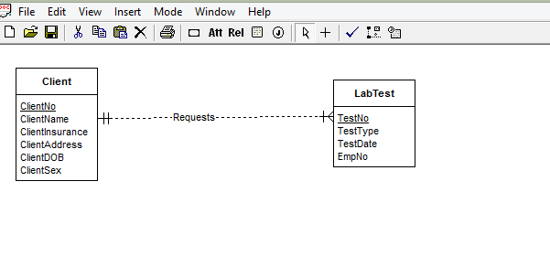

Given two entity types-Client and LabTest.

Both the entity types have unique attributes acting as primary keys and few other attributes. The client is present only if he has requested atleast one test. A client can request many tests.So cardinality for labtest is min 1 max M. Each test must be associated to one client.

There is a 1-M relation between client and labtest.