Problem 2:

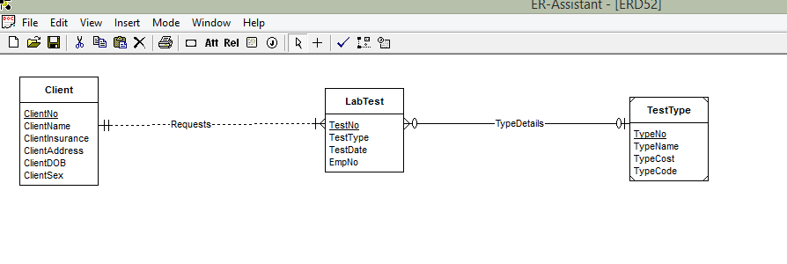

Given that each test has few type details. So a weak entity is used to represent the test type because the test type requires the TestNo identifier along with the type identifier to get identified uniquely. Each test is associated with one type and a type may or may not be administered to a client.