Problem 3:

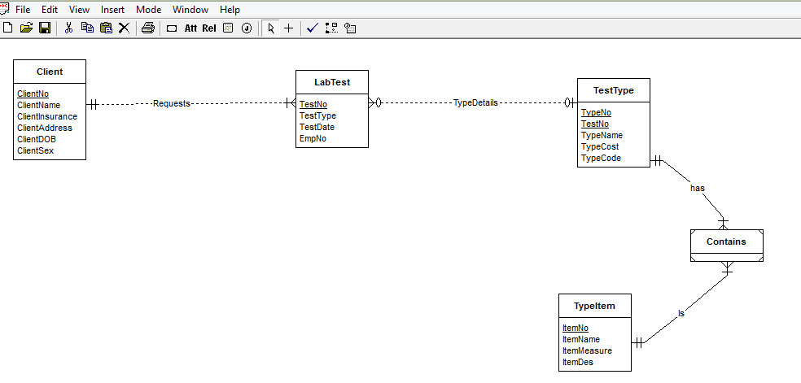

Given each test type has one or more test items. Test type item and test type are connected with a weak entity’contains’ so that there is no direct M-N relation between type and type item. A minimum cardinality of 1 is required on both relations.