Problem 4:

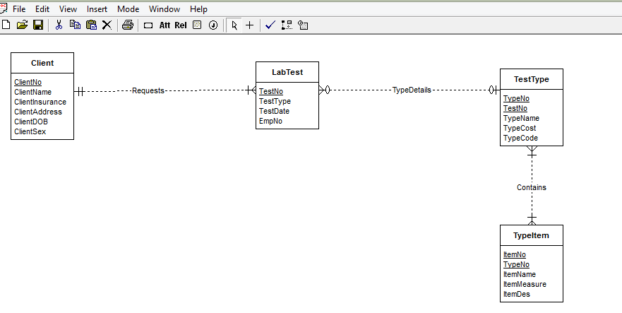

The weak entity type item can be identified to a strong entity by adding the typeno as a primary key.

Now the relationship is a regular M-N relationship.