Problem 2:

Given the initial ERD in the question is as below:



Figure 1: ERD for the Auto Dealership Database

The following are the diagram and design errors found in the above ERD diagram.

1. Account entity is not a weak entity(Diagram error). Change it to regular entity.
2. Each payment is related to only on account. And an account can be used for many payments.( Design error)
3. On sale an employee acts as a sales associate and process the payment for the vehicle.So a weak entity sales associate employee processes the payment.(Diagram error).
4. A single account is used for an expense. An account can be used to for many expenses.(Design error).
5. A relationship exists between the payment entity and the expense entity.

(Missing relationships).

1. Sales associate is also an employee.(Missing relationship).

THE REVISED ERD AFTER RESOLVING DESIGN AND DIAGRAM ERRORS IS BELOW.

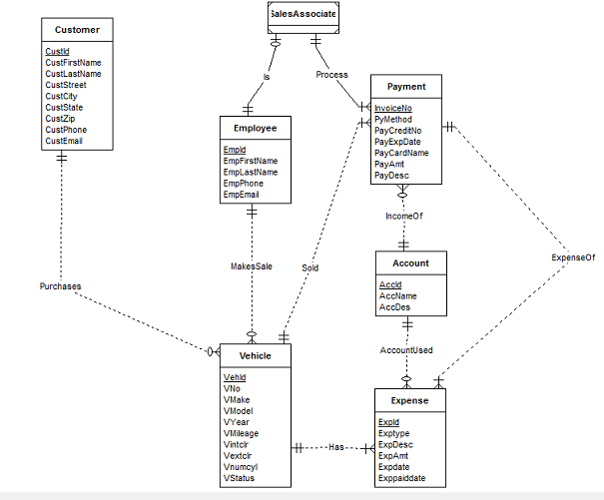

FIGURE 2: REVISED ERD FOR AUTO DEALERSHIP DATABASE.