MODULE 9:

WEEK 5:

PROBLEM 1:

INITIAL ERD FOR THE GIVEN REQUIREMENTS:

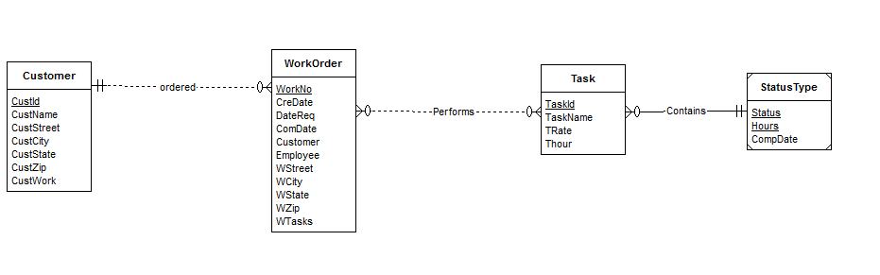

Customer entity has a set of attributes and has a collection of submitted workorders. So each customer may have 0 or more workorders submitted. WorkOrder entity ha a unique workno and other set of attributes. It also has a set of tasks assigned to it. Each workorder requires a customer to order that . So cardinality of customer is 1. So 1-M with minimum 1 relation exists between these entity types.

Task entity ha a unique task id and other attributes. A task can be assigned to many workorders. A work order may contain any number of tasks. So a M-N relation exists between these two entity types.

Each task has status related to that. Status is related to each task and has other attributes. So an M-1 relation exists between them.

After specifying new requirements, the revision is made on the initial erd.

REVISED ERD IS BELOW:

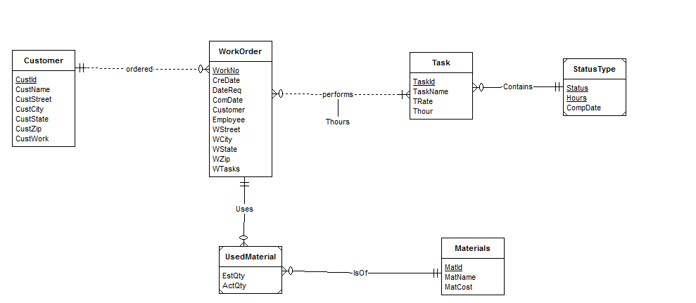

A new entity type called Materials is also added. Each work order contains many materials. The material that a work order uses contains quantities. So used material is a weak entity representing that.

The estimated hours is related to both workorder and task. It must be in the task entity.