**INTELLIGENT TUTORING SYSTEM: PERSONALISED**

**LEARNING PLANS WITH AI**

**Milind Bhushan*1, Rajat Shingate*2, Tanvi Shah*3, Naman Vyas*4,**

**Prof. Shraddha Shirsath*5**

*1,2,3,4,5Department Of Computer Engineering, Sinhgad Institute of Technology, Lonavala, Pune.

Affiliated To Savitribai Phule Pune University, India

**ABSTRACT**

The Intelligent Tutoring System with Artificial Intelligence (AI) offers personalized learning for students and is

brought into this abstract through two 3major key factors: Personalized Learning and the use of AI for Intelligent Tutoring. The incorporation of Intelligent Tutoring Systems (ITS) has garnered significant interest in contemporary educational paradigms due to the swift progress made in Artificial Intelligence (AI) and educational technology. The ITS is a cutting-edge learning tool that uses Machine Learning (ML) and AI algorithms to adjust to each student's unique learning preferences and styles. Using advanced data analytics and cognitive models, the system can evaluate each student's strengths and limitations in a way that makes it possible to create individualized learning paths that are catered to their individual requirements and rate of learning.

**Keywords:** Intelligent Tutoring System (ITS), Personalized Learning, Artificial Intelligence (AI), Machine Learning (ML), Advanced Data Analytics, Cognitive Models.

1. **INTRODUCTION**

The way knowledge is taught and acquired in the ever-changing field of education has been completely transformed by the incorporation of technology. Intelligent Tutoring Systems (ITS) are one of the newest breakthroughs and a ground-breaking method for helping students have individualized learning experiences.

By utilizing artificial intelligence (AI) and data analytics, these systems can customize instructional materials and approaches to meet the unique demands and learning styles of each user. ITS can greatly improve educational efficacy by offering dynamic and adaptable learning environments that meet the individual needs of every learner. This introduction presents a strong argument for the inclusion of intelligent tutoring systems in modern educational settings by giving a brief outline of the concept and exploring how AI may be used to create personalized learning plans.

There are gaps in understanding and engagement when using traditional educational approaches since they frequently cannot adapt to the different learning styles and paces of pupils. Personalized learning plans powered by AI, however, will enable schools to overcome these obstacles and provide a more effective and inclusive learning environment. The Intelligent Tutoring System can adapt to the unique strengths and limitations of each learner by combining cognitive models and cutting-edge data analytics. This fosters a holistic grasp of subjects and gives students a sense of autonomy and authority over their education.

1. **LITERATURE SURVEY**

The Reference Paper [1], titled “Examining the applications of intelligent tutoring systems in real educational contexts: A systematic literature review from the social experiment perspective,” reveals that it makes a significant contribution to the literature by identifying the most recent trends and challenges, as well as potential factors that can account for the mixed results concerning the effectiveness of ITSs in genuine and authentic educational settings. In general, the findings validate that ITS can be exceptionally influential in

supporting teaching and learning.

The paper [2], entitled "Predictive learning analytics in online education: A deeper understanding through explaining algorithmic errors," concludes that the significance of unexpected events occurring during studies, which can affect students' behavior and cannot be foreseen and accounted for in PLA, includes changes in family and work responsibilities, unexpected health issues, and computer problems. Interview data helped identify new data sources that could be integrated into predictions to mitigate some of the errors, such as study loan application information. Insights from this study highlight the importance of complementing AI-based systems with human intelligence, specifically teachers, which goes beyond what a good AI system can provide.

Paper [3], titled "Needs and requirements for an additional AI qualification during dual vocational training: Results from studies of apprentices and teachers," demonstrates that the investigation offers insights into the expectations, concerns, and desires of apprentices and vocational teachers regarding additional training in the field of AI. They also discovered that expectations and ideas differ among teachers and apprentices, particularly concerning the didactic design and content of additional AI qualification programs. It could be challenging,

as teachers find a student-oriented didactic design most suitable, while apprentices prefer teacher-centered lessons.

The paper [4], "How students' self-assessment behavior affects their online learning performance," presents research on clustering analysis to profile students based on their behaviors during online self-assessment in the form of formative quizzes. We used the Kruskal-Wallis H-test to explore the relationship between behavioral patterns and course success. Self-assessment behaviors can have a significant impact on student evaluation, and as a result, the analysis of online self-assessment behaviors is gaining more attention. In this

study, we applied exploratory methods to extract actionable knowledge for educational practitioners. The research contributes to the fields of learning analytics and behavioral analysis of online self-assessment.

The research paper [5], titled "Enhancement of the online education system by using a multiagent approach," delves into the concepts of agent technology and the utilization of MultiAgent Systems (MAS) in the field of education. It also discusses the significance of adaptivity in online educational systems, which enhances the educational development of learners by presenting content based on learners' changing interests and learning mode preferences. In the following sections, we explore the contributions of researchers in implementing MAS technology and integrating online agents. The paper proceeds with a description of the system's design and implementation.

The paper [6], titled "Explainable Artificial Intelligence in education," in this paper, we have explored the various intricate aspects of Explainable AI in education. We have introduced a framework known as XAIED, which can be used to examine, design, and develop educational AI tools. XAI-ED encompasses six fundamental facets of Explainable AI in education, which pertain to stakeholders, advantages, methodologies, models, designs, and challenges. This comprehensive discussion of these six facets provides an in-depth comprehension of the current state-of-the-art and the challenges that remain open.

The paper [7], "AI-assisted knowledge assessment techniques for adaptive learning environments," concludes that this study also confirms an unexpected result initially observed. The IRT* model performs better in predicting the next item outcome for dynamic data. This outcome can be attributed to the item difficulty factor, which is explicitly incorporated into the models, unlike DKT and other student models that do not consider item information. Furthermore, this conclusion is supported by the observation that the advantage of IRT* disappears for the ASS-14 dataset, in which item difficulty is inaccessible, as only the skill involved in the exercises is provided. Additionally, some student models that explicitly utilize item information deliver superior predictive performance compared to models without item information.

The research paper [8], "Building a dataset for Personalized Learning Recommendation System," provides a comprehensive explanation of the proposed framework for constructing a TEL dataset within our research project, "Personalized Recommendation Systems and Social Interaction through Learner Networks." The intended dataset is designed to enrich the student learning experience by offering recommendations for learning materials. The dataset architecture was primarily constructed using the Moodle learning management system framework, but it has the potential for expansion and enhancement through integration with

other learning management systems.

The paper [9], "A Novel Intelligent System for Learning Programming," introduces a novel intelligent tutoring system for programming learning, encompassing code classification, program error correction, and knowledge tracing functionalities. The code classification function assists students in understanding various solutions to the same problem, while the error correction function helps students identify and rectify code errors promptly. The knowledge tracing function aids students in gaining a clear comprehension of their learning progress.

The paper [10], titled "ElectronixTutor: an intelligent tutoring system with multiple learning resources for electronics," discloses that the ElectronixTutor system effectively integrates various empirically based components into one system for teaching a STEM subject (electronics) to students. A prototype of this intelligent tutoring system has been created and is presently undergoing testing. ElectronixTutor stands out in its amalgamation of a set of extensively tested intelligent tutoring systems into a unified integrated learning environment.

1. **SYSTEM IMPLEMENTATION PLAN**

Intelligent Tutoring System, as the name implies, is a system centered around AI and its capabilities. AI-based intelligent tutoring systems enable the creation of personalized learning experiences that offer immediate instruction and feedback to learners, typically without the need for human intervention.

Simplified Structure:

Intelligent tutoring systems (ITSs) comprise four fundamental components, established through consensus. The essential components of an ITS include:

1. The Domain Model

2. The Student Model

3. The Tutoring Model

4. The User Interface Model

1. **The domain model**, also referred to as the cognitive model or expert knowledge model, is constructed based on a learning theory, such as the ACT-R theory, which aims to encompass all potential steps necessary to solve a problem. This model encompasses the concepts, rules, and problem-solving strategies within the domain targeted for learning. It serves multiple functions, acting as a wellspring of expert knowledge, a benchmark for assessing a student's performance, or for identifying errors, among other roles.

2. **The student model** can be visualized as an additional layer atop the domain model, and it serves as the fundamental element of an ITS, with a strong focus on the cognitive and affective states of the student and how they evolve as the learning process unfolds. During the student's progression through their problem-solving journey, an ITS employs a process known as model tracing. Whenever the student model diverges from the domain model, the system detects or highlights an error occurrence.

In contrast, within constraint-based tutors, the student model is presented as an overlay on the constraint set. Constraint-based tutors assess the student's solution against the constraint set, distinguishing between satisfied and violated constraints. If any constraints are violated, the student's solution is deemed incorrect, and the ITS offers feedback concerning those constraints. Constraintbased tutors provide not only negative feedback (addressing errors) but also positive feedback.

3. **The tutoring model** receives input from both the domain and student models and makes decisions regarding tutoring strategies and actions. Throughout the problem-solving process, the learner can request guidance on their next steps, considering their current position within the model. Furthermore, the system identifies deviations from the production rules of the model and offers timely feedback to the learner. This results in a quicker path to proficiency in the targeted skills.

The tutoring model may encompass numerous production rules, each existing in one of two states: learned or unlearned. Whenever a student successfully applies a rule to a problem, the system updates a probability estimate that the student has acquired the rule. The system continues to provide students with exercises that necessitate the effective application of a rule until the probability of having learned the rule reaches at least 95%.

4. **Knowledge tracing** monitors the learner's advancement as they move from one problem to another, constructing a profile that highlights strengths and weaknesses in relation to the production rules. In the context of the cognitive tutoring system, this information is presented as a skillometer, a graphical representation of the learner's proficiency in the various skills associated with solving algebra problems. Whenever a learner seeks a hint or an error is detected, the knowledge tracing data and the skillometer are dynamically updated in real-time.

5. **The user interface** component harmoniously incorporates three essential types of information crucial for conducting a dialogue: knowledge about patterns of interpretation (for understanding a speaker) and action (for generating utterances) within dialogues; domain-specific knowledge required for conveying content effectively; and the knowledge necessary for conveying intent.

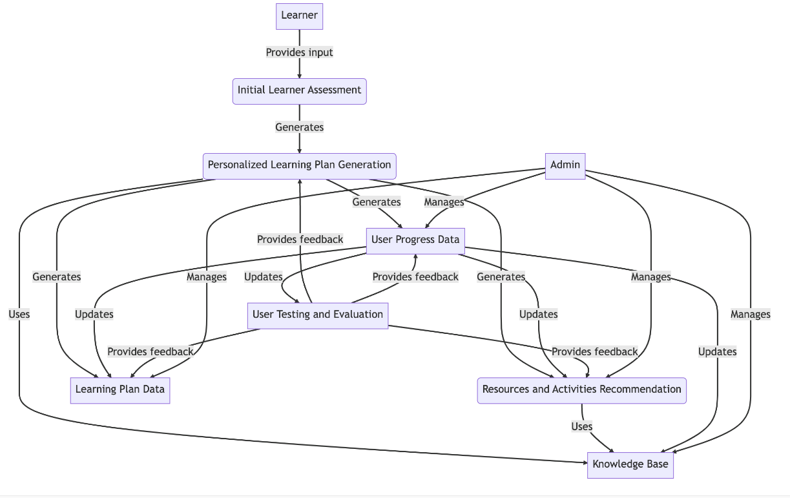

**Figure 1:** System Implementation Plan

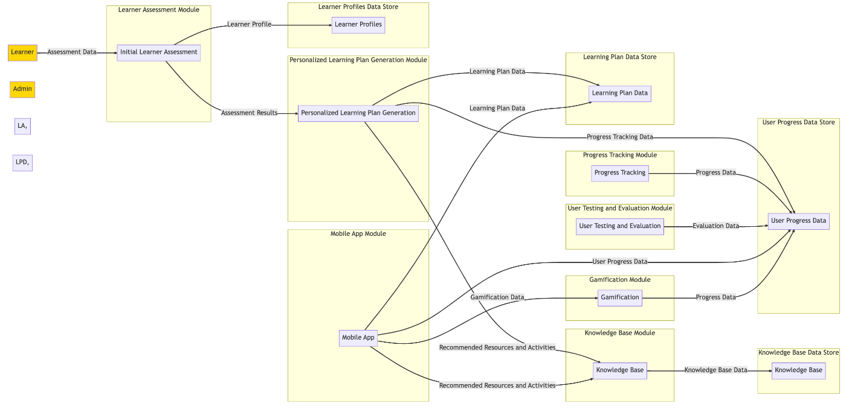

**Figure 2:** System Architecture

1. **SYSTEM REQUIREMENTS**

1. **Database Requirements:** User Data Management Database: Maintain and archive user profiles, containing private data, preferred methods of learning, and past performance information. Safely store login credentials, such as passwords, usernames, and access rights for various user roles. Record and monitor user interactions and activities inside the system to support customized learning pathways and progress tracking. Content Management Database: A wide variety of instructional materials, such as lectures, activities, tests, films, and interactive learning resources, should be stored and arranged. Facilitate the effective retrieval and distribution of educational materials in accordance with the curriculum's structure, learning objectives, and user preferences. To ensure that users have access to the most recent and pertinent instructional materials, use version control and content update management. Assessment and Analytics Database: Gather and evaluate user performance information, such as test scores, skill competency levels, and quiz scores, to deliver tailored feedback and suggestions for adaptive learning. To assess user progress, pinpoint areas of learning need, and guide administrators' and instructors' instructional tactics, provide thorough performance reports and analytics. User Interactions and Communications Database: Using chat rooms, discussion boards, and collaborative learning areas, encourage user involvement and conversation. Save pertinent interaction data for later use. Handle user-generated content while maintaining data security and integrity, such as comments, conversations, and shared resources.

2**. Software Requirements:** Programming Languages and Frameworks: Python, Java, or other suitable programming languages can be used to build the ITS's main features. Frameworks for developing web application components and ensuring effective application development, such as Django, Flask, or Spring. Databases: To store and maintain user data, instructional materials, and system logs, utilize relational database management systems like PostgreSQL, MySQL, or others. If the ITS handles a substantial amount of user-generated content, NoSQL databases like MongoDB or Cassandra can assist with scalability and the management of unstructured data.

Web Development Technologies: To offer a seamless user experience and create interactive and user-friendly interfaces, make use of HTML, CSS, and JavaScript. Real-time interactions and dynamic content changes can be achieved with AJAX (Asynchronous JavaScript and XML) without the need for page reloads.

Integrated Development Environments (IDEs): Eclipse, PyCharm, IntelliJ IDEA, or other suitable IDEs for efficient writing, debugging, and testing of the ITS application. Text editors like Atom, Sublime Text, or Visual Studio Code are handy for quick development tasks and speedy script editing.

APIs: Utilize APIs to facilitate data sharing and interoperability with other educational technologies by integrating learning management systems (LMS), educational portals, or external services.

**3. Hardware Requirements:** For the optimal performance of the system, it is imperative to implement high-capacity servers that house ample RAM, possess formidable computational power, and boast a substantial reservoir of storage capacity from a hardware perspective. Moreover, the integration of cutting-edge Graphics Processing Units (GPUs) takes center stage in adeptly managing the intricacies of advanced machine learning algorithms, while concurrently addressing the computationally demanding tasks intertwined with the domain of natural language processing. Furthermore, it emerges as a non-negotiable necessity for the system to operate fluidly across an eclectic spectrum of devices, including but not limited to tablets, smartphones, laptops, and desktop PCs. This imperative ensures not only wide-reaching accessibility for an extensive user base but also guarantees the versatility of user interactions spanning a multifaceted realm of technological platforms.

1. **ADVANTAGES OF INTELLIGENT TUTORING SYSTEM**

**1. Personalized Learning:** ITS enhances learning by providing tailored educational experiences that align with individual student requirements, competencies, and preferred learning methods, fostering more effective and engaging learning.

**2. Adaptive Instruction:** ITS dynamically customizes the level of challenge and support in activities and content to match each student's progress and pace, ensuring an optimal learning experience.

**3. Available 24/7:** The system's flexibility and accessibility cater to students with diverse schedules and learning preferences, enabling them to access it at any time and from any location.

**4. Uniform Teaching:** ITS provides standardized instruction, guaranteeing that all learners, regardless of their geographical location or access to educational resources, receive consistent and high-quality content and guidance.

**5. Interactive Learning Environment:** Leveraging ITS's interactive and multimedia-rich materials can enhance students' motivation and cultivate their interest in the subject matter, fostering a more immersive and engaging learning environment.

**6. Fosters Self-Directed Learning:** ITS plays a pivotal role in nurturing students' self-directed learning abilities and fostering a sense of autonomy, both of which are essential for lifelong learning.

**7. Scalability and Cost-Effectiveness:** ITS presents a cost-effective solution for providing personalized instruction and support to a diverse student population, thanks to its ability to scale to accommodate numerous users.

1. **APPLICATIONS OF INTELLIGENT TUTORING SYSTEM**

**1. Higher Education:** The applications of ITS in higher education encompass assisting with research methodologies, enhancing access to advanced learning materials, facilitating complex courses, and furnishing personalized feedback on academic assignments.

**2. Professional Training and Development:** ITS can be utilized in corporate training programs, professional development courses, and skills enhancement seminars, providing customized learning experiences tailored to the unique requirements of professionals across various sectors.

**3. STEM Education (Science, Technology, Engineering, and Mathematics):** ITS can enhance STEM education by utilizing interactive simulations, virtual experiments, and problem-solving exercises to help students efficiently grasp complex scientific and mathematical concepts.

**4. Special Education:** ITS can assist students with special education needs by offering individualized support, adaptive materials, and customized learning experiences. This approach promotes inclusive education and addresses a variety of learning requirements.

**5. Test Preparation and Exam Coaching:** ITS can help students achieve their academic goals by providing

tailored preparation for competitive exams and standardized tests. This includes personalized study programs, practice questions, and performance monitoring.

**6. Vocational Training:** ITS can support programs that prepare students for specific occupations and real-world work positions by offering interactive courses, realistic simulations, and real-world case studies.

**7. Healthcare Education:** ITS can enhance medical and healthcare education by incorporating case-based learning, diagnostic training, and virtual patient simulations, helping students develop their clinical reasoning and decision-making abilities.

1. **FUTURE SCOPE**

Creating ITS that is even more adaptable and individualized to cater to a broad spectrum of learning preferences, unique styles, and innovative teaching methods. Exploring the possibilities of integrating VR and AR technologies to construct interactive, immersive learning environments that allow students to engage more deeply and experientially with challenging concepts and simulations.

Advancing ITS to incorporate empathy and emotional intelligence, enabling it to identify and respond to students' emotional states and learning needs, leading to more holistic and supportive learning environments. Enhancing the effectiveness of feedback and guidance mechanisms by integrating conversational interfaces and advanced natural language processing (NLP) into ITS to facilitate more natural and interactive communication between the learner and the system. Leveraging state-of-the-art data analytics and learning analytics methodologies to gain a deeper insight into student learning preferences, behaviors, and performance trends, empowering educators and administrators to make more informed decisions. Developing an ITS that can offer recommendations and personalized learning materials tailored to each learner's interests, learning profiles, and skill levels, fostering a dynamic and engaging learning environment. Exploring the establishment of a comprehensive and integrated educational ecosystem by integrating ITS with other innovative educational technologies, including personalized learning platforms, adaptive learning management systems, and blockchain for certification.

Researchers, educators, and technologists can collaborate to advance the potential of ITS by focusing on these future domains. This will pave the way for more innovative and impactful solutions that will shape the future of education and learning delivery.

1. **CONCLUSION**

In summary, the proposed AI-based intelligent web tutoring system has the potential to revolutionize how students engage with and access instructional materials. This system can provide personalized learning objectives, recommend resources and activities, and assess progress in a way tailored to each student's needs, addressing the limitations of existing tutoring systems. This level of customization will not only motivate students to pursue further studies but also enhance the system's effectiveness.

Furthermore, there is an opportunity that the proposed approach can benefit students, teachers, and society. This approach can help bridge the gap between those who have access to high-quality education and those who do not by offering individualized and accessible instruction.

Moreover, the implementation of ITS for personalized learning fosters a student-centric approach to education, emphasizing the importance of continuous progress monitoring, customized support, and data-driven insights for teachers. Through the utilization of data analytics made possible by ITS, teachers can identify learning gaps, make well-informed instructional decisions, and provide targeted interventions to enhance student achievement.

While there are numerous advantages to employing ITS for personalized learning, it's crucial to acknowledge the potential drawbacks and challenges that may accompany its implementation. These challenges encompass technical issues, the necessity for adequate educator training and support, as well as concerns related to security and privacy.

Considering these factors, educators, administrators, and technology specialists should collaborate to ensure the effective utilization and sustainable deployment of these systems as they continually enhance and integrate personalized learning via ITS. By addressing these challenges and optimizing personalized learning, ITS can play a pivotal role in revolutionizing the field of education and equipping students with the essential skills and

knowledge needed to thrive in a dynamic global environment.

1. **REFERENCES**
2. Huanhuan Wang, Ahmed Tlili, Ronghuai Huang, Zhenyu Cai, Min Li, Zui Cheng, Dong Yang, Mengti Li, Xixian Zhu, Cheng Fei, “Examining the applications of intelligent tutoring systems in real educational contexts: A systematic literature review from the social experiment perspective” under exclusive licence to Springer Science + Business Media, LLC, part of Springer Nature, Educational Informatization Strategy Research Base, Ministry of Education, Beijing, China.
3. Martin Hlosla, Christothea Herodotou, Tina Papathoma, Anna Gillespie, Per Bergamin, “Predictive learning analytics in online education: A deeper understanding through explaining algorithmic errors” under The Swiss Distance University of Applied Sciences – 2022 (Fernfachhochschule Schweiz – FFHS), Schinerstrasse, Switzerland.
4. Karin Julia Rott, Lena Lao, Efthymia Petridou Bernhard Schmidt-Hertha, “Needs and requirements for an additional AI qualification during dual vocational training: Results from studies of apprentices and teachers” a 2022 Funded as an InnoVET project with funds from the German Federal Ministry of Education and Research.
5. Albert C.M Yang, Irene Y.L Chen, Brendan Flanagan, Hiroaki Ogata, “How students’ self-assessment behaviour affects their online learning performance” a 2022-year research paper published under A.C.M. Yang et al. his work was partly supported by JSPS Grant-in-Aid for Scientific Research (B) 20H01722, JSPS Grant-in-Aid for Scientific Research (S) 16H06304 and NEDO JPNP20006 and JPNP18013.
6. Nethra Vishwanathan, Sofia Meacham, Festus Fatai Adedoyin, “Enhancement of online education system by using a multi agent approach” A paper published in 2022 under Department of Computing and Informatics, Bournemouth University, UK
7. Hassan Khosravi, Simon Buckingham Shum, Guanliang Chen, Cristina Conati, Yi-Shan Tsai, Judy Kay, Simon Knight, Roberto Martinez-Maldonado, Shazia Sadiq, Dragan Gasavic, “Explainable Artificial Intelligence in education” – 2022 The University of Queensland, Brisbane - Australia, University of Technology Sydney - Australia Monash University - Australia, The University of British Columbia – Australia, The University of Sydney – Australia
8. Sein Minn, “AI-assisted knowledge assessment techniques for adaptive learning environments” – 2022 under Ecole Polytechnique, Institute Polytechnique de Paris, France
9. Thoufeeq Ahmed Syed, Vasile Palade, Rahat Iqbal, Smitha Sunil Kumaran Nair, “Building a dataset for Personalized Learning Recommendation System” – 2021- year paper published under Conventry University – UK and Muscat – Oman.
10. Meng Wang, Yu Liang, Wenjun Wu, “A Novel Intelligent System for Learning Programming” – 2020-year published paper under Beijing University of Technology.
11. Arthur C. Graesser, Xiangen Hu, Benjamin D. Nye, Kurt Vanlehn, Rohit Kumar, Cristina Heffernan, Neil Heffernan, Beverly Woolf, Andrew J. Hampton, “ElectronixTutor: an intelligent tutoring system with multiple learning resources for electronics” – 2018 published paper under Institute for Intelligent Systems, University of Memphis, Memphis, USA