**initDB.sql -- Automates creation of the products table**

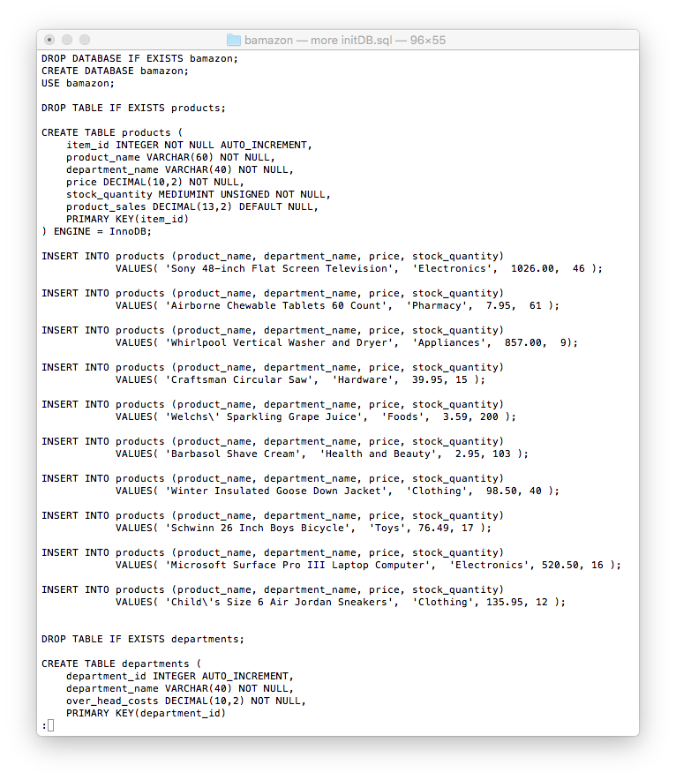

**Creation/Populating of products Table**

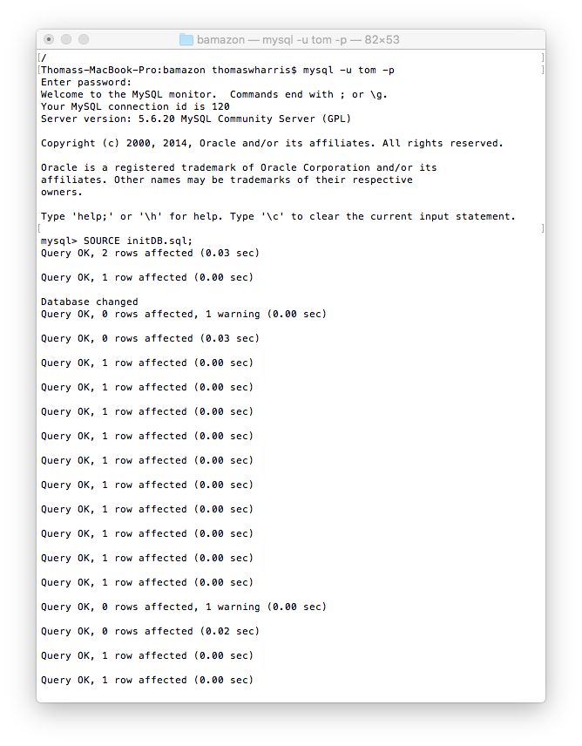

**Initial State of products Table**

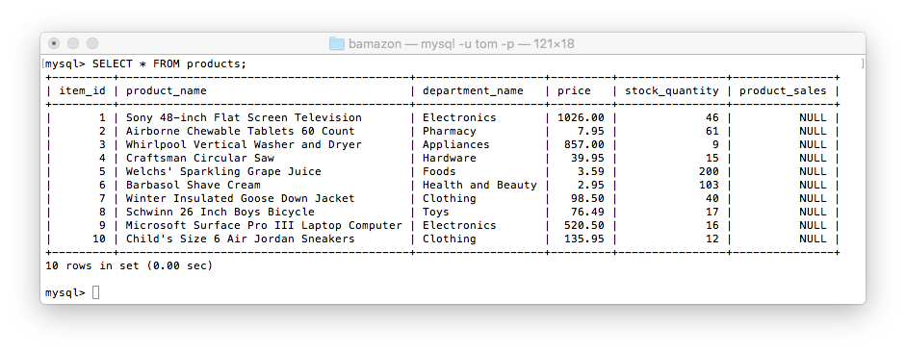

**Order Cannot be Fulfilled Because of Insufficient Stock**

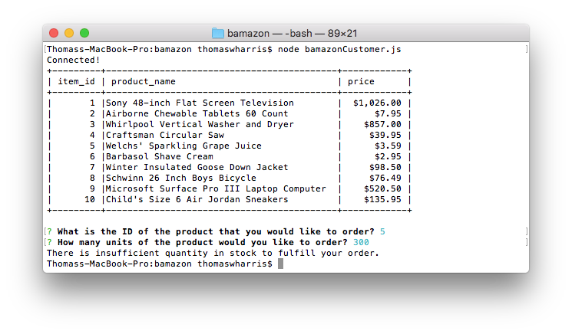

**Customer Has Entered an Invalid Item ID**

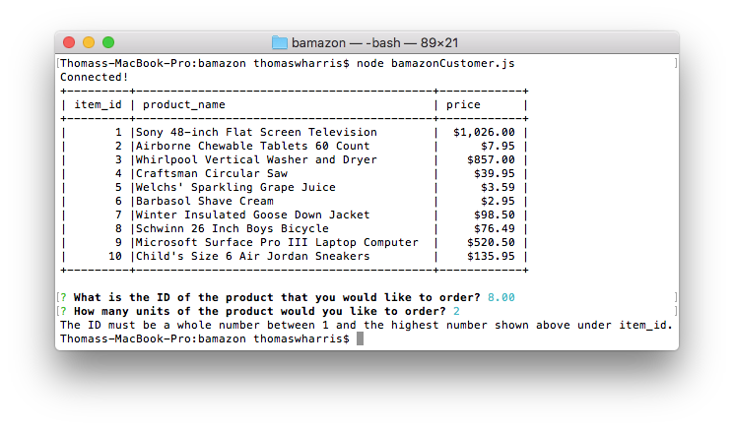

**Customer Has Entered an Invalid Quantity**

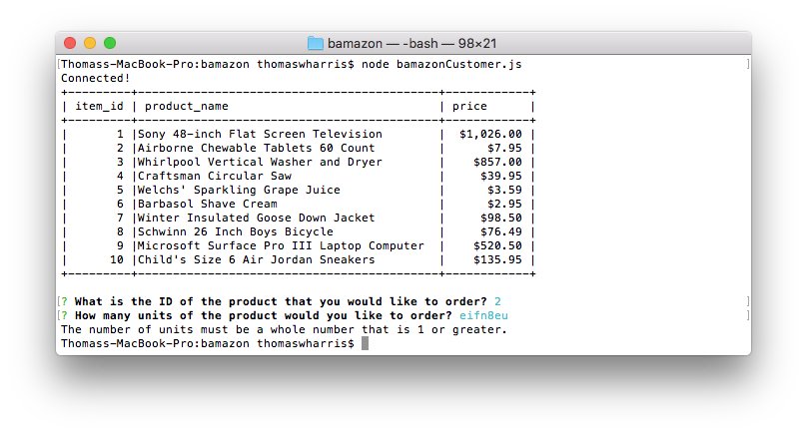

**State of ID 5 Before Successful Purchase**

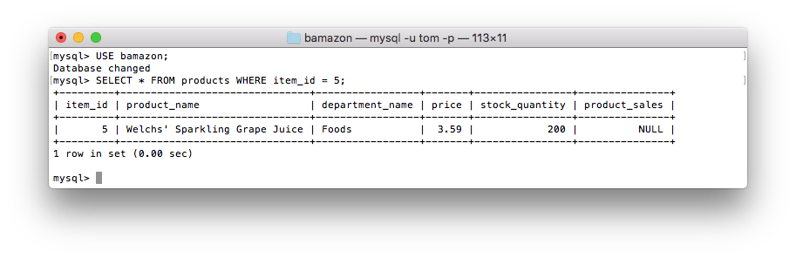

**A Purchase of Item ID 5 Has Been Successful**

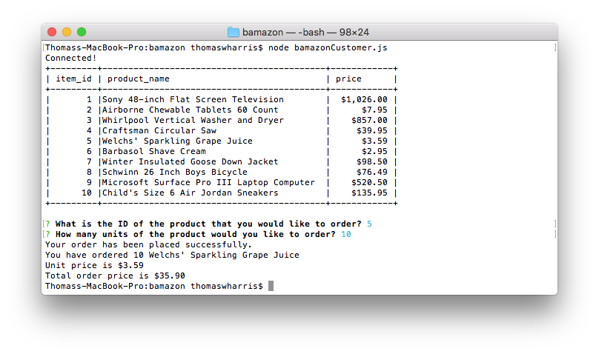

**State of ID 5 After Successful Purchase**

