***Basic Programs Using Class, Objects and methods***

**LAB - I**

**Object Oriented Programming (CSE2005)**

**Tharshith Goud**

*19BCN7112*

**SLOT - L6**

**Faculty: Dr Aravapalli Rama Satish**



**Question 1.A:** Create an application named Percentages whose main() method holds two double variables. Assign values to the variables. Pass both variables to a method named computePercent() that displays the two values and the value of the first number as a percentage of the second one. For example, if the numbers are 2.0 and 5.0, the method should display a statement similar to “2.0 is 40 percent of 5.0.” Then call the method a second time, passing the values in reverse order. Save the application as Percentages.java.

***Solution:***

class Percentages{

    public static void main(String[] args){

        double x=2.0;

        double y=5.0;

        computepercent(x,y);

        computepercent(x,y);

    }

    static void computepercent(double x,double y){

         System.out.println(x+" is "+(x/y)*100+" percent of "+y);

    }

}

**Output:**

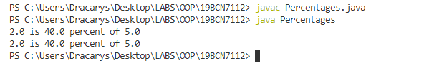

**Question 1.B:** Modify the Percentages class to accept the values of the two doubles from a user at the keyboard. Save the file as Percentages2.java.

***Solution:***

import java.util.Scanner;

class Percentages2{

    static Scanner in = new Scanner(System.in);

    public static void main(String[] args){

        computepercent();

        computepercent();

    }

    static void computepercent(){

        System.out.println("Enter the First Double Number");

        double x = in.nextDouble();

        System.out.println("Enter the Second Double Number");

        double y = in.nextDouble();

        System.out.println(x+" is "+(x/y)*100+" percent of "+y);

    }

}

**Output:**

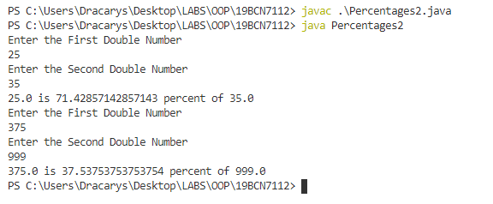

**Question 2:** There are 12 inches in a foot and 3 feet in a yard. Create a class named InchConversion. Its main() method accepts a value in inches from a user at the keyboard, and in turn passes the entered value to two methods. One converts the value from inches to feet, and the other converts the same value from inches to yards. Each method displays the results with appropriate explanation. Save the application as InchConversion.java.

***Solution:***

import java.util.Scanner;

class InchConversion{

    static Scanner in = new Scanner(System.in);

    public static void main(String[] args){

       System.out.println("Enter a values in terms of Inches: ");

       double n = in.nextDouble();

       IntoFeet(n);

       IntoYards(n);

    }

    static void IntoFeet(double n){

        System.out.println(n+" inches is equals to "+ n/12 + " foot");

    }

    static void IntoYards(double n){

         System.out.println(n+" inches is equals to "+ n/(12)*3 + " Yards");

    }

}

**Output:**

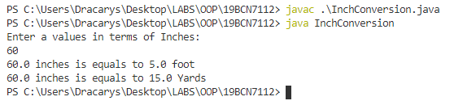

**Question 3:** Assume that a gallon of paint covers about 350 square feet of wall space. Create an application with a main() method that prompts the user for the length, width, and height of a rectangular room. Pass these three values to a method that does the following:

•• Calculates the wall area for a room

•• Passes the calculated wall area to another method that calculates and returns the number of gallons of paint needed

•• Displays the number of gallons needed

•• Computes the price based on a paint price of $32 per gallon, assuming that the painter can buy any fraction of a gallon of paint at the same price as a whole gallon

•• Returns the price to the main() method

The main() method displays the final price. For example, the cost to paint

a 15-by-20-foot room with 10-foot ceilings is $64. Save the application as

PaintCalculator.java.

***Solution:***

import java.util.Scanner;

class PaintCalculator{

    static Scanner in = new Scanner(System.in);

    public static void main(String[] args){

       System.out.println("Enter the length of the Rectangular room: ");

       double l = in.nextDouble();

       System.out.println("Enter the height of the Rectangular room: ");

       double h = in.nextDouble();

       System.out.println("Enter the breadth of the Rectangular room: ");

       double b = in.nextDouble();

       double a = area(l,h,b);

       System.out.println("Area of the room's wall space is "+a+" sq.ft");

       double p = paint(a);

       print(p);

       double c = cost(p);

       System.out.println("Total cost of painting to paint a room of dimensions "+l+"x"+h+"x"+b+" is "+c);

    }

    static double area(double l,double b, double h){

        return 2*(l*b)+2*(b*h)+2*(h*l);

    }

    static double paint(double a){

         return a/350;

     }

     static void print(double p){

      System.out.println("Total gallons of paint required is "+p);

  }

     static double cost(double p){

        return p*32;

     }

}

**Output:**

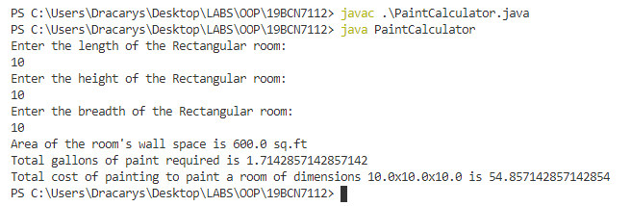

**Question 4:** Herbert’s Home Repair estimates each job cost as the cost of materials plus $35 per hour while on the job, plus $12 per hour for travel time to the job site. Create a class that contains a main() method that prompts the user for the name of a job (for example, Smith bathroom remodel), the cost of materials, the number of hours of work required, and the number of hours travel time. Pass the numeric data to a method that computes estimate for the job and returns the computed value to the main() method where the job name and estimated price are displayed. Save the program as JobPricing.java.

***Solution:***

import java.util.Scanner;

class JobPricing{

        static Scanner in = new Scanner(System.in);

        public static void main(String[] args){

        System.out.println("Enter the name of Job: ");

        String job = in.nextLine();

        System.out.println("Enter the cost of materials: ");

        double cost = in.nextDouble();

        System.out.println("Enter No. of hours worked: ");

        double hours = in.nextDouble();

        System.out.println("Enter Travel Time: ");

        double travel = in.nextDouble();

        double price = estimateadprice(cost,hours,travel);

        System.out.println("Total estimatead cost to finish "+job+" is $"+price);

        }

        static double estimateadprice(double c, double h, double t){

                 return (c+(h*35)+(t*12));

        }

}

**Output:**

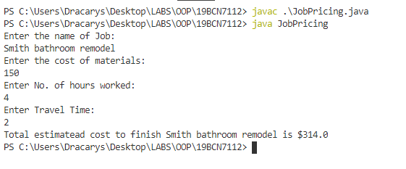

**Question 5.A:** Create a class named Student that has fields for an ID number, number of credit hours earned, and number of points earned. (For example, many schools compute grade point averages based on a scale of 4, so a three-credit-hour class in which a student earns an A is worth 12 points.) Include methods to assign values to all fields. A Student also has a field for grade point average. Include a method to compute the grade point average field by dividing points by credit hours earned. Write methods to display the values in each Student field. Save this class as Student.java.

***Solution:***

import java.util.Scanner;

class Student1{

  String ID;

  double c;

  double p;

  double gpa;

  void setID(String ID){

    this.ID = ID;

   }

  void setc(double c){

      this.c = c;

   }

  void setp(double p){

      this.p = p;

   }

void calculategpa(){

       this.gpa = p/c;

   }

  void displayID(){

    System.out.println("Your ID is "+ID);

   }

  void displaycred(){

    System.out.println("Your total credits is "+c);

   }

   void displayp(){

    System.out.println("No of points earned is "+p);

   }

   void displaygpa(){

    System.out.println("Your GPA is "+gpa);

   }

}

class Student{

  public static void main(String[] args){

    Student1 ob = new Student1();

        ob.setID("19BCN7112");

        ob.setc(20);

        ob.setp(76);

        ob.calculategpa();

        ob.displayID();

        ob.displaycred();

        ob.displayp();

        ob.displaygpa();

  }

}

**Output:**

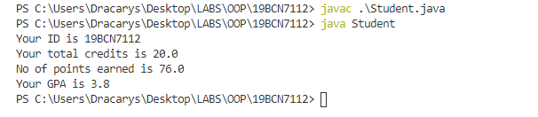

**Question 5.B:** Write a class named ShowStudent that instantiates a Student object from the class you created and assign values to its fields. Compute the Student grade point average, and then display all the values associated with the Student. Save the application as ShowStudent.java.

***Solution: (The code for 5a and 5b is almost same)***

class Student{

  String ID;

  double c;

  double p;

  double gpa;

  void setID(String ID){

    this.ID = ID;

   }

  void setc(double c){

      this.c = c;

   }

  void setp(double p){

      this.p = p;

   }

  void calculategpa(){

       this.gpa = p/c;

   }

  void displayID(){

    System.out.println("Your ID is "+ID);

   }

  void displaycred(){

    System.out.println("Your total credits is "+c);

   }

   void displayp(){

    System.out.println("No of points earned is "+p);

   }

   void displaygpa(){

    System.out.println("Your GPA is "+gpa);

   }

}

class ShowStudent{

  public static void main(String[] args){

    Student ob = new Student();

        ob.setID("19BCN7112");

        ob.setc(20);

        ob.setp(76);

        ob.calculategpa();

        ob.displayID();

        ob.displaycred();

        ob.displayp();

        ob.displaygpa();

  }

}

**Output:**



**Question 5.C:** Create a constructor for the Student class you created. The constructor should initialize each Student’s ID number to 9999, his or her points earned to 12, and credit hours to 3 (resulting in a grade point average of 4.0). Write a program that demonstrates that the constructor works by instantiating an object and displaying the initial values. Save the application as ShowStudent2.java.

***Solution:***

class Student{

    String ID;

    double c;

    double p;

    double gpa;

    Student(){

       this.ID = "9999";

       this.c=3;

       this.p=12;

    }

    void setID(String ID){

      this.ID = ID;

     }

    void setc(double c){

        this.c = c;

     }

    void setp(double p){

        this.p = p;

     }

    void calculategpa(){

         this.gpa = p/c;

     }

    void displayID(){

      System.out.println("Your ID is "+ID);

     }

void displaycred(){

      System.out.println("Your total credits is "+c);

     }

     void displayp(){

      System.out.println("No of points earned is "+p);

     }

     void displaygpa(){

      System.out.println("Your GPA is "+gpa);

     }

  }

  class ShowStudent2{

    public static void main(String[] args){

      Student ob = new Student();

          ob.calculategpa();

          ob.displayID();

          ob.displaycred();

          ob.displayp();

          ob.displaygpa();

    }

  }

**Output:**

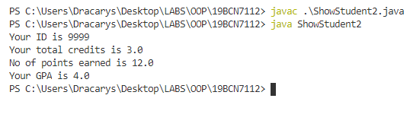

**Question 6.A:**

Create a class named Lease with fields that hold an apartment tenant’s name, apartment number, monthly rent amount, and term of the lease in months. Include a constructor that initializes the name to “XXX”, the apartment number to 0, the rent to 1000, and the term to 12. Also include methods to get and set each of the fields. Include a nonstatic method named addPetFee() that adds $10 to the monthly rent value and calls a static method named explainPetPolicy() that explains the pet fee. Save the class as Lease.java.

***Solution:***

class Lease{

    String tennant;

    int aptNo;

    double rent;

    int term;

    Lease(){

        tennant = "XXX";

        aptNo = 0;

        rent = 1000;

        term = 12;

    }

    public String getTennant() {

        return tennant;

    }

    public void setTennant(String tennant) {

        this.tennant = tennant;

    }

    public int getAptNo() {

        return aptNo;

    }

    public void setAptNo(int aptNo) {

        this.aptNo = aptNo;

    }

    public double getRent() {

        return rent;

    }

    public void setRent(double rent) {

        this.rent = rent;

    }

    public int getTerm() {

        return term;

    }

    public void setTerm(int term) {

        this.term = term;

    }

    public void addPetFee(){

        this.rent = rent+10;

    }

    public static void explainPetPolicy(){

        System.out.println("You are Havihg pet So you need to pay a $10 premium");

    }

}

**Output:**

***No Output***

**Question 6.B:** Create a class named TestLease whose main() method declares four Lease objects. Call a getData() method three times. Within the method, prompt a user for values for each field for a Lease, and return a Lease object to the main() method where it is assigned to one of main()’s Lease objects. Do not prompt the user for values for the fourth Lease object, but let it continue to hold the default values. Then, in main(), pass one of the Lease objects to a showValues() method that displays the data. Then call the addPetFee() method using the passed Lease object and confirm that the fee explanation statement is displayed. Next, call the showValues() method for the Lease object again and confirm that the pet fee has been added to the rent. Finally, call the showValues() method with each of the other three objects; confirm that two hold the values you supplied as input and one holds the constructor default values. Save the application as TestLease.java.

***Solution:***

import java.util.Scanner;

class TestLease{

       static Scanner in = new Scanner(System.in);

       public static void main(String[] ar){

       Lease ob1 = new Lease();

       Lease ob2 = new Lease();

       Lease ob3 = new Lease();

       Lease ob4 = new Lease();

       getData(ob1);

       getData(ob2);

       getData(ob3);

       showValues(ob1);

       ob1.addPetFee();

       ob1.explainPetPolicy();

        showValues(ob1);

        showValues(ob2);

        showValues(ob3);

        showValues(ob4);

       }

       public static void getData(Lease ob){

          System.out.print("Input the name of tenant: ");

          String name = in.nextLine();

       System.out.print("Input the Apartment number: ");

       int apt = in.nextInt();

       System.out.print("Input the Monthly Rent: ");

       double rent = in.nextDouble();

       System.out.print("Input Total Term in Months: ");

       int term = in.nextInt();

       ob.setTennant(name);

       ob.setAptNo(apt);

       ob.setRent(rent);

       ob.setTerm(term);

       in.nextLine();

       }

       public static void showValues(Lease ob){

              System.out.println("The Name of Tennant is "+ob.tennant+" He lives in Apartment number "+ob.aptNo+". His Monthly rent is "+ ob.rent+" his lease term is "+ob.term);

       }

}

**Output:**

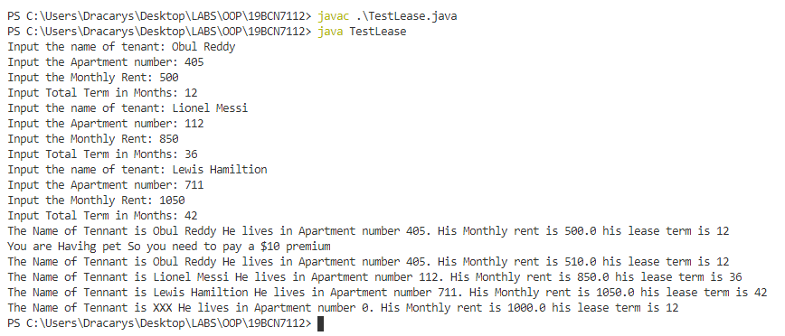

**THE END**