**APPLICATION OF EUCLIDIAN ALGORITHM IN**

***“PARTIAL FRACTIONS”***

**DIGITAL ASSIGNMENT-I**

**DISCRETE MATHEMATICAL STRUCTURES(MAT1003)**

**THARSHITH GOUD**

19BCN7112

**SLOT - C1**

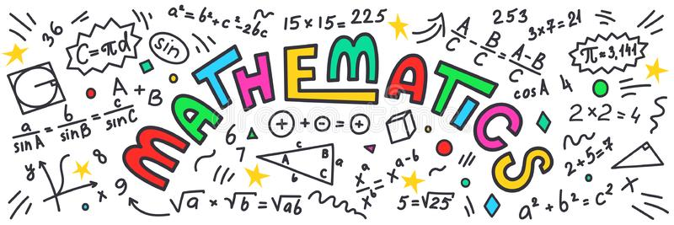

**OBJECTIVE:**

Euclidean Algorithm is the most optimized and efficient method to find the Greatest Common Divisor (GCD) of two numbers. It also has some other applications in Mathematics. One such Application is Solving Partial Fraction using Euclidean Algorithm instead of the conventional method. This application is known as the partial fraction’s theorem.

**What is a Partial Fraction?**

The partial fraction decomposition or partial fraction expansion of a rational fraction is an operation that consists of expressing the fraction as a sum of a polynomial and one or several fractions with a simpler denominator.

**Extended Euclidian Algorithm:**

In [arithmetic](https://en.wikipedia.org/wiki/Arithmetic) and [computer programming](https://en.wikipedia.org/wiki/Computer_programming), the extended Euclidean algorithm is an extension to the [Euclidean algorithm](https://en.wikipedia.org/wiki/Euclidean_algorithm), and computes, in addition to the [greatest common divisor](https://en.wikipedia.org/wiki/Greatest_common_divisor) of integers a and b, which are integers S and T such that:

**Sa + Tb = gcd(a, b)**

**Note:**

* In this assignment I have only implemented partial fraction expansion for two factors using Extended Euclidian Algorithm. It is also possible to apply the same concept for a general scenario i.e., for more than 2 factors.
* Mathematical tool used for this assignment is MATLAB.

**IMPLEMENTATION:**

Let n(x) be the numerator of the fraction, which we want to expand. $d_{1}\left(x\right) and d_{2}(x)$ are the factors of the denominator of the given fraction. Then we can find polynomials $h_{1}\left(x\right) and h_{2}\left(x\right)$ with

$$\frac{n\left(x\right)}{d_{1}\left(x\right)d_{2}\left(x\right)} = \frac{h_{1}\left(x\right)}{d_{1}\left(x\right)} + \frac{h_{2}\left(x\right)}{d_{2}\left(x\right)}$$

By the Extended Euclidean Algorithm, we can find the polynomials s(x), t(x) and g(x). where g(x) is the GCD of $d_{1}\left(x\right){and d}_{2}\left(x\right)$ such that

$$1= d_{1}(x)s(x) + d_{2}(x)t(x)$$

By the division algorithm, if we divide t(x)n(x) by $d_{1}\left(x\right)$ we get,

$$t(x)n(x) = d_{1}(x)q_{1}(x) + h_{1}(x)$$

By the division algorithm, if we divide s(x)n(x) by $d_{2}\left(x\right)$ we get,

$$s(x)n(x) = d_{2}(x)q_{2}(x) + h_{2}(x)$$

Here the remainder of the division gives us the result which we require for the partial fraction expansion.

**ILLUSTRATION:**

$$Write the partial fraction expansion of \frac{8x+7}{\left(x+2\right)\left(x-1\right)} using$$

1. Regular Method
2. Extended Euclidian Algorithm

**SOLUTION: A.** Using the regular method

$$\frac{8x+7}{\left(x+2\right)\left(x-1\right)} =\frac{A}{x+2}+\frac{B}{x-1}$$

$$\frac{8x+7}{\left(x+2\right)\left(x-1\right)} = \frac{ A\left(x-1\right)+B(x+2)}{(x+2)(x-1)}$$

$$8x+7 = A\left(x-1\right)+B(x+2)$$

By comparing the coefficients of the x and constant variable gives us,

$$A+B = 8$$

$$-A+2B=7$$

After solving the above equations, we get the values of A and B as 3 and 5

$$A=3 and B=5$$

$$\frac{8x+7}{\left(x+2\right)\left(x-1\right)} =\frac{3}{x+2}+\frac{5}{x-1}$$

**B. Using Extended Euclidian Algorithm**

$$\frac{8x+7}{\left(x+2\right)\left(x-1\right)} =\frac{h_{1}\left(x\right)}{x+2}+\frac{h_{2}\left(x\right)}{x-1}$$

Given,

n(x) = 8x+7

$$d_{1}\left(x\right)=x+2$$

$$d_{2}\left(x\right)=x-1$$

Finding the GCD of $d_{1}\left(x\right) and d_{2}\left(x\right)$ using the Euclidian Algorithm,

Gives us the GCD of $d_{1}\left(x\right) and d_{2}\left(x\right)$ is 1 and by Extended Euclidian Algorithm,

The values of s(x) and t(x) as $\frac{1}{3} and-\frac{1}{3}$

By the division algorithm, if we divide t(x)n(x) with $d_{1}\left(x\right)$ we get,

$$t(x)n(x) = d_{1}(x)q_{1}(x) + h_{1}(x)$$

$$-\frac{1}{3} X (8x+7) =\left(x+2\right)\left(-\frac{8}{3}\right)+ 3$$

Here $h_{1}\left(x\right)=3$.

By the division algorithm, if we divide s(x)n(x) with $d_{2}\left(x\right)$ we get,

$$s(x)n(x) = d_{2}(x)q_{2}(x) + h_{2}(x)$$

$$\frac{1}{3} X (8x+7) =\left(x+2\right)\left(\frac{8}{3}\right)+ 5$$

Here $h_{2}\left(x\right)=5$.

Putting the values in the equation gives us,

$$\frac{8x+7}{\left(x+2\right)\left(x-1\right)} =\frac{3}{x+2}+\frac{5}{x-1}$$

By the above example we can clearly see that Partial fractions can be solved by Extended Euclidian Algorithm.

**MATLAB IMPLEMENTATION:**

clc

close all

syms x

n = input('Equation of the Numerator: ');

d1 = input('Enter First factor in the denominator: ');

d2 = input('Enter Second factor in the denominator: ');

[g,s,t]=gcd(d1,d2);

[q1, h1] = quorem(n*t,d1);

[q2, h2] = quorem(n*s,d2);

disp('The Expanded Form of the given Fraction is: ');

disp(h1/d1+h2/d2);

**OUTPUT:**

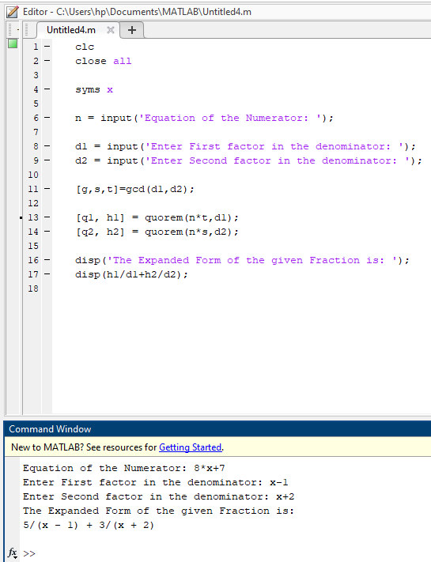

**REFERENCES:**

1. Mathematics Magazine Vol. 28, No. 2 (Nov. - Dec., 1954), pp. 71-82

<https://www.jstor.org/stable/3029367>

1. Definitions of Partial Fractions and Euclidian algorithm - Wikipedia

<https://en.wikipedia.org/>

**GITHUB Repository of the MATLAB code:**

<https://github.com/tharshith44/discreteMathsAssignment>

**Some Other Applications of Euclidian Algorithm are:**

* It is widely used in cryptography
* Approximations of numbers by rationals
* Solving linear Diophantine equation, etc…

**THANK YOU**