# Webservices

SOAP REST

JAX-WS JAX-RS

App server 2

App server 1

**App 2**

**App 1**

**WS**

In order to call this method From other server

over the network

configure the method as **Web Service**

Advantage:

1, App1 is implemented in java

App2 is in .net, but can call java implemented webService(method1

## Web service vs. API

### Web service

collection of **open** protocols and standards used for exchanging data between systems or applications.

Is kind of API

### API (Application programming Interface)

It is a software interface. Allows 2 applications to interact, without any user action

Here also no need know how other service implemented

API is specification of possible interactions with a software component.

Software component

Specifications

Just abstract form(simplified easy to handle form) of complex system.

Example: Amazon order button

Just one click, in backend getting your address, verify visa card … many thinks happens

#### The java api

Example: collections api

 library refers to the code itself, while API refers to the interface.

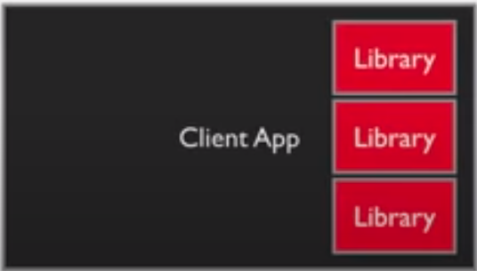

Library: actual code, api: like interface

When developing local java application we have to use

# Rest API

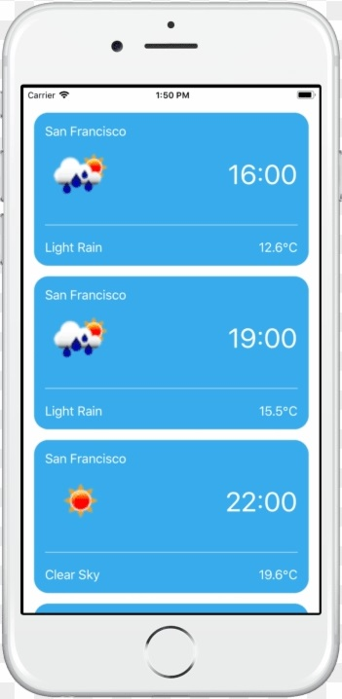

Request

Response

(HTML/ XML/ JSON)

Java Object

JSON / XML

(Representational state) Transfer