# Serialization

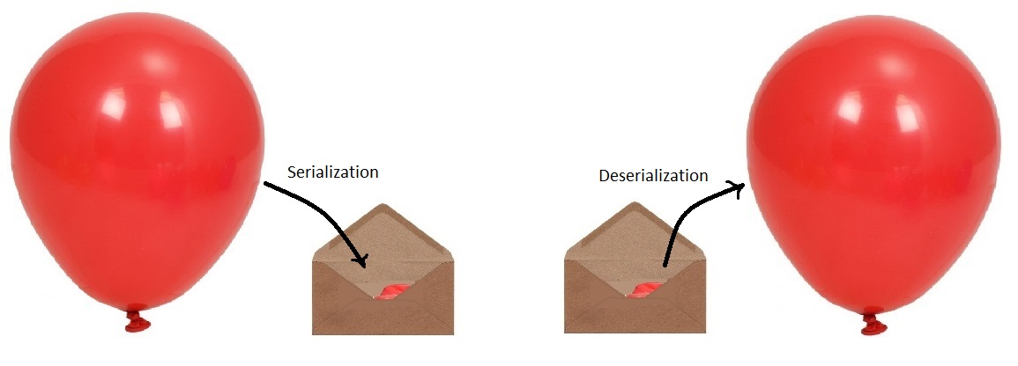

Process of saving a state of an Object to a file.

Process of Converting Object From java supported form to File supported form/ network supported form.

Java supported form

File supported form

Network supported form

### Deserialization

Process of reading a state of an Object from a file.

Process of Converting Object From File supported form/ network supported form to java supported form.