**Chapter 6. Building your first deep neural network: introduction to backpropagation**

**In this chapter**

* The streetlight problem
* Matrices and the matrix relationship
* Full, batch, and stochastic gradient descent
* Neural networks learn correlation
* Overfitting
* Creating your own correlation
* Backpropagation: long-distance error attribution
* Linear versus nonlinear
* The secret to sometimes correlation
* Your first deep network
* Backpropagation in code: bringing it all together

“O Deep Thought computer,” he said, “the task we have designed you to perform is this. We want you to tell us...” he paused, “The Answer.”

*Douglas Adams, The Hitchhiker’s Guide to the Galaxy*

**The streetlight problem**

**This toy problem considers how a network learns entire datasets**

Consider yourself approaching a street corner in a foreign country. As you approach, you look up and realize that the street light is unfamiliar. How can you know when it’s safe to cross the street?

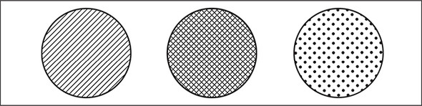

You can know when it’s safe to cross the street by interpreting the streetlight. But in this case, you don’t know how to interpret it. Which light combinations indicate when it’s time to *walk*? Which indicate when it’s time to *stop*? To solve this problem, you might sit at the street corner for a few minutes observing the correlation between each light combination and whether people around you choose to walk or stop. You take a seat and record the following pattern:

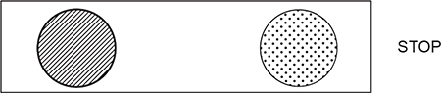

Livebook feature - Free preview

In livebook, text is yatplciqd in books you do not own, but our free preview unlocks it for a couple of minutes.

OK, nobody walked at the first light. At this point you’re thinking, “Wow, this pattern could be anything. The left light or the right light could be correlated with stopping, or the central light could be correlated with walking.” There’s no way to know. Let’s take another datapoint:



People walked, so something about this light changed the signal. The only thing you know for sure is that the far-right light doesn’t seem to indicate one way or another. Perhaps it’s irrelevant. Let’s collect another datapoint:

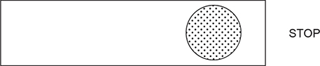

Now you’re getting somewhere. Only the middle light changed this time, and you got the opposite pattern. The working hypothesis is that the *middle* light indicates when people feel safe to walk. Over the next few minutes, you record the following six light patterns, noting when people walk or stop. Do you notice a pattern overall?

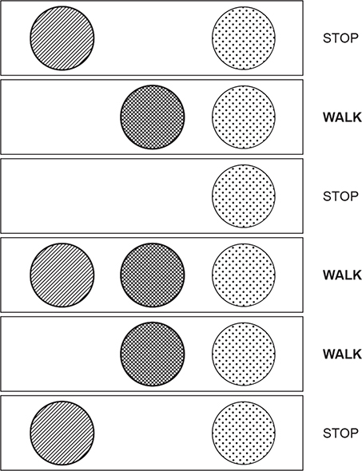

As hypothesized, there is a *perfect correlation* between the middle (crisscross) light and whether it’s safe to walk. You learned this pattern by observing all the individual datapoints and *searching for correlation*. This is what you’re going to train a neural network to do.

**Preparing the data**

**Neural networks don’t read streetlights**

In the previous chapters, you learned about supervised algorithms. You learned that they can take one dataset and turn it into another. More important, they can take a dataset of *what you know* and turn it into a dataset of *what you want to know*.

How do you train a supervised neural network? You present it with two datasets and ask it to learn how to transform one into the other. Think back to the streetlight problem. Can you identify two datasets? Which one do you always know? Which one do you want to know?

You do indeed have two datasets. On the one hand, you have six streetlight states. On the other hand, you have six observations of whether people walked. These are the two datasets.

You can train the neural network to convert from the dataset you *know* to the dataset that you *want to know*. In this particular real-world example, you know the state of the streetlight at any given time, and you want to know whether it’s safe to cross the street.

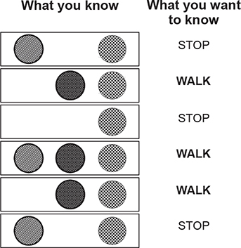

To prepare this data for the neural network, you need to first split it into these two groups (what you know and what you want to know). Note that you could attempt to go backward if you swapped which dataset was in which group. For some problems, this works.

### Matrices and the matrix relationship

#### Translate the streetlight into math

Math doesn’t understand streetlights. As mentioned in the previous section, you want to teach a neural network to translate a streetlight pattern into the correct stop/walk pattern. The operative word here is *pattern*. What you really want to do is mimic the pattern of the streetlight in the form of numbers. Let me show you what I mean.

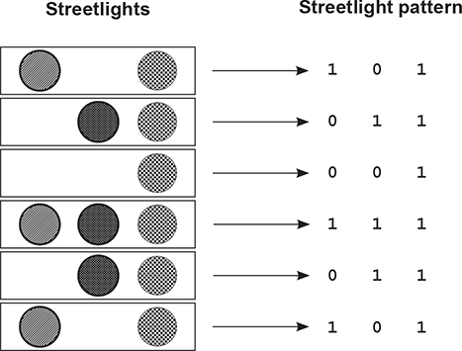

Notice that the pattern of numbers shown here mimics the pattern from the streetlights in the form of 1s and 0s. Each light gets a column (three columns total, because there are three lights). Notice also that there are six rows representing the six different observed streetlights.

This structure of 1s and 0s is called a *matrix*. This relationship between the rows and columns is common in matrices, especially matrices of data (like the streetlights).

In data matrices, it’s convention to give each *recorded example* a single *row*. It’s also convention to give each *thing being recorded* a single *column*. This makes the matrix easy to read.

So, a column contains every state in which a thing was recorded. In this case, a column contains every on/off state recorded for a particular light. Each row contains the simultaneous state of every light at a particular moment in time. Again, this is common.

#### Good data matrices perfectly mimic the outside world

The data matrix doesn’t have to be all 1s and 0s. What if the streetlights were on dimmers and turned on and off at varying degrees of intensity? Perhaps the streetlight matrix would look more like this:

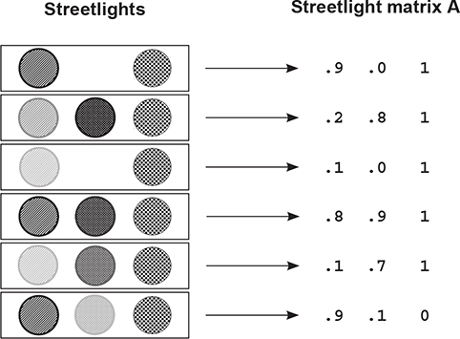

Matrix A is perfectly valid. It’s mimicking the patterns that exist in the real world (streetlight), so you can ask the computer to interpret them. Would the following matrix still be valid?

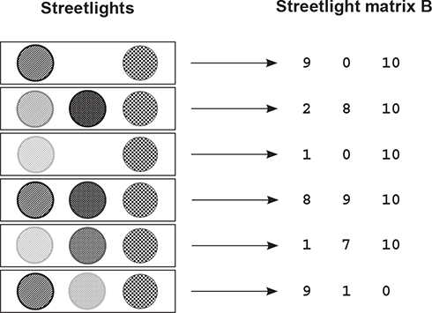

Matrix (B) *is* valid. It adequately captures the relationships between various training examples (rows) and lights (columns). Note that Matrix A * 10 == Matrix B (A * 10 == B). This means these matrices are *scalar multiples* of each other.

#### Matrices A and B both contain the same underlying pattern

The important takeaway is that an *infinite* number of matrices exist that perfectly reflect the streetlight patterns in the dataset. Even the one shown next is perfect.

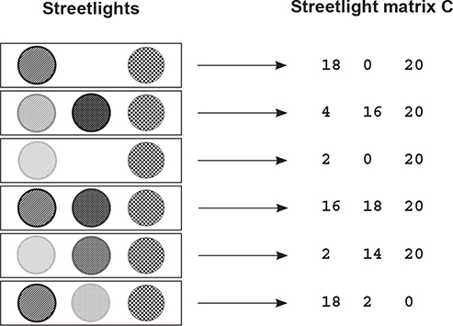

It’s important to recognize that the underlying pattern isn’t the same as the matrix. It’s a *property of* the matrix. In fact, it’s a property of all three of these matrices (A, B, and C). The pattern is what each of these matrices is *expressing*. The pattern also existed in the streetlights.

This *input data pattern* is what you want the neural network to learn to transform into the *output data pattern*. But in order to learn the output data pattern, you also need to capture the pattern in the form of a matrix, as shown here.

Note that you could reverse the 1s and 0s, and the output matrix would still capture the underlying STOP/WALK pattern that’s present in the data. You know this because regardless of whether you assign a 1 to WALK or to STOP, you can still decode the 1s and 0s into the underlying STOP/WALK pattern.

The resulting matrix is called a *lossless representation* because you can perfectly convert back and forth between your stop/walk notes and the matrix.

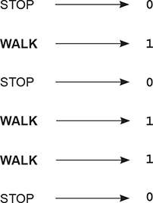

**Creating a matrix or two in Python**

**Import the matrices into Python**

You’ve converted the streetlight pattern into a matrix (one with just 1s and 0s). Now let’s create that matrix (and, more important, its underlying pattern) in Python so the neural network can read it. Python’s NumPy library (introduced in [chapter 3](https://livebook.manning.com/book/grokking-deep-learning/chapter-6/53#!/book/grokking-deep-learning/chapter-3/ch03)) was built just for handling matrices. Let’s see it in action:

Top of Form

1

2

3

4

5

6

7

import numpy as np

streetlights = np.array( [ [ 1, 0, 1 ],

[ 0, 1, 1 ],

[ 0, 0, 1 ],

[ 1, 1, 1 ],

[ 0, 1, 1 ],

[ 1, 0, 1 ] ] )

Bottom of Form

[copy](javascript:void(0))

If you’re a regular Python user, something should be striking in this code. A matrix is just a list of lists. It’s an array of arrays. What is NumPy? NumPy is really just a fancy wrapper for an array of arrays that provides special, matrix-oriented functions. Let’s create a NumPy matrix for the output data, too:

Top of Form

1

2

3

4

5

6

walk_vs_stop = np.array( [ [ 0 ],

[ 1 ],

[ 0 ],

[ 1 ],

[ 1 ],

[ 0 ] ] )

Bottom of Form

[copy](javascript:void(0))

What do you want the neural network to do? Take the streetlights matrix and learn to transform it into the walk_vs_stop matrix. More important, you want the neural network to take *any matrix containing the same underlying pattern* as streetlights and transform it into a matrix that contains the underlying pattern of walk_vs_stop. More on that later. Let’s start by trying to transform streetlights into walk_vs_stop using a neural network.

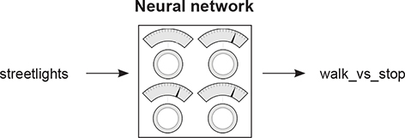

**Building a neural network**

You’ve been learning about neural networks for several chapters now. You have a new dataset, and you’re going to create a neural network to solve it. Following is some example code to learn the first streetlight pattern. This should look familiar:

1

2

3

4

5

6

7

8

9

10

11

12

13

14

15

16

17

18

19

20

21

22

23

import numpy as np

weights = np.array([0.5,0.48,-0.7])

alpha = 0.1

streetlights = np.array( [ [ 1, 0, 1 ],

[ 0, 1, 1 ],

[ 0, 0, 1 ],

[ 1, 1, 1 ],

[ 0, 1, 1 ],

[ 1, 0, 1 ] ] )

walk_vs_stop = np.array( [ 0, 1, 0, 1, 1, 0 ] )

input = streetlights[0]

goal_prediction = walk_vs_stop[0]

for iteration in range(20):

prediction = input.dot(weights)

error = (goal_prediction - prediction) ** 2

delta = prediction - goal_prediction

weights = weights - (alpha * (input * delta))

print("Error:" + str(error) + " Prediction:" + str(prediction))

[copy](javascript:void(0))

This code example may bring back several nuances you learned in [chapter 3](https://livebook.manning.com/book/grokking-deep-learning/chapter-6/53#!/book/grokking-deep-learning/chapter-3/ch03). First, the use of the dot function was a way to perform a dot product (weighted sum) between two vectors. But not included in [chapter 3](https://livebook.manning.com/book/grokking-deep-learning/chapter-6/53#!/book/grokking-deep-learning/chapter-3/ch03) was the way NumPy matrices can perform elementwise addition and multiplication:

Top of Form

1

2

3

4

5

6

7

8

9

import numpy as np

a = np.array([0,1,2,1])

b = np.array([2,2,2,3])

print(a*b) 1

print(a+b) 2

print(a * 0.5) 3

print(a + 0.5) 4

Bottom of Form

[copy](javascript:void(0))

* ***1* Elementwise multiplication**
* ***2* Elementwise addition**
* ***3* Vector-scalar multiplication**
* ***4* Vector-scalar addition**

NumPy makes these operations easy. When you put a + between two vectors, it does what you expect: it adds the two vectors together. Other than these nice NumPy operators and the new dataset, the neural network shown here is the same as the ones built previously.

**Learning the whole dataset**

**The neural network has been learning only one streetlight. Don’t - we want it to learn them all?**

So far in this book, you’ve trained neural networks that learned how to model a single training example (input -> goal_pred pair). But now you’re trying to build a neural network that tells you whether it’s safe to cross the street. You need it to know more than one streetlight. How do you do this? You train it on all the streetlights at once:

import numpy as np

weights = np.array([0.5,0.48,-0.7])

alpha = 0.1

streetlights = np.array( [[ 1, 0, 1 ],

[ 0, 1, 1 ],

[ 0, 0, 1 ],

[ 1, 1, 1 ],

[ 0, 1, 1 ],

[ 1, 0, 1 ] ] )

walk_vs_stop = np.array( [ 0, 1, 0, 1, 1, 0 ] )

input = streetlights[0]

goal_prediction = walk_vs_stop[0]

for iteration in range(40):

error_for_all_lights = 0

for row_index in range(len(walk_vs_stop)):

input = streetlights[row_index]

goal_prediction = walk_vs_stop[row_index]

prediction = input.dot(weights)

error = (goal_prediction - prediction) ** 2

error_for_all_lights += error

delta = prediction - goal_prediction

weights = weights - (alpha * (input * delta))

print("Prediction:" + str(prediction))

print("Error:" + str(error_for_all_lights) + "\n")

Error:2.6561231104

Error:0.962870177672

...

Error:0.000614343567483

Error:0.000533736773285

### Full, batch, and stochastic gradient descent

#### Stochastic gradient descent updates weights one example at a time

As it turns out, this idea of learning one example at a time is a variant on gradient descent called *stochastic gradient descent*, and it’s one of the handful of methods that can be used to learn an entire dataset.

How does stochastic gradient descent work? As you saw in the previous example, it performs a prediction and weight update for each training example separately. In other words, it takes the first streetlight, tries to predict it, calculates the weight_delta, and updates the weights. Then it moves on to the second streetlight, and so on. It iterates through the entire dataset many times until it can find a weight configuration that works well for all the training examples.

#### (Full) gradient descent updates weights one dataset at a time

As introduced in [chapter 4](https://livebook.manning.com/book/grokking-deep-learning/chapter-6/1#!/book/grokking-deep-learning/chapter-4/ch04), another method for learning an entire dataset is gradient descent (or *average/full gradient descent*). Instead of updating the weights once for each training example, the network calculates the average weight_delta over the entire dataset, changing the weights only each time it computes a full average.

#### Batch gradient descent updates weights after n examples

This will be covered in more detail later, but there’s also a third configuration that sort of splits the difference between stochastic gradient descent and full gradient descent. Instead of updating the weights after just one example or after the entire dataset of examples, you choose a *batch size* (typically between 8 and 256) of examples, after which the weights are updated.

We’ll discuss this more later in the book, but for now, recognize that the previous example created a neural network that can learn the entire streetlights dataset by training on each example, one at a time.

### Neural networks learn correlation

#### What did the last neural network learn?

You just got done training a single-layer neural network to take a streetlight pattern and identify whether it was safe to cross the street. Let’s take on the neural network’s perspective for a moment. The neural network doesn’t know that it was processing streetlight data. All it was trying to do was identify which input (of the three possible) correlated with the output. It correctly identified the middle light by analyzing the final weight positions of the network.

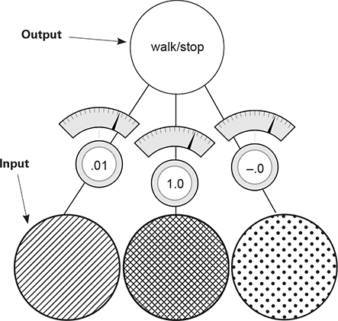

Notice that the middle weight is very near 1, whereas the far-left and far-right weights are very near 0. At a high level, all the iterative, complex processes for learning accomplished something rather simple: the network *identified correlation* between the middle input and output. The correlation is located wherever the weights were set to high numbers. Inversely, *randomness* with respect to the output was found at the far-left and far-right weights (where the weight values are very near 0).

How did the network identify correlation? Well, in the process of gradient descent, each training example asserts either *up pressure* or *down pressure* on the weights. On average, there was more up pressure for the middle weight and more down pressure for the other weights. Where does the pressure come from? Why is it different for different weights?

### Up and down pressure

#### It comes from the data

Each node is individually trying to correctly predict the output given the input. For the most part, each node ignores all the other nodes when attempting to do so. The only *cross communication* occurs in that all three weights must share the same error measure. The *weight update* is nothing more than taking this shared error measure and multiplying it by each respective input.

Why do you do this? A key part of why neural networks learn is *error attribution*, which means given a shared error, the network needs to figure out which weights contributed (so they can be adjusted) and which weights did *not* contribute (so they can be left alone).

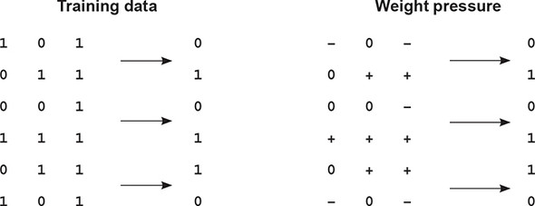

Consider the first training example. Because the middle input is 0, the middle weight is *completely irrelevant* for this prediction. No matter what the weight is, it’s going to be multiplied by 0 (the input). Thus, any error at that training example (regardless of whether it’s too high or too low), can be *attributed* to only the far-left and right weights.

Consider the pressure of this first training example. If the network should predict 0, and two inputs are 1s, then this will cause error, which drives the weight values *toward 0*.

The Weight Pressure table helps describe the effect of each training example on each respective weight. + indicates that it has pressure toward 1, and – indicates that it has pressure toward 0. Zeros (0) indicate that there is no pressure because the input datapoint is 0, so that weight won’t be changed. Notice that the far-left weight has two negatives and one positive, so on average the weight will move toward 0. The middle weight has three positives, so on average the weight will move toward 1.

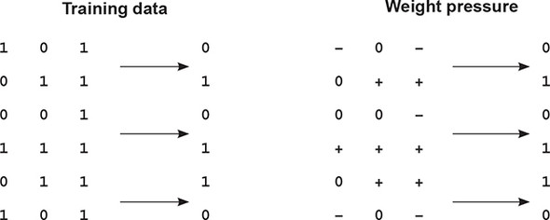

Each individual weight is attempting to compensate for error. In the first training example, there’s *discorrelation* between the far-right and far-left inputs and the desired output. This causes those weights to experience down pressure.

This same phenomenon occurs throughout all six training examples, rewarding correlation with pressure toward 1 and penalizing decorrelation with pressure toward 0. On average, this causes the network to find the correlation present between the middle weight and the output to be the dominant predictive force (heaviest weight in the weighted average of the input), making the network quite accurate.

##### Bottom line

The prediction is a weighted sum of the inputs. The learning algorithm rewards inputs that correlate with the output with upward pressure (toward 1) on their weight while penalizing inputs with discorrelation with downward pressure. The weighted sum of the inputs find perfect correlation between the input and the output by weighting decorrelated inputs to 0.

The mathematician in you may be cringing a little. Upward pressure and downward pressure are hardly precise mathematical expressions, and they have plenty of edge cases where this logic doesn’t hold (which we’ll address in a second). But you’ll later find that this is an *extremely* valuable approximation, allowing you to temporarily overlook all the complexity of gradient descent and just remember that *learning rewards correlation* with larger weights (or more generally, *learning finds correlation between the two datasets*).

### Edge case: Overfitting

#### Sometimes correlation happens accidentally

##### Consider again the first example in the training data. What if the far-left weight was 0.5 and the far-right weight was –0.5? Their prediction would equal 0. The network would predict perfectly. But it hasn’t remotely learned how to safely predict streetlights (those weights would fail in the real world). This phenomenon is known as *overfitting*. Deep learning’s greatest weakness: Overfitting

Error is shared among all the weights. If a particular configuration of weights *accidentally* creates perfect correlation between the prediction and the output dataset (such that error == 0) without giving the heaviest weight to the best inputs, *the neural network will stop learning*.

If it wasn’t for the other training examples, this fatal flaw would cripple the neural network. What do the other training examples do? Well, let’s look at the second training example. It bumps the far-right weight upward while not changing the far-left weight. This throws off the equilibrium that stopped the learning in the first example. As long as you don’t train exclusively on the first example, the rest of the training examples will help the network avoid getting stuck in these edge-case configurations that exist for any one training example.

This is *very important*. Neural networks are so flexible that they can find many, many different weight configurations that will correctly predict for a subset of training data. If you trained this neural network on the first two training examples, it would likely stop learning at a point where it did *not* work well for the other training examples. In essence, it memorized the two training examples instead of finding the *correlation* that will *generalize* to any possible streetlight configuration.

f you train on only two streetlights and the network finds just these edge-case configurations, it could *fail* to tell you whether it’s safe to cross the street when it sees a streetlight that wasn’t in the training data.

##### Key takeaway

The greatest challenge you’ll face with deep learning is convincing your neural network to *generalize* instead of just *memorize*. You’ll see this again.

### Edge case: Conflicting pressure

#### Sometimes correlation fights itself

Consider the far-right column in the following Weight Pressure table. What do you see?

This column seems to have an equal number of upward and downward pressure moments. But the network correctly pushes this (far-right) weight down to 0, which means the downward pressure moments must be larger than the upward ones. How does this work?

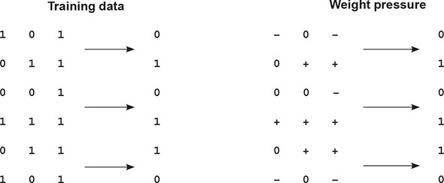

The left and middle weights have enough signal to converge on their own. The left weight falls to 0, and the middle weight moves toward 1. As the middle weight moves higher and higher, the error for positive examples continues to decrease. But as they approach their optimal positions, the decorrelation on the far-right weight becomes more apparent.

Let’s consider the extreme example, where the left and middle weights are perfectly set to 0 and 1, respectively. What happens to the network? If the right weight is above 0, then the network predicts too high; and if the right weight is beneath 0, the network predicts too low.

As other nodes learn, they absorb some of the error; they absorb part of the correlation. They cause the network to predict with *moderate* correlative power, which reduces the error. The other weights then only try to adjust their weights to correctly predict what’s left.

In this case, because the middle weight has consistent signal to absorb all the correlation (because of the 1:1 relationship between the middle input and the output), the error when you want to predict 1 becomes very small, but the error to predict 0 becomes large, pushing the middle weight downward.

#### It doesn’t always work out like this

In some ways, you kind of got lucky. If the middle node hadn’t been so perfectly correlated, the network might have struggled to silence the far-right weight. Later you’ll learn about *regularization*, which forces weights with conflicting pressure to move toward 0.

As a preview, regularization is advantageous because if a weight has equal pressure upward and downward, it isn’t good for anything. It’s not helping either direction. In essence, regularization aims to say that only weights with really strong correlation can stay on; everything else should be silenced because it’s contributing noise. It’s sort of like natural selection, and as a side effect it would cause the neural network to train faster (fewer iterations) because the far-right weight has this problem of both positive and negative pressure.

In this case, because the far-right node isn’t definitively correlative, the network would immediately start driving it toward 0. Without regularization (as you trained it before), you won’t end up learning that the far-right input is useless until after the left and middle start to figure out their patterns. More on this later.

If networks look for correlation between an input column of data and the output column, what would the neural network do with the following dataset?

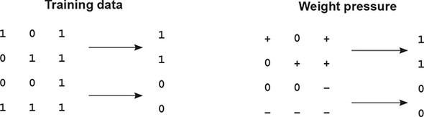

There is no correlation between any input column and the output column. Every weight has an equal amount of upward pressure and downward pressure. *This dataset is a real problem for the neural network.*

Previously, you could solve for input datapoints that had both upward and downward pressure because other nodes would start solving for either the positive or negative predictions, drawing the balanced node to favor up or down. But in this case, all the inputs are equally balanced between positive and negative pressure. What do you do?

### Learning indirect correlation

#### If your data doesn’t have correlation, create intermediate data that does!

Previously, I described a neural network as an instrument that searches for correlation between input and output *datasets*. I want to refine this just a touch. In reality, neural networks search for correlation between their input and output *layers*.

You set the values of the input layer to be individual rows of the input data, and you try to train the network so that the output layer equals the output dataset. Oddly enough, the neural network doesn’t know about data. It just searches for correlation between the input and output layers.

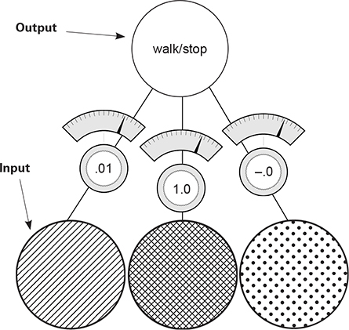

Unfortunately, this is a new streetlights dataset that has *no correlation* between the input and output. The solution is simple: use two of these networks. The first one will create an intermediate dataset that has limited correlation with the output, and the second will use that limited correlation to correctly predict the output.

*does*

### Creating correlation

Here’s a picture of the new neural network. You basically stack two neural networks on top of each other. The middle layer of nodes (layer_1) represents the *intermediate dataset*. The goal is to train this network so that even though there’s no correlation between the input dataset and output dataset (layer_0 and layer_2), the layer_1 dataset that you create *using layer_0* will have correlation with layer_2.

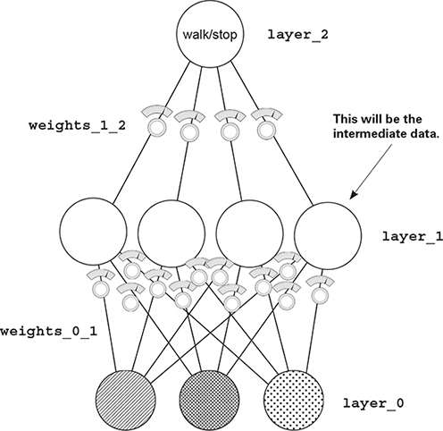

Note: this network is still just a function. It has a bunch of weights that are collected together in a particular way. Furthermore, gradient descent still works because you can calculate how much each weight contributes to the error and adjust it to reduce the error to 0. And that’s exactly what you’re going to do.

### Stacking neural networks: A review

#### [Chapter 3](https://livebook.manning.com/book/grokking-deep-learning/chapter-3/ch03) briefly mentioned stacked neural networks. Let’s review

When you look at the following architecture, the prediction occurs exactly as you might expect when I say, “Stack neural networks.” The output of the first lower network (layer_0 to layer_1) is the input to the second upper neural network (layer_1 to layer_2). The prediction for each of these networks is identical to what you saw before.

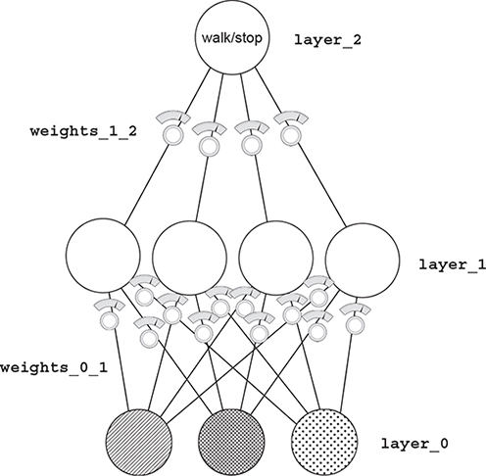

As you start to think about how this neural network learns, you already know a great deal. If you ignore the lower weights and consider their output to be the training set, the top half of the neural network (layer_1 to layer_2) is just like the networks trained in the preceding chapter. You can use all the same learning logic to help them learn.

The part that you don’t yet understand is how to update the weights between layer_0 and layer_1. What do they use as their error measure? As you may remember from [chapter 5](https://livebook.manning.com/book/grokking-deep-learning/chapter-6/1#!/book/grokking-deep-learning/chapter-5/ch05), the cached/normalized error measure is called delta. In this case, you want to figure out how to know the delta values at layer_1 so they can help layer_2 make accurate predictions.

### Backpropagation: Long-distance error attribution

#### The weighted average error

What’s the prediction from layer_1 to layer_2? It’s a weighted average of the values at layer_1. If layer_2 is too high by *x* amount, how do you know which values at layer_1 contributed to the error? The ones with *higher weights* (weights_1_2) contributed more. The ones with *lower weights* from layer_1 to layer_2 contributed less.

Consider the extreme. Let’s say the far-left weight from layer_1 to layer_2 was zero. How much did that node at layer_1 cause the network’s error? *Zero*.

It’s so simple it’s almost hilarious. The weights from layer_1 to layer_2 exactly describe how much each layer_1 node contributes to the layer_2 prediction. This means those weights also exactly describe how much each layer_1 node contributes to the layer_2 error.

How do you use the delta at layer_2 to figure out the delta at layer_1? You multiply it by each of the respective weights for layer_1. It’s like the prediction logic in reverse. This process of moving delta signal around is called *backpropagation*.

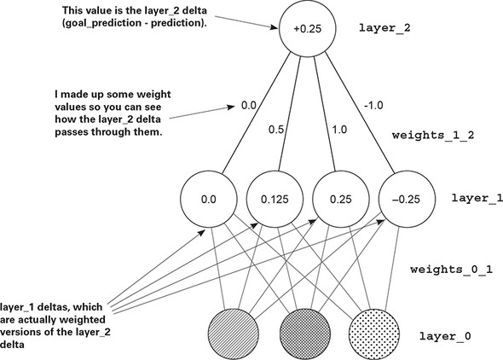

### Backpropagation: Why does this work?

#### The weighted average delta

In the neural network from [chapter 5](https://livebook.manning.com/book/grokking-deep-learning/chapter-6/1#!/book/grokking-deep-learning/chapter-5/ch05), the delta variable told you the direction and amount the value of this node should change next time. All backpropagation lets you do is say, “Hey, if you want this node to be *x* amount higher, then each of these previous four nodes needs to be x*weights_1_2 amount higher/lower, because these weights were amplifying the prediction by weights_1_2 times.”

When used in reverse, the weights_1_2 matrix amplifies the error by the appropriate amount. It amplifies the error so you know how much each layer_1 node should move up or down.

Once you know this, you can update each weight matrix as you did before. For each weight, multiply its output delta by its input value, and adjust the weight by that much (or you can scale it with alpha).

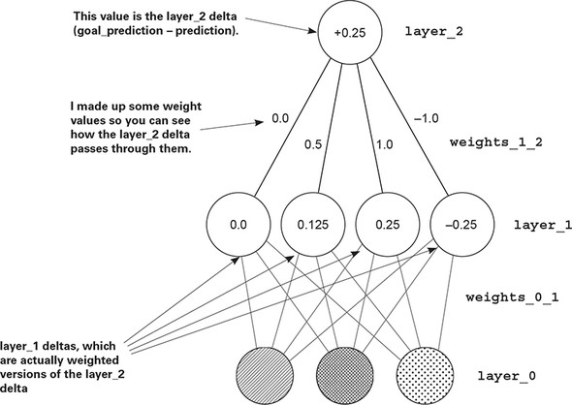

### Linear vs. nonlinear

#### This is probably the hardest concept in the book. Let’s take it slowly

I’m going to show you a phenomenon. As it turns out, you need one more piece to make this neural network train. Let’s take it from two perspectives. The first will show why the neural network can’t train without it. In other words, first I’ll show you why the neural network is currently broken. Then, once you add this piece, I’ll show you what it does to fix this problem. For now, check out this simple algebra:

Top of Form

1

2

1 * 10 * 2 = 100 1 * 0.25 * 0.9 = 0.225

5 * 20 = 100 1 * 0.225 = 0.225

Bottom of Form

[copy](javascript:void(0))

Here’s the takeaway: for any two multiplications, I can accomplish the same thing using a single multiplication. As it turns out, this is bad. Check out the following:

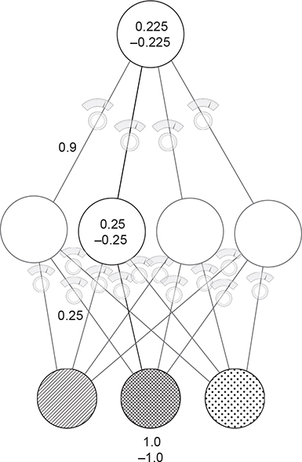

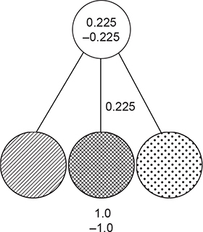

These two graphs show two training examples each, one where the input is 1.0 and another where the input is –1.0. The bottom line: *for any three-layer network you create, there’s a two-layer network that has identical behavior*. Stacking two neural nets (as you know them at the moment) doesn’t give you any more power. Two consecutive weighted sums is just a more expensive version of one weighted sum.

### Why the neural network still doesn’t work

#### If you trained the three-layer network as it is now, it wouldn’t converge

**Problem:**

Let’s talk about the middle layer (layer_1) before it’s fixed. Right now, each node (out of the four) has a weight coming to it from each of the inputs. Let’s think about this from a correlation standpoint. Each node in the middle layer subscribes to a certain amount of correlation with each input node. If the weight from an input to the middle layer is 1.0, then it subscribes to exactly 100% of that node’s movement. If that node goes up by 0.3, the middle node will follow. If the weight connecting two nodes is 0.5, each node in the middle layer subscribes to exactly 50% of that node’s movement.

The only way the middle node can escape the correlation of one particular input node is if it subscribes to additional correlation from another input node. *Nothing new* is being contributed to this neural network. Each hidden node subscribes to a little correlation from the input nodes.

The middle nodes don’t get to add anything to the conversation; they don’t get to have correlation of their own. They’re more or less correlated to various input nodes.

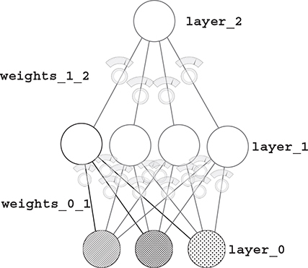

But because you *know* that in the new dataset there is no correlation between any of the inputs and the output, how can the middle layer help? It mixes up a bunch of correlation that’s already useless. What you really need is for the middle layer to be able to selectively correlate with the input.

You want the middle layer to *sometimes* correlate with an input, and *sometimes not correlate*. That gives it correlation of its own. This gives the middle layer the opportunity to not just always be *x*% correlated to one input and *y*% correlated to another input. Instead, it can be *x*% correlated to one input only when it wants to be, but other times not be correlated at all. This is called *conditional correlation* or *sometimes correlation*.

### The secret to sometimes correlation

#### Turn off the node when the value would be below 0

This might seem too simple to work, but consider this: if a node’s value dropped below 0, normally the node would still have the same correlation to the input as always. It would just happen to be negative in value. But if you turn off the node (setting it to 0) when it would be negative, then it has *zero correlation to any inputs* whenever it’s negative.

What does this mean? The node can now selectively pick and choose when it wants to be correlated to something. This allows it to say something like, “Make me perfectly correlated to the left input, but only when the right input is turned off.” How can it do this? Well, if the weight from the left input is 1.0 and the weight from the right input is a huge negative number, then turning on both the left and right inputs will cause the node to be 0 all the time. But if only the left input is on, the node will take on the value of the left input.

This wasn’t possible before. Earlier, the middle node was either always correlated to an input or always not correlated. Now it can be conditional. Now it can speak for itself.

##### Solution:

The fancy term for this “if the node would be negative, set it to 0” logic is *nonlinearity*. Without this tweak, the neural network is *linear*. Without this technique, the output layer only gets to pick from the same correlation it had in the two-layer network. It’s subscribing to pieces of the input layer, which means it can’t solve the new streetlights dataset.

There are many kinds of nonlinearities. But the one discussed here is, in many cases, the best one to use. It’s also the simplest. (It’s called relu.)

For what it’s worth, most other books and courses say that consecutive matrix multiplication is a linear transformation. I find this unintuitive. It also makes it harder to understand what nonlinearities contribute and why you choose one over the other (which we’ll get to later). It says, “Without the nonlinearity, two matrix multiplications might as well be 1.” My explanation, although not the most concise answer, is an intuitive explanation of why you need nonlinearities.

### A quick break

#### That last part probably felt a little abstract, and that’s totally OK

Here’s the deal. Previous chapters worked with simple algebra, so everything was ultimately grounded in fundamentally simple tools. This chapter started building on the premises you learned earlier. Previously, you learned lessons like this:

You can compute the relationship between the error and any one of the weights so that you know how changing the weight changes the error. You can then use this to reduce the error to 0.

That was a *massive lesson*. But now we’re moving past it. Because we already worked through why that works, you can take the statement at face value. The next big lesson came at the beginning of this chapter:

Adjusting the weights to reduce the error over a series of training examples ultimately searches for correlation between the input and the output layers. If no correlation exists, then the error will never reach 0.

This is an *even bigger lesson*. It largely means you can put the previous lesson out of your mind for now. You don’t need it. Now you’re focused on correlation. The takeaway is that you can’t constantly think about everything all at once. Take each lesson and let yourself trust it. When it’s a more concise summarization (a higher abstraction) of more granular lessons, you can set aside the granular and focus on understanding the higher summarizations.

This is akin to a professional swimmer, biker, or similar athlete who requires a combined fluid knowledge of a bunch of small lessons. A baseball player who swings a bat learned thousands of little lessons to ultimately culminate in a great bat swing. But the player doesn’t think of all of them when he goes to the plate. His actions are fluid—even subconscious. It’s the same for studying these math concepts.

Neural networks look for correlation between input and output, and you no longer have to worry about how that happens. You just know it does. Now we’re building on that idea. Let yourself relax and trust the things you’ve already learned.

### Your first deep neural network

#### Here’s how to make the prediction

The following code initializes the weights and makes a forward propagation. New code is **bold**.

import numpy as np

np.random.seed(1)

def relu(x):

return (x > 0) * x

alpha = 0.2

hidden_size = 4

streetlights = np.array( [[ 1, 0, 1 ],

[ 0, 1, 1 ],

[ 0, 0, 1 ],

[ 1, 1, 1 ] ] )

walk_vs_stop = np.array([[ 1, 1, 0, 0]]).T

weights_0_1 = 2*np.random.random((3,hidden_size)) - 1

weights_1_2 = 2*np.random.random((hidden_size,1)) - 1

layer_0 = streetlights[0]

layer_1 = relu(np.dot(layer_0,weights_0_1))

layer_2 = np.dot(layer_1,weights_1_2)

[copy](javascript:void(0))

For each piece of the code, follow along with the figure. Input data comes into layer_0. Via the dot function, the signal travels up the weights from layer_0 to layer_1 (performing a weighted sum at each of the four layer_1 nodes). These weighted sums at layer_1 are then passed through the relu function, which converts all negative numbers to 0. Then a final weighted sum is performed into the final node, layer_2.

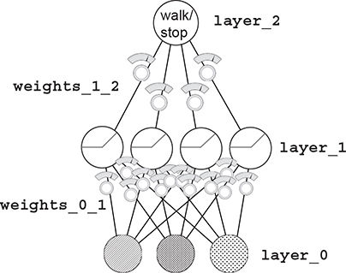

### Backpropagation in code

#### You can learn the amount that each weight contributes to the final error

At the end of the previous chapter, I made an assertion that it would be important to memorize the two-layer neural network code so you could quickly and easily recall it when I reference more-advanced concepts. This is when that memorization matters.

The following listing is the new learning code, and it’s essential that you recognize and understand the parts addressed in the previous chapters. If you get lost, go to [chapter 5](https://livebook.manning.com/book/grokking-deep-learning/chapter-6/1#!/book/grokking-deep-learning/chapter-5/ch05), memorize the code, and then come back. It will make a big difference someday.

1

2

3

4

5

6

7

8

9

10

11

12

13

14

15

16

17

18

19

20

21

22

23

24

25

26

27

28

29

30

31

32

33

import numpy as np

np.random.seed(1)

def relu(x):

return (x > 0) * x

def relu2deriv(output):

return output>0

alpha = 0.2

hidden_size = 4

weights_0_1 = 2*np.random.random((3,hidden_size)) - 1

weights_1_2 = 2*np.random.random((hidden_size,1)) - 1

for iteration in range(60):

layer_2_error = 0

for i in range(len(streetlights)):

layer_0 = streetlights[i:i+1]

layer_1 = relu(np.dot(layer_0,weights_0_1))

layer_2 = np.dot(layer_1,weights_1_2)

layer_2_error += np.sum((layer_2 - walk_vs_stop[i:i+1]) ** 2)

layer_2_delta = (walk_vs_stop[i:i+1] - layer_2)

layer_1_delta=layer_2_delta.dot(weights_1_2.T)*relu2deriv(layer_1)

weights_1_2 += alpha * layer_1.T.dot(layer_2_delta)

weights_0_1 += alpha * layer_0.T.dot(layer_1_delta)

if(iteration % 10 == 9):

print("Error:" + str(layer_2_error))

Believe it or not, the only truly new code is in bold. Everything else is fundamentally the same as in previous pages. The relu2deriv function returns 1 when output > 0; otherwise, it returns 0. This is the *slope* (the *derivative*) of the relu function. It serves an important purpose, as you’ll see in a moment.

Remember, the goal is *error attribution*. It’s about figuring out how much each weight contributed to the final error. In the first (two-layer) neural network, you calculated a delta variable, which told you how much higher or lower you wanted the output prediction to be. Look at the code here. You compute the layer_2_delta in the same way. Nothing new. (Again, go back to [chapter 5](https://livebook.manning.com/book/grokking-deep-learning/chapter-6/1#!/book/grokking-deep-learning/chapter-5/ch05) if you’ve forgotten how that part works.)

Now that you know how much the final prediction should move up or down (delta), you need to figure out how much each middle (layer_1) node should move up or down. These are effectively *intermediate predictions*. Once you have the delta at layer_1, you can use the same processes as before for calculating a weight update (for each weight, multiply its input value by its output delta and increase the weight value by that much).

How do you calculate the deltas for layer_1? First, do the obvious: multiply the output delta by each weight attached to it. This gives a weighting of how much each weight contributed to that error. There’s one more thing to factor in. If relu set the output to a layer_1 node to be 0, then it didn’t contribute to the error. When this is true, you should also set the delta of that node to 0. Multiplying each layer_1 node by the relu2deriv function accomplishes this. relu2deriv is either 1 or 0, depending on whether the layer_1 value is greater than 0.

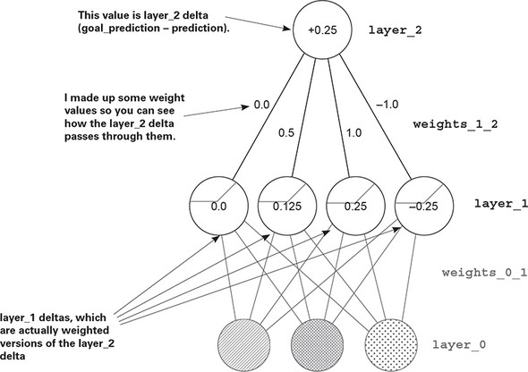

### One iteration of backpropagation

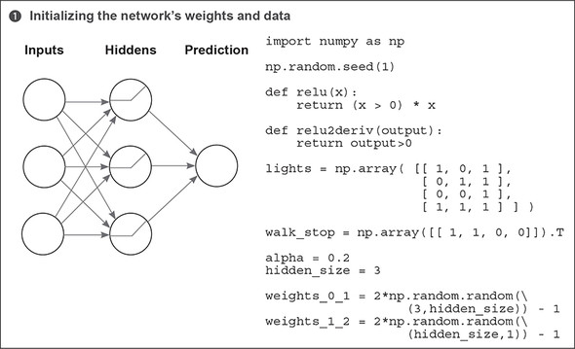

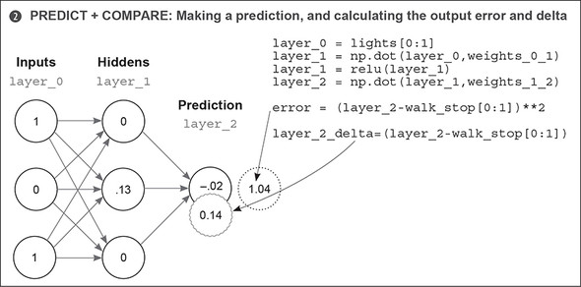

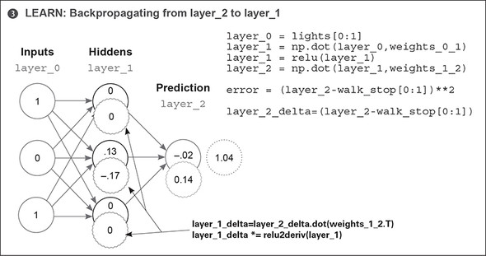

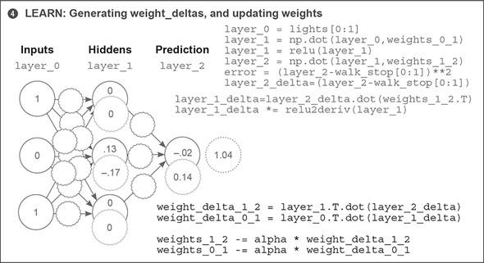

As you can see, backpropagation is about calculating deltas for intermediate layers so you can perform gradient descent. To do so, you take the weighted average delta on layer_2 for layer_1 (weighted by the weights in between them). You then turn off (set to 0) nodes that weren’t participating in the forward prediction, because they couldn’t have contributed to the error.

### Putting it all together

#### Here’s the self-sufficient program you should be able to run (run- ntime output follows)

1

2

3

4

5

6

7

8

9

10

11

12

13

14

15

16

17

18

19

20

21

22

23

24

25

26

27

28

29

30

31

32

33

34

35

36

37

38

39

40

import numpy as np

np.random.seed(1)

def relu(x):

return (x > 0) * x

def relu2deriv(output):

return output>0

streetlights = np.array( [[ 1, 0, 1 ],

[ 0, 1, 1 ],

[ 0, 0, 1 ],

[ 1, 1, 1 ] ] )

walk_vs_stop = np.array([[ 1, 1, 0, 0]]).T

alpha = 0.2

hidden_size = 4

weights_0_1 = 2*np.random.random((3,hidden_size)) - 1

weights_1_2 = 2*np.random.random((hidden_size,1)) - 1

for iteration in range(60):

layer_2_error = 0

for i in range(len(streetlights)):

layer_0 = streetlights[i:i+1]

layer_1 = relu(np.dot(layer_0,weights_0_1))

layer_2 = np.dot(layer_1,weights_1_2)

layer_2_error += np.sum((layer_2 - walk_vs_stop[i:i+1]) ** 2)

layer_2_delta = (layer_2 - walk_vs_stop[i:i+1])

layer_1_delta=layer_2_delta.dot(weights_1_2.T)*relu2deriv(layer_1)

weights_1_2 -= alpha * layer_1.T.dot(layer_2_delta)

weights_0_1 -= alpha * layer_0.T.dot(layer_1_delta)

if(iteration % 10 == 9):

print("Error:" + str(layer_2_error))

[copy](javascript:void(0))

Top of Form

Error:0.358384076763

Error:0.0830183113303

Error:0.0064670549571

Error:0.000329266900075

Error:1.50556226651e-05

Bottom of Form

[copy](javascript:void(0))

### Why do deep networks matter?

#### What’s the point of creating “intermediate datasets” that have correlation?

Consider the cat picture shown here. Consider further that I had a dataset of images with cats and without cats (and I labeled them as such). If I wanted to train a neural network to take the pixel values and predict whether there’s a cat in the picture, the two-layer network might have a problem.

Just as in the last streetlight dataset, no individual pixel correlates with whether there’s a cat in the picture. Only different configurations of pixels correlate with whether there’s a cat.



This is the essence of deep learning. Deep learning is all about creating intermediate layers (datasets) wherein each node in an intermediate layer represents the presence or absence of a different configuration of inputs.

This way, for the cat images dataset, no individual pixel has to correlate with whether there’s a cat in the photo. Instead, the middle layer will attempt to identify different configurations of pixels that may or may not correlate with a cat (such as an ear, or cat eyes, or cat hair). The presence of many cat-like configurations will then give the final layer the information (correlation) it needs to correctly predict the presence or absence of a cat.

Believe it or not, you can take the three-layer network and continue to stack more and more layers. Some neural networks have hundreds of layers, each node playing its part in detecting different configurations of input data. The rest of this book will be dedicated to studying different phenomena within these layers in an effort to explore the full power of deep neural networks.

Toward that end, I must issue the same challenge I did in [chapter 5](https://livebook.manning.com/book/grokking-deep-learning/chapter-6/1#!/book/grokking-deep-learning/chapter-5/ch05): memorize the previous code. You’ll need to be very familiar with each of the operations in the code in order for the following chapters to be readable. Don’t progress past this point until you can build a three-layer neural network from memory!