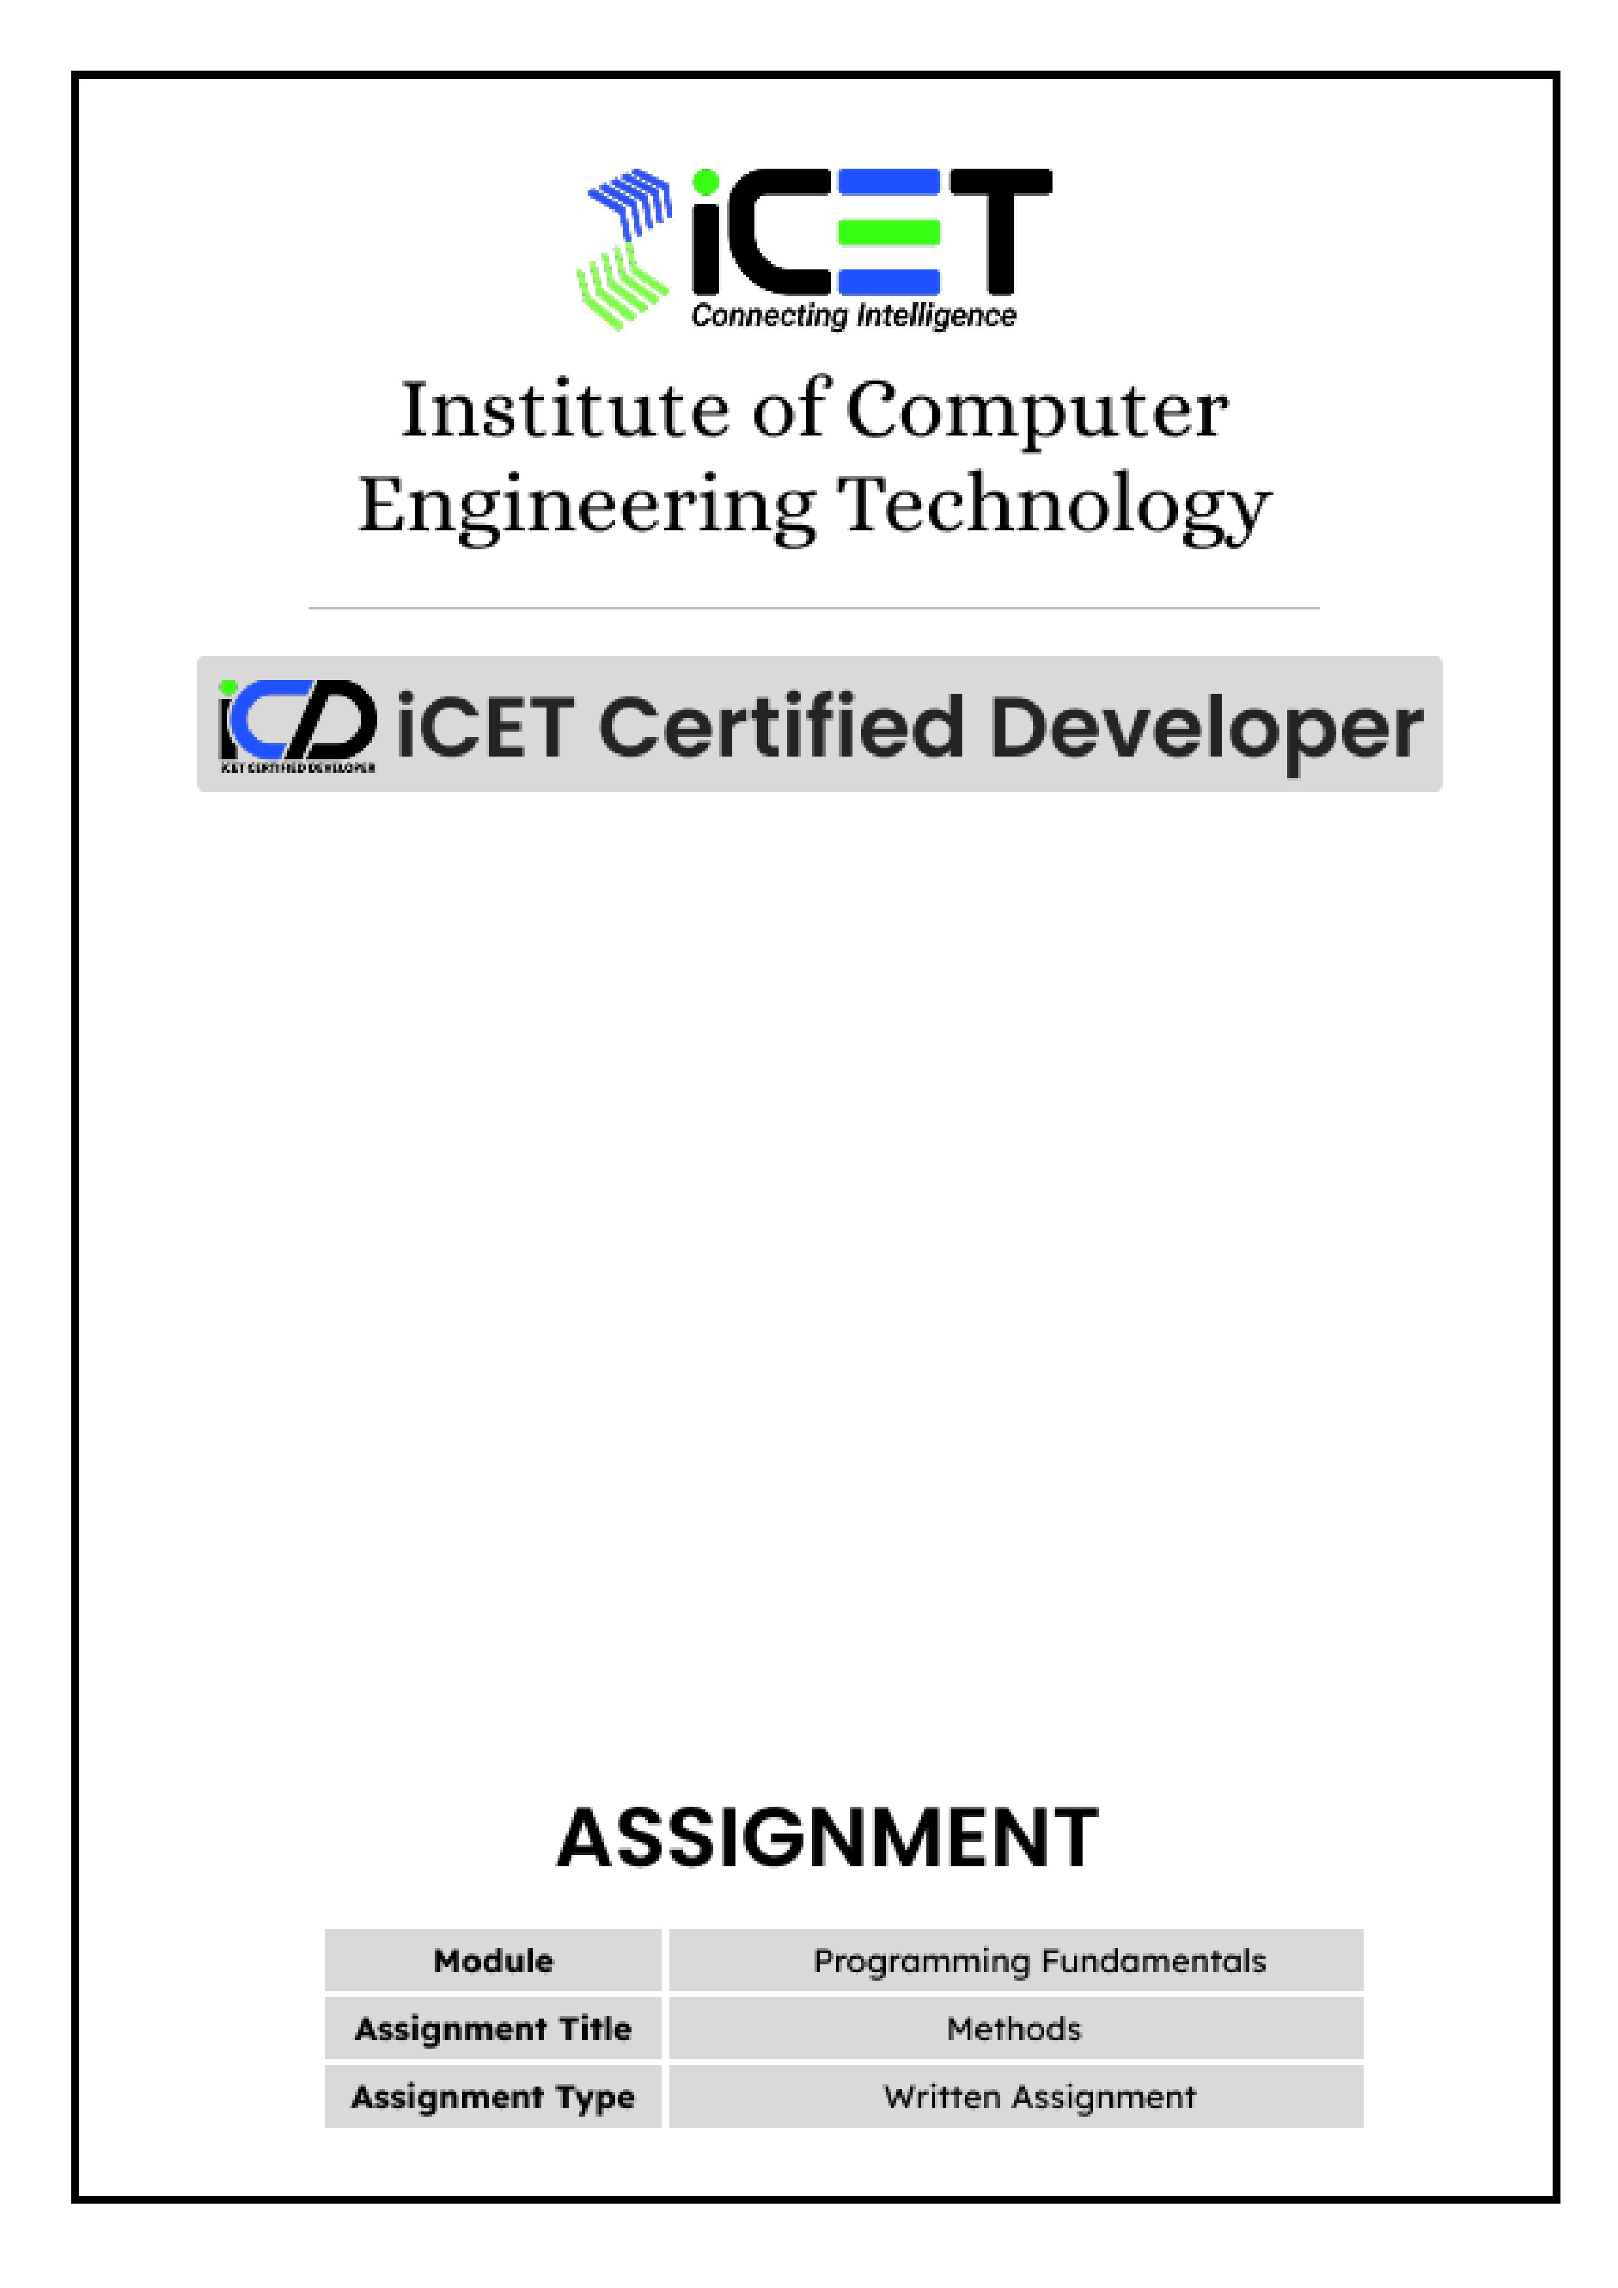

- Invoke printMyMethod in the main method to print “Hello JAVA…”.

class Demo{
public static void printMyMethod(){
System.out.println("Hello JAVA...");
}

public static void main(String[] args) {
//invoke method
}
}
- printMyMethod();

- Write a method to print your name and birthday. Invoke your method in the main method.
Class Demo1{
Public static void printMyself(){
System.out.println(“MY NAME : Tharusha”)
System.out.println(MY BIRTH : 08/25)
}
Public static void main(String[] args){
printMyself();
}
}

- Write a method to print the English Alphabet as below.
Aa Bb Cc Dd ……

- Write a method to get a String from the user and print it.

- Write a method to print whether a year (integer) entered by the user is a leap year or not.

- Write a method to compare two user input numbers.
Input number 1 – 20
Input number 2 – 25
Output --> 20 < 25

- Program 01
import java.util.*; class Demo{
public static void printName(){
Scanner input=new Scanner(System.in);
System.out.print("Input first name : ");
String name1=input.nextLine();
System.out.print("Input secound name : ");
String name2=input.nextLine();
System.out.println(name1+" "+name2);
}

public static void main(String[] args){ printName(); // Line X
}
}

Program 02

import java.util.*; class Demo{
public static void printName(String name1, String name2){
System.out.println(name1+" "+name2);
}

public static void main(String[] args){ Scanner input=new Scanner(System.in);
System.out.print("Input first name : ");
String name1=input.nextLine();
System.out.print("Input secound name : ");
String name2=input.nextLine();

printName(name1,name2); // Line Y
}
}

- What are the different methods invoking between Program 1 and Program 2?

- Can replace line Y in Program 2 with line X in Program 1 ? Give the reason for your answer.

08.Write a method that takes two words as a parameter and prints true if two words have the same first letter.

- Write a method that takes a decimal number as a parameter and rounds to two decimal places.

- Write a method to calculate how much money should be deposited to receive the user input monthly interest. (bank annual interest is 20% )

- Write a method that takes Celsius value as a parameter and converts Celsius(⁰C) to Fahrenheit and Celsius(⁰C) to Kelvin.

F = ⁰C (9/5) +32 K = C + 273.15

- Write a method to find the perimeter and area of a sector when given its angle and radius.
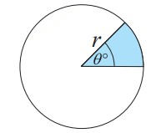

- Write a method to find the quadratic equation of x by getting 2 integer answers of x from the user. x = a , x = b
x^2 + (a+b)x +(a*b) = 0

- Create a class “Calculator” which contains the following method that takes two integers as parameters.
I.add() II. subtraction() III. multiplication()
IV. dividend() V. reminder() V. power()

identify the operator and called the suitable method in the main method.
Expected Output:-
Enter the first number : 5
Enter the second number : 2
Enter the operator (+,-,*,/,%,^) : ^
5 ^ 2 = 25

- Write a method to swap two numbers without using 3rd variable and print that numbers.

- Write a Java method to check if a given number is a perfect number or not.

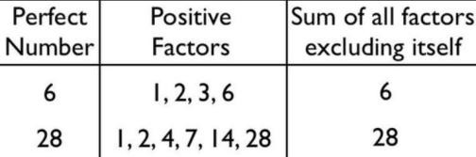

- Write a method to get how many multiples of user input numbers in user given range.
Input number: 3
The lower bound of the range: 10
The upper bound of the range: 100
Output
Multiples of 3 between 10 and 100 – 30

- Mark legal and illegal lines. Write the most suitable reason for each illegal line.
class Demo{
public static void test(){
System.out.println("Hello....");
}
public static void test(String name){ System.out.println("Hello "+name+"....");
}
public static void main(String args[]){
String s="java"; //Line 1
test; //Line 2
test(); //Line 3
test(){ } //Line 4
test(){ }; //Line 5
Demo.test(); //Line 6
System.out.println("test()"); //Line 7
System.out.println(test()); //Line 8
test(s); //Line 9
System.out.println(test(s)); //Line 10
System.out.println("test(s)"); //Line 11
}

}

- Write a method when the user input a student name, the system should randomly select the 3 group subject from 3 groups and print selected subjects.
GROUP 01:  Business & Accounting  Geography  Citizenship Education  Entrepreneurship studies  2nd language Sinhala  2nd Language Tamil  Foreign Languages  Arabic  Hindi  French  Japan | GROUP 02:  Art  Tamil Literature  English Literature  Sinhala Literature  Music  Dancing | GROUP 03:  Information & technology  Agriculture  Home Economics  Health Science  Art & Craft  Media

- Which line will occur a compile error and give the acceptable reason for the error.

class Test{
public static void testMethod(){
System.out.println("testMethod of Test");
}
}

class Demo{
public static void testMethod(){
System.out.println("testMethod of Demo");
}
public void testMethod2(){
System.out.println("testMethod of Demo");
}
public static void main(String args[]){
testMethod(); //line 1
testMethod2(); //line 2
Test.testMethod(); //line 3
Demo.testMethod(); //line 4
Demo.testMethod2(); //line 5
Demo d=new Demo(); //line 6 d.testMethod(); //line 7 d.testMethod2(); //line 8
}
}
- What is the correct method declaration? Give a reason for the illegal declaration.
  - public static void myMethod() { } ;
  - public static void main() { }
  - public void static subMethod( );
  - public static void () { }
  - public static void_();
  - public static void _(){}
  - public static void myMethod(int x;){ }
  - public static void myMethod(x) { }
  - public static void myNewMethod(100) { }
  - public static void m(int a){return 0;}
  - public static void m1(){return;}
  - public static int me(int a){return 0;}

- Write a method to get speed in kmh⁻¹ and return speed in ms⁻¹.

- Write a method that takes a String and returns the vowel count of that String.

- Write a method that takes the radius and height in meters of a water tank(cylinder) and returns the volume of the tank in liters.(1m³ = 1000l)

- Write a method that takes the length of a cube and finds the volume of the sphere with the largest radius that can be cut from the given cube.

- Briefly explain the outputs for the following program.
class Example{
public static int increment(int x){ x++;
System.out.println("x : "+x);
return x;
}
public static void main(String args[]){ int x=100;
System.out.println("x : "+x); increment(x);
System.out.println("x : "+x); x=increment(x);
System.out.println("x : "+x);
}
}
- Write a method to check whether every digit of user given integer is even. Return true if every digit is even otherwise false.

- Which of the following can be inserted into line 10 in order to be a legal code fragment?
class Example{
public static boolean isPass(double avg){
//Insert code here //Line 10
}
}

  - return;
  - return true;
  - return avg>=50;
  - if(avg>=50){return true;}else{return false;}
  - if(avg>=50){return true;}
  - return avg>=50 ? true:false;
  - if(avg>=50){return true;} return false;

- Write a method that takes the month name and returns how many dates of the month. Otherwise, print “month name incorrect!”.
- Write a method that takes positive integers and returns even digits and odd digits separately. Input - 12345678
Output - 1357 2468

- Write a method that simulates the rolling of six-sided two dice until both dice roll the same number. Each time the dice is rolled, the program should print the number rolled as below and finally print how many times the dice have been rolled.
2 4
6 1
3 5
2 2
Dice roll – 4 times

- Which of the following code can be inserted at line 1 and line 2 to still code will compile? class Demo{
public static void main(String args[]){
//Insert code line 1 testMethod(n)
}
public static float testMethod(int x){
//Insert code line 2 return n;
}
}

A. byte n=10; |  |  | B. short n=100; |  | C. int n=100;
D. long n=100; G. char n='A'; |  |  | E. float n=1.0f; |  | F. double n=1.2;

- Which of the following method declarations are legal?

  - public static boolean testMethod(int num){ System.out.println("number : "+num);
}

  - public static boolean testMethod(int num){
return;
}

  - public static boolean testMethod(int num){
return true;
}

  - public static boolean testMethod(int num){
return num>=50?true:false;
}

  - public static boolean testMethod(int num){ return num>=50;
}

  - public static boolean testMethod(int num){
if(num>=50){ return true; }else{ return false;
}
}

  - public static boolean testMethod(int num){
if(num>=50){
return true;
}
}

  - public static boolean testMethod(int num){
if(num>=50){ return true;
}
return false;
}

  - public static int testMethod(int num){
System.out.println("number : "+num); return num>=50;
}

  - public static boolean testMethod(int num){ System.out.println("number : "+num); return num;
System.out.println("End");
}

  - public static void testMethod(int num,int num2){ }

  - public static void testMethod(int num,num2){ }

  - public static void testMethod(int num,int num2){
int num; int num2; int num3;
}

  - public static void testMethod(int num){
System.out.println("number : "+num); return num;
}

  - public static void testMethod(int num){ System.out.println("number : "+num); return ;
}

  - public static void testMethod(int num){
System.out.println("number : "+num);
return ;
System.out.println("End");
}

- Write a method to calculate and return how many groups of the desired size the user can create from the number of children that the user inputs.
(n! – factorial of n)
Input
Number of children – n
Number of group members – r
Output
The number of groups = n!

(n-r)! x r!

- Write a Java method to find the smallest positive number that is evenly divisible by all of the numbers from 1 to 20. 2520 is the smallest number that can be divided by each of the numbers from 1 to 10 without any remainder.

- Write a method that takes the coordinate of a point in an X-Y coordinate system as input and print the Quadrant I / Quadrant II / Quadrant III / Quadrant IV /Origin determining in which quadrant that point lies and print the distance to
(0,0) point (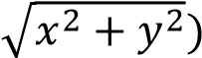 .
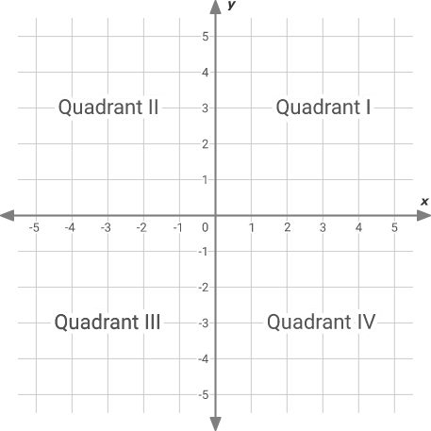

- Write a method to input the length of three sides of a triangle and check whether the triangle is valid or not and if it is valid triangle returns the perimeter of the triangle. The triangle is valid if all three conditions are satisfied.
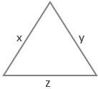
x + y > z
        - + z > y
        - + z > x

- If a line joined by two points is divided by a point in the interior in a certain ratio, the coordinates of that point can find by the following equation. Write a method that takes the coordinates of two points and the ratio and returns the coordinates of the point where the line divides.

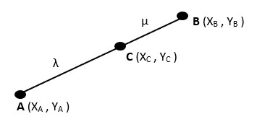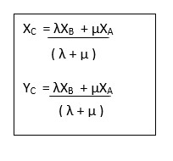

- Write a method that takes two integer numbers and prints the sum of numbers. Overload the two methods to take two double and print sum of numbers and takes two String and print String concatenated.

- Write a method that takes two integer numbers and returns absolute differences. Overload the method to take two doubles and return the absolute difference.

- Write a method that takes the radius of the circle and returns the perimeter of the Circle. Overload the two methods for taking the perimeter of a Rectangle, Square, and Triangle.

- Write a method that takes an integer number and checks whether the number is palindrome or not. Return true if the number is palindrome, otherwise, return false. Overload the method for the String word.

- Write a method to convert decimal to binary and overload that method to convert decimal to octal and convert decimal to hexadecimal.

- Write a method that takes an integer and finds the factorial of that integer.

- Write a method to reverse a String using recursion.

- Write a method to print the first 10th term of the geometric series using recursion when the user inputs common ratio(r) and 1st term (a).
a , ar , ar² , ar³

- Write a method to find the power of a number using recursion.

- Write a method that takes an integer and returns the sum of digits using recursion.

49.Write a method that generates a random number between 0 to 100 and asks the user to guess what the number is and the user can try to guess the number only 5 times. The program should display:
  - "Too high, try again.", If the user's guess is higher than the random number
  - "Too low, try again.", If the user's guess is lower than the random number
  - "Correct! ", If the user’s guess is correct

50. Create a class “Me” which contains the following method.
checkPassword() displayDetails()

when you run the program, first invoke checkPassword() method.
You should check the user enter password is the same as the password variable value of your checkPassword method. If the password is correct, invoke displayDetails() method and If the password is incorrect ask the question “Do you want to continue (Yes/No)?” . If user say “Yes” then invoke password() method again , if user say “No” then end the program.
The password() method can be run a maximum of 3 times.If user fail to enter correct password in 3 times, program should end at that time.

