URBAN COMPANY WEBSITE

#### A MINI PROJECT REPORT

SUBMITTED IN PARTIAL FULFILLMENT OF THE REQUIREMENTS FOR THE IN-HOUSE INTERNSHIP CUM TECHNICAL TRAINING

#### Master of Computer Application

MCA

#### SUBMITTED TO

**Dayananda Sagar College of Engineering Department of MCA**

#### SUBMITTED BY

Name of Student(s) University Roll No. (14pt)

Shilton R 1DS21MC099

Tharun 1DS21MC111

Pranav 1DS21MC072

#### SUPERVISED BY

Mahendra Kumar Assistant professor Dept.of MCA

Shilpa Vaidya



WEBSITE DESIGN FOR URBAN COMPANY

#### A MINI PROJECT REPORT on WEB

SUBMITTED IN PARTIAL FULFILLMENT OF THE REQUIREMENTS FOR THE AWARD OF

#### Master of Computer Application

**SUBMITTED TO**

#### Dayananda Sagar College of Engineering, Department of MCA, Bangalore

**SUBMITTED BY**

Name of Student(s) University Roll No.

Shilton R 1DS21MC099

Tharun A 1DS21MC111

Pranav N 1DS21MC072

#### SUPERVISED BY

Mahendra Kumar

Asst Professor Dept of MCA

Shilpa Vaidya Corporate Trainer

May 2023



#### Dayananda Sagar College of Engineering, Department of MCA, Bangalore

**ACKNOWLEDGEMENT**

I would like to place on record my deep sense of gratitude to Prof. Samitha Khayum, HOD-Dept. of MCA, Dayananda Sagar College of Engineering, India for his generous guidance, help and useful suggestions.

Placement –Cell - Mr. GuruVenkatesh – VP – Placement & Training – Quality control.

Mr. Rajeev Enhanced Knowledge Works, Bengaluru – Mrs/Ms. Shilpa – Corporate Trainer & Freelance Trainer.

I express my sincere gratitude to Prof. Mahendra Kumar Dept. of MCA, Dayananda Sagar College of Engineering India, for his stimulating guidance, continuous encouragement and supervision throughout the course of present work.

#### Signature(s) of Students

**CERTIFICATE**

I hereby certify that the work which is being presented in the MCA, Mini Project Report entitled **“URBAN COMPANY WEBSITE”,** in partial fulfillment of the requirements for the award of the In-House Internship cum Technical Training and submitted to the **Department of MCA, Dayananda Sagar College of Engineering, Bangalore** is an authentic record of my own work carried out during a period from **April 2023 to May 2023** (IV **semester**) under the supervision of **Prof. Mahendra Kumar, Asst Prof , MCA Department**.

The matter presented in this Project Report has not been submitted by me for the award of any other degree elsewhere.

#### Signature of Student (S)

This is to certify that the above statement made by the student(s) is correct to the best of my knowledge.

#### Signature of Supervisor(s)

**Date: Name & Designation**

#### Head MCA

**TABLE OF CONTENTS**

|  |  |  |
| --- | --- | --- |
| **Sl.No** | **Topics** | **Page.No** |
| **1.** | Introduction | 05 |
| **2.** | Project Modules | 05-06 |
| **3.** | Code Implementation | 07-82 |
| **4.** | Screenshots | 82-89 |
| **5.** | Tools and Technologies | 90 |
| **6.** | Conclusion | 91 |
| **7.** | References | 92 |

## Introduction

Urban Company is a technology platform offering a variety of services at home. Customers use our platform to book services such as beauty treatments, haircuts, massage therapy, cleaning, plumbing, carpentry, appliance repair, painting etc. These services are delivered in the comfort of their home and at a time of their choosing. We promise our customers a high quality, standardised and reliable service experience. To fulfill this promise, we work closely with our hand-picked service partners, enabling them with technology, training, products, tools, financing, insurance and brand, helping them succeed and deliver on this promise.

### Project Modules:

**Home Module**:

Whenever the user will open the site user must have to click on the Home module to view all the information about the URBAN COMPANY services

User will get all the information in the Home page and he can get access to it and view all the services provided by the URBAN COMPANY and also about downloading the apps etc

### About Us module:

After the user views the homepage he can click on the About us page to check the services provided and facilities and the champions details of the URBAN COMPANY company and the types of jobs available in the company will be known here.

### Experiences:

This modules contains all the details about the different types of Experiences in the spotlight the URBAN COMPANY company for the Customers and for the Professional and benefits about using URBAN COMPANY .

### Appliances:

When the user click on the appliances module. He will get the information about all the Appliances service and repair in the

URBAN COMPANY and people who are working in the Company and all the information about them and their experiences.

### Reviews:

After getting different services and repair from the URBAN COMPANY the user can Give feedbacks through reviews by sharing their Experiences and Rate the given Professional .

### Login/Signin:

### The user has to register themselves by entering all the details like Name, e-mail id password and contact number in correct format to login to URBAN COMPANY services

## Code Implementation

**Home page:**

<!DOCTYPE html>

<html>

<head>

<title>Urban Company - Get Expert Professional Services at Home in Bangalore</title>

<link rel="stylesheet" type="text/css" href="css/style.css">

<!-- Latest compiled and minified CSS -->

<link rel="stylesheet" href="https://cdn.jsdelivr.net/npm/bootstrap@4.6.2/dist/css/bootstrap.min.css">

<!-- jQuery library -->

<script src="https://cdn.jsdelivr.net/npm/jquery@3.6.4/dist/jquery.slim.min.js"></script>

<!-- Popper JS -->

<script src="https://cdn.jsdelivr.net/npm/popper.js@1.16.1/dist/umd/popper.min.js"></script>

<!-- Latest compiled JavaScript -->

<script src="https://cdn.jsdelivr.net/npm/bootstrap@4.6.2/dist/js/bootstrap.bundle.min.js"></script>

<meta name="viewport" content="width=device-width, initial-scale=1">

<link rel="stylesheet" href="https://cdnjs.cloudflare.com/ajax/libs/font-awesome/4.7.0/css/font-awesome.min.css">

</head>

<body>

<div class="bgimg">

<nav class="navbar navbar-expand-md fixed-top">

<div class="container">

<a href="" class="navbar-brand text-warning font-weight-bold" ><img src="css/img/logo.png"height="39px" width="130px" ></a>

<button class="navbar-toggler" type="button" data-toggle="collapse" data-target

="#collapsenavbar">

<samp class="navbar-toggler-icon"></samp></button>

<div class="collapse navbar-collapse" text="center" id="collapsenavbar">

<ul class="navbar-nav ml-auto ">

<li class="nav-item active">

<a class="nav-link text-white" href="#">Home <span class="sr-only">(current)</span></a>

</li>

<li class="nav-item">

<a class="nav-link text-white" href="#experience">Experience</a>

</li>

<li class="nav-item">

<a class="nav-link text-white" href="#appliances">Appliances</a>

</li>

<li class="nav-item">

<a class="nav-link text-white" href="#reviews">Reviews</a>

</li>

<li class="nav-item">

<a class="nav-link text-white" href="#cleaning">Cleaning</a>

</li>

<li class="nav-iteam">

<a href="login.html" class="nav-link text-white" data-toggle="modal" data-target="#loginModal">Login/Sign Up</a>

</li>

</ul>

</div>

</div>

</nav>

<div class="container text-center headerset text-white">

<section>

<ol>

<li>

<a href="/">

<samp class="text-white">Home</samp>

</a>

<meta itemprop="position" content="1">

<samp>&nbsp;/&nbsp;</samp>

<a href="/Bangalore">

<samp class="text-white">Bangalore</samp>

</a>

</li>

</ol>

</section>

<h1>Home services, on demand.</h1>

</div>

</div>

<!-- Experiences Section -->

<section id="experience">

<div class="container p-5">

<div class="row justify-content-center">

<h3 class="text-center font-weight-bolder">Experiences in the Spotlight</h3>

</div>

<div class="row justify-content-center">

<h6 class="text-center light-text font-weight-normal">Hygienic & single-use products | low-contact

services</h6>

</div>

<div class="row justify-content-center mt-4">

<div class="col-12 col-md-6">

<img src="css/img/experience1.jpeg" alt="Image" class="img-fluid">

<h5 class="text-center mt-3 font-weight-bold">Salon at Home</h5>

<p class="text-center lighter-text">Single-use tools & products</p>

</div>

<div class="col-12 col-md-6">

<img src="css/img/experience2.jpeg" alt="Image" class="img-fluid">

<h5 class="text-center mt-3 font-weight-bold">Salon at Home</h5>

<p class="text-center lighter-text">Single-use cape & towels</p>

</div>

</div>

</div>

</section>

<!-- Section Separate -->

<section style="background: #F1F4F6;height: 20px;"></section>

<!-- Appliances Section -->

<section id="appliances">

<div class="container p-5">

<div class="row justify-content-center">

<h3 class="text-center font-weight-bolder">Appliances: Service &amp; Repair</h3>

</div>

<div class="row justify-content-center">

<h6 class="text-center light-text font-weight-normal">Expert technicians at your doorstep in 2 hours

</h6>

</div>

<div class="row justify-content-center mt-4">

<div class="col-12 col-md-3">

<img src="https://res.cloudinary.com/urbanclap/image/upload/q_auto,f_auto,fl_progressive:steep,w_532/t_high_res_category/categories/category_v2/category_ef2b79d0.png"

alt="Image" class="img-fluid">

<p class="text-center mt-3">AC Service and Repair</p>

<p class="text-center lighter-text">30% off on Second AC onwards</p>

</div>

<div class="col-12 col-md-3">

<img src="https://res.cloudinary.com/urbanclap/image/upload/q_auto,f_auto,fl_progressive:steep,w_532/t_high_res_category/categories/category_v2/category_c0667020.png"

alt="Image" class="img-fluid">

<p class="text-center mt-3">Geyser Service and Repair</p>

</div>

<div class="col-12 col-md-3">

<img src="https://res.cloudinary.com/urbanclap/image/upload/q_auto,f_auto,fl_progressive:steep,w_532/t_high_res_category/categories/category_v2/category_bbb8c690.png"

alt="Image" class="img-fluid">

<p class="text-center mt-3">RO or Water Purifier Repair</p>

</div>

<div class="col-12 col-md-3">

<img src="https://res.cloudinary.com/urbanclap/image/upload/q_auto,f_auto,fl_progressive:steep,w_532/t_high_res_category/categories/category_v2/category_b78221c0.png"

alt="Image" class="img-fluid">

<p class="text-center mt-3">Washing Machine Service & Repair</p>

</div>

</div>

</div>

</section>

<!-- Section Separate -->

<section style="background: #F1F4F6;height: 20px;"></section>

<!-- Reviews Section -->

<section id="reviews">

<div class="container p-5">

<div class="row justify-content-center">

<h3 class="text-center font-weight-bolder">Customer safety is our priority</h3>

</div>

<div class="row justify-content-center">

<h6 class="text-center light-text font-weight-normal">What customers are saying about our safety

standards

</h6>

</div>

<div class="row justify-content-center mt-4">

<div class="col-12 col-md-3">

<img src="https://res.cloudinary.com/urbanclap/image/upload/q_auto,f_auto,fl_progressive:steep,w_568/t_high_res_template/categories/category_v2/category_3782c0d0.png"

alt="Image" class="img-fluid">

</div>

<div class="col-12 col-md-3">

<img src="https://res.cloudinary.com/urbanclap/image/upload/q_auto,f_auto,fl_progressive:steep,w_568/t_high_res_template/categories/category_v2/category_38337330.png"

alt="Image" class="img-fluid">

</div>

<div class="col-12 col-md-3">

<img src="https://res.cloudinary.com/urbanclap/image/upload/q_auto,f_auto,fl_progressive:steep,w_568/t_high_res_template/categories/category_v2/category_387cb130.png"

alt="Image" class="img-fluid">

</div>

<div class="col-12 col-md-3">

<img src="https://res.cloudinary.com/urbanclap/image/upload/q_auto,f_auto,fl_progressive:steep,w_568/t_high_res_template/categories/category_v2/category_3bbf0af0.png"

alt="Image" class="img-fluid">

</div>

</div>

</div>

</section>

<!-- Section Separate -->

<section style="background: #F1F4F6;height: 20px;"></section>

<!-- Cleaning Section -->

<section id="cleaning">

<div class="container p-5">

<div class="row justify-content-center">

<h3 class="text-center font-weight-bolder">Cleaning & Pest Control </h3>

</div>

<div class="row justify-content-center">

<h6 class="text-center light-text font-weight-normal"> Removes hard stains & more

</h6>

</div>

<div class="row justify-content-center mt-4">

<div class="col-12 col-md-3">

<img src="https://res.cloudinary.com/urbanclap/image/upload/q_auto,f_auto,fl_progressive:steep,w_532/t_high_res_category/categories/category_v2/category_165bfd50.png"

alt="Image" class="img-fluid" style="height:150px">

<p class="text-center mt-3">Professional Bathroom Cleaning</p>

</div>

<div class="col-12 col-md-3">

<img src="https://res.cloudinary.com/urbanclap/image/upload/q_auto,f_auto,fl_progressive:steep,w_532/t_high_res_category/categories/category_v2/category_e06f0000.jpeg"

alt="Image" class="img-fluid" style="height:150px">

<p class="text-center mt-3">Car Cleaning</p>

</div>

<div class="col-12 col-md-3">

<img src="https://res.cloudinary.com/urbanclap/image/upload/q_auto,f_auto,fl_progressive:steep,w_532/t_high_res_category/categories/category_v2/category_2effaaf0.png"

alt="Image" class="img-fluid" style="height:150px">

<p class="text-center mt-3">Professional Sofa Cleaning</p>

</div>

<div class="col-12 col-md-3">

<img src="https://res.cloudinary.com/urbanclap/image/upload/q_auto,f_auto,fl_progressive:steep,w_532/t_high_res_category/categories/category_v2/category_5cadb240.jpeg"

alt="Image" class="img-fluid" style="height:150px">

<p class="text-center mt-3">Pest Control</p>

</div>

</div>

</div>

</section>

<!-- Section Separate -->

<section style="background: #F1F4F6;height: 20px;"></section>

<!-- Insurance Section -->

<section id="insurance">

<div class="container-fluid p-2">

<div class="row justify-content-center">

<img src="assets/img/1.png" alt="Image" class="img-fluid" style="width: 100%">

</div>

</div>

</section>

<!-- Section Separate -->

<section style="background: #F1F4F6;height: 20px;"></section>

<!-- Government Section -->

<section id="government">

<div class="container-fluid p-2">

<div class="row justify-content-center">

<img src="assets/img/2.png" alt="Image" class="img-fluid" style="width: 100%">

</div>

</div>

</section>

<!-- Section Separate -->

<section style="background: #F1F4F6;height: 20px;"></section>

<!-- Refer Section -->

<section id="refer">

<div class="container p-5">

<div class="row justify-content-center">

<div class="col-12 col-md-6">

<div class="row justify-content-start mt-md-2">

<h2 class="text-left font-weight-bolder mt-md-5">Refer and get free services </h2>

</div>

<div class="row justify-content-start">

<h6 class="text-left light-text font-weight-normal">Invite your friends to Urban Company

services. They get Rs. 100 off. You win upto Rs. 5000

</h6>

</div>

<div class="row justify-content-start">

<div class="buttonIn">

<input type="number" id="referralForm" class="form-control" placeholder="9876543210">

<button id="submitRefer" class="btn btn-black">Send</button>

</div>

</div>

<div class="row justify-content-start mt-5">

<div class="col-12 col-md-4">

<a

href="https://app.appsflyer.com/com.urbanclap.urbanclap?pid=MobileWeb&c=home_app_buttons"><img

src="https://images.urbanclap.com/image/upload/categories/category_v2/category_7f907eb0.png"

alt="Image" class="img-fluid" style="height: 50px"></a>

</div>

<div class="col-12 col-md-4">

<a href="https://app.appsflyer.com/id1032480595?pid=MobileWeb&c=home_app_buttons"><img

src="https://images.urbanclap.com/image/upload/categories/category_v2/category_7f741d10.png"

alt="Image" class="img-fluid" style="height: 50px"></a>

</div>

</div>

</div>

<div class="col-12 col-md-6">

<img src="assets/img/phones.png" alt="Image" class="img-fluid">

</div>

</div>

</div>

</section>

<!-- Footer -->

<footer class="site-footer">

<div class="container" style="overflow-x: hidden;">

<div class="row">

<div class="col-12 col-md-12">

<img src="https://res.cloudinary.com/urbanclap/image/upload/q_auto,f_auto,fl_progressive:steep/t_high_res_template,q_auto:low,f_auto/categories/category_v2/category_425cd8c0.png"

class="img-fluid" alt="UrbanClap" style="width: 250px">

<p class="text-justify mt-3">Lorem Ipsum. Proin gravida

nibh vel velit auctor aliquet. Aenean

sollicitudin, lorem quis bibendum nisi elit consequat ipsum, nec sagittis sem nibh id elit. Duis

sed odio sit amet nibh vulputate cursus a sit amet mauris orbi accumsan.Lorem Ipsum. Proin

gravida nibh vel velit auctor aliquet. Aenean sollicitudin, lorem quis bibendum nisi elit

consequat ipsum, nec sagittis sem nibh id elit. Duis sed odio sit amet nibh vulputate cursus a

sit amet mauris orbi accumsan.</p>

</div>

<div class="col-12 col-md-3">

<h6>Candidates</h6>

<ul class="footer-links">

<li><a href="#">Lorem Ipsum</a></li>

<li><a href="#">Lorem Ipsum</a></li>

<li><a href="#">Lorem Ipsum</a></li>

<li><a href="#">Lorem Ipsum</a></li>

</ul>

</div>

<div class="col-12 col-md-3">

<h6>Employees</h6>

<ul class="footer-links">

<li><a href="#">Lorem Ipsum</a></li>

<li><a href="#">Lorem Ipsum</a></li>

<li><a href="#">Lorem Ipsum</a></li>

<li><a href="#">Lorem Ipsum</a></li>

</ul>

</div>

<div class="col-12 col-md-3">

<h6>Quick Links</h6>

<ul class="footer-links">

<li><a href="index.html">Lorem Ipsum</a></li>

<li><a href="about.html">Lorem Ipsum</a></li>

<li><a href="features.html">Lorem Ipsum</a></li>

<li><a href="jobs.html">Lorem Ipsum</a></li>

<li><a href="contact.html">Lorem Ipsum</a></li>

</ul>

</div>

<div class="col-12 col-md-3">

<h6>Workspace</h6>

<ul class="footer-links">

<li>Lorem Ipsum. Proin gravida

nibh vel velit auctor aliquet. Kolkatta-560038.</li>

<li><b>Phone: </b><a href="tel:9876543210">9876543210</a></li>

<li><b>Email: </b><a href="mailto:support@urbanclap.com">support@urbanclap.com</a></li>

</ul>

</div>

</div>

<hr>

</div>

<div class="container">

<div class="row">

<div class="col-md-8 col-sm-6 col-xs-12">

<p class="copyright-text">© Copyright 2020 | UrbanClap | All right reserved.

</p>

</div>

<div class="col-md-4 col-sm-6 col-xs-12">

<ul class="social-icons">

<li><a class="facebook" href="#"><i class="fa fa-facebook"></i></a></li>

<li><a class="twitter" href="#"><i class="fa fa-twitter"></i></a></li>

<li><a class="linkedin" href="#"><i class="fa fa-linkedin"></i></a></li>

<li><a class="youtube" href="#"><i class="fa fa-youtube"></i></a></li>

</ul>

</div>

</div>

</div>

</footer>

<!-- JS, Popper.js, and jQuery -->

<script src="https://code.jquery.com/jquery-3.5.1.slim.min.js"

integrity="sha384-DfXdz2htPH0lsSSs5nCTpuj/zy4C+OGpamoFVy38MVBnE+IbbVYUew+OrCXaRkfj"

crossorigin="anonymous"></script>

<script src="https://cdn.jsdelivr.net/npm/popper.js@1.16.0/dist/umd/popper.min.js"

integrity="sha384-Q6E9RHvbIyZFJoft+2mJbHaEWldlvI9IOYy5n3zV9zzTtmI3UksdQRVvoxMfooAo"

crossorigin="anonymous"></script>

<script src="https://stackpath.bootstrapcdn.com/bootstrap/4.5.0/js/bootstrap.min.js"

integrity="sha384-OgVRvuATP1z7JjHLkuOU7Xw704+h835Lr+6QL9UvYjZE3Ipu6Tp75j7Bh/kR0JKI"

crossorigin="anonymous"></script>

<script src="https://ajax.googleapis.com/ajax/libs/jquery/3.4.1/jquery.min.js" type="text/javascript"></script>

<script src="https://unpkg.com/aos@2.3.1/dist/aos.js" type="text/javascript"></script>

</body>

</html>

LOGIN page

<!DOCTYPE html>

<html lang="en">

<head>

<meta charset="UTF-8">

<meta http-equiv="X-UA-Compatible" content="IE=edge">

<link rel="stylesheet" href="logstyle.css">

<meta name="viewport" content="width=device-width, initial-scale=1.0">

<link href="https://cdn.jsdelivr.net/npm/bootstrap@5.3.0-alpha3/dist/css/bootstrap.min.css" rel="stylesheet" integrity="sha384-KK94CHFLLe+nY2dmCWGMq91rCGa5gtU4mk92HdvYe+M/SXH301p5ILy+dN9+nJOZ" crossorigin="anonymous">

<title>Document</title>

</head>

<body style="background-color: beige;">

<main class="form-signin m-auto ">

<form class="cl" >

<img class="mb-4" src="https://resize.indiatvnews.com/en/resize/newbucket/730_-/2020/01/uc-1580381809.jpg" alt="" width="100px" height="100px" style="margin-left: 70px;">

<h1 class="h3 mb-3 fw-normal">Please sign in</h1>

<div class="form-floating">

<input style="background-color: beige;"type="email" class="form-control" id="floatingInput" placeholder="name@example.com">

<label for="floatingInput">Email address</label>

</div>

<div class="form-floating">

<input style="background-color: beige;" type="password" class="form-control" id="floatingPassword" placeholder="Password">

<label for="floatingPassword">Password</label>

</div>

<div class="checkbox mb-3">

<label>

<input type="checkbox" value="remember-me"> Remember me

</label>

</div>

<button class="w-100 btn btn-sm btn-outline-dark" type="submit" onclick="window.location.href='index.html'"><a href="index.html">Login</a></button>

<p class="mt-5 mb-3 text-body-secondary">© </p>

</form>

</main>

</body>

</html>

CSS

.bgimg{

background-image: url('img/bg.jpeg');

background-size: 100% 100%;

background-attachment: fixed;

width: 1530px;

height: 555px;

}

.logo img{

margin-left: 110px;

}

.headerset{

padding-top: 250px;

box-sizing: border-box;

}

.headerset h1{

font-size: 48px;

}

.headerset{

padding-top: 250px;

box-sizing: border-box;

}

.headerset h2{

font-size: 42px;

}

.ind{

width: 20px;

height: 14px;

object-fit: cover;

margin-left: 16px;

}

.india{

border-radius: 4px;

background-color: aliceblue;

min-width: 180px;

width: 80px;

height: 50px;

margin-left: 100px;

align-items: center;

justify-content: center;

position: relative;

}

/*

......ourservices.....*/

.ourservices{

padding: 100px 0px 60px;

height: 700px;

}

.rowsetting{

margin: 80px 0px !important ;

}

.imagesetting{

border-radius: 50%;

height: 100px;

width: 100px;

}

.fa-shopping-cart{

margin-top: 25px;

}

.fa-camera{

margin-top: 25px;

}

.fa-lock{

margin-top: 25px;

}

.rowsetting p{

padding: 10px;

color: #6c757d;

}

.rowsetting h2{

margin-top: 20px;

}

/*...portfolio...*/

.card img{

width: 350px;

height: 350px;

}

.card{

margin-top: 20px;

}

/*....team...*/

.team h1{

margin-top: 40px;

}

.team{

height: 700px;

padding: 100px 0px 60px;

width: 100%;

}

.figure img{

width: 250px;

height: 250px;

}

.row{

margin-top: 50px;

margin-left: 180px;

margin-right: auto;

}

/*..footer..*/

.footer{

height: 50px;

}

.footer h6{

line-height: 50px;

}

/*...Responsive...*/

@media(min-width:992px){

}

@media(min-width:768px) and (max-width:991px){

}

@media(min-width: 575px) and (max-width: 767px){

}

@media(min-width: 460px) and (max-width: 574px){

}

@media(max-width: 479px){

.ourservices{

height: 1300px;

}

.footer h6{

line-height: 1800px;

}

.cl{

margin-top: 100px;

margin-bottom:100px;

margin-left: 500px;

margin-right: 500px;

padding: 100px;

border: solid;

}

### SCREENSHOTS

**Homepage :**

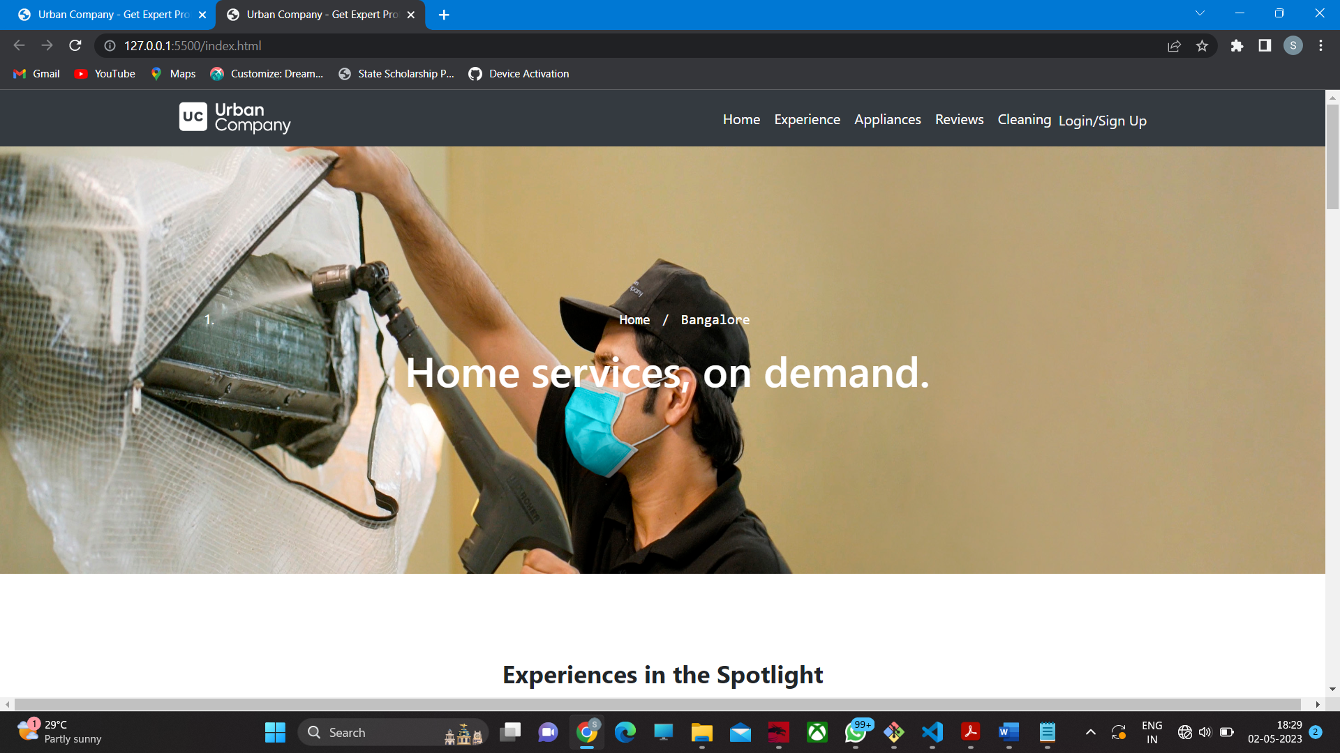

### Experience :

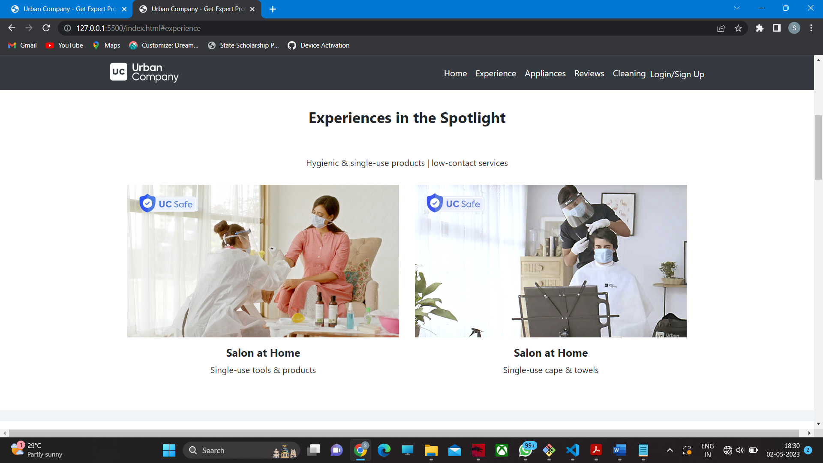

**Appliances :**

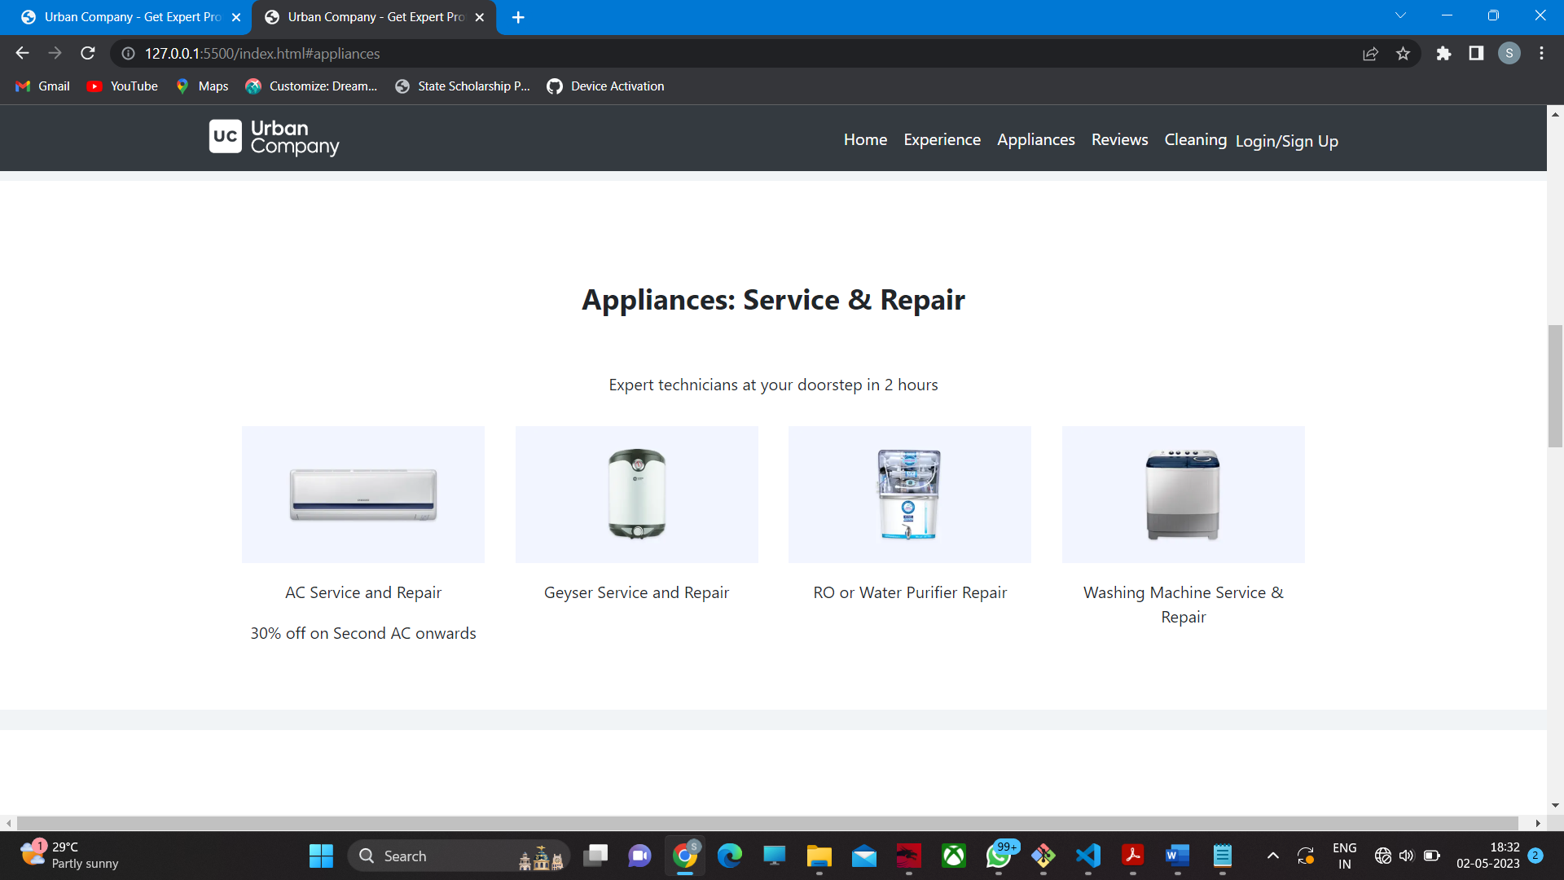

**Blog Page :**

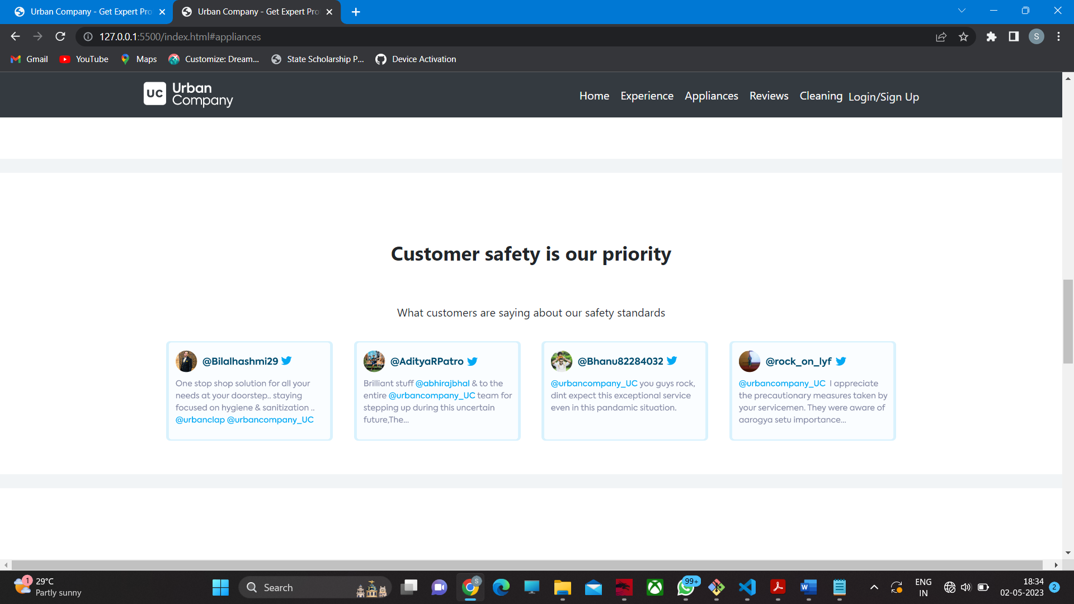

**Signup Page :**

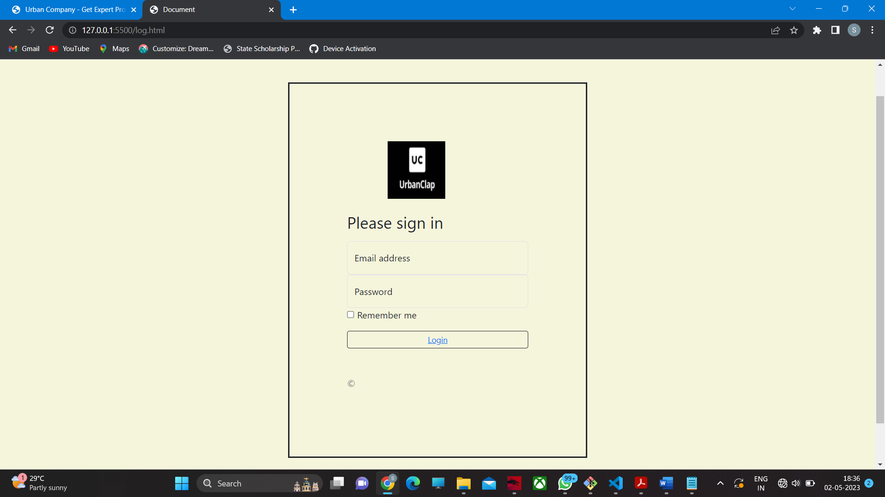

# Tools and Technologies

**Requirements:**

1. **Hardware Requirements :**

Processor: Intel Pentium Dual Core. RAM : 4GB or more.

Hard Disk : 512 GB. Processor Speed : 2 GHz.

### Software Requirements :

Front End : Google Chrome, FireFox ,Opera browsers. Operating System : Windows 7 or more.

1. **Languages** :

HTML5,CSS,Bootstrap.

# Conclusion

The URBAN COMPANY WEBSITE provides facility to know the information about the services anywhere. User can get all the details about the Services from this website anytime. The user can register through the website by providing all the required information to contact to the URBAN COMPANY and to Download the app. One can also contact and can also give feedback about his/her experience and opinions to the URBAN COMPANY center.

**Limitations of the project :**

* + Connection to the Internet is Needed.
  + The user has to register for joining URBAN COMPANY .
  + Internet is required to install and use the App.

**Future Enhancement:**

We will be able to implement UPI Transactions feature in the application in the future.

We will also include the professionals page and the Reviews about the Profissionals

Progressive enhancement for strong foundations so that its accessible to the wide range of browsing situations.

**REFERENCES:**

1. <https://www.w3schools.com/>
2. <https://www.geeksforgeeks.org/>
3. <https://getbootstrap.com/>
4. <https://en.wikipedia.org/>