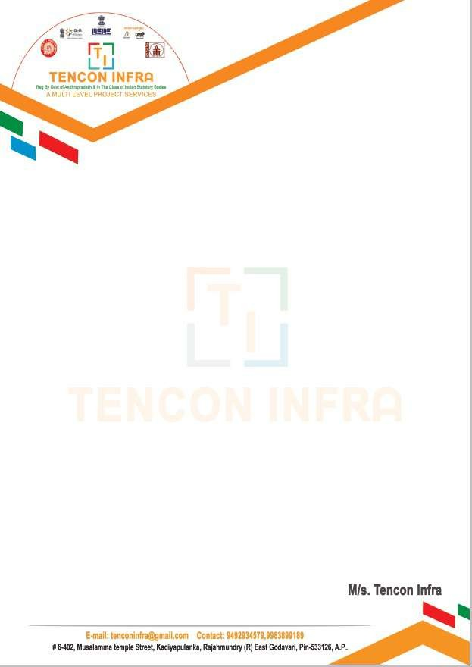

**INTERNSHIP CERTIFICATE**

This is to certify that \***THARUN POLINATI**

Reg.No * **220377400198**

Of **ADITYA DEGREE COLLEGE, KAKINADA** underwent internship in

**TENCON INFRA** from 08/05/2024 to 19/06/2024

The overall performance of the intern during her internship is found to be Satisfactory.