SIMATS ENGINEERING
ASSESSMENT TOOL 1
COURSE NAME: Computer Networks (CSA0713)
COURSE CODE: CSA0713
Course Outcome Covered
CO1: Apply the functions of OSI layer in enabling reliable data transmission across networks. (BL2, BL3)
Assessment Tool Weightage: 40%
Annexure A
SHORT ANSWER TEST
Faculty: Dr. V. Parthipan
Code of Conduct:
I __B Tharun Kumar / 192424356_(Name / Reg No) certify that this submission is my original work and that I have adhered to the guidelines specified for this assessment.
I understand that any violation of academic integrity rules will result in disciplinary action.
Signature of the Student: ____________________

Annexure A – Short Answer Test: Solutions
This document presents the complete, step-by-step solutions to the ten short-answer questions on the OSI Reference Model and reliable data transmission across network layers. Each solution follows a consistent structure — Given Data, Calculation, Final Answer, and Explanation — so that the underlying concepts, the mathematical working, and their real-world significance are all clearly demonstrated.
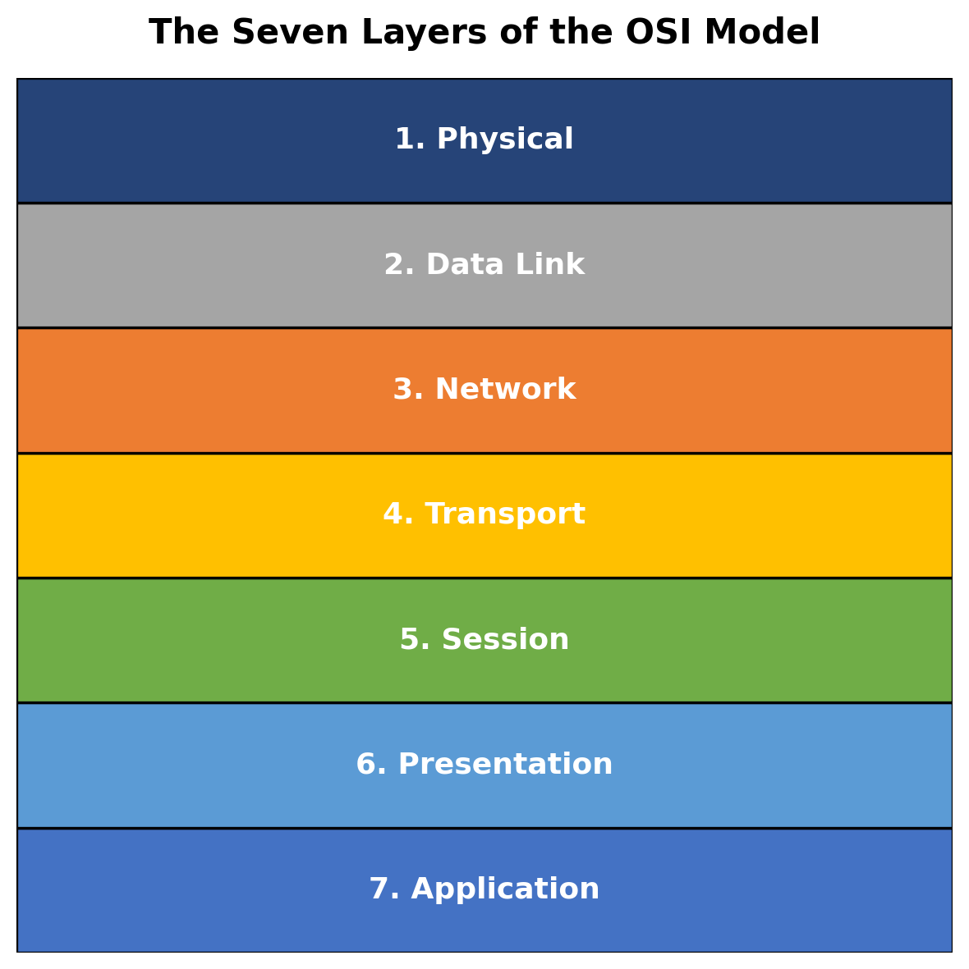
Figure 1: The Seven Layers of the OSI Reference Model
The OSI (Open Systems Interconnection) model organizes network communication into seven layers, each responsible for a specific function — from the physical transmission of bits to the delivery of application-level services. As data moves down the stack at the sender, each layer adds its own control information (encapsulation); as it moves up the stack at the receiver, each layer removes and interprets that information (decapsulation). This layered approach ensures modularity, interoperability, and reliable communication, which the ten problems below explore quantitatively.

Question 1
A company needs to transfer a 150 MB design file from a client computer to a remote server over a network with a bandwidth of 50 Mbps. The Transport Layer divides the file into 1500-byte segments, while the Data Link Layer encapsulates each segment into frames by adding 40 bytes of header and trailer. Calculate the total number of segments and frames transmitted, the total transmission overhead introduced by the Data Link Layer, and estimate the total transmission time (ignoring propagation delay). Explain how the Transport and Data Link layers ensure reliable communication.
Given Data
- File size = 150 MB = 150,000,000 bytes
- Segment size (Transport Layer) = 1500 bytes
- Data Link Layer overhead per frame = 40 bytes (header + trailer)
- Bandwidth = 50 Mbps
Calculation / Solution
- Number of segments = File size ÷ Segment size = 150,000,000 ÷ 1500 = 100,000 segments
- Each segment is encapsulated into exactly one frame, so Number of frames = 100,000 frames
- Total Data Link overhead = Number of frames × overhead per frame = 100,000 × 40 = 4,000,000 bytes = 4 MB
- Total data actually transmitted = File size + overhead = 150,000,000 + 4,000,000 = 154,000,000 bytes
- Convert to bits: 154,000,000 bytes × 8 = 1,232,000,000 bits
- Transmission time = Total bits ÷ Bandwidth = 1,232,000,000 ÷ 50,000,000 = 24.64 seconds

Final Answer: 100,000 segments, 100,000 frames, 4 MB Data Link overhead, and approximately 24.64 seconds transmission time.

Explanation
The Transport Layer ensures reliable communication by breaking the file into manageable segments, numbering them with sequence numbers, and using acknowledgements and retransmission (as in TCP) so that lost or corrupted segments are detected and resent, guaranteeing that the complete file arrives intact and in order. The Data Link Layer complements this by wrapping each segment in a frame with header and trailer fields that carry addressing and error-detection information (such as a CRC checksum). This lets each hop verify that a frame was not damaged in transit and request retransmission at the link level if necessary, ensuring end-to-end reliability layer by layer.

Question 2
A Transport Layer protocol uses a sliding window size of 6 frames. Each frame carries 1024 bytes of user data. If the sender transmits 48 frames, calculate the number of transmission windows required. If one frame in every window is lost and must be retransmitted, determine the total number of retransmissions. Explain how flow control improves communication efficiency.
Given Data
- Sliding window size = 6 frames
- Frame data size = 1024 bytes (not needed for the window count, but confirms frame size)
- Total frames to send = 48 frames
- Loss rate = 1 lost frame per window
Calculation / Solution
- Number of windows required = Total frames ÷ Window size = 48 ÷ 6 = 8 windows
- Since 1 frame is lost per window and there are 8 windows, Total retransmissions = 8 × 1 = 8 retransmissions

Final Answer: 8 transmission windows are required, and a total of 8 frames must be retransmitted.

Explanation
Flow control, implemented through the sliding window mechanism, allows the sender to transmit multiple frames (up to the window size) before waiting for an acknowledgement, instead of sending one frame at a time and waiting for confirmation. This keeps the communication channel continuously utilized, improves throughput, and prevents the sender from overwhelming a slower receiver's buffer. When a frame is lost, only the affected frame (or, in Go-Back-N, the frames from that point onward) needs retransmission, which keeps recovery efficient while still guaranteeing that all data eventually arrives correctly.
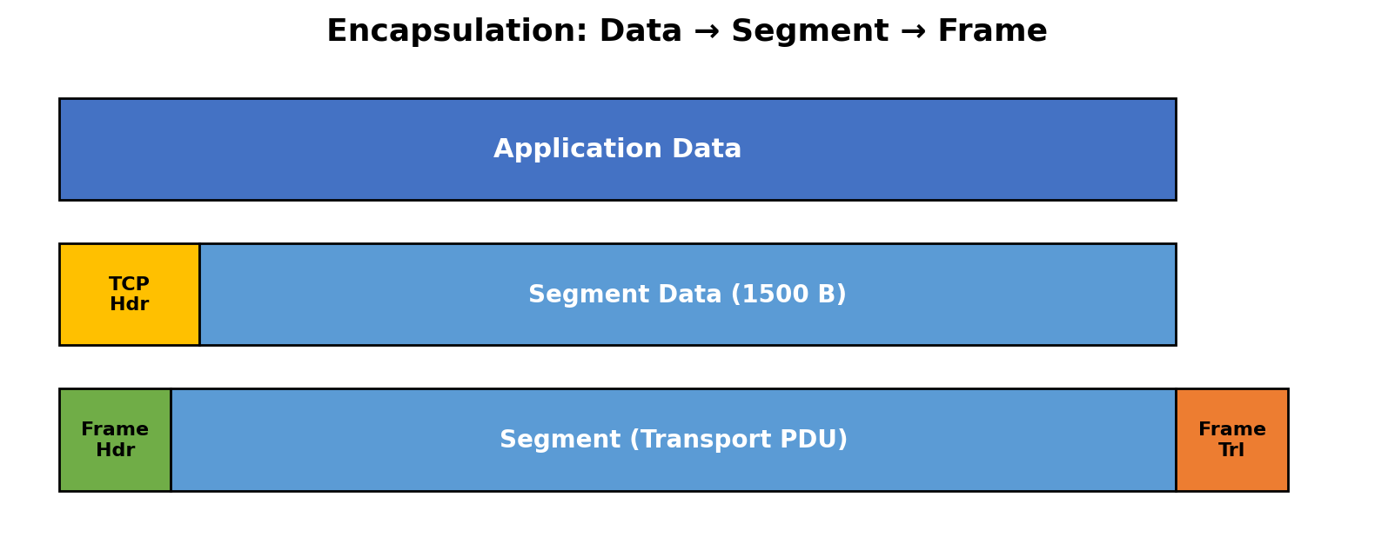
Figure 2: Encapsulation of Data into a Segment and then into a Frame (relevant to Q1 and Q3)

Question 3
A 12,000-byte IP packet is transmitted through a router where the Maximum Transmission Unit (MTU) is 1500 bytes. Assuming each fragment requires a 20-byte IP header, calculate the total number of fragments created and the total header overhead introduced. Explain how the Network Layer ensures successful delivery of fragmented packets to the destination.
Given Data
- Original packet size = 12,000 bytes
- MTU (maximum size per fragment) = 1500 bytes
- IP header size per fragment = 20 bytes
- Usable data per fragment = MTU − header = 1500 − 20 = 1480 bytes
Calculation / Solution
- Number of fragments = ceil(Packet size ÷ Usable data per fragment) = ceil(12,000 ÷ 1480) = ceil(8.11) = 9 fragments
- Total header overhead = Number of fragments × header size = 9 × 20 = 180 bytes

Final Answer: 9 fragments are created, introducing a total header overhead of 180 bytes.

Explanation
The Network Layer ensures successful delivery of fragmented packets by assigning each fragment the same identification number as the original packet, along with a fragment offset field that records its position within the original data stream. A "more fragments" flag marks all but the last fragment, telling the destination when reassembly is complete. At the receiving host, the Network Layer (IP) buffers all fragments carrying the same identifier and offset sequence, reassembles them in the correct order using the offset values, and discards or requests retransmission if any fragment is missing, ensuring the original packet is reconstructed accurately before being passed up to the Transport Layer.

Question 4
A Transport Layer protocol uses a sliding window size of 6 frames. Each frame carries 1024 bytes of user data. If the sender transmits 48 frames, calculate the number of transmission windows required. If one frame in every window is lost and must be retransmitted, determine the total number of retransmissions. Explain how flow control improves communication efficiency.
Given Data
- Sliding window size = 6 frames
- Frame data size = 1024 bytes
- Total frames to send = 48 frames
- Loss rate = 1 lost frame per window
Calculation / Solution
- Number of windows required = Total frames ÷ Window size = 48 ÷ 6 = 8 windows
- Total retransmissions = 8 windows × 1 lost frame per window = 8 retransmissions

Final Answer: 8 transmission windows are required, and a total of 8 frames must be retransmitted.

Explanation
This question repeats Question 2. As explained there, flow control via the sliding window mechanism lets the sender keep several frames "in flight" before requiring an acknowledgement, maximizing use of the available bandwidth instead of idling after every single frame. This significantly raises effective throughput on links with non-trivial round-trip time, while the window's built-in retransmission strategy ensures that occasional frame losses are corrected without stopping the overall data flow.

Question 5
A multimedia application transfers a 600 MB video file. The Session Layer inserts a synchronization checkpoint after every 60 MB of transmitted data. During transmission, a failure occurs after 390 MB has been transferred. Determine the number of checkpoints created before failure and calculate the amount of data that must be retransmitted after recovery. Explain the importance of synchronization in the Session Layer.
Given Data
- Total file size = 600 MB
- Checkpoint interval = every 60 MB
- Point of failure = after 390 MB transferred
Calculation / Solution
- Checkpoints occur at 60, 120, 180, 240, 300, and 360 MB — the last checkpoint before failure is at 360 MB
- Number of checkpoints created before failure = 390 ÷ 60 = 6.5 → floor(6.5) = 6 checkpoints
- Data retransmitted after recovery = Failure point − Last checkpoint = 390 − 360 = 30 MB

Final Answer: 6 checkpoints are created before the failure, and 30 MB of data must be retransmitted after recovery.

Explanation
The Session Layer is responsible for establishing, managing, and synchronizing communication sessions between two systems. By inserting periodic synchronization checkpoints, it allows a long transfer to resume from the last successful checkpoint rather than restarting from the very beginning if a failure occurs. This dramatically reduces the amount of data that must be resent (only 30 MB out of 390 MB already sent in this case), saving time, bandwidth, and processing resources — which is especially valuable for large multimedia transfers where restarting from zero would be highly inefficient.

Question 6
Before transmission, the Presentation Layer compresses a 900 MB file by 40%. The compressed data is encrypted, adding 5% overhead to the compressed size. Calculate the compressed file size, the encrypted file size, and the total percentage reduction compared to the original file. Explain how the Presentation Layer improves transmission efficiency and security.
Given Data
- Original file size = 900 MB
- Compression reduces size by 40%
- Encryption adds 5% overhead to the compressed size
Calculation / Solution
- Compressed size = Original × (1 − 0.40) = 900 × 0.60 = 540 MB
- Encrypted size = Compressed size × (1 + 0.05) = 540 × 1.05 = 567 MB
- Total reduction compared to original = (900 − 567) ÷ 900 × 100 = 333 ÷ 900 × 100 = 37%

Final Answer: Compressed size = 540 MB, Encrypted size = 567 MB, and the overall size reduction compared to the original file is 37%.

Explanation
The Presentation Layer improves transmission efficiency by compressing data before it is sent, reducing the number of bits that must travel across the network and thereby lowering transmission time and bandwidth consumption. It improves security by encrypting the data, converting it into a form that is unreadable to unauthorized parties who might intercept it in transit, and by handling data-format translation (such as character encoding) so that systems with different native formats can still communicate correctly. Even though encryption adds a small overhead here, the net effect — 567 MB versus the original 900 MB — is still a substantial 37% reduction, demonstrating that the layer's efficiency gains outweigh its security overhead.

Question 7
An FTP application transfers 3 GB of data over a network with an effective throughput of 120 Mbps. The Application Layer divides the data into requests of 3 MB each. Calculate the total number of requests generated and estimate the total transmission time in seconds. Discuss how the Application Layer provides reliable services to users.
Given Data
- Total data = 3 GB = 3000 MB
- Request size = 3 MB
- Effective throughput = 120 Mbps
Calculation / Solution
- Number of requests = Total data ÷ Request size = 3000 ÷ 3 = 1000 requests
- Total data in bits = 3000 MB × 8 = 24,000 Mb (megabits) = 24,000,000,000 bits
- Transmission time = Total bits ÷ Throughput = 24,000,000,000 ÷ 120,000,000 = 200 seconds

Final Answer: 1000 requests are generated, and the estimated total transmission time is 200 seconds.

Explanation
The Application Layer, through protocols such as FTP, provides reliable services to users by breaking large transfers into smaller, well-defined requests and responses, each of which can be individually tracked, acknowledged, and — if necessary — retried. It also handles session control (login, directory navigation, file transfer mode), error reporting to the user, and relies on the underlying Transport Layer (typically TCP) for guaranteed, in-order delivery of each request's data. This layered reliability means the end user experiences a complete, correctly reassembled file even though it was physically delivered as many independent chunks.

Question 8
A packet experiences the following processing delays at different OSI layers: Application Layer = 4 ms, Transport Layer = 3 ms, Network Layer = 5 ms, Data Link Layer = 2 ms, and Physical Layer = 1 ms. The propagation delay is 18 ms, and the transmission delay is 12 ms. Calculate the total end-to-end delay experienced by the packet and explain how each layer contributes to the communication process.
Given Data
- Application Layer processing delay = 4 ms
- Transport Layer processing delay = 3 ms
- Network Layer processing delay = 5 ms
- Data Link Layer processing delay = 2 ms
- Physical Layer processing delay = 1 ms
- Propagation delay = 18 ms
- Transmission delay = 12 ms
Calculation / Solution
- Total processing delay = 4 + 3 + 5 + 2 + 1 = 15 ms
- Total end-to-end delay = Processing delay + Propagation delay + Transmission delay = 15 + 18 + 12 = 45 ms

Final Answer: The total end-to-end delay experienced by the packet is 45 milliseconds.

Explanation
Each OSI layer contributes a distinct processing delay as it performs its designated function: the Application Layer prepares and formats user data (4 ms), the Transport Layer segments the data and manages end-to-end connections (3 ms), the Network Layer performs routing and logical addressing decisions (5 ms, the largest share, reflecting route lookups), the Data Link Layer handles framing and error checking (2 ms), and the Physical Layer converts the frame into signals for transmission (1 ms). Beyond this cumulative processing delay, the transmission delay (time to push all bits onto the link) and the propagation delay (time for the signal to physically travel the medium) add further latency, together producing the total 45 ms end-to-end delay experienced from source to destination.

Question 9
A network transfers 80 MB of useful data using frames of 1600 bytes, where each frame contains 80 bytes of protocol overhead added by different OSI layers. Calculate the total number of frames required, the total overhead transmitted, and the transmission efficiency as a percentage. Explain how protocol overhead affects network performance.
Given Data
- Useful (payload) data = 80 MB = 80,000,000 bytes
- Total frame size = 1600 bytes
- Overhead per frame = 80 bytes
- Usable payload per frame = 1600 − 80 = 1520 bytes
Calculation / Solution
- Number of frames required = ceil(Useful data ÷ Payload per frame) = ceil(80,000,000 ÷ 1520) = ceil(52,631.6) = 52,632 frames
- Total overhead transmitted = Number of frames × overhead per frame = 52,632 × 80 = 4,210,560 bytes ≈ 4.21 MB
- Total data transmitted = Number of frames × frame size = 52,632 × 1600 = 84,211,200 bytes ≈ 84.21 MB
- Transmission efficiency = (Useful data ÷ Total data transmitted) × 100 = (80,000,000 ÷ 84,211,200) × 100 ≈ 95.0%

Final Answer: 52,632 frames are required, total overhead ≈ 4.21 MB, and transmission efficiency ≈ 95.0%.

Explanation
Protocol overhead is the "non-payload" data (headers, trailers, control fields) that every layer adds to enable addressing, error checking, and flow/session control. While essential for reliable communication, it consumes bandwidth that could otherwise carry user data, so a higher overhead-to-payload ratio lowers transmission efficiency and effectively slows down large transfers. In this scenario the overhead is relatively small (80 bytes in a 1600-byte frame), keeping efficiency high at about 95%; however, on networks that use small frames or add multiple layers of headers, overhead can consume a much larger share of the available bandwidth, which is why real network designs try to balance frame size, reliability, and overhead carefully.

Question 10
A hospital transfers a patient's medical record of 240 MB through an IoT-enabled healthcare network. The Presentation Layer compresses the data by 30%, the Transport Layer divides the compressed data into 1400-byte segments, and the Data Link Layer adds 60 bytes of overhead to each frame. Calculate the compressed file size, the total number of segments transmitted, the total protocol overhead introduced, and the final amount of data transmitted across the Physical Layer. Explain how multiple OSI layers work together to ensure secure and reliable communication.
Given Data
- Original medical record size = 240 MB
- Presentation Layer compression = 30% reduction
- Transport Layer segment size = 1400 bytes
- Data Link Layer overhead per frame = 60 bytes
Calculation / Solution
- Compressed size = Original × (1 − 0.30) = 240 × 0.70 = 168 MB = 168,000,000 bytes
- Number of segments = Compressed size ÷ Segment size = 168,000,000 ÷ 1400 = 120,000 segments
- Each segment becomes one frame, so total Data Link overhead = 120,000 × 60 = 7,200,000 bytes = 7.2 MB
- Final data transmitted at the Physical Layer = Compressed size + Total overhead = 168 + 7.2 = 175.2 MB

Final Answer: Compressed size = 168 MB, Number of segments = 120,000, Total protocol overhead = 7.2 MB, and the final data transmitted at the Physical Layer = 175.2 MB.

Explanation
Secure and reliable delivery of sensitive healthcare data depends on every OSI layer performing its role in coordination. The Presentation Layer compresses (and, in practice, encrypts) the medical record for efficient and confidential transmission; the Transport Layer divides the compressed data into fixed-size segments and manages end-to-end reliability through sequencing and acknowledgements; the Network Layer routes these segments across the IoT-enabled hospital network to the correct destination; the Data Link Layer frames each segment with addressing and error-detection overhead so that transmission errors on any single hop can be detected and corrected; and the Physical Layer carries the resulting frames as raw signals over the transmission medium. Because each layer adds its own safeguard — compression and encryption for efficiency and privacy, segmentation and acknowledgement for reliability, and framing for error control — the patient record arrives at the destination completely, accurately, and securely despite the cumulative 7.2 MB of protocol overhead involved.

Conclusion
Across all ten problems, a consistent pattern emerges: each OSI layer adds a measurable, purposeful cost — in the form of segmentation, framing overhead, compression, encryption, or synchronization checkpoints — in exchange for a specific reliability, security, or efficiency benefit. The Transport and Data Link layers guarantee that data arrives complete and error-free; the Network layer ensures correct routing and reassembly of fragmented packets; the Session layer allows large transfers to recover gracefully from failure; the Presentation layer optimizes data for secure, efficient transport; and the Application layer delivers a seamless experience to the end user. Understanding these layer-by-layer trade-offs — quantified here through overhead calculations, transmission-time estimates, and efficiency percentages — is essential to designing and troubleshooting real-world computer networks.

