**CODE**

%{

#include<stdio.h>

int nc=0;

%}

%%

"/*"[a-zA-Z0-9\n\t ]*"*/" {nc++;}

"//"[a-zA-Z0-9\t ]*"\n" {nc++;}

%%

int yywrap( ){}

int main(int argc ,char* argv[])

{

yyin=fopen(argv[1],"r");

yyout=fopen("output.c","w");

yylex( );

printf("The number of comment lines=%d\n",nc);

}

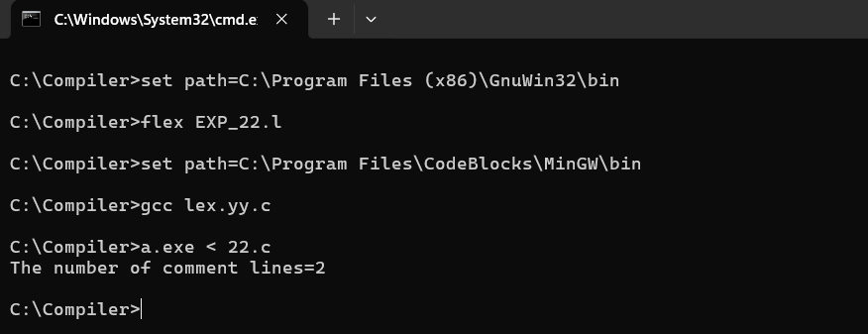**SCREENSHOT**