**CODE**

%{

#include<stdio.h>

%}

%%

[A-Z]+ { printf("Capital word: %s\n", yytext); }

.|\n { /* ignore other characters */ }

%%

int yywrap() { return 1; }

int main() {

yylex();

return 0;

}

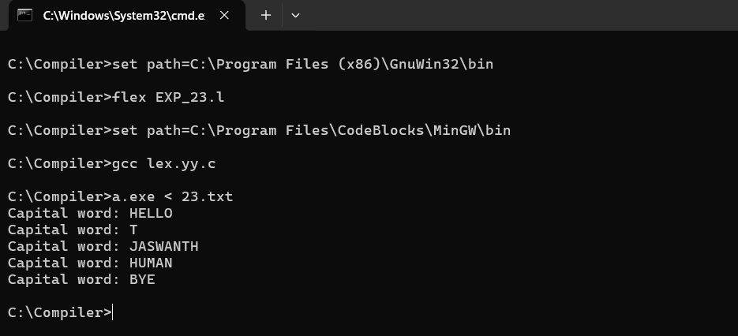**SCREENSHOT**