**CODE**

%{

#include <stdio.h>

%}

/* Basic regex for email: username@domain.extension */

%%

[a-zA-Z0-9._]+@[a-zA-Z0-9]+\.(com|in|org|net) { printf("It is a valid email: %s\n", yytext); }

.+ { printf("It is not valid: %s\n", yytext); }

%%

int yywrap() { return 1; }

int main() {

printf("Enter the email: ");

yylex(); // takes input directly from keyboard

return 0;

}

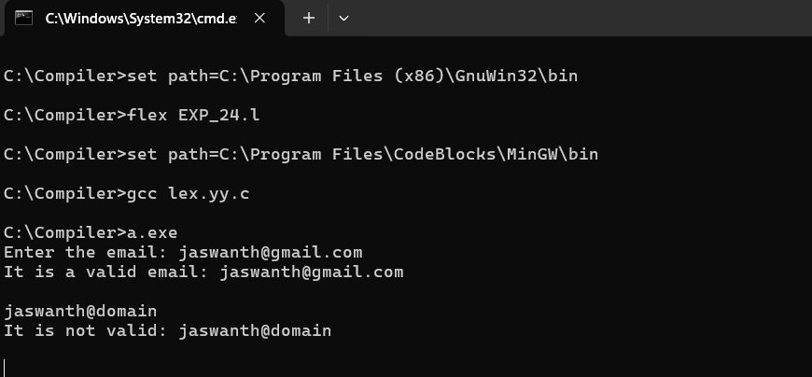**SCREENSHOT**