**CODE**

%{

#include <stdio.h>

%}

%%

[0-9]+ { printf("It is an Integer : %s\n", yytext); }

[0-9]*"."[0-9]+ { printf("It is a Float : %s\n", yytext); }

[a-zA-Z0-9]+ { printf("It is a String : %s\n", yytext); }

.|\n ;

%%

int yywrap() { return 1; }

int main() {

printf("Enter input: ");

yylex();

return 0;

}

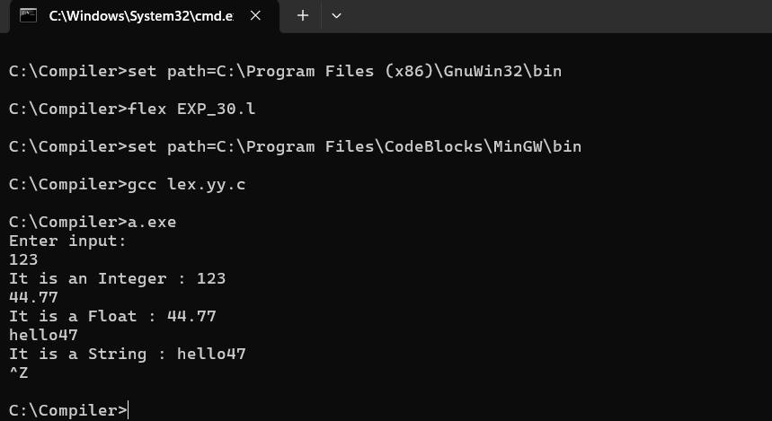**SCREENSHOT**