**Non-Roaming 5G System Architecture**

* **Introduction to 5G**
  + 5G is the fifth generation of mobile networks, offering faster speeds, lower latency, and more capacity than previous generations.
  + It enables new applications like IoT, autonomous vehicles, and smart cities.
  + 5G architecture is designed to be flexible, scalable, and service-oriented.

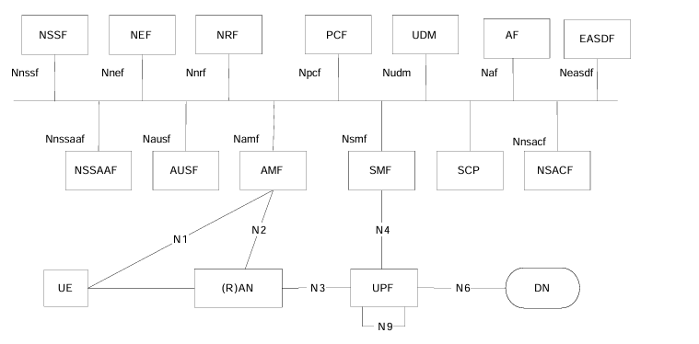

* Core Network: Manages data and connectivity for devices.
* Radio Access Network (RAN): Connects devices to the core network.
* User Equipment (UE): Devices used by end-users to access the network.
* **Core Network Functions**
* **NSSF (Network Slicing Selection Function)**
  + **Function**: NSSF selects the network slice instance for a particular service request, ensuring that the appropriate resources are allocated based on the user's subscription and service requirements.
  + **Use Case**: Essential for enabling network slicing, which allows multiple virtual networks to be created on a single physical infrastructure, each optimized for different types of services (e.g., IoT, enhanced mobile broadband).
* **NEF (Network Exposure Function)**
  + **Function**: NEF exposes network capabilities and events to external applications and network functions securely. It also facilitates the authorization of applications to access certain services and resources.
  + **Use Case**: Used for service-based architecture to allow third-party applications to interact with the network, enabling innovative services and partnerships.
* **NRF (Network Repository Function)**
  + **Function**: NRF keeps a record of all available network functions and their profiles. It provides registration and discovery services to other network functions.
  + **Use Case**: Ensures that network functions can dynamically discover and communicate with each other, promoting scalability and flexibility in the network.
* **PCF (Policy Control Function)**
  + **Function**: PCF provides policy rules to control how data flows through the network. It handles Quality of Service (QoS) management, access control, and charging policies.
  + **Use Case**: Essential for enforcing policies that optimize network performance and ensure users receive the service quality they are entitled to.
* **UDM (Unified Data Management)**
  + **Function**: UDM handles user data management, including user profiles, authentication credentials, and subscription information.
  + **Use Case**: Centralized management of subscriber data ensures consistency and efficiency in user authentication and session management.
* **AF (Application Function)**
  + **Function**: AF interacts with the 5G core network to provide specific services, such as initiating QoS adjustments or triggering certain network behaviors.
  + **Use Case**: Supports application-driven network behavior, allowing services to dynamically adjust network parameters based on application needs.
* **AUSF (Authentication Server Function)**
  + **Function**: AUSF performs authentication of user devices to ensure secure access to the network.
  + **Use Case**: Critical for maintaining the security and integrity of network access, preventing unauthorized usage.
* **AMF (Access and Mobility Management Function)**
  + **Function**: AMF manages registration, connection, and mobility aspects of user equipment, handling signaling traffic between the UE and the core network.
  + **Use Case**: Ensures that users remain connected to the network as they move and manage their access rights.
* **SMF (Session Management Function)**
  + **Function**: SMF handles session establishment, modification, and release. It also manages the assignment of IP addresses to UEs.
  + **Use Case**: Manages user sessions and data paths, ensuring efficient use of network resources.
* **UPF (User Plane Function)**
  + **Function**: UPF is responsible for forwarding user data packets and managing data transport between the user equipment and data networks.
  + **Use Case**: Ensures efficient routing and forwarding of data, supporting high-speed data services.
* **Interfaces and Connections**
* **N1, N2, N3 Interfaces**
  + **N1 (UE to AMF)**: The interface between User Equipment (UE) and AMF, handling signaling for registration and mobility.
  + **N2 (AMF to RAN)**: The interface between AMF and the Radio Access Network (RAN), managing signaling for handover and other mobility functions.
  + **N3 (RAN to UPF)**: The interface between RAN and UPF, responsible for the transfer of user data.
* **N4 (SMF to UPF)**
  + **Function**: Manages control messages between SMF and UPF for session management and data path control.
  + **Use Case**: Ensures the proper establishment and management of data paths in the user plane.
* **N6 (UPF to DN)**
  + **Function**: Connects the user plane to external data networks, managing data routing and forwarding.
  + **Use Case**: Provides connectivity to internet services and other external data resources.
* **Other Components**
* **NSACF (Network Slice Awareness and Control Function)**
  + **Function**: Manages network slice-specific control functions and ensures that the appropriate network slice is used for service delivery.
  + **Use Case**: Supports dynamic slice management and helps operators optimize resource allocation.
* **SCP (Service Communication Proxy)**
  + **Function**: Provides proxy services for service-based architecture, facilitating communication between network functions.
  + **Use Case**: Ensures secure and efficient message routing between different network components.
* **DN (Data Network)**
  + **Function**: Represents the external data networks that the 5G network connects to, including the internet and other service networks.
  + **Use Case**: Provides end-users with access to various data services and applications.
* **User Equipment and Radio Access**
* **UE (User Equipment)**
  + **Function**: Refers to any device used by the end-user to access network services, such as smartphones, tablets, or IoT devices.
  + **Use Case**: Acts as the endpoint for service delivery, enabling users to interact with the network.
* **RAN (Radio Access Network)**
  + **Function**: The part of the network that connects UEs to the core network via radio signals, comprising base stations and other radio infrastructure.
  + **Use Case**: Provides wireless connectivity and handles data transmission between user devices and the network core.
* **Network Slicing**
* Allows multiple virtual networks on a single physical infrastructure.
* Each slice optimized for different services (e.g., IoT, enhanced mobile broadband).
* Facilitates efficient resource allocation and service delivery.
* **Example**: A dedicated network slice for autonomous vehicles to ensure low-latency communication.
* **Security in 5G Networks**
* Enhanced security protocols to protect user data and network integrity.
* AUSF ensures secure authentication of devices.
* NEF manages secure exposure of network capabilities.
* **Example**: Enhanced encryption and authentication for secure financial transactions over 5G.