Software Development Life Cycle:

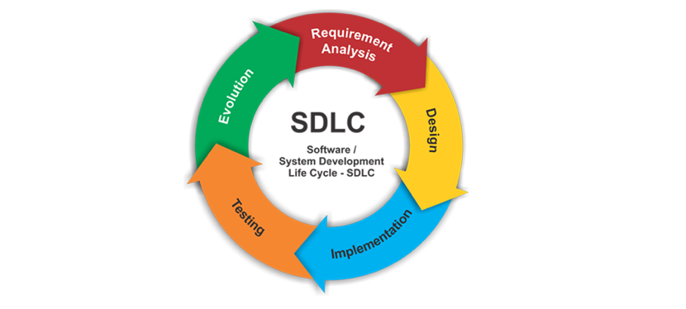
SDLC Phases:
1)Requirement Phase:
*)Define what that software should do, gathering user needs.
*)Lays the foundation for the entire project, ensuring aligment with user expectations.
*)Directly influences design and implementation phases.

2)Design Phase:
*)Architect the software structure, UI/UX, and system components.
*)Transforms requirements into a blueprint for development.
*)Guides implementation and testing by providing a roadmap.

3)Implementation Phase:
*)Writing, coding and building the software according to the design.
*)Converts design into a functional product.
*)Relies on requrements and design to create the intended solution.

4)Testing Phase:
*)Verify Software functionality, identify defects, and ensure quality.
*)Validates that the software meets user expectations and requirements.
*)Validates implementation against design and requirements, leading to adjustments if necessary.

5)Deployment Phase:
*)Introduce the software into the production environment for user access.
*)Marks the culmination of development efforts, making the software available for use.
*)Builds on testing results, ensuring the software is ready for deployment.

