Comparative Infographic: TDD vs BDD vs FDD

1. Test-Driven Development (TDD)
- Approach:
  - Write tests before writing functional code.
  - Red-Green-Refactor cycle: Write a failing test (red), write code to pass the test (green), refactor code (improve without changing functionality).
- Benefits:
  - Early bug detection.
  - Clear, verifiable requirements through tests.
  - Promotes modular and reusable code.
- Suitability:
  - Agile environments.
  - Projects with clear, stable requirements.
  - Developers focused on code quality and maintainability.

2. Behavior-Driven Development (BDD)
- Approach:
  - Focus on the behavior of the system from the end user’s perspective.
  - Uses natural language specifications (Given-When-Then) to describe scenarios.
- Benefits:
  - Collaboration between developers, testers, and non-technical stakeholders.
  - Ensures that development meets business expectations.
  - Enhances communication and reduces misunderstandings.
- Suitability:
  - Cross-functional teams.
  - Projects with changing requirements.
  - Customer-centric development.

3. Feature-Driven Development (FDD)
- Approach:
  - Iterative and incremental development focusing on features or functionalities.
  - Emphasizes domain object modeling and class ownership.
- Benefits:
  - Scalability for large projects.
  - Efficient use of resources.
  - Clear division of tasks based on features.
- Suitability:
  - Large-scale enterprise projects.
  - Development teams experienced in object-oriented design.
  - Projects requiring systematic and predictable progress.

Comparison Overview
- Focus:
  - TDD: Code-centric.
  - BDD: Behavior-centric.
  - FDD: Feature-centric.
- Methodology:
  - TDD and BDD: Test-driven.
  - FDD: Feature-driven.
- Benefits:
  - TDD: Code quality, early bug detection.
  - BDD: Improved collaboration, customer satisfaction.
  - FDD: Scalability, resource efficiency.
- Suitability:
  - TDD: Agile, stable requirements.
  - BDD: Changing requirements, customer involvement.
  - FDD: Large-scale projects, systematic development.

Conclusion
- Choosing the Right Methodology:
  - Consider project size, team composition, and development stage.
  - Combine methodologies where suitable (e.g., TDD with BDD for comprehensive testing and user satisfaction).

This infographic visually represents the distinct characteristics of TDD, BDD, and FDD, helping developers and project managers choose the most suitable methodology for their software development projects.

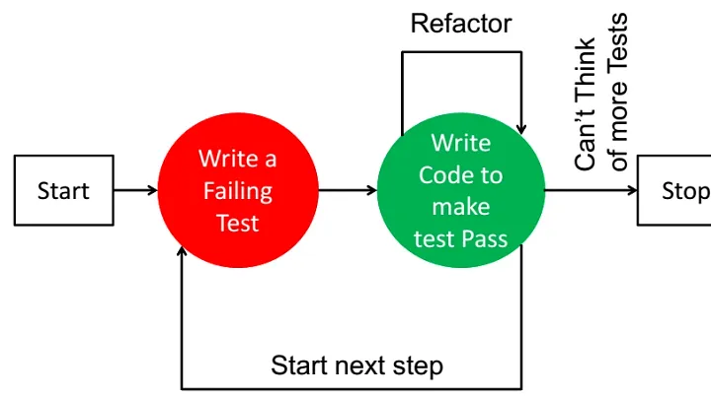

INFOGRAPHIC STRUCTURE OF TDD:
1. Introduction to TDD:
- Definition: Test-Driven Development (TDD) is a software development process where tests are written before the code.
2. Steps of TDD:
- Step 1: Write a Test
  - Develop a test that defines a new function or improvement.
  - Tests are written in small, manageable increments.
- Step 2: Run the Test
  - Execute the test to ensure it fails.
  - This confirms that the test initially identifies missing functionality.
- Step 3: Write the Code
  - Implement the minimal code necessary to pass the test.
  - Focus on meeting the test requirements only.
- Step 4: Run All Tests
  - Execute all tests to ensure the new code doesn’t break existing functionality.
  - Rapid feedback helps catch errors early.
- Step 5: Refactor Code
  - Improve code structure and design while keeping all tests passing.
  - Enhances software quality and maintainability.
3. Benefits of TDD:
- Bug Reduction
  - Early identification of issues minimizes bugs in the final product.
- Improved Software Reliability
  - Continuous testing ensures each feature works as expected, leading to reliable software.
- Enhanced Code Quality
  - Encourages cleaner and modular code through iterative development and refactoring.
- Customer Satisfaction
  - Delivering bug-free features on time increases customer confidence and satisfaction.
4. Conclusion:
- Adopting TDD promotes a disciplined approach to software development, resulting in higher quality, reliability, and customer satisfaction.

Design Notes:
- Use a clean and modern design with icons representing each step.
- Ensure clarity in text and diagrams to facilitate understanding.
- Include statistics or quotes on how TDD improves software development metrics.

