**What is Machine Learning?**

* Machine Learning is a subset of artificial intelligence which gives a machine the ability to learn without being explicitly programmed.
* Data is the key and the learning algorithm.

**Types of Machine Learning**

* Supervised Learning
* Unsupervised Learning
* Reinforcement Learning

# Supervised Learning

## Use case: Spam classifier

Filter used – Text filter, client filter

**Regression**:

A technique of finding the relationship between two or more variables.

Change in dependent variable is associated with a change in one or more independent variables.

There are various types of Regression, but we will focus on:

* Linear Regression
* Logistic Regression

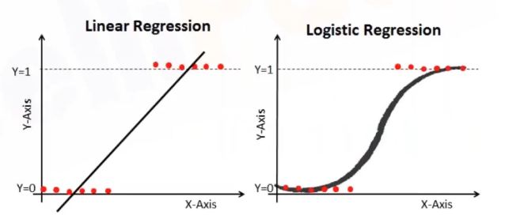

|  |  |
| --- | --- |
| Linear Regression | Logistic Regression |
| Continuous Variables | Categorical Variables |
| Solves Regression Issue | Solves Classification Issue |
| Straight Line | S-Curve |

**Linear Regression:**

* Simple linear regression is useful for finding relationship between two continuous variables
* One is predictor or independent variable and other is response or dependent variable

Reinforcement Learning:

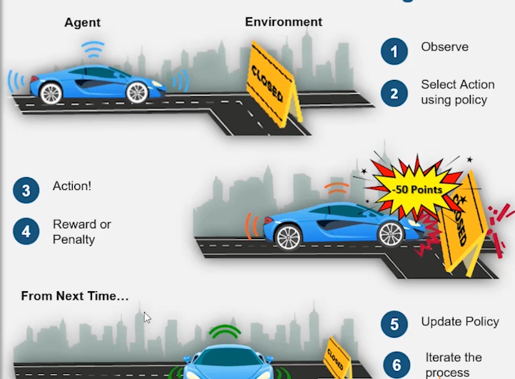

**1. Accuracy:**

The proportion of correctly classified instances among all instances in a dataset. It's calculated as

$$\text{Accuracy}=\frac{\text{True Positives}+\text{True Negatives}}{\text{Total Instances}}$$

* **Use**: Indicates the overall effectiveness of a model but can be misleading if the data is imbalanced.

**2. Confusion Matrix:**

* A table used to describe the performance of a classification model. It shows the counts of true positives, true negatives, false positives, and false negatives.
* **True Positives (TP)**: Correctly predicted positive instances.
* **True Negatives (TN)**: Correctly predicted negative instances.
* **False Positives (FP)**: Incorrectly predicted positive instances.
* **False Negatives (FN)**: Incorrectly predicted negative instances.

**3. Precision:**

* The proportion of true positive predictions among all positive predictions. It’s calculated as
$\text{Precision}=\frac{\text{TP}}{\text{TP}+\text{FP}}$

* **Use**: Measures the accuracy of the positive predictions, useful when the cost of false positives is high.

**4. Recall:**

* The proportion of true positive predictions among all actual positives. It’s calculated as
* **Use**: Measures the ability of a model to find all relevant instances, important when missing positive cases is costly.

**5. F1 Score:**

* The harmonic mean of precision and recall. It’s calculated as
$\text{F1 Score}=2×\frac{\text{Precision}×\text{Recall}}{\text{Precision}+\text{Recall}}$

* **Use**: Provides a single metric that balances precision and recall, useful for imbalanced datasets.

**6. K-Fold Cross Validation:**

* A technique to evaluate the performance of a model by splitting the data into $k$ subsets (folds), training the model on $k-1$ folds, and testing it on the remaining fold. This process is repeated $k$ times, with each fold used as the test set once.
$\text{Recall}=\frac{\text{TP}}{\text{TP}+\text{FN}}$

* **Use**: Helps in assessing the model's performance more reliably by reducing overfitting.

**7. Mean Squared Error (MSE):**

* **Definition**: The average squared difference between the actual values and the predicted values. It’s calculated as
$$\text{MSE}=\frac{1}{n}\sum_{i=1}^{n}{{\left(y_{i}-\hat{y_{i}}\right)}^{2}}$$

* **Use**: A measure of the quality of an estimator; it’s always non-negative and values closer to zero are better.

**8. Root Mean Squared Error (RMSE):**

* **Definition**: The square root of the Mean Squared Error. It’s calculated as $\text{RMSE}=\sqrt{\text{MSE}}$
* **Use**: Provides an interpretable error metric in the same units as the target variable, often preferred for regression problems.

**9. Hyperparameters:**

* **Definition**: Parameters that are set before the learning process begins and control the behavior of the training process (e.g., learning rate, number of trees in a random forest).
* **Use**: Tuned to optimize the performance of the model.

**10. Parameters:**

* The internal variables of the model that are learned from the training data (e.g., weights in a neural network).
* **Use**: Directly influence the predictions of the model.

**11. Tuning Model:**

* The process of optimizing hyperparameters to improve the performance of a model.
* **Use**: Ensures the model is well-suited for the specific problem and dataset.

**12. Learning Rate:**

* A hyperparameter that controls the step size at each iteration while moving toward a minimum of the loss function.
* **Use**: Affects the speed and quality of the model's learning process.

**13. Epochs:**

* One complete pass through the entire training dataset. Multiple epochs are often used to improve model performance.
* **Use**: Helps the model to learn from the data by iterating multiple times over the training set.

# Annotate: