# **Linear Regression With Multiple Variables (Multivariate Regression)**

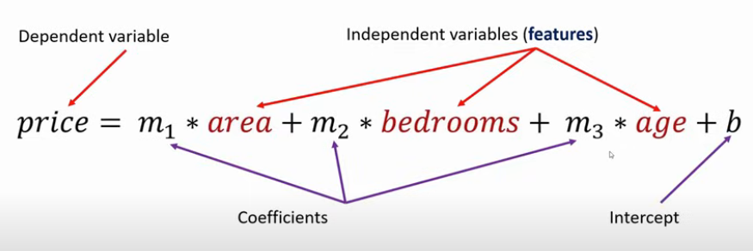



Gradient descent is an algorithm that finds best fit line for given training data set

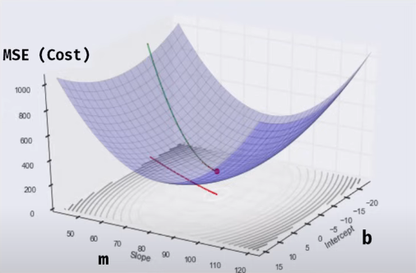

Mean Squared Error

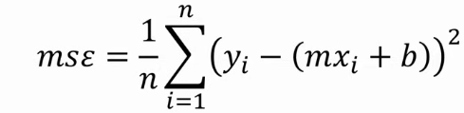

Partial Derivative of m:

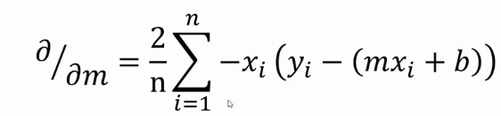

Partial Derivative of b:

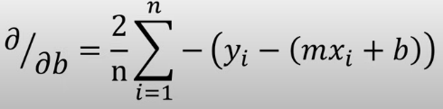

## **Learning Rate**

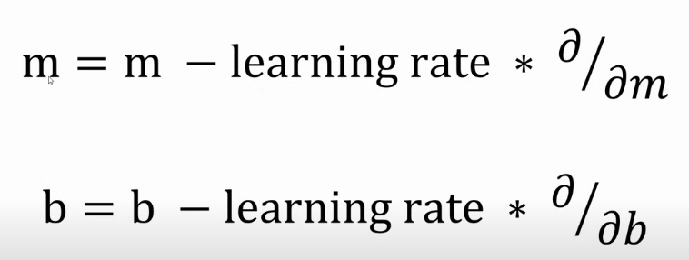

<https://www.mathsisfun.com/calculus/derivatives-introduction.html>