Game Shop Application
SKILL DEVELOPMENT PROGRAM REPORT SUBMITTED TO
THE NATIONAL INSTITUTE OF ENGINEERING, MYSURU
(An Autonomous Institute Under Visvesvaraya Technological University, Belagavi)


In partial fulfillment of the award of degree of
Bachelors of Engineering
Computer Science And Engineering
Under the guidance of
Ms. Divyashree R
Assistant Professor
Department of CS&E
NIE, Mysuru


Department of Computer Science & Engineering
The National Institute of Engineering
(Autonomous Institution)
Mysuru- 570 008
2025-26

The National Institute of Engineering
(An Autonomous Institute Under Visvesvaraya Technological
University, Belagavi)

Department of Computer Science & Engineering

CERTIFICATE
This is to certify that the project work entitled “Game Shop Application” is a bonafide work carried out by T Tharun Prabhu (4NI23CS226), Sinchana V (4NI23CS208), Shubham Kumar Singh (4NI23CS204), and Yashashv Singh (4NI23CS251) in partial fulfillment for the award of the degree of Bachelor of Engineering in Computer Science and Engineering, of Visvesvaraya Technological University, Belagavi, during the academic year 2025–26.
It is certified that all corrections and suggestions indicated during the internal assessments have been duly incorporated, and the corrected copy has been submitted to the Department Library. This project report has been approved in partial fulfillment for the award of the said degree as per the academic regulations of The National Institute of Engineering (Autonomous Institution), Mysuru.

________ __________
Ms. Divyashree R Dr.Anitha R
Assistant Professor Professor and Head
Dept of CS&E Dept of CS&E

ABSTRACT
The Gaming Shop & Management System is a web-based application developed to digitalize and streamline the process of managing gaming activities, wallet recharges, and user transactions. Traditional manual systems are time-consuming and prone to errors, often resulting in data inconsistencies and inefficiency. This project aims to provide an automated and reliable solution that integrates functionality with gaming management through a single platform.
The system allows members to register, recharge their accounts, and participate in games, while administrators can manage games, view transactions, and monitor user activity from a centralized dashboard. It is built using Java with the Spring Boot framework for the backend, ensuring secure and modular development, and MongoDB as the database for efficient storage and retrieval of structured data. The frontend, designed with HTML, CSS, and JavaScript, provides a responsive and intuitive user interface for smooth interaction.
This system improves data accuracy, transparency, and efficiency by automating operations and validating every transaction in real time. The layered architecture separates the presentation, logic, and data components, making the application easy to maintain and scale. Overall, the project successfully demonstrates how modern web technologies can transform traditional management systems into efficient digital solutions, offering convenience for users and control for administrators while laying a foundation for future enhancements such as payment gateway integration and mobile accessibility.

ACKNOWLEDGMENT
We sincerely express our gratitude to all those who supported and guided us throughout the successful completion of this minor project.
We are thankful to Dr. Rohini Nagapadma, Principal, The National Institute of Engineering, Mysuru, for providing continuous encouragement and institutional support.
We extend our sincere thanks to Dr. Anitha R, Professor and Head, Department of Computer Science and Engineering, for her constant support and motivation throughout the duration of this project.
We would also like to express our heartfelt gratitude to our guide, Prof. Divyashree R, Assistant Professor, Department of Computer Science and Engineering, for her valuable guidance, insightful suggestions, and continuous support, which were instrumental in the successful completion of this project.
We are also grateful to our faculty members, friends, and family for their encouragement and cooperation during the course of this work.

T Tharun Prabhu 4NI23CS226
Sinchana V 4NI23CS208
Shubham Kumar Singh 4NI23CS204
Yashashv Singh 4NI23CS251

Table of Contents
Title | Page No.
Abstract | 3
Introduction | 3
Problem Statement | 4
Objectives | 4
System Requirements | 5
System Design | 7
Implementation | 9
Testing | 10
Results and Outputs | 11
Future Enhancements | 13
Conclusion | 13

Introduction
Background
The Gaming Application is developed as a digital platform aimed at simplifying and improving the management of games, players, and activity records. In many traditional setups, these processes are handled manually through paper-based records or basic spreadsheets. Such methods often lead to errors, data duplication, delays in retrieving information, and overall inefficiency.
With the growing shift toward digital solutions, automated systems have become essential for ensuring accuracy and faster operations. This project addresses these challenges by creating a system that minimizes manual effort and provides a reliable, structured, and efficient way to manage all gaming-related data. The platform integrates modern technologies to offer a smooth workflow, greater transparency, and improved performance.

Purpose
The main purpose of developing this application is to replace outdated, error-prone manual workflows with a streamlined and accessible digital system. The application aims to:
- Provide a structured platform for managing games
- Maintain accurate and organized records of players and activities
- Allow administrators to easily add, update, or delete game-related data
- Improve operational efficiency through automation and centralized data handling
This ensures a modern, reliable, and user-friendly solution for managing gaming operations.

Objectives
The major objectives of the project are:
- Build an intuitive and user-friendly game shop & management platform
- Automate the handling and tracking of game and player data
- Implement a secure, scalable, and efficient backend architecture
- Deliver a clean, responsive, and easy-to-use user interface for both admins and users
These objectives collectively help in developing a system that is robust, practical, and capable of supporting real-time gaming management needs.

PROBLEM STATEMENT
Many institutions and gaming clubs still depend on manual methods for managing members, recharges, and game activities. These outdated practices introduce several challenges:

Issues in the Existing System
- Manual record-keeping leads to frequent data loss and duplication.
- Scattered spreadsheets make it difficult to maintain centralized information.
- No real-time verification of member balances or game availability.
- Poor transparency in tracking financial transactions.
- High dependency on human effort, increasing chances of errors.
- Limited scalability, making it unsuitable for growing user bases.

Need for a Solution
To address these issues, there is a need for a system that offers:
- Centralized and secure data storage
- Automated recharge and transaction management
- Real-time validation and monitoring
- Transparent reports for admins
- Reduced manual effort and improved efficiency

Proposed Direction
This project aims to develop a complete web-based solution capable of handling:
- User registration
- Game and player management
- Recharges and transaction tracking
- Secure, efficient, and scalable operations

OBJECTIVES
The primary objective of this project is to build a unified digital platform that automates all essential gaming and recharge management processes. To achieve this, the project focuses on the following key goals:

Core Functional Objectives
- Develop a secure member registration module using phone-based identification.
- Provide an admin dashboard to add, update, or manage games.
- Enable dynamic recharge and wallet balance management for all members.
- Record every transaction with date, time, and amount for full transparency.
- Maintain real-time validation of user data and wallet balances.

Technical Objectives
- Implement strong database-level validation using MongoDB schema constraints.
- Ensure smooth integration between Java (Spring Boot) backend and MongoDB.
- Build a fully data-driven application with reliable CRUD operations.
- Design the system to be scalable, secure, and maintainable for long-term use.

Overall Goal
To deliver an end-to-end web solution that improves accuracy, reduces manual effort, enhances user experience, and provides a modern digital platform for gaming and recharge management.

System Requirements
4.1 SOFTWARE REQUIREMENTS
Component | Specification
Operating System | Windows 10/11, Linux, macOS
Frontend | React.js, TailwindCSS
Backend | Java Spring Boot
Authentication | Java Spring Boot
Database | MongoDB, MongoDB Atlas
Development Tools | VS Code, Postman

4.2 HARDWARE REQUIREMENTS
Component | Specification
Processor | Intel Core i5 or higher (quad-core preferred)
Memory | Minimum 8 GB RAM; 16 GB recommended for model training
Storage | 100 GB SSD or higher for dataset and model storage
Devices Supported | Desktop, Laptop, or Local Server Deployment

4.3 FUNCTIONAL REQUIREMENTS
- Role-based login (Doctor/Admin).
- Secure data entry and validation.
- Prediction module with real-time output.
- Explainable dashboard visualizing LIME values.
- Patient record management with analytics.
- High-risk alert notifications.

SYSTEM DESIGN

5.1 System Architecture
The Gaming Club Management System follows a three-tier architecture comprising the Presentation Layer, Application Layer, and Data Layer. This modular structure ensures scalability, security, and efficient management of gaming club operations such as memberships, game sessions, recharges, and collections.

1. Presentation Layer (Frontend)
- Implemented using React 18 + Vite + Tailwind CSS 4.1 for fast rendering and modern UI.
- Provides an intuitive Admin Web Portal to manage members, games, balances, and daily collections.
- Key user interface features include:
  - Member registration, editing, and searching (by phone number).
  - Game catalog display and game-play initiation.
  - Real-time balance updates when members play games or add recharges.
  - Dashboard showing daily collection summaries.
- Includes a JWT-based login system, ensuring only authenticated admins can access the dashboard.
- The frontend communicates with the backend through secure HTTPS REST APIs.
- Fully responsive design, supporting desktops, tablets, and mobile devices for flexible administration.

2. Application Layer (Backend)
- Developed using Spring Boot 3.5.5 (Java 17), acting as the core engine of the system.
- Responsible for implementing business logic, including:
  - Membership creation, updates, and retrieval operations.
  - Game management (adding games, updating game details).
  - Game-play logic including automatic balance deduction per session.
  - Recharge and daily collection computation.
- Implements a secure JWT Authentication and Authorization module, ensuring restricted access to admin-only features.
- Provides well-defined REST API endpoints for:
  - Authentication (/auth)
  - Member management (/members)
  - Game operations (/game)
  - Daily collection analytics (/collection/{date})
- Includes robust exception handling, request validation, and standardized API responses.
- Ensures smooth integration with MongoDB Atlas for all CRUD operations.

High Level Design
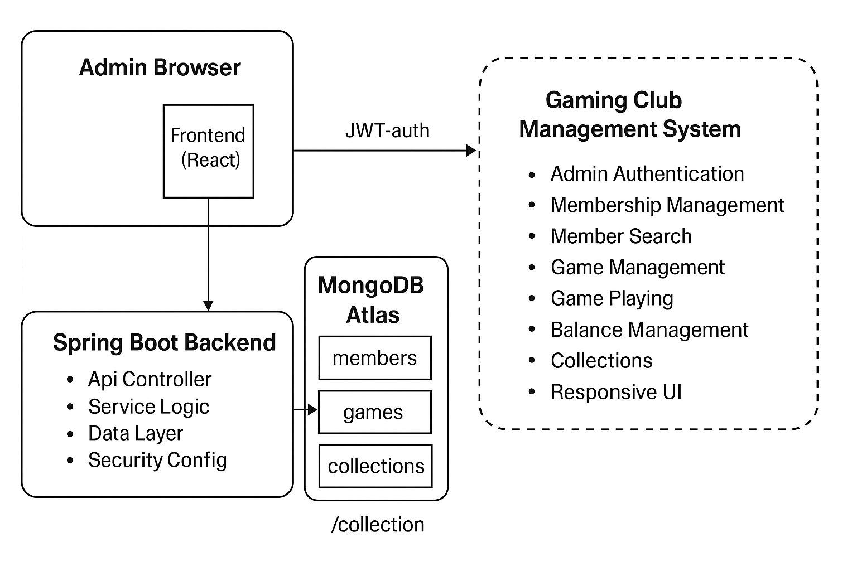

Implementation
The implementation phase transformed the system design into a fully functional Gaming & Recharge Management System. The development process was carried out in modular stages, focusing on backend logic, frontend interaction, and database integration.

1. Backend Implementation (Java + Spring Boot)
The backend served as the core engine of the system, performing all major operations:
- Built using Java and Spring Boot, offering modularity and security.
- Implemented business logic for:
  - User registration
  - Authentication
  - Recharge processing
  - Wallet balance updates
  - Transaction management
- Developed RESTful APIs to communicate with the frontend.
- Exchanged data in JSON format for smooth, lightweight communication.
- Ensured input validation, error handling, and secure API access.

2. Frontend Implementation (React.js and TailwindCSS)
The frontend was designed to be user-friendly and responsive:
- Developed using React.js and TailwindCSS.
- Focused on clean UI design so both admins and members can use the system easily.
- Implemented:
  - Form validations
  - Streamlined navigation
  - Intuitive user interface
- Ensured responsive page layouts for different screen sizes.

3. Database Implementation (MongoDB)
MongoDB acted as the primary data storage layer:
- Collections created for Members, Games, Recharges, and Transactions.
- Used JSON-schema validators to maintain strong data integrity.
- Assigned unique identifiers for mapping transactions to corresponding members and games.
- Ensured consistent, fast, and scalable data operations.

4. Build & Configuration (Maven)
- Used Maven for dependency management and project build tasks.
- Automated library imports and maintained version compatibility.
- Ensured smooth compilation and packaging of the backend application.

5. Deployment & Testing Integration
- All modules were first tested locally in a controlled environment.
- Verified that APIs, frontend components, and database operations worked seamlessly together.
- Ensured system stability, accuracy, and performance across all modules.

Summary
The final implementation delivered a complete and stable system integrating:
- Efficient backend logic
- User-friendly frontend interface
- Secure and structured MongoDB data layer
This combination ensured reliability, scalability, and a smooth user experience throughout the application.

Testing
Testing was conducted in a structured and systematic manner to ensure that each module of the Gaming & Recharge Management System functioned correctly and met all project requirements.

1. Unit Testing
Unit tests were performed on all individual modules to verify their correctness:
- User registration
- Wallet recharge functionality
- Transaction creation and validation
- Game management operations
Each function was tested with multiple input variations to ensure proper handling of valid, invalid, and boundary-case inputs.

2. Integration Testing
After successful unit-level checks, integration testing verified the interaction between system components:
- Communication between frontend, backend, and MongoDB
- Accuracy of data exchange through RESTful APIs
- Real-time reflection of changes (e.g., recharges, transactions) in the user interface
This ensured that the complete system worked smoothly as a combined unit.

3. Functional & Validation Testing
Real-world scenarios were simulated to ensure the system behaves correctly under typical usage:
- Creating members and adding games
- Performing wallet recharges
- Entering transactions
- Generating reports
Database validation rules were also tested by attempting operations such as:
- Missing required fields
- Incorrect data types
- Invalid transaction values
MongoDB correctly rejected all invalid entries, confirming strong data integrity.

4. Performance Testing
Performance tests were conducted to measure:
- API response time
- UI loading speed
- System stability during multiple concurrent operations
The system maintained accuracy and responsiveness, confirming readiness for scalable usage.

Results and Outputs
The developed system achieved all the objectives established during the planning and analysis stages. The Gaming & Recharge Management System now functions as a fully automated web application where users can register, recharge their accounts, and participate in games without administrative delays. Administrators can view all members, manage games, monitor financial transactions, and generate summary reports through a single dashboard. Every operation is validated and stored instantly in the database, ensuring transparency and consistency.
Performance results show that data retrieval and transaction updates occur in real time, while the modular structure allows easy maintenance and scalability. The frontend interface operates smoothly on different devices and browsers, offering a consistent user experience. The backend performs efficiently under high data loads, thanks to optimized API handling and indexed database collections. Visual outputs such as member registration forms, recharge confirmation screens, and transaction logs demonstrate the completeness of the system. The project successfully replaces the limitations of manual management with a secure, accurate, and user-friendly digital platform. Overall, the results confirm that the system fulfills its intended purpose and provides a strong base for future enhancements and integration with larger environments.

Screenshots
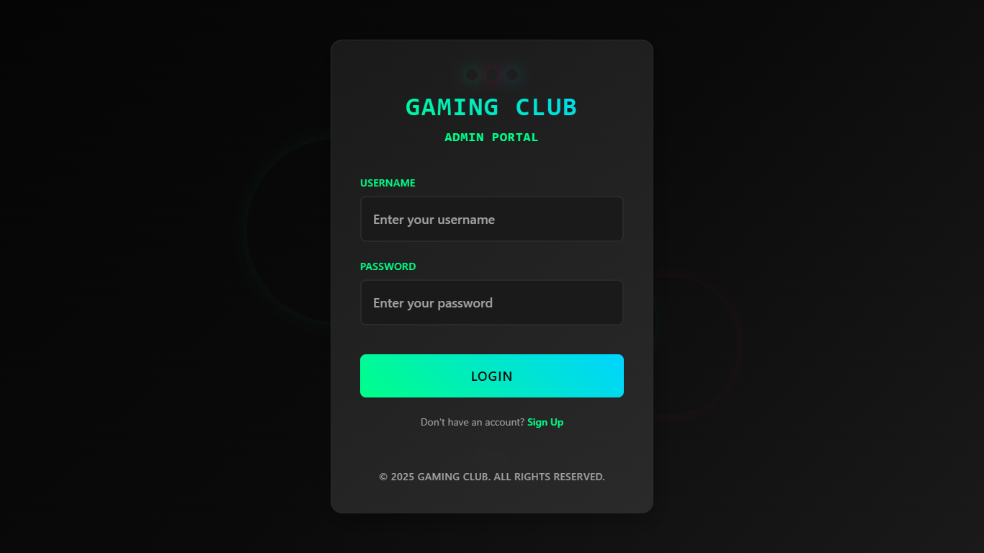
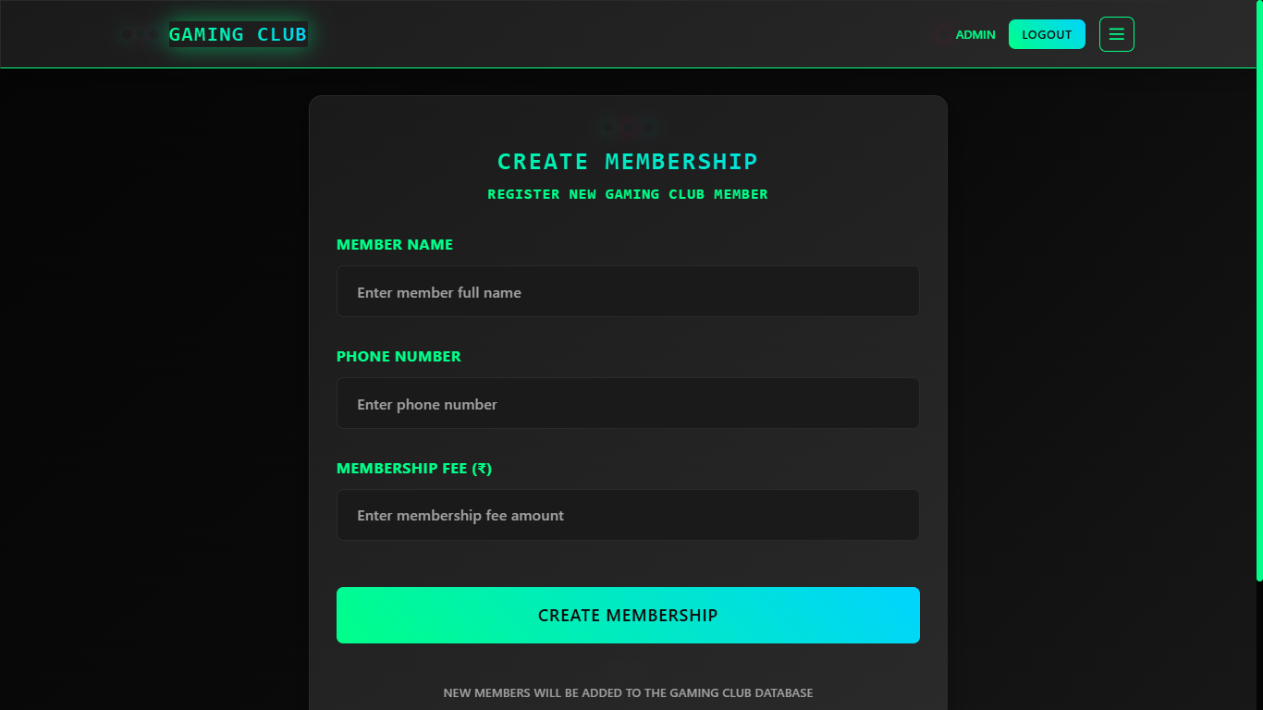
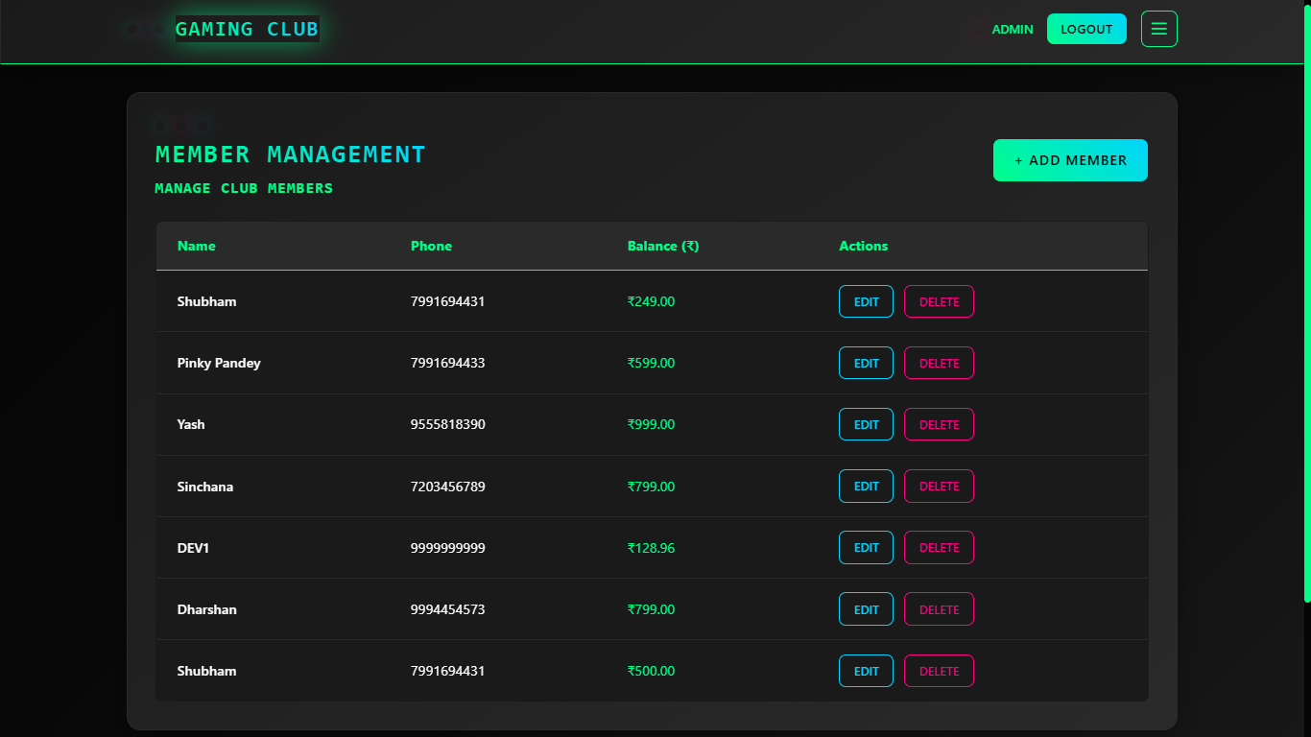
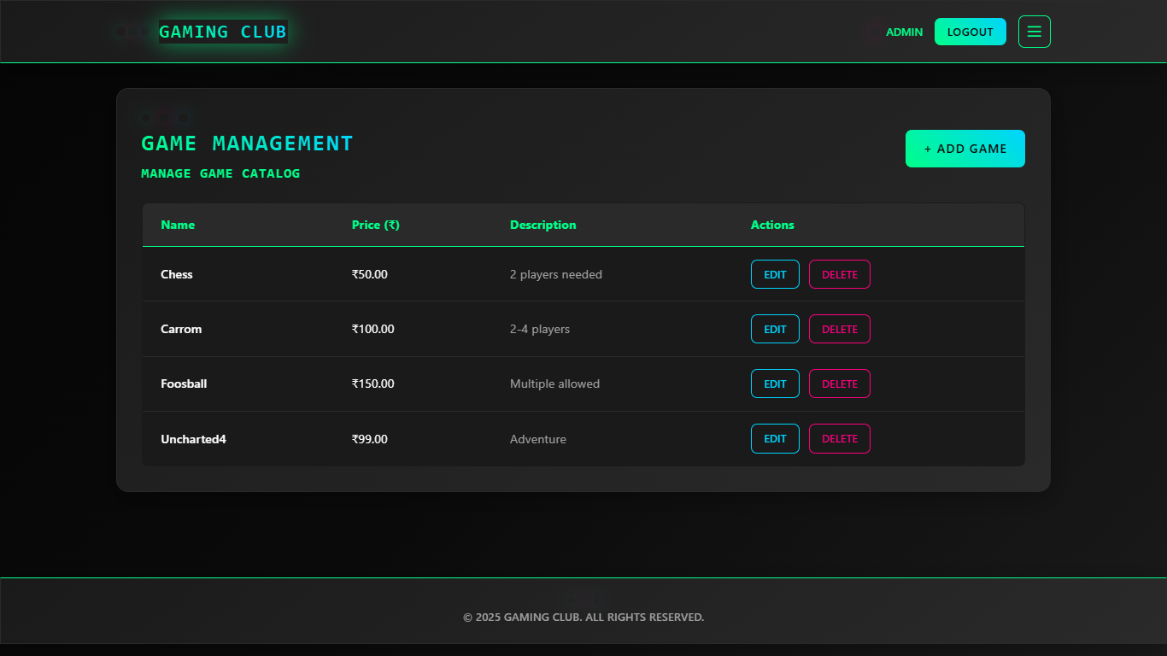
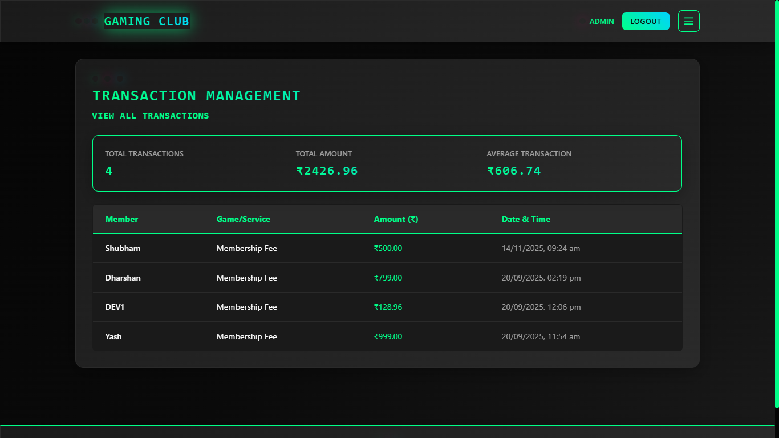
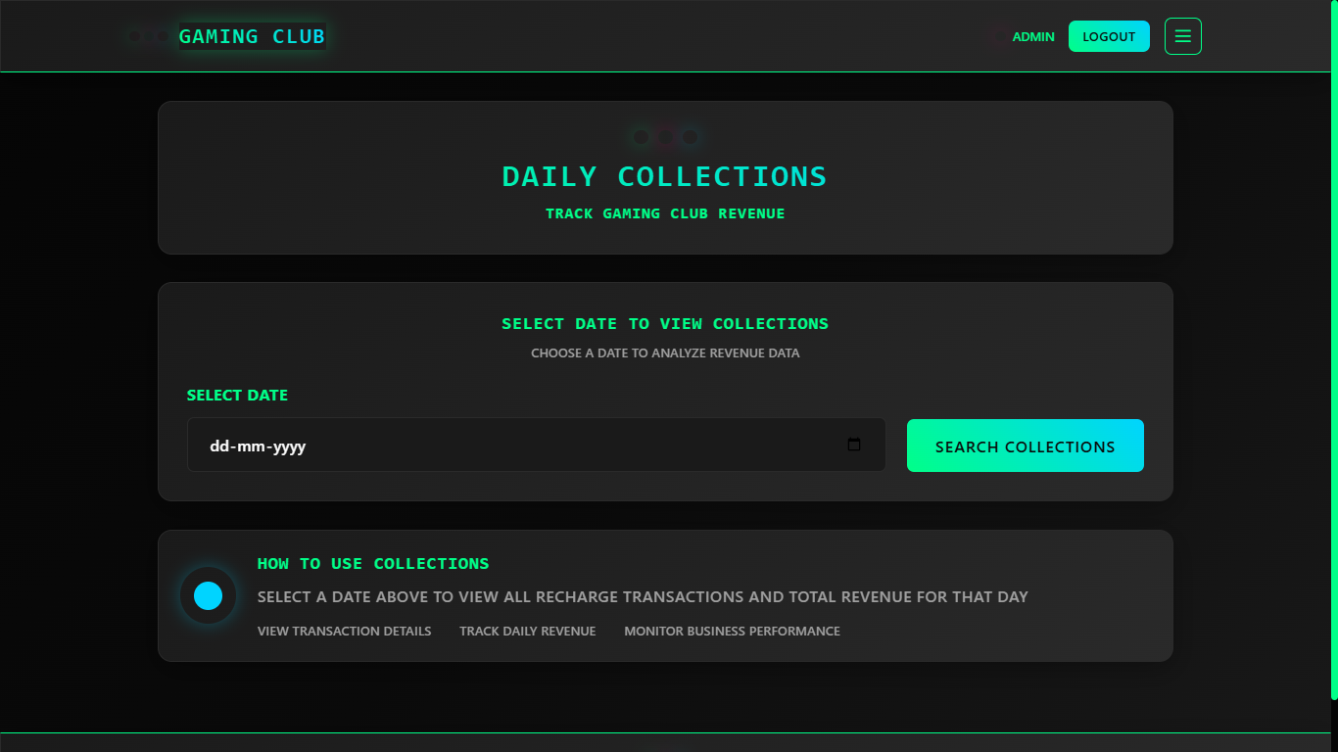

Future Enhancement and Conclusion
While the system meets all current requirements, several enhancements can further improve functionality, scalability, and user experience:

Potential Improvements
- Online Payment Integration:
Add support for UPI, debit/credit cards, and wallet payments to enable real-money transactions directly within the system.
- Mobile Application:
Develop an Android/iOS app to provide members and admins with on-the-go access.
- Analytical Dashboards:
Introduce visual dashboards for tracking member activity, recharge statistics, game trends, and revenue analysis.
- Role-Based Access Control (RBAC):
Implement separate roles for admin, staff, and member users with controlled permissions.
- Advanced Authentication:
Add features such as OTP verification, email login, and multi-factor authentication for improved security.
- Cloud Deployment:
Host the application on scalable cloud platforms (AWS, Azure, GCP) to support higher traffic and ensure better uptime.

Long-Term Vision
These enhancements would transform the current system from a functional prototype into a fully commercial, production-ready platform capable of supporting real-world gaming centers and digital recharge services at scale.

Conclusion
The Gaming & Recharge Management System successfully demonstrates how modern web technologies can streamline and automate complex transactional workflows. By leveraging Java (Spring Boot) for backend services and MongoDB for secure data storage, the system delivers a powerful combination of performance, reliability, and flexibility.
The project accomplished all major objectives, including:
- Digital member registration
- Automated wallet recharge management
- Accurate transaction tracking
- Clean and responsive user interface
- Secure and scalable database integration
Throughout the development process, the team gained hands-on experience in full-stack development, API design, database modeling, and collaborative project execution.
Overall, the system provides a strong foundation for future innovation and serves as a practical solution that can be expanded into a fully commercial gaming and recharge management platform.

