Room-1: What Is A Network?

Modules
What is Networking?
What is the internet?
Identifying Devices on a Network
Ping (ICMP)

Done BY:
G.Tharun
ECE-DS 1-A
Tryhackme id: TryHackMe | tharun67853
What I did :
- I watched the video regarding the module.
- Learnt about:
  - Network
  - Internet and Types of Network
  - History of ARPANET
  - Creation of WWW
  - IP Adress and MAC Adress

- Attended questions regarding those concepts.

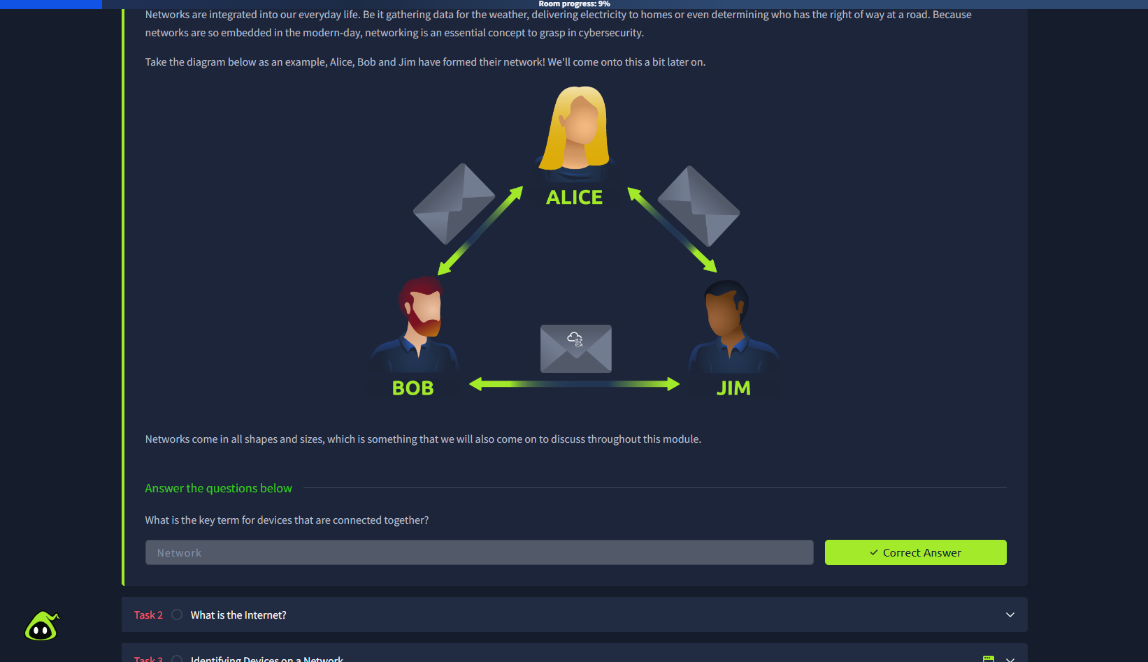

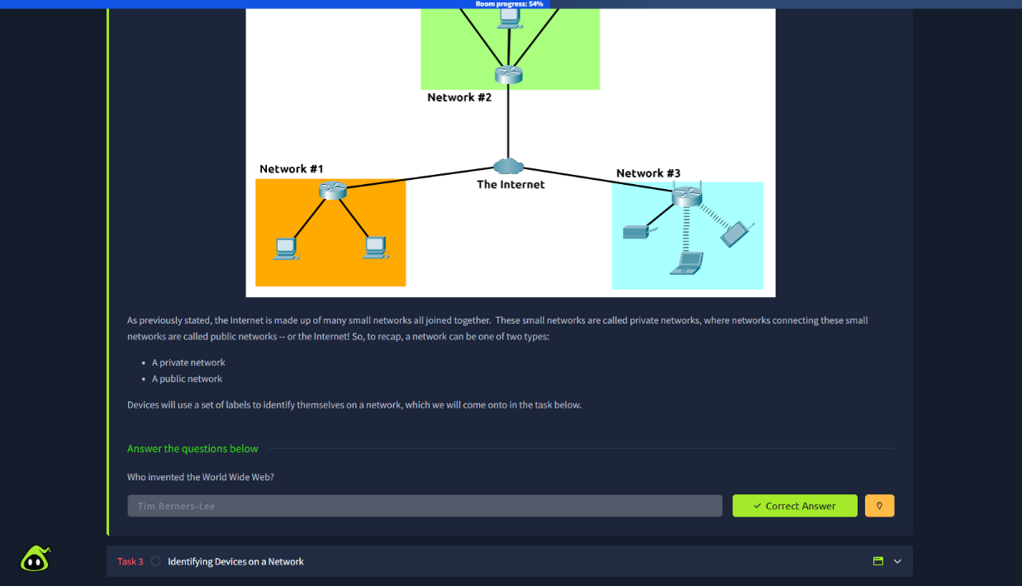

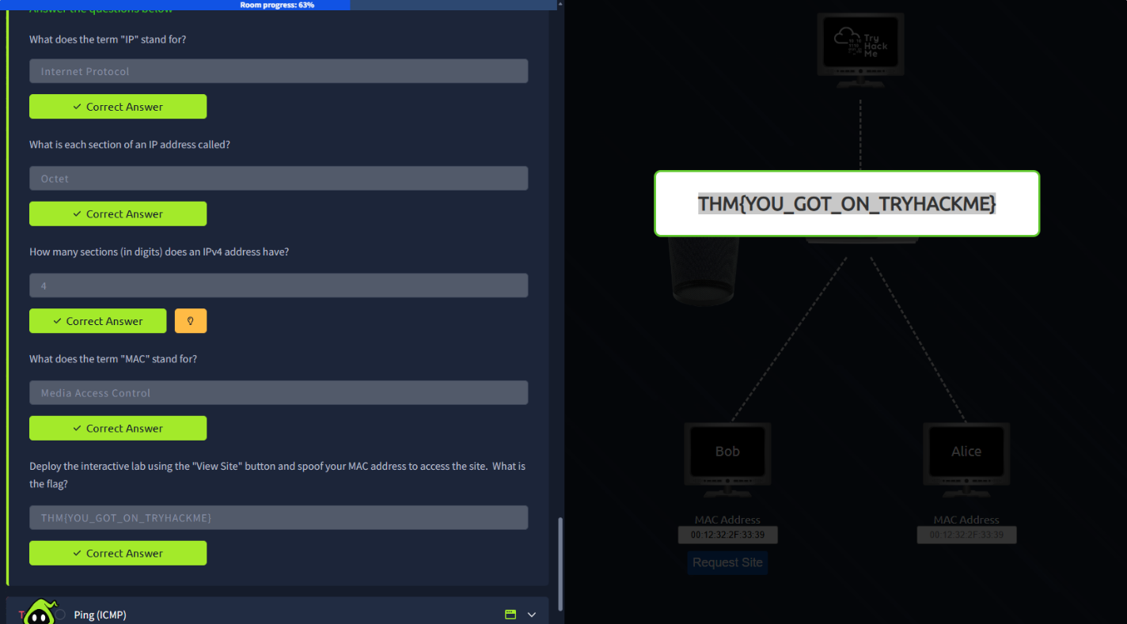

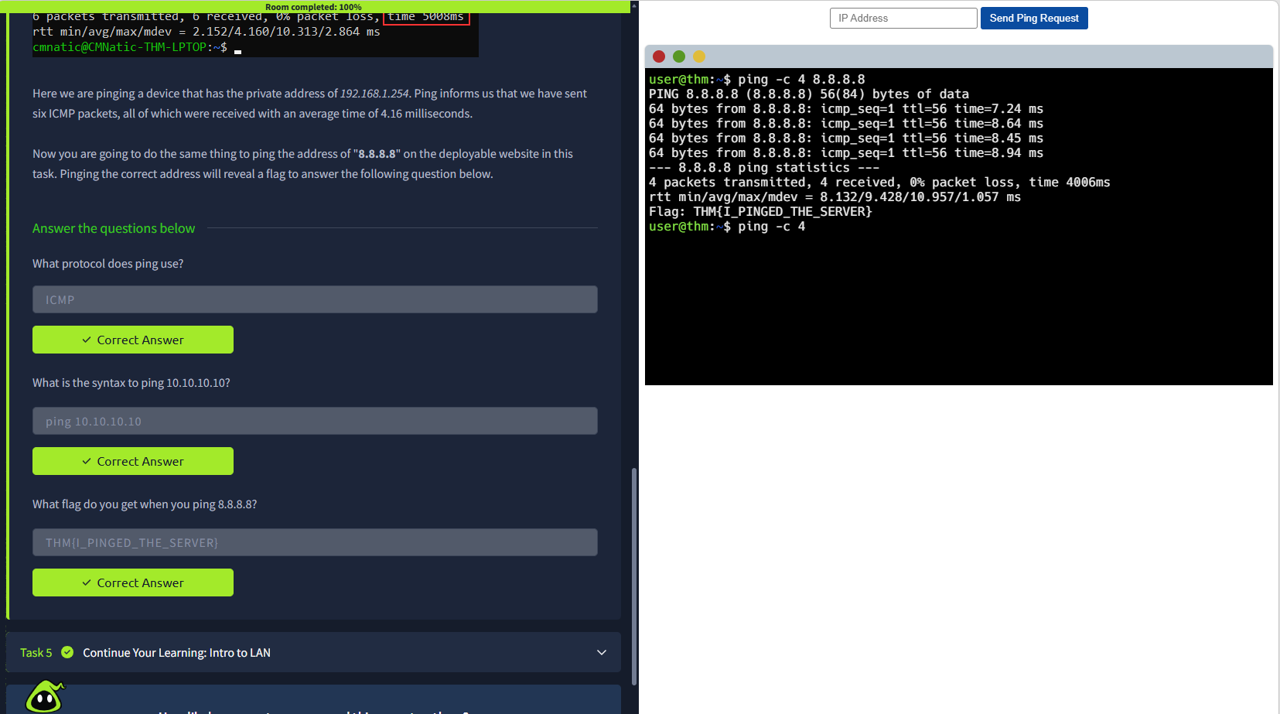

What I learnt:
- Networks are simply things connected. For example, your friendship circle: you are all connected because of similar interests, hobbies, skills and sorts.
- Networks are integrated into our everyday life. Be it gathering data for the weather, delivering electricity to homes or even determining who has the right of way at a road. Networks are so embedded in the modern-day, networking is an essential concept to grasp in cybersecurity.
- The Internet is one giant network that consists of many, many small networks within itself. The Internet is one giant network that consists of many, many small networks within itself.
- The first iteration of the Internet was within the ARPANET project in the late 1960s. This project was funded by the United States Defence Department and was the first documented network in action. However, it wasn't until 1989 when the Internet as we know it was invented by Tim Berners-Lee by the creation of the World Wide Web (WWW)
- The Internet is made up of many small networks all joined together. These small networks are called private networks, where networks connecting these small networks are called public networks.
- IP address (or Internet Protocol) address can be used as a way of identifying a host on a network for a period of time, where that IP address can then be associated with another device without the IP address changing.
- IP Addresses follow a set of standards known as protocols. These protocols are the backbone of networking and force many devices to communicate in the same language
- The MAC address is a twelve-character hexadecimal number split into two's and separated by a colon. These colons are considered separators. The first six characters represent the company that made the network interface, and the last six is a unique number.
- Ping is one of the most fundamental network tools available to us. Ping uses ICMP (Internet Control Message Protocol) packets to determine the performance of a connection between devices.

Room-2: Intro To Networking

Modules:
OSI Model
Encapsulation
The TCP/IP Model
Ping
Traceroute
WHOIS
Dig

What I did:
- Read the contents given in every module.
- Learnt about:
- OSI Model
- Layers of OSI
- Encapsulation
- De-encapsulation
- TCP/IP Model
- Layers of TCP/IP
- History of TCP/IP Model
- Ping command
- Traceroute command
- Domains and WHOIS
- DNS and Hosts File

- Questions regarding to that.

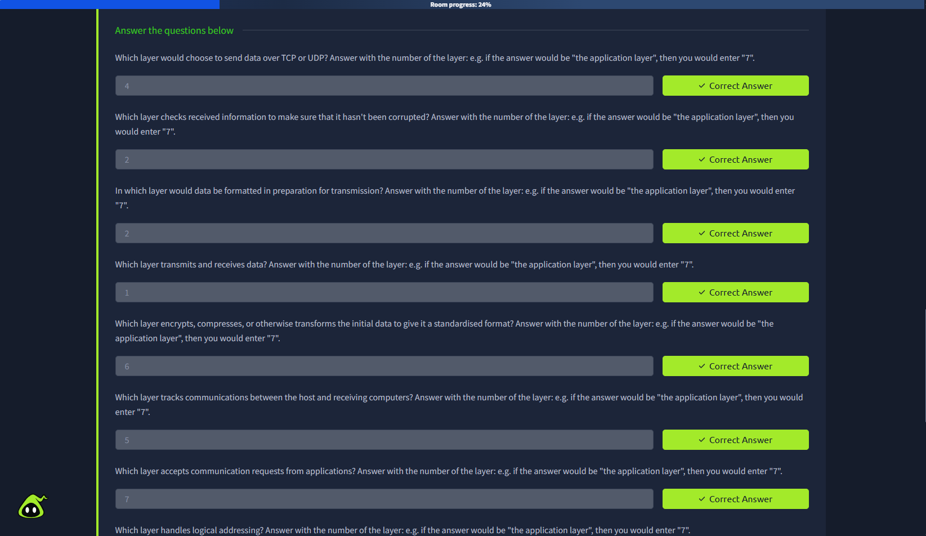

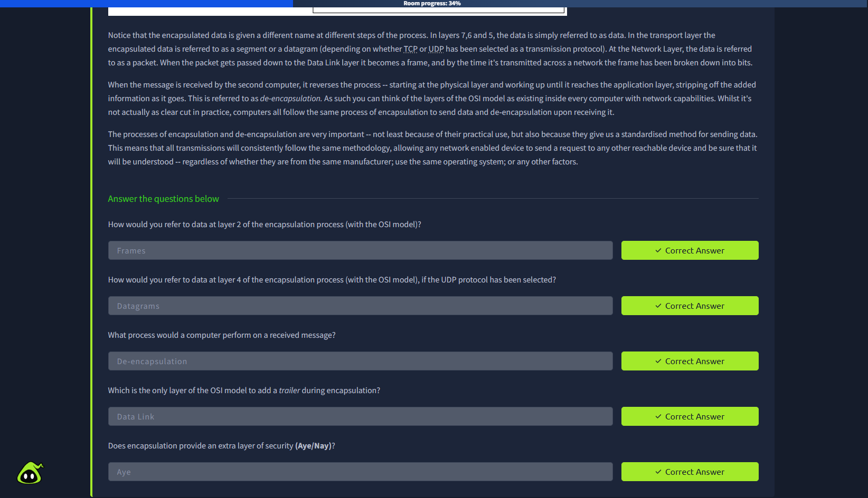

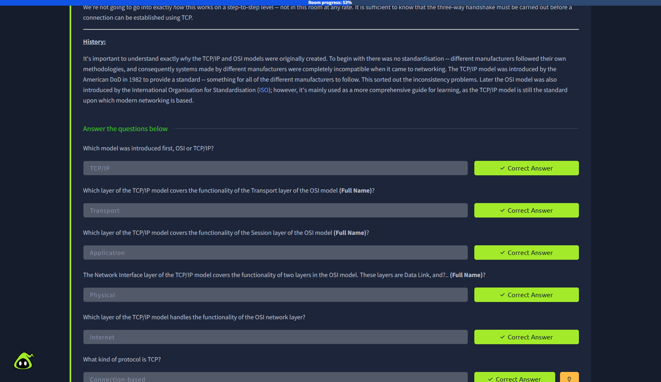

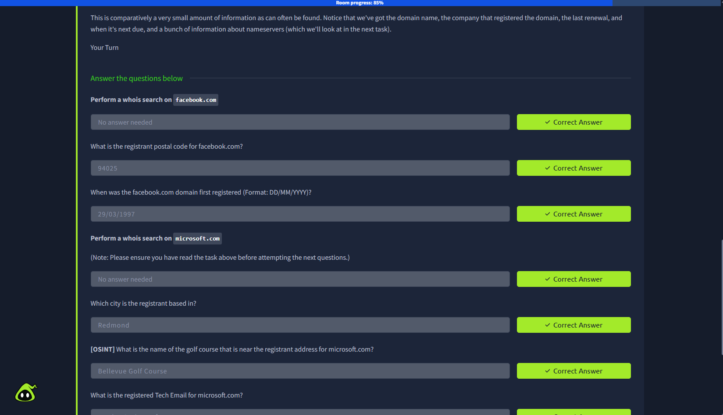

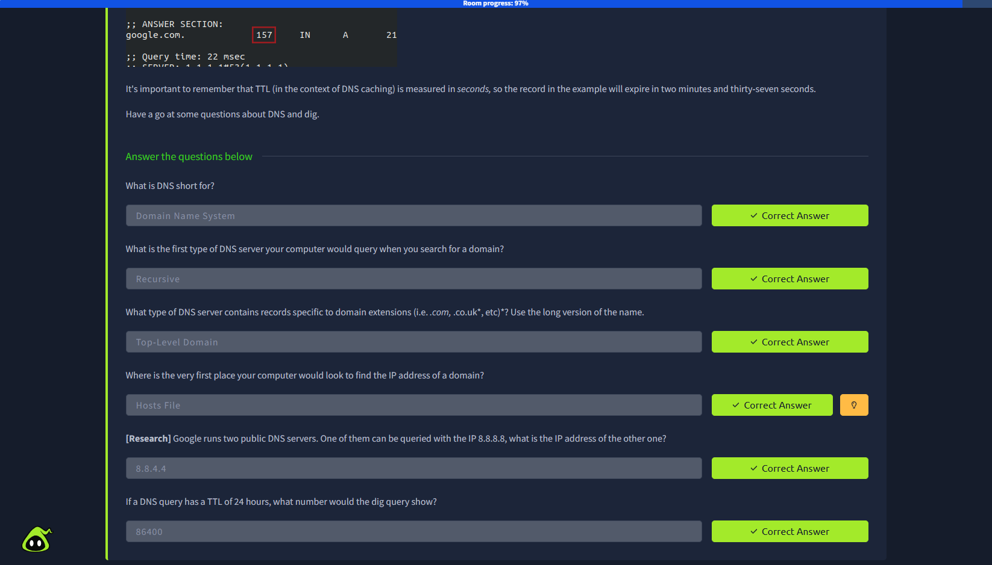

What I learnt:
- The OSI (Open Systems Interconnection) Model is a standardised model which they use to demonstrate the theory behind computer networking.
- It have seven layers:
- Physical
- Data Link
- Network
- Transport
- Session
- Presentation
- Application
- Encapsulation means wrapping data with the information required by each OSI layer for successful communication.
- When the message is received by the second computer, it reverses the process starting at the physical layer and working up until it reaches the application layer, stripping off the added information as it goes. This is referred to as
de-encapsulation.
- The TCP/IP model is, in many ways, very similar to the OSI model. It's a few years older, and serves as the basis for real-world networking. The TCP/IP model consists of four layers: Application, Transport, Internet and Network Interface.
- The processes of encapsulation and de-encapsulation work in exactly the same way with the TCP/IP model as they do with the OSI model. At each layer of the TCP/IP model a header is added during encapsulation, and removed during de-encapsulation.
- There was no standardisation different manufacturers followed their own methodologies, and consequently systems made by different manufacturers were completely incompatible when it came to networking. The TCP/IP model was introduced by the American DoD in 1982 to provide a standard.
- The ping command is used when we want to test whether a connection to a remote resource. The ICMP protocol works on the Network layer of the OSI Model, and thus the Internet layer of the TCP/IP model. The basic syntax for ping is ping <target>.

