MedExpiry
How the Medicine Expiry System Works
A plain-language guide to the full journey — from a pack photo to a clear “expired or not” answer, including every checking step, special cases, languages, and spoken results.
Version 1.0 · August 2026 · Written for non-technical readers
What this document is for
This guide explains the MedExpiry product in everyday language. You do not need a software background. We avoid programming names and focus on what happens, why it happens, and what you will see on screen in each situation.
1. The big picture
MedExpiry helps a household answer a simple but important question: “Is this medicine still safe to use, based on the dates printed on the pack?”
A person takes or uploads a photo of the medicine pack (especially the area with manufacturing and expiry dates). The system carefully reads those dates, double-checks itself, applies calendar rules, and shows a clear result. If the user prefers, it can also speak the result aloud in one of several Indian languages.
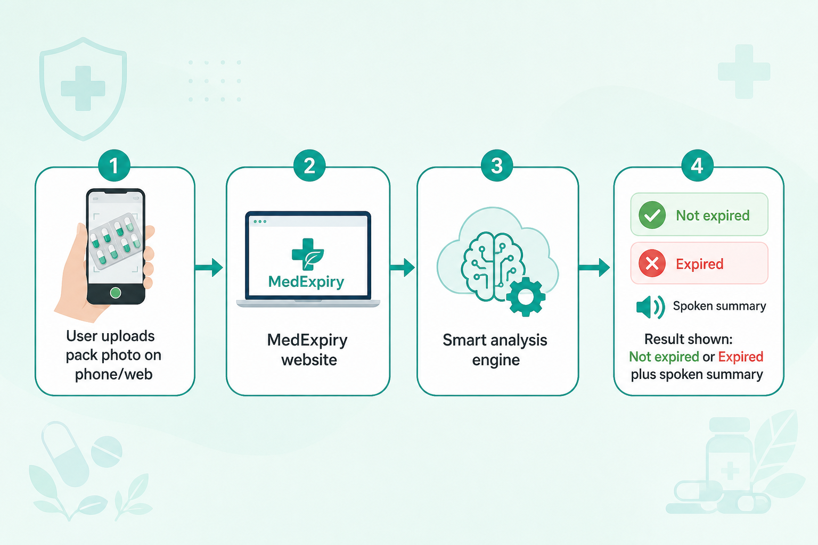
Figure 1. The overall journey: photo → MedExpiry → careful analysis → clear spoken/written result.
What the product does well
- Reads manufacturing and expiry dates from a pack photo.
- Uses two independent “eyes” so one mistaken reading is less likely to win.
- Brings in a third careful review only when the two readings disagree or look unsure.
- Applies fixed calendar rules at the end (not a guess) to decide expired vs not expired.
- Separately tells you if a human should still take a second look.
- Works in ten languages and can read the answer aloud.
What it does not claim
- It does not replace a pharmacist, doctor, or official recall notice.
- It cannot magically invent dates that are not visible in the photo.
- Blurry, cropped, or glare-heavy photos reduce accuracy.
2. What a person sees in the app
The MedExpiry website has a welcoming home page and a Detection page where you upload a pack photo. After analysis finishes (this can take a short while because several careful checks run), you see:
- Manufacturing date — Manufacturing date (as printed on the pack).
- Expiry date — Expiry date (as printed on the pack).
- Main status — A clear headline such as Not expired, Expired, or Unable to determine.
- Review flag — Whether human review is still recommended.
- Agreement note — Whether the two readings agreed (for transparency).
- Speech — Listen and Stop buttons for spoken summary.
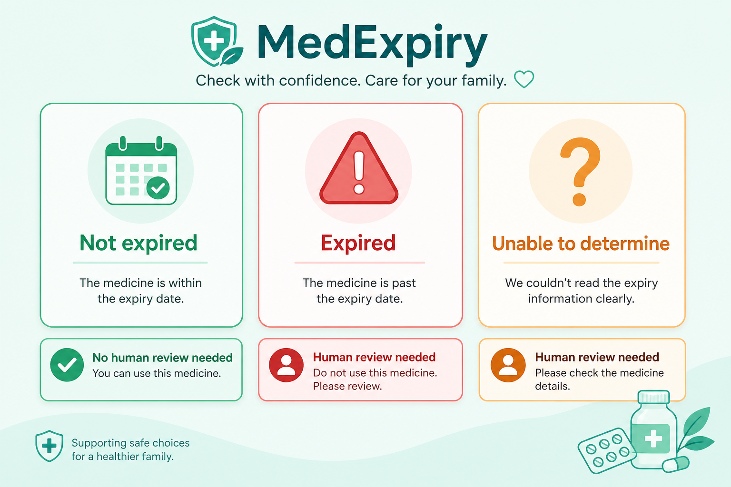
Figure 2. The three main outcomes people can see, plus the separate human-review flag.
Two separate answers (this matters)
“Not expired / Expired” is decided from the expiry date and today’s calendar. “Needs human review / No human review needed” is a separate trust signal. A pack can be Not expired and still need human review if the pipeline was uncertain — or Not expired with no review needed when everything checked out cleanly.
3. The step-by-step checking process
Behind the scenes, MedExpiry runs a fixed sequence of steps — like a checklist that never skips a stage. Think of it as a production line for reading dates safely. Some steps use advanced vision models; some steps use plain, fixed rules that never “hallucinate.”
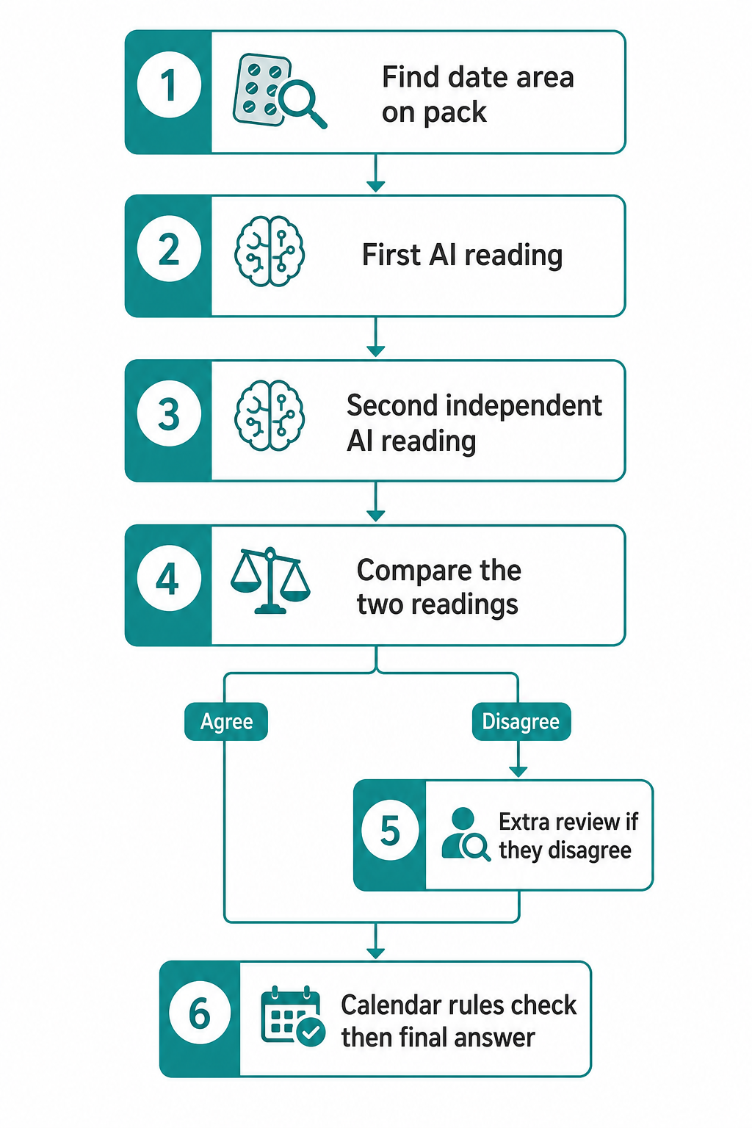
Figure 3. The six main steps from finding the date area to the final calendar decision.
Step 1 — Find the date area on the pack
Before trying to read tiny printed characters, the system first tries to locate the region on the pack that usually holds manufacturing and expiry markings. This is done with a specialist detector trained for those date regions (not a general “chat” model inventing a box).
Scenarios in this step
- Success — The detector finds the date region. The system crops that area, adds a little padding around the edges (so letters are not cut off), and enlarges small crops so the next steps can read them more clearly.
- Miss / fallback — The detector cannot find a clear date region (unusual lighting, odd angle, or pack style). The system does not give up. It falls back to using the whole photo as the crop, and continues. Quality may be lower, but the pipeline still runs.
Why this step matters for quality
Reading an entire busy pack photo is harder than reading a close-up of the date strip. Finding the right area first improves accuracy and reduces mistakes from nearby text (batch numbers, addresses, logos).
Step 2 — First careful reading
A vision model looks only at the cropped date area and tries to transcribe exactly what is printed for manufacturing and expiry — character by character. It is instructed not to invent a “plausible” date when text is unreadable. It also reports how confident it feels about each field (high, medium, or low).
Scenarios in this step
- Clear print — Both dates are clear → high confidence values are returned.
- Partly unclear — One character is smudged → medium or low confidence, with honesty preferred over guessing.
- Missing field — A field is missing or fully illegible → that field is left empty rather than invented.
Step 3 — Second independent reading
A second reading is done on the same crop. Critically, this second reader does not see the first reader’s answer. That prevents the second check from simply copying the first mistake. Independence is a major quality feature.
Scenarios in this step
- Agreement path — Same dates as the first reading → strong agreement later.
- Disagreement path — Different digits or month names → disagreement path later.
- Label-only noise — Sometimes the second reader returns only a label fragment such as “EXP.” or “MFG” without numbers. The system treats that specially in the next step so a real numeric date from the first reader is not thrown away.
Step 4 — Compare the two readings
This step does not use an AI model. It uses fixed comparison rules: clean up spacing and letter case, then compare manufacturing and expiry strings, and look at confidence flags.
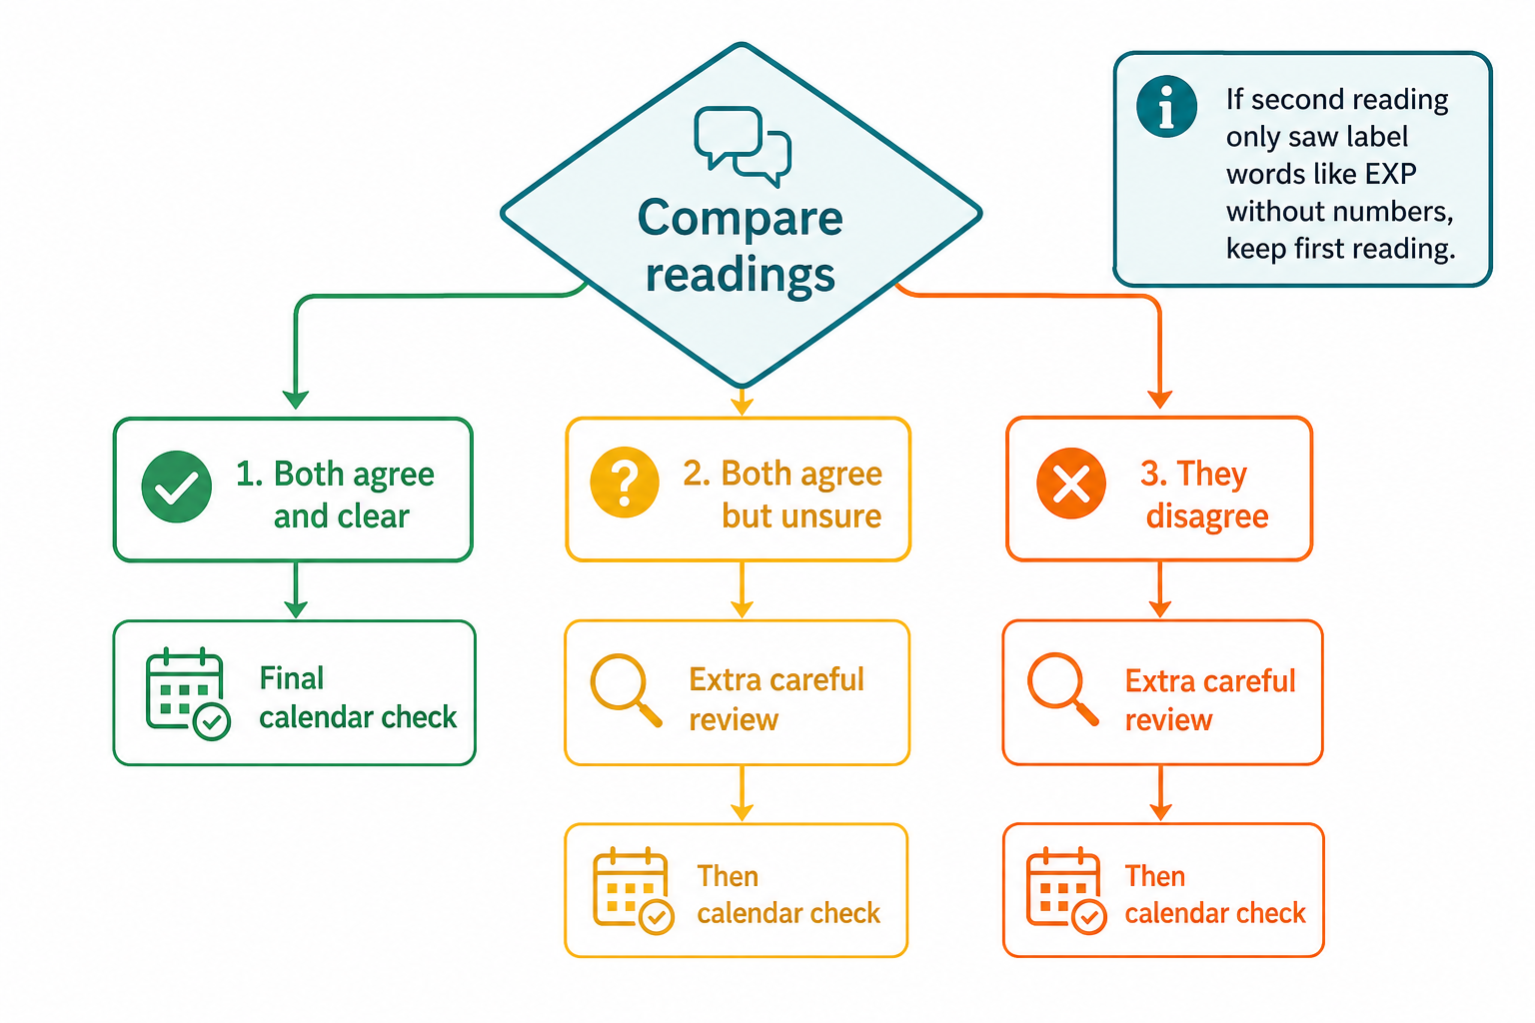
Figure 4. How the comparison step decides whether to go straight to calendar checks or ask for an extra review.
Scenarios covered by comparison
- Clear agreement — Both readings match and confidence is not low → use those dates and go straight to calendar validation (fast, common happy path).
- Agreement but unsure — Both readings match, but at least one field was marked low confidence → still send to extra review. Two models can agree on the same wrong guess when print is poor.
- Disagreement — Manufacturing or expiry differs between the two readings → extra review.
- Label-prefix guard — Second reading looks like label words without digits, while first reading has real numbers → keep the first reading as a match and skip unnecessary extra review.
Step 5 — Extra careful review (only when needed)
When readings disagree or look unsure, a third vision review looks at the crop again with both candidate answers. It is asked to justify the choice from what is visually present — not from what “sounds like a normal medicine date.”
Scenarios in this step
- Resolved — The third review can clearly see which digits are correct → it returns a resolved final manufacturing and/or expiry value.
- Unresolved — The disputed character is still illegible even on close look → it marks the case unresolved. Later steps will flag human review rather than forcing a fake answer.
- Skipped on clear match — If the earlier comparison already matched confidently, this step is skipped. That saves time and cost on clear packs.
Step 6 — Calendar and format rules (final gate)
This is the last word on pipeline trust for acceptance. It is not an AI guess. It parses the printed date into a real calendar meaning and applies strict checks.
Many pack formats are supported, including styles like APR.2024, MAR.2027, 08/2024, 2024-08, 15-08-2024, 15 AUG 2024, and several compact numeric forms. If a date shows only month and year (common on packs), the medicine is treated as valid through the last day of that month.
Checks performed
- Can the expiry date be understood as a real date format?
- Is the pack still within its valid period relative to today?
- If manufacturing date exists, does expiry come after (or at) manufacturing?
- Did an earlier extra review leave the case unresolved?
Outcomes of this gate
- Accepted — All required checks pass → the pipeline marks the case as accepted (trusted enough).
- Human review — Any required check fails (unreadable expiry, already past validity, impossible date order, unresolved dispute) → human review is flagged.
4. Turning pipeline results into what people understand
After the checklist finishes, MedExpiry creates a simple assessment for the screen and for speech. This assessment is calculated with the same date rules on the server — the website does not recalculate expiry on its own. That keeps answers consistent.
What you see | What it means | Typical cause
Not expired | Expiry date is still within its valid period (including end-of-month for month-only dates). | Clear future expiry such as MAR.2027 when today is earlier.
Expired | Today is after the last valid day of the expiry period. | Past month/year such as APR.2024 when today is later.
Unable to determine | Expiry could not be read as a known date format. | Missing, garbled, or non-date text.
No human review needed | Pipeline accepted the case and expiry was readable. | Clean agreement + calendar checks passed.
Needs human review | Pipeline was not fully confident, or expiry was unreadable. | Disagreement, low confidence, unresolved review, or bad parse.

Combined scenarios people actually encounter
- Best case — Clear photo, both readings agree, future expiry → Not expired + No human review needed. (This matches a healthy pack like manufacturing APR.2024 and expiry MAR.2027.)
- Expired pack — Clear photo of an old pack whose expiry month has passed → Expired. Human review depends on whether calendar/format checks were fully satisfied.
- Hard photo, recovered — Two readings disagree, third review resolves the digits, expiry still in the future → Not expired, but may still show Needs human review depending on acceptance rules.
- Truly illegible — Third review cannot resolve the disputed digit → Unable to determine or incomplete dates, with Needs human review.
- Fallback crop — Detector missed the strip, full photo used as fallback → pipeline still runs; risk of weaker readings and more review flags.
- Label noise — Second reading returns “EXP.” only → system keeps the numeric first reading when appropriate.
5. Languages and spoken results
MedExpiry is built for Indian households where not everyone reads English comfortably. The interface and the spoken summary follow the language chosen in the app.

Figure 5. Choose a language, then use Listen / Stop to hear the result.
Supported languages
English, Hindi, Tamil, Telugu, Marathi, Bengali, Gujarati, Kannada, Malayalam, and Punjabi. The choice is remembered on the device for the next visit.
How speech works
- The server decides the facts (dates, expired or not, review needed).
- The app builds a short spoken sentence in the selected language.
- The device’s built-in speech voices read it aloud (no separate audio server required).
- Listen starts speech; Stop immediately cancels it.
- If a matching voice for that language is not installed on the device, the app may fall back to a default voice and show a gentle notice.
Design choice in plain words
Screen labels and speech wording live with the app (so the experience feels fast and local). The hard facts — whether the medicine is expired — are decided on the server so every client gets the same truth.
6. Overall pipeline quality — why this design is careful
MedExpiry is intentionally cautious. Healthcare-adjacent tools should prefer “I am unsure — please check” over a confident wrong date.
Quality principles built into the flow
- Focus — Locate first, then read (better focus on the right print).
- Redundancy — Two independent readings reduce single-model mistakes.
- Selective escalation — Extra review only when needed (efficient and safer on hard cases).
- Deterministic last word — Final acceptance uses fixed calendar rules, not model opinion.
- Honesty — Abstain rather than invent illegible digits.
- Clear communication — Human-review flag is shown separately from expired/not expired.
- Patience — Long analysis window supported (vision checks can take time).
What improves results in real homes
- Bright, even lighting without strong glare.
- Fill the frame with the date print (MFG / EXP area).
- Keep the camera steady; avoid motion blur.
- Prefer JPEG/PNG/WebP/BMP photos from the pack itself (not a screenshot of a screenshot).
Known limits (honest)
- Very damaged, faded, or handwritten overprints may remain unreadable.
- Unusual date formats outside the supported set may need human review.
- Spoken quality depends on the voices installed on the user’s phone or computer.
- The tool reads printed dates; it does not verify whether the medicine was stored correctly.
7. A complete example walkthrough
Imagine a blister pack photo showing manufacturing APR.2024 and expiry MAR.2027, taken in August 2026.
- Date area is found and cropped.
- First reading returns APR.2024 and MAR.2027 with good confidence.
- Second independent reading returns the same values.
- Comparison: clear agreement → skip extra review.
- Calendar rules: MAR.2027 is still valid through the end of March 2027 → not expired.
- Acceptance checks pass → no human review needed.
- Screen shows Not expired; Listen can speak that summary in the chosen language.
Now imagine the same pack but the second reading mis-reads the year. Comparison detects disagreement → extra review looks again → if it resolves to MAR.2027, calendar rules still say not expired. If it cannot resolve the year, the app will not pretend certainty and will ask for human review.
8. Summary for decision-makers
MedExpiry combines specialist date-area detection, dual independent readings, optional third-party adjudication, and strict calendar validation. Users receive a plain expired/not-expired answer plus a separate review flag, in multiple Indian languages, with optional speech. The design prioritizes safety and honesty over speed-at-all-costs guessing.
One sentence takeaway
Upload a pack photo → the system finds the dates, double-checks them, applies calendar rules, and tells you clearly whether the medicine looks expired — and whether a person should still verify.
MedExpiry System Guide · Compatible with Microsoft Word and Google Docs · Upload this .docx file to Google Drive and open with Google Docs

